PBC decision-making, certification and fees for service
Discussion Paper

Overview
This Discussion Paper explains how native title decisions and decisions to make a compensation application are to be made by Prescribed Bodies Corporate (PBCs) and explains the decision-making processes available to PBCs and common law holders. It also includes information on when PBCs can charge fees for their services.

Rules and Regulations
When a PBC wants to make a native title decision, it must follow regulations and rules in:
- the Native Title (Prescribed Bodies Corporate) Regulations 1999 (Cth);
- the Native Title (Indigenous Land Use Agreements) Regulations 1999 (Cth); and
- its rule book (if the rule book has special rules for native title decisions).

What is a Native Title Decision?
The PBC Regulations define native title decisions in sub-regulation 3(1) by outlining five types of decisions.
These types of decisions fall into two categories which are also defined in sub-regulation 3(1):
- low level decisions and
- high level decisions – refer to figure 1 below for details.

Native title decisions are decisions to:
- surrender native title rights and interests in relation to land or waters [a high level decision];
- enter into an indigenous land use agreement (ILUA) or an agreement in relation to the right to negotiate process (also known as a ‘section 31 agreement’) [a high level decision];
- allow a person who is not a common law holder, or a class of persons who are not common law holders, to become members of a PBC [a high level decision];
- include one or more consultation process in the constitution (or ‘rule book’) of a PBC [a high level decision]; or
- do, or agree to, any act that would otherwise affect the native title rights or interests of the common law holders (other than a decision to make a compensation application) [a low level decision].
Before PBCs can make a native title decision, they must consult and obtain the consent of the (relevant) common law holders.
Note: Native title decisions are different to corporate decisions, which are made by a PBC’s directors or members. Corporate decisions relate to the operation of the corporation, for example decisions about staff, when to hold Annual General Meetings and decisions about strategy and finance (of the corporation, not money associated with native title agreements). These decisions must be made pursuant to the Corporations (Aboriginal and Torres Strait Islander) Act 2006 (CATSI Act) and the PBC’s rule book.

Decision-making processes and alternatives
The process that a PBC must follow to ensure that the decision-making requirements are met, and whether alternative processes are available, depends on whether a native title decision is a high level or low level decision.
High level decisions have a mandated consultation process under regulation 8 (with one exception, mentioned below). There is greater flexibility for PBCs regarding low level decisions.
Standing instructions can be given for a low level decision. This option is not available for high level decisions except for decisions to enter an ILUA in relation to the doing of an act by or for the benefit of the PBC or a section 31 agreement in relation to which the PBC is the only grantee party (ie the body that has applied to the government for the grant of the mining tenement such an exploration licence and a mining lease).
For low level decisions there is also the option of using an alternative consultation process, if such a process is included in the PBC’s rule book.
Further information about standing instruction decisions and alternative consultation processes is below pages 9-10.
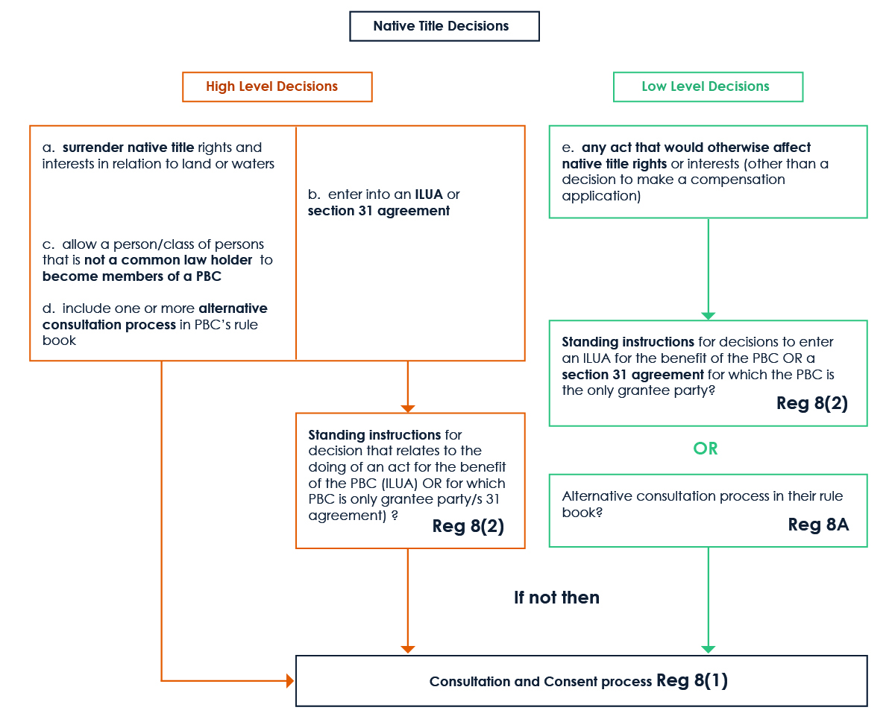Figure 1: Native Title Decision tree describing the process for both High Level Decisions and Low Level Decisions. Figure description in the Appendix

How native title decisions are to be made under the consultation and consent process in regulation 8
If there are no standing instructions or alternative consultation processes that apply, the PBC must follow the process in regulation 8 of the PBC Regulations before it can make any of the five types of native title decisions. That means a PBC must consult with the relevant common law holders about the proposed native title decision and must obtain their consent for that decision.
There are three key decisions to be made when following this process in regulation 8:

Who makes the decision?
If the native title determination for the PBC identifies more than one group of common law holders (the regulations refer to ‘classes of common law holders’) such as different language groups, then the PBC only has to consult the group(s) that are affected by the native title decision (the regulations refer to ‘on whom the proposed native title decision would have an effect’) and get their consent, using the particular decision-making process of the group(s).
Whether or not there are more than one class of common law holders depends on the wording of the native title determination. If the determination does not identify classes of common law holders, then all common law holders must be consulted and their consent obtained using their decision-making process. Examples of classes of common law holders identified in a determination may be different language groups or estate groups.

What is the decision-making process?
The native title decision must be made in accordance with the process of decision-making that must be followed under the traditional laws and customs of the relevant common law holders. Only if no traditional decision-making process exists, can the common law holders choose their own process (the regulations refer to ‘agree and adopt’ a decision-making process).
Therefore the following must be determined:
- Is there a traditional decision-making process that must be followed? If yes, that process must be followed.
- If not, the relevant common law holders must agree and adopt a decision-making process.

Is the native title decision consented to?
The native title decision must be made by the relevant common law holders by following the decision-making process determined under 2 above.
Note: even when the determination does not identify classes of common law holders, it is possible, depending on the traditional or adopted decision-making process, that consent is given by subgroups of the common law holders such as family groups.

Example 1 – there are classes of common law holders
A mining company would like to negotiate a section 31 agreement and approaches the PBC.
The PBC manages the native title for two language groups (ie two classes of common law holders), as described in the determination: Group A who hold the native title in the West of the determination area, and Group B in the East. The proposed mine (X) is located on Group B’s country.
Also, in this example, under Group B’s traditional laws and customs, particular families have the right to speak for particular areas, although these details are not in the determination itself.
The three decisions that need to be taken in this example would be taken as follows:
- Who makes the decision? The determination identifies more than one class of common law holders. The relevant class is Group B. The PBC determines that the proposal will only affect Group B, and so will need to consult with Group B only and seek their consent, using the relevant decision-making process of Group B.
- What is the decision-making process? The members of Group B are required to determine whether they have a traditional decision-making process that must be followed for making this kind of decision (ie entering into a mining agreement). Group B has such a process being that particular families have the right to speak for country.
- Is the native title decision consented to? The relevant family that speaks for the proposed area of the mine is to make the decision about whether or not it consents to entering into the section 31 agreement.
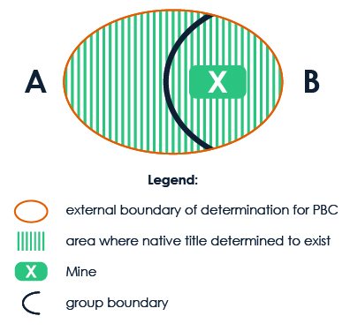
Diagram description in the Appendix
Note: if Group B did not have a traditional decision-making process that it must follow, the members of Group B would have to agree on a process and make the decision following this adopted process.

Example 2 – there is only one group of common law holders
The determination does not identify different classes of common law holders. The common law holders don’t have a traditional decision-making process that must be followed. They wish to make decisions by a majority vote of those common law holders present at the meeting at which the agreement is considered.
- Who makes the decision? As the determination does not identify more than one class of common law holders, the PBC will have to consult all the common law holders recognised in the determination.
- What is the decision-making process?
  - The common law holders will need to make a decision (for example by passing a resolution) that they don’t have a traditional decision-making process that must be followed for making the native title decision.
  - They are then required to agree to and adopt a decision-making process. The common law holders in this example agree to and adopt a decision-making process by majority vote of those common law holders present at the meeting at which the agreement is considered.
- Is the native title decision consented to? The decisions has been consented to if the majority of the common law holders present at the meeting at which the agreement is considered, agree to enter into it.
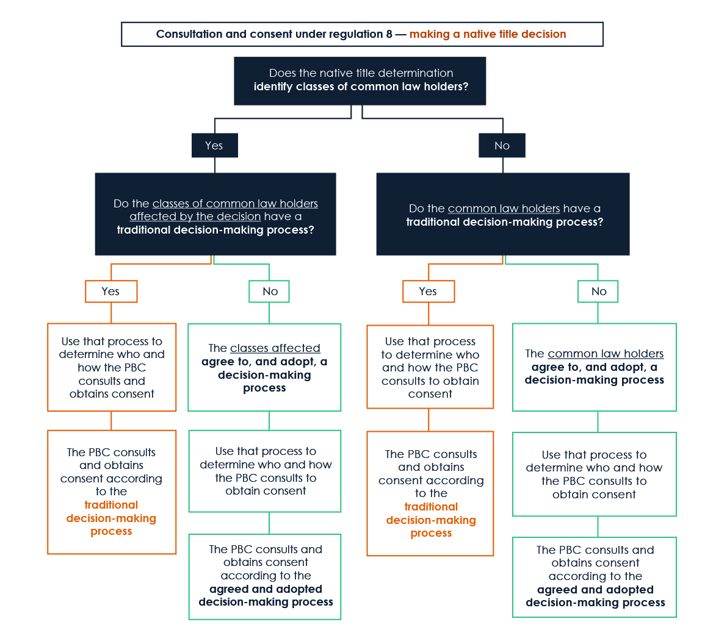
Figure 2: flowchart further explaining how the consultation and consent process under regulation 8 works. Figure description in the Appendix

How decisions to make a native title compensation application are to be made under regulation 8B
Subsection 61(1) of the Native Title Act 1993 (NTA) states that a registered native title body corporate (RNTBC), on behalf of all the persons who claim to be entitled to compensation (and who are the common law holders), can bring native title compensation applications.
Regulation 8B of the PBC Regulations require an RNTBC consult with, and obtain the consent of, the relevant common law holders, in relation to the making of a compensation application. The relevant common law holders are also the persons who claim to be entitled to the compensation.
The process in regulation 8B is similar to the process in regulation 8 (that applies in the case of making native title decisions) in that there are three decisions to be made:

1. Who makes the decision?
To determine this question, the following steps need to be completed:
- Identify the relevant native title determination for the compensation application: does the native title determination cover:
  - the land or waters over which compensation is being claimed; or
  - the area of land or waters whose external boundary includes the relevant land or waters over which compensation is being claimed?
- Identify the relevant common law holders: these are generally the common law holders for the relevant native title determination.
Where there is a determination that native title exists in relation to all of the land or waters to which the compensation application relates (ie category 1 in the table above) AND the native title determination identifies classes of common law holders, then only the class of common law holders who hold native title rights and interests for the area to which the compensation application relates have to be consulted and give their consent using their relevant decision-making process.
This is the only instance in relation to compensation applications where only the consent of the relevant class(es) of common law holders is required.
In the example illustrated in the graphic below the consent of Group A would be required as they are the common law holders for the proposed compensation claim area (the area in yellow).

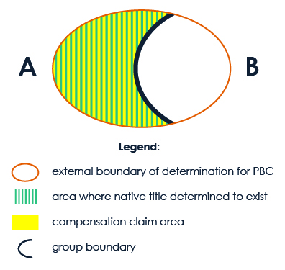
Description of diagram in Appendix

2. What is the decision-making process?
- Is there a traditional decision-making process that must be followed? If yes, that process must be followed.
- If not, the relevant common law holders must agree and adopt a decision-making process.

3. Is the compensation application consented to?
For a PBC to be able to make a compensation application, the relevant common law holders must have been consulted and they must have given their consent, following the relevant decision-making process.
How Standing Instructions decisions are to be made under regulation 8
Sub-regulation 3(1) of the PBC Regulations defines a ‘standing instructions decision’ as a native title decision that is:
- a Low Level Decision;
- a decision to enter an indigenous land use agreement in relation to the doing of an act by or for the benefit of the PBC; or
- a decision to enter a section 31 agreement in relation to which the PBC is the only grantee party.
To streamline decision making, common law holders can give standing instructions to their PBC in relation to decisions that fall within the above three decision types. They are also able to impose conditions on the standing instructions and can withdraw them at any time.
- Where the native title determination for the PBC identifies classes of common law holders, the standing instructions have to be given by the class(es) of common law holders on whom the decision would have an effect.
- In any other case the standing instructions have to be given by the common law holders (see subregulation 8(8)).
The manner in which the standing instructions, including conditions, are given, varied or removed, depends on the type of decision and the decision-making process of the relevant common law holders (see subregulation 8(9)).
If standing instructions have been given (and the relevant conditions have been met), the PBC does not need to consult or obtain consent in relation to decisions covered by the instructions (see subregulation 8(2)).

Example
A PBC has set up an exploration business and plans to apply for several exploration licences in its determination area over the next three years. The Native Title Act requires an ILUA or section 31 agreement between the PBC and the state or territory government every time the PBC applies for an exploration licence.
The standing instructions decisions provisions allow the common law holders to give their PBC standing instructions to enter into the exploration licence agreements (regulation 8(8) refers to ‘decisions of that kind’) without the PBC having to consult with the common law holders each time a new exploration licence agreement is proposed.
Standing instructions are available in this example because the PBC is the only grantee party for the exploration licence.

Alternative consultation process in relation to native title decisions under regulation 8A
A PBC can include, in its rule book, alternative consultation and consent processes for the making of a low level decision.
The decision to include one or more consultation processes in the rule book of the PBC is itself a native title decision (see definition of ‘native title decision’ in subregulation 3(1) – decision type d)). As a result, the consultation and consent process in regulation 8 has to be followed for making the decision to include such an alternative consultation process in the rule book.
Note: if a determination identifies more than one class of common law holders, then it is open to the classes of common law holders to agree to the inclusion in the rule book of an alternative consultation process that only applies to them.
If the rule book includes an alternative consultation process that has been consented to by the relevant common law holders, then the PBC must use this process before making the low level decision (see regulation 8A).
The following steps are to be taken by the PBC:
- Determine whether there is an alternative consultation process in the PBC rule book that the relevant common law holders have consented to.
- Consult and obtain the consent of the relevant common law holders using that alternative consultation process.

Certification of native title decisions and decisions to make compensation claim under regulation 9
Regulation 9 of the PBC Regulations requires that a certificate must be prepared for each native title decision that the PBC makes, and for decisions by the PBC to make a compensation application. An example of a certificate which a PBC may wish to adopt or use as the basis for creating its own template is at Attachment A.
A valid certificate in relation to a native title decision or a decision to make a compensation application is prima facie evidence that the PBC has consulted on the decision and obtained consent of the relevant common law holders -see subregulations 9(6) and (7).
The certificate must be executed by the PBC in accordance with subsections 99-5(1) and (2) of the CATSI Act or can be signed by its chief executive officer (if the PBC has a CEO) – see subregulation 9(4).
The certificate must include the following information:
- the date of the certificate;
- details of the process of making the decision;
- details (including names) of the persons who participated in the process of making the decision; and
- the details of the consultation and consent process – see sub-regulation 9(3).

If the certificate relates to a native title decision made on the basis of standing instructions, the certificate must set out the details of how the approval for the standing instructions was given.
Under regulation 10, common law holders (whether or not they are members of the PBC) and persons with a ‘substantial interest’ in the decision to which the certificate relates (for example the proponent of a section 31 agreement that the PBC entered into) and the Registrar of Indigenous Corporations (Registrar) are entitled to a copy of a certificate on request.
Under regulation 55A of the Corporations (Aboriginal and Torres Strait Islander) Regulations 2017, the Registrar has the power to make a non-binding assessment of the certificate’s compliance with the PBC Regulations (ie whether it contains all the required information and is signed according to the requirements).
- This assessment can only be done on request by a common law holder or a person who has a substantial interest in the decision to which the certificate relates.
- A PBC’s refusal to properly prepare a certificate would be a relevant consideration in deciding consequent regulatory action by the Office of the Registrar of Indigenous Corporations (ORIC) under the CATSI Act, in particular consideration of the new special administrator power for PBCs – see discussion above in the CATSI Act changes section – see section 487-5 of the CATSI Act and factsheet on the NIAA website on the changes to the CATSI Act and other legislation as part of the native title reform package.

Fees for service under section 60AB of the NTA regulation 20 of the PBC Regulations
Section 60AB of the NTA states that an RNTBC may charge a person (except those persons mentioned below) a fee for costs it incurs when negotiating certain agreements, including a section 31 agreement or an ILUA. This may include costs incurred by the RNTBC in consulting and obtaining the consent of the common law holders in relation to a particular agreement.
The PBC Regulations further provide that a RNTBC may charge a fee for costs it incurs in performing certain functions specified in regulation 20. These relate to:
- providing certain comments on proposed future acts, such as contacting affected common law holders;
- the exercise of certain procedural rights;
- certain consultations; and
- making certain submissions in relation to the approval of opal or gem mining.
RNTBCs can set their own fees but a fee must not ‘amount to taxation’. This means the fee should not go beyond the reasonable recovery of the cost to the RNTBC of performing the function.
An RNTBC may not charge a fee to their common law holders, another RNTBC, a native title representative body or service provider and persons who claim to hold native title in relation to relevant land or waters.
An RNTBC may also not charge a fee for being a party in any court proceedings or participating in certain other proceedings or inquiries specified in subsection 60AB(5) of the NTA.
The Registrar of Indigenous Corporations has powers under section 60AC of the NTA to give an opinion on whether the fee is one that the RNTBC may charge. If it is the Registrar’s opinion that the fee is not one that the RNTBC may charge then the RNTBC must withdraw that charge.
Regulation 21 sets out the process by which a request for an opinion is made to the Registrar and is considered by the Registrar and regulation 22 sets out the process by which the Registrar must give the opinion.

Attachment A:

Example of a regulation 9 Native Title (Prescribed Bodies Corporate) Regulations 1999 certificate
XYZ RNTBC (the Corporation) certifies that the common law holders were consulted about, and have consented to, the proposed native title decision to enter into an Indigenous Land Use Agreement with ABC company regarding Mining Lease 123 (the Agreement) in accordance with regulation 8 of the PBC Regulations, before the Corporation entered into the Agreement.

Details of the process of making the decision
A meeting of common law holders was advertised on [X date] on the Corporation website and on the community notice boards in A, B and C communities, where the common law holders reside. Meeting notices were also emailed to common law holders who provided their contact details to the RNTBC… [examples of other/additional notification options: sent to common law holders on via social media/published in ABC newspaper/broadcast on 123 community radio].
The meeting notice stated that the meeting will be held on [X date and time] in [x location] and that all common law holders are invited to attend the meeting. The purpose of the meeting was to provide information to, and consult the common law holders about the Agreement and for common law holders to make a decision about whether or not they consent to entering into the Agreement.

Details (including names) of the common law holders who participated in the process of making the native title decision
The meeting was attended by 136 common law holders who participated in the process of making the native title decision. The details of these common law holders are set out in the attached attendance list which forms part of this certificate.

Details of the consultation and consent process
The common law holders at the meeting passed a resolution that there was no traditional decision-making process that applied to the making of the Agreement. At the meeting, the common law holders agreed to, and adopted the following decision-making process:
- All common law holders attending have one vote.
- Decisions are made by majority by show of hands.
The above decision-making process was unanimously adopted by all common law holders (moved by Person A, seconded by Person B). Following the above process, a resolution was passed by the attending common law holders to enter into the Agreement (moved by Person D, seconded by Person A, 1 abstained, 5 no, 30 yes).
[insert date of certification], executed/signed by XXX

Glossary

CATSI Act
The Corporations (Aboriginal and Torres Strait Islander) Act 2006 (CATSI Act) governs how to set up and run an Indigenous corporation. A PBC has to be set up under the CATSI Act.

Native Title Act
The Native Title Act 1993 governs native title determinations in relation to land or waters. After the Federal Court determines that native title exists, the Federal Court must then determine the name of the PBC that holds the native title on behalf of the native title holders.

Native Title (Prescribed Bodies Corporate) Regulations 1999 or PBC Regulations
Amongst other things, the PBC regulations govern how and when a PBC must consult with the common law holders and get their consent before the PBC can make a native title decision or a decision to make a compensation claim.

Rule books
Each PBC has to have its own rule book which tells the corporation and its members how it has to do its business, how the directors are elected and who can become a member. It can also have special rules about making native title decisions. Sometimes rules books are called constitutions.

Common law holders
The persons that are included in a native title claim and subsequent determination. Often referred to as native title holders. To consultation and consent requirements apply to common law holder whether or not they are members of the PBC.

Disclaimer
The information provided in this discussion paper represents the views of NIAA, in summary form, regarding the operation of recent amendments to the Native Title (Prescribed Bodies Corporate) Regulations 1999 at the time of publication. The information is not legal advice and should not be relied on as such. You should make your own inquiries regarding the accuracy of any information provided in this discussion paper, and seek formal legal advice regarding the requirements of the legislation if they are unclear to you.

Appendix: Figure Descriptions

Figure 1: Native Title Decision tree describing the process for both High Level Decisions and Low Level Decisions.
The flow chart shows the decision making processes for high level native title decisions and low level native title decisions.
For high level decisions, being: surrendering native title rights and interests; allowing a person that is not a common law holder to become a member of a PBC; or including one or more alternative consultation processes in the PBC’s rule book, the consultation and consent process Reg 8(1) must be followed.
For the high level decision of entering into an ILUA or section 31 agreement, there can be standing instructions for decisions that relate to the doing of an act for the benefit of the PBC (ILUA) or for which the PBC is the only grantee party (s 31 agreement) (Reg 8(2)). If the decision does not fall into one of these categories, the mandated process under Reg 8(1) must be followed.
For low level decisions, being any act that would otherwise affect native title rights or interests, there can be standing instructions for decisions to enter an ILUA for the benefit of the PBC or a s 31 agreement for which the PBC is the only grantee party (Reg 8(2)). Or there can be an alternative consultation process outlined in the PBC’s rule book (Reg 8A). If the decision does not fall into one of these categories, the mandated process under Reg 8(1) must be followed.
Return to text following Figure 1

Diagram 1: Native title determination where classes of common law holders have been identified.
The diagram shows the external boundary of a determination represented in ochre as an oval shape. The oval is hatched in green showing the area within the external boundary where native title exists. An A outside of the oval shape on the left represents Group A, who hold native title in the West of the determination area, and a B outside of the oval shape on the right represents Group B, who hold native title in the East of the determination area. A black line bisecting the oval shows the boundary between the native title held by Group A and Group B. A white X inside the oval to the right represents a mine that falls within the area where native title is held by Group B.
Return to text following Diagram 1

Figure 2: Consultation and consent under regulation 8 – making a native title decision [flow chart]
The flow chart shows the decision making processes for native title decisions where the native title determination does, and does not, identify classes of common law holders.
Where the native title determination identifies classes of common law holders the PBC must determine if the classes of common law holders affected by the decision have a traditional decision making process.
If there is a traditional decision making process the PBC must use that process to determine who and how the PBC consults and obtains consent, and then consult and obtain consent according to that process (8(3).
If there is no traditional decision making process the classes of common law holders affected must agree to, and adopt, a decision making process. The PBC must use that process to determine who and how the PBC consults, and then consult and obtain consent according to that process.
Where the native title determination does not identify classes of common law holders the PBC must determine if the common law holders have a traditional decision making process.
If there is a traditional decision making process the PBC must use that process to determine who and how the PBC consults and obtains consent, and then consult and obtain consent according to that process (8(3).
If there is no traditional decision making process the common law holders must agree to, and adopt, a decision making process. The PBC must use that process to determine who and how the PBC consults and obtains consent, and then consult and obtain consent according to that process.
Return to text following Figure 2

Diagram 2: Native title determination and compensation claim area
The diagram shows the external boundary of a determination represented in ochre as an oval shape. An A outside of the oval shape on the left represents Group A, who hold native title in the West of the determination area, and a B outside of the oval shape on the right represents Group B, who hold native title in the East of the determination area. A black line bisecting the oval shows the boundary between the native title held by Group A and Group B. The left side of the oval is hatched in green and shows the area within the external boundary where native title is determined to exist. This area is also coloured yellow showing the compensation claim area.
Return to text following Diagram 2

If an alternative process under regulation 8A has been used, note that the consultation and consent process was in accordance with regulation 8A and include information about the native title decision by the relevant common law holders to include the alternative consultation process in the rule book.
Or a particular class or classes of common law holders, depending on whether the determination identifies classes of common law holders and on whom the native title decision has an effect.
Subregulation 9(4) requires that the certificate must be (a) executed by the body corporate in accordance with subsection 99 5(1) or (2) of the CATSI Act; or (b) signed by the chief executive officer of the body corporate.

