CORPORATE PLAN

2022–23

CORPORATE PLAN

2022–23

# CONTENTS

Acknowledgement of country 2

Message from the Chief Executive Officer 2

Our Corporate Plan 2

Overview 2

Our operating environment 2

Our priorities 2

Enhancing our capabilities 2

Risk oversight and management 2

Partnerships 2

Our performance 2

### National Indigenous Australians Agency Corporate Plan 2022-23

© Commonwealth of Australia 2022

ISSN - 2652-9416

**Copyright Notice**

With the exception of the Commonwealth Coat of Arms, this work is licensed under a Creative Commons Attribution 4.0 International license (CC BY 4.0)(<https://creativecommons.org/licenses/by/4.0/>).

[ccby](http://library.pmc.gov.au/wp-content/uploads/ccby.png)

**Third party copyright**  
Wherever a third party holds copyright in this material, the copyright remains with that party.  Their permission may be required to use the material. Please contact them directly.

**Attribution**  
This publication should be attributed as follows:

© Commonwealth of Australia, National Indigenous Australians Agency Corporate Plan 2022-23

**Use of the Coat of Arms**  
The terms under which the Coat of Arms can be used are detailed on the following website:  
<https://pmc.gov.au/cca>

**Other uses**  
Enquiries regarding this document are welcome at:

[NIAA-Governance@niaa.gov.au](mailto:NIAA-Governance@niaa.gov.au)

# Acknowledgement of country

The National Indigenous Australians Agency (NIAA) acknowledges the Traditional Owners and Custodians of Country throughout Australia and acknowledges their continuing connection to land, waters and community. We pay our respects to the people, the cultures and the Elders past, present and emerging.

### Warning

Aboriginal and Torres Strait Islander peoples are advised that this document may contain images of deceased people.

# Message from the Chief Executive Officer

As the accountable authority of the National Indigenous Australians Agency (NIAA), I am pleased to present the 2022–23 corporate plan, which covers the periods of 2022–23 to 2025–26 as required under paragraph 35(1)(b) of the *Public Governance, Performance and Accountability Act 2013*.

The NIAA’s corporate plan sets out the priorities, activities and expected performance required to achieve our purpose over the respective period.

The change of Government brought with it an ambitious agenda for Indigenous affairs, emphasised by a strong commitment to implementing the Uluru Statement from the Heart in full — Voice, Treaty and Truth.

The NIAA has a critical role in delivering on the Government’s commitment to hold a referendum to enshrine a First Nations’ Voice in the Constitution in the current parliamentary term. The NIAA is leading, in partnership with the Attorney-General’s Department, a process comprising important procedural steps to enable a referendum to occur. In addition, the NIAA will play a critical role in facilitating strong engagement with First Nations peoples as we deliver on this commitment.

Truth-telling is a practical step towards reconciliation and healing in Australia. The NIAA will support the process for an independent Makarrata Commission and work in partnership with First Nations peoples to determine a suitable model and terms of reference for the commission. Once established, the commission will develop a national framework for agreement-making and support local models of truth-telling in partnership with First Nations communities and other levels of government.

The NIAA continues to build the foundations for working effectively with First Nations peoples, leaders and communities. We will leverage our partnerships and relationships to ensure First Nations voices are heard. We are committed to supporting aspirations of First Nations peoples and removing barriers to ensure full and equal participation in the social and economic life of Australia.

Shared decision-making and partnering with First Nations peoples and communities will be central to our ability to deliver the agenda and intention of the Government. We will broaden our focus and leverage the solid foundations we’ve already laid through our work on the Indigenous Voice and the National Agreement on Closing the Gap (National Agreement) to accelerate action in the following ways:

* **Consider the full detail of the final report of the Indigenous Voice,** including how a Voice would function and connect to communities at all levels. This important work will drive targeted solutions and practical action plans to improve outcomes in communities.
* **Continue to work in partnership** with the Coalition of Aboriginal and Torres Strait Islander Peak Organisations, other Indigenous organisations, and all levels of government to raise ambitions and ensure sustained progress against the Priority Reforms and socio-economic outcomes in the National Agreement on Closing the Gap.
* **Ensure the First Nations Voice and Closing the Gap arrangements will complement each other** and help meet commitments under the National Agreement, including helping realise Priority Reform One on formal partnership and shared decision-making. These place-based partnerships between regional Voice arrangements and all levels of government will provide whole-of-government mechanisms to progress the Closing the Gap agenda with local communities.
* **Establish a new employment program, delivering real jobs in communities** — developed with First Nations peoples — that will give communities more control to determine local projects and increase economic opportunities and jobs in remote areas.
* **Work with the Attorney-General’s Department and First Nations communities** **and organisations,** including the Aboriginal and Torres Strait Islander Legal Services and the Family Violence and Prevention Legal Services, to establish an independent national justice reinvestment unit, and tailor justice re-investment initiatives to meet local needs. With those same partners, and state and territory governments, design and convene a National Justice Summit to ensure coordinated action to reduce the incarceration rates of First Nations adults and youth, and deaths in custody.
* **Improve housing in remote Indigenous communities,** commencing with the negotiation of a new remote housing agreement with the Northern Territory, including homelands. Work will start immediately on urgent housing and essential infrastructure on NT homelands to improve water, power and community facilities, as well as housing upgrades, extensions, and new builds.
* **Strengthen First Nations economic and job opportunities**, working ambitiously with business, and in the public sector to increase representation of First Nations peoples.
* **Administer the Territories Stolen Generations Redress Scheme,** which has been funded $378.6 million over five years as part of the Closing the Gap Commonwealth Implementation Plan with investments that total more than $1 billion. The scheme represents a major step towards truth-telling and the full implementation of the Uluru Statement from the Heart — supporting the healing process for members of the Stolen Generations and their families.
* **In partnership with the Australian Public Service Commission,** continue to implement the Commonwealth Aboriginal and Torres Strait Islander Workforce Strategy 2020–2024 to contribute to the Government’s commitment of improving First Nations representation in the Commonwealth Public Sector.

Beyond these priorities, the NIAA will continue to collaborate with partner agencies, departments and key stakeholders to influence and align our collective efforts to shape national and local agendas that have the greatest impact for First Nations peoples.

I am very proud of the work we do, striving to deliver a reconciled Australia and a future for First Nations peoples, families and communities.

I look forward to building on the NIAA’s successes, and reporting our results against the corporate plan in the annual report.

**Jody Broun**

Chief Executive OfficerNational Indigenous Australians Agency

August 2022

# Our Corporate Plan

**How the elements of our plan interrelate**

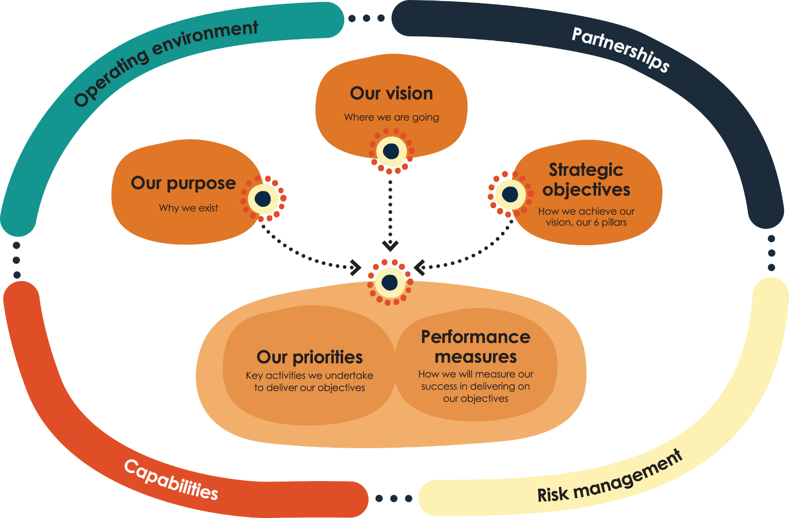

# Overview

## Our vision

Aboriginal and Torres Strait Islander peoples are heard, recognised and empowered.

## Our purpose

The NIAA works in genuine partnership to enable the self-determination and aspirations of First Nations communities. We lead and influence change across government to ensure Aboriginal and Torres Strait Islander peoples have a say in the decisions that affect them.

## Our strategic objectives

We have 6 strategic pillars that enable us to achieve our purpose:

1. Building our influence
2. Identifying economic and human capital development opportunities
3. Building genuine partnerships
4. Investing to deliver the greatest benefit
5. Being a capable, engaged and united workforce
6. Using data and evidence to inform our approach

## Our **values**

How we work is underpinned by our shared values:

* We respect multiple perspectives
* We are authentic
* We are professional and act with integrity
* We invest in each other’s success
* We deliver with purpose

Our locations

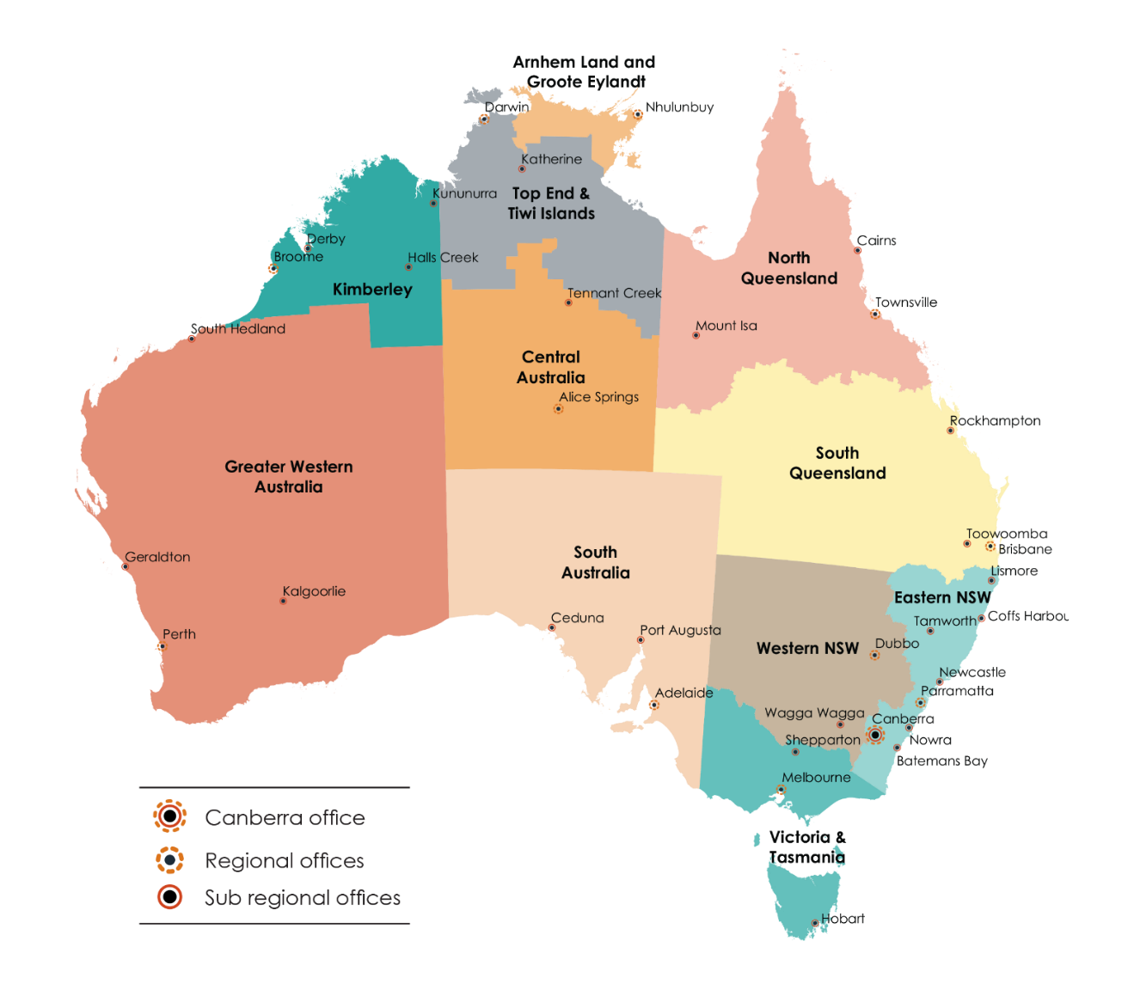

## Our regional work and impact

In the NIAA, one of our most valuable assets is our regional presence — our staff who work closely with communities in urban, regional and remote locations. The regional presence ensures the NIAA supports the Australian Government to achieve its objectives of empowering and supporting the aspirations of First Nations peoples through building key partnerships with Aboriginal and Torres Strait Islander communities, organisations, peak bodies and other strategic stakeholders. Our work allows us to value-add in place, including in response to emerging priorities, pandemics, and natural disasters.

We deliver these outcomes by building partnerships with First Nations communities to support the design and delivery of policy and programs that reflect the uniqueness of each community and their changing priorities. Our goal is to broker innovative local solutions. We achieve this through our deep understanding of place and our strategic stakeholder engagement. We influence all levels of government and connect First Nations peoples with opportunities across the public and private sector. By working closely with communities and organisations, we strengthen our ability to better deliver on their needs and aspirations.

# Our operating environment

We operate in a complex, uncertain, and constantly changing environment which presents a number of challenges and opportunities. We are committed to anticipating and responding to these trends proactively to ensure we continue to provide the greatest benefit to Aboriginal and Torres Strait Islander peoples. By understanding our operating environment we are able to take advantage of these opportunities and build our capabilities to deliver on our purpose.

## Ongoing recovery from COVID-19

The COVID-19 pandemic has presented unprecedented challenges to the health and livelihood of all Australians. The NIAA plays a key role working closely with lead agencies to help Indigenous communities, businesses and individuals build resilience and recover from these challenges. We will continue to provide support by focusing on critical issues such as the wellbeing of remote communities and ensuring everyone has access to the relevant government support. The pandemic continues to shape government priorities and influences how we work. We respond to these challenges by adapting the way we work and how we interact with our stakeholders to ensure we continue to fulfil our purpose.

## Place-based work

Our geographical reach and presence in remote regions around Australia provides an additional complexity to our operating environment. Each community is unique and our regional presence allows us to work in place and respond to these unique needs and aspirations. Our teams are based across Australia to support working-in-place and to ensure effort and investment achieves the most benefit for Aboriginal and Torres Strait Islander communities. We endeavour to ensure that Aboriginal and Torres Strait Islander peoples are active partners in service delivery as well as policy and program design by considering place in everything we do.

The NIAA has both a service delivery and policy development role in Indigenous affairs. Our head office in Canberra (Ngunnawal Country) complements our regional presence and supports evidence-based approaches tailored to place. Our head office provides critical services and strategic support which enables us to build relationships with other government departments and ministers to facilitate our influence and engage in partnerships across all aspects of Indigenous affairs. Throughout the reporting period we will focus on unity, equality and acceptance of our shared history as Australians to continue to work effectively in and with Aboriginal and Torres Strait Islander communities.

# Our priorities

We are committed to implementing the Government’s policies and programs to provide the greatest benefit to all First Nations peoples. Our priorities are informed by the Government’s commitment to work in genuine partnership with First Nations peoples for better outcomes.

We support the Minister and Assistant Minister for Indigenous Australians, as well as the Special Envoy for Reconciliation and the Implementation of the Uluru Statement from the Heart. Over the reporting period, our key priorities are to:

* continue to embed initiatives and Priority Reforms to Close the Gap
* implement the Uluru Statement from the Heart
* reduce incarceration of First Nations adults and youth
* strengthen First Nations peoples economic and job opportunities
* deliver the Territories Stolen Generations Redress Scheme
* assist First Nations peoples to care for and connect with Country
* continue to champion reconciliation throughout Australia.

## National Agreement on Closing the Gap

The Australian Government’s Closing the Gap Implementation Plan (the Implementation Plan) sets out the actions it is taking to drive and embed the 4 Priority Reforms and contribute to the 17 socio-economic outcomes and commitments in the National Agreement on Closing the Gap (the National Agreement). In August 2021, all parties completed their respective Closing the Gap implementation plans. The Implementation Plan enables a clear line of sight between Australian Government actions and the contributions to achieving the Closing the Gap targets.

Between 2022 and 2026, the NIAA will continue to work across Australian Government agencies, in partnership with the Coalition of Aboriginal and Torres Strait Islander Peak Organisations, to implement the Australian Government’s commitments as outlined in its Implementation Plan, which will be updated post the tabling of the Australian Government’s first Closing the Gap Annual Report due later in 2022.

We play a key influencing role in supporting the Minister for Indigenous Australians on the Joint Council on Closing the Gap, and representing the Australian Government in the Partnership Working Group to drive the implementation of the National Agreement. We will continue to work with other Australian Government agencies, particularly central agencies including the Department of the Prime Minister and Cabinet, to embed the 4 Priority Reforms across government and change how we work. We will also work with data agencies and the Productivity Commission to continue to build the data and evidence base to support outcomes under Closing the Gap.

## Uluru Statement from the Heart – Voice, Treaty, Truth

The Uluru Statement from the Heart (the Uluru Statement) calls for a First Nations’ Voice to Parliament enshrined in Australia’s Constitution, and the appointment of the Makarrata Commission charged with overseeing truth-telling and agreement-making. The Government is committed to implementing the 2017 Uluru Statement in full. The Uluru Statement follows a decade of consideration on appropriate forms of recognition by First Nations leaders, constitutional experts, Parliamentary committees and First Nations communities.

The Government will hold a referendum to enshrine a First Nations’ voice in the Constitution as a matter of priority. Enshrinement of a First Nations Voice will include our First Nations in the founding document of our country. It addresses the injustice of their past exclusion, provides healing for the future, and a richer understanding of our nationhood for all Australians. It is a practical model that provides a systematic process for First Nations peoples to provide advice to the Australian Parliament and Australian Government, allowing First Nations peoples to have a say in decisions that impact their lives. It will be a Voice for First Nations peoples, run by First Nations peoples.

As part of its commitment to the Uluru Statement, the Government will also establish the Makarrata Commission. *‘Makarrata’* is a Yolngu Matha term, meaning to ‘come together after a struggle’. The Makarrata Commission will be established as an independent entity to support local models of truth-telling in partnership with First Nations communities and other levels of government. It will also develop a national framework for agreement-making, taking into account existing state and territory processes. Once established, the commission will work with a First Nations Voice to Parliament.

Throughout the reporting period, the NIAA will work with Australian Government agencies, First Nations leaders and communities, as well as other stakeholders to prepare for a referendum and achieve the Government’s commitment to implement the Uluru Statement.

## Addressing incarceration rates of adults and youth

First Nations adults and youth are over represented in the criminal justice system. Over the next 4 years, the NIAA will partner with First Nations peak bodies and communities, and our Australian Government and jurisdiction partners, to coordinate and focus effort on addressing the drivers of contact with the criminal justice system. This includes strengths-based, trauma aware and healing informed approaches, funded through the Indigenous Advancement Strategy, such as adult and youth through-care programs, reducing alcohol and substance misuse, and improving social and emotional wellbeing through connection to land, culture and Country.

The NIAA and the Attorney-General’s Department will continue to lead the Australian Government in the Justice Policy Partnership. We broker relationships and work with our collective evidence and experience to embed the Closing the Gap Priority Reforms and achieve progress towards targets 10 and 11.

## Remote Jobs Program

Employment is critical to the economic prosperity of Aboriginal and Torres Strait Islander peoples. The NIAA will continue to prioritise strengthening First Nations economic and job opportunities throughout the reporting period. We will design and implement a new remote jobs program to increase opportunities for Aboriginal and Torres Strait Islander peoples in remote communities. Our focus will be on continuing to champion First Nations employment in the Australian Public Service and working in cooperation with key partners across the national, state, and local governments to improve economic outcomes for First Nations peoples.

Communities in remote Australia will determine local projects that support economic development and improved employment outcomes. Programs and policies will be community led with local decision-making. This will advance greater self-determination for remote communities.

## Territories Stolen Generations Redress Scheme

The implementation and delivery of the Territories Stolen Generations Redress Scheme is a high priority for the NIAA and will continue to be a focus for this reporting period.

The scheme was announced in 2021 and seeks to recognise the harm and trauma experienced by Stolen Generations survivors who were removed from their families or communities in the Northern Territory and the Australian Capital Territory (prior to self-government), as well as in the Jervis Bay Territory. The scheme operates on the basis of trauma-informed service delivery and design, and cultural competency and safety for all individuals involved.

In line with the commitments set out in the National Agreement to engage fully and transparently on significant policy change that primarily impacts on First Nations peoples, a Territories Stolen Generations Redress Scheme External Advisory Board (Board) has been established. The Board comprises Stolen Generations organisations, survivors and trauma specialists. The Board assisted with the design, implementation and evaluation of the scheme and will continue to ensure it operates to best meet the needs of Stolen Generations survivors and their families.

## Caring for Country

The Australian Government is investing in programs that assist First Nations peoples to care for and connect with Country. These programs maintain or support traditional obligations while also providing communities with important opportunities for employment, economic development and environmental improvement. Through the management and stewardship of land and waters, these programs produce significant benefits for the protection of Australia’s natural environment and cultural heritage, whilst helping Australia meet international treaty obligations to conserve biodiversity.

The Indigenous Rangers and Indigenous Protected Areas (IPA) programs are two very successful Australian Government caring for Country initiatives with 128 ranger groups operating nationally and 81 dedicated IPAs comprising nearly 50% of Australia’s National Reserve System.

Over the next 4 years we will continue to work with ranger provider organisations to deliver the $746 million awarded in grants to existing projects under the Indigenous Rangers Program for 2021–2028. We will also be expanding the program further by delivering on the Government’s commitments to double the number of rangers by the end of the decade.

Delivery of this commitment over the next 4 years will be through competitive grant opportunities for both existing and new ranger provider organisations. The details of these opportunities will be informed by community consultations and feedback on previous grant processes.

We will continue to work with the Department of Climate Change, Energy, the Environment and Water (DCCEEW) and Traditional Owners to manage 81 dedicated IPAs and achieve dedication status for 19 IPA projects currently in their consultation phase. We will deliver funding agreements to manage 10 Sea Country IPAs and to increase investment in IPAs by $10 million per year. Future investment in IPAs will be in consultation with the DCCEEW.

Increased investment in First Nations environment programs provides the opportunity to achieve valuable cultural and social outcomes in more locations across Australia through working on Country. More ranger jobs and better use of rangers in place will result in more skilled leaders and stronger cultural and community capital. The social determinants of health and wellbeing for First Nations peoples caring for Country are well demonstrated and contribute to our efforts to Close the Gap.

Throughout the reporting period the NIAA will continue to work in close partnership with other Australian Government departments and agencies to deliver First Nations land and water management programs, such the IPA Program, and to encourage the embedding of First Nations principles in all mainstream environmental programs. In addition, the NIAA is developing an Indigenous Rangers Sector Strategy, supported by a national implementation plan, that explores opportunities for cross-agency, Australian Government, jurisdictional and non-government sector partnerships to identify and action initiatives that will support and further strengthen the Indigenous land and water management/ranger sector.

## Reconciliation

At the NIAA, our vision for reconciliation is for Australians to work in partnership with Aboriginal and Torres Strait Islander peoples. A reconciled nation respects the living cultures, stories and histories of Aboriginal and Torres Strait Islander peoples.

We champion the Reconciliation Action Plan (RAP) Program delivered by Reconciliation Australia, using our influence to raise awareness, drive change, inspire and enable all Australians to contribute to the reconciliation of the nation.

We understand the importance of embedding reconciliation initiatives throughout the NIAA. The Reconciliation Action Plan Working Group was established in 2022 and comprises representatives across our Agency. All staff are responsible for implementing our Stretch RAP 2022–2025, supported by the NIAA RAP Working Group. We are ambitious for change and see the RAP as complementary to our implementation of the Commonwealth Aboriginal and Torres Strait Islander Workforce Strategy 2020–2024, both key levers for Closing the Gap Priority Reform 3, Transforming government organisations. The NIAA is also a signatory to the Australian Human Rights Commission’s *RACISM. It Stops With Me* campaign.

As part of the governance process, the RAP Working Group regularly reports achievements against the RAP to the People and Culture Committee and the Executive Board. The RAP Working Group will also participate in the Australian Reconciliation Barometer, a national research study looking at the relationship between Aboriginal and Torres Strait Islander peoples and other Australians.

## Next Steps and transformation

To deliver on the Government’s commitments, the NIAA Next Steps program has been established to make sure our functions and resources are appropriately aligned to provide the greatest benefit for First Nations peoples. We have sought permission from the Winanggaay Ngunnawal Language Aboriginal Corporation to use the word *‘Galambany’* to represent the implementation of this program. *Galambany* means ‘you, me, we together’ and represents the importance of partnership, a notion which will be reflected throughout our transformation journey. The Next Steps program will consider, plan and implement the transformation required to deliver on the Government’s significant agenda. The NIAA Next Steps program will build on our strong foundations, and guide the journey that the NIAA must take so that we operate in the best way to deliver the strongest outcomes for First Nations peoples. We will refresh our operating model and develop a roadmap for transformation against six work streams that align with our strategic objectives:

* Our Policy and Strategy — aligning our policies to the Government’s agenda, to deliver in partnership with First Nations peoples.
* Our Investment — prioritising and streamlining our effort and investment to deliver better funding outcomes into the future.
* Our Data and Information — identifying our data needs to support effective policy and engagement.
* Our Engagement — developing the tools for best-practice engagement with our stakeholders.
* Our People — building the capabilities and skills the Agency needs to deliver strong outcomes.
* Our Enabling Services — tailoring our services to meet our business needs, and reduce red tape and duplication.

This will also be an opportunity to review some of the practices, policies and process within the NIAA, and allow all of us all to look at how we do our business. This process will also help us identify and build the relationships we need to achieve better outcomes in the future.

# Enhancing our capabilities

A strong internal capability is critical for delivering our priorities and achieving our purpose. Our internal capabilities allow us to quickly respond to challenges and take advantage of opportunities in the working environment. We invest in our people, technology and structures to ensure we continue to provide positive outcomes for Aboriginal and Torres Strait Islander peoples.

## People

We value our people — they’re at the heart of our Agency. Our leaders inspire a sense of purpose in the 1,300 employees spread across our offices in urban, regional and remote locations. Each employee is supported and empowered to build their career, professional skills and, importantly, their cultural understanding. We invest in each other’s success and share the fundamental values of respect, authenticity, honesty and professionalism.

Throughout the reporting period, we will continue to ensure we have the people we need supporting the aspirations of First Nations peoples. We will refresh our workforce plan over the next 12 months ensuring that we are a key partner in fulfilling the Australian Government’s commitments to elevating First Nation’s voices. We will continue to build on the positive trend we saw in our 2022 APS Census results, which showed our workforce is highly committed and engaged. Our 2022 results are a testament to our progress as an agency and a reflection of our ongoing commitment to staff wellbeing and development.

To support our people we will have a greater focus on engagement and partnership capabilities. We will identify and grow employee capability and improve performance by assessing and developing required competencies. We will continue to support our people through on-the-job learning opportunities, communities of practice and mobility programs. Leadership expectations are outlined in our Leadership Continuum. Activities and programs to reward and build leaders will continue to align with these expectations.

Our Footprints Program is our award-winning cross-cultural continuous learning initiative. We will continue to deliver the Indigenous Development and Employment Program (IDEP). IDEP participants are supported to build a structured career development and training plan tailored to their individual learning requirements. The Executive Level 2 Leadership Assessment Program (LeAP) was launched in 2022 to identify high performing leaders to assist in creating talent pipelines to senior roles. This program supports the Commonwealth Aboriginal Torres Strait Islander Workforce Strategy (CATSIWS) and we will continue to deliver in 2022–23.

Diversity and Inclusion is about empowering our people to contribute their skills and perspectives for the benefit of the NIAA’s outcomes. Throughout the reporting period, the NIAA will focus on removing barriers to support staff to fully participate in the workplace.

Creating and maintaining a strong culture of integrity is crucial for the NIAA’s staff to model and promote. The shared values of our Agency are lived through our behaviours and underpin how we work. The impact of these values and behaviours go beyond internal work practices. As we each live out these values and behaviours within the workplace, they inform the way we do our business with each other, our partners and stakeholders.

## Health, safety and wellbeing

The safety and wellbeing of staff is fundamental. We continue to mature our safety management system and wellbeing strategies, with a continued emphasis on building the mental health capability of our workforce. Particular effort will be invested in understanding and appropriately responding to psycho-social hazards. Through Compassionate Foundations, a skills-led learning approach for the APS, our people access a range of capability areas including: vicarious trauma, psychological first aid, and suicide prevention. In recognising the challenges faced by our workforce and communities, we continue to prioritise the safety and wellbeing of all of our people. Our forward focus is to provide the tools and resources that are supported by evidence and build the mental health capability of our workforce. This will strengthen our ability to identify, manage and reduce psycho-social risks. We will continue to fulfil our due diligence obligations through effective communication and consultation with our workforce.

## Technology

The NIAA is in the second year of implementing the NIAA Information Communication Technology (ICT) Strategy 2020–2023. Working hand in hand with the Department of the Prime Minister and Cabinet (and more recently, the Department of Finance), we are committed to delivering a set of ambitious digital transformation initiatives so that our technology better supports our staff needs now and into the future.

The One Network Project has been established to transition all NIAA staff onto a single ICT environment. This is the most ambitious digital transformation initiative the NIAA has embarked on since the Agency’s inception. This transition will allow the NIAA staff across all of Australia to work more effectively and efficiently together. The project will be delivered over 18 months, and will see significant improvements to staff experience, productivity and organisational culture. The NIAA One Network Project strongly aligns to the NIAA ICT Strategy, and the Australian Government’s Digital Strategy.

Building on this, we will continue to explore options to improve the consistency of products and services across the NIAA and geographies. We will introduce ICT enhancements to streamline grants administration processes and reporting, as well as improve Indigenous procurement policy compliance, productivity and user experience.

Aligning with Closing the Gap Priority Reform 4, the NIAA is at the forefront of uplifting the digital and data capabilities of our staff and engagement partners. Steps have already been taken to consolidate technology, digital and data functions to provide greater insights and impacts. Over the reporting period, we will seek to complete the NIAA data asset register, develop targeted policies and prepare our application for Data Availability and Transparency Scheme accreditation following the *Data Availability and Transparency Act 2022*. These focused steps will further facilitate Indigenous data sharing across the Australian Government and inform regional-level decision making in the future.

## Governance

An appropriate governance structure is central to achieving our purpose and vital to ensure effective and efficient operating practices. We have a strong governance framework in place to support effective decision-making, transparency and accountability. Our committees provide oversight of strategic, operational, risk and reporting matters that affect the NIAA. They work together to build our organisational capability and culture. We are committed to the continued improvement of our governance and management practices to assure all stakeholders of our integrity and accountability as an Agency.

### Our governance structure:

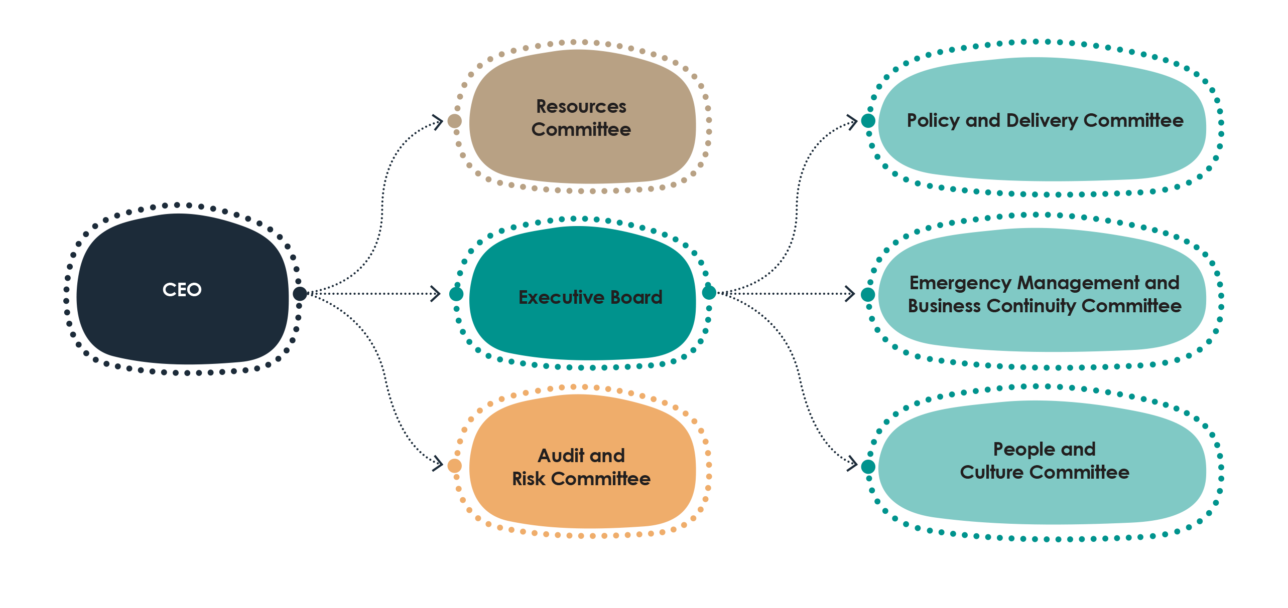

# Risk oversight and management

The NIAA addresses challenges and identifies opportunities in a rapidly evolving landscape of enterprise, operational, shared and emerging risks in order to deliver on our purpose. We are committed to achieving and maintaining strong processes that align with the Commonwealth Risk Management Policy and section 16 of the *Public Governance, Performance and Accountability Act 2013*.

## Managing risk

As part of implementing our principles-based and practical approach to risk management, we work to identify and understand shared risks in delivering on our initiatives with key partners across the nation. We are implementing improved risk monitoring and reporting practices, along with developing staff capability to proactively identify, manage and escalate risk. This will ensure we have the best chance of succeeding on the delivery of our important outcomes for First Nations peoples.

The NIAA is refining its internal controls and governance arrangements to efficiently and effectively manage risk across our Agency. We already have strong mechanisms in place to ensure the NIAA is best positioned for success in service delivery and policy development. For example, one of the key operational risk processes for the NIAA is the Grant Risk Management Framework. This framework addresses both provider risk, and individual activity risk in relation to grant funding.

Our Audit and Risk Committee and internal audit functions provide independent advice and assistance to the NIAA executive team on the appropriateness of the Agency’s financial performance, reporting responsibilities, risk oversight and management, and serves as a system of internal control. Through this mechanism, the NIAA has progressed its ability to identify and understand shared risk in delivery of initiatives with key partners across the nation. This will ultimately enhance our ability to maintain strong relationships, increase transparency, and identify trends and opportunities to better support us to collaborate with stakeholders and manage risk in the delivery of outcomes. Over the next 4 years the NIAA will continue to mature our approach to risk management by integrating, strengthening and embedding our Risk Management Framework and Policy to deliver on our purpose. Further, we will build our resilience and responsiveness as an Agency by enhancing our identification and understanding of emerging risks in the economic, environmental and health domains.

## Our risk appetite

We articulate our appetite for engaging with risk through the following statement:

“The NIAA recognises that many of its activities are inherently risky, and that it is not possible or desirable to eliminate all risk. With operations across the country, involving regional and remote locations and the direct funding of services, there will always be risks including to people and to the reputation of the Agency. We need to engage with risk and manage it as best we can in order to achieve our important outcomes.”

We have a **greater appetite** to engage with risks that aim to improve the efficiency and effectiveness of our operations, or that will contribute to the achievement of our important outcomes.

We have **less appetite** to pursue risk where it will maintain the status quo, where there are suitable alternate options, or where the potential consequence is one where we have low or no tolerance.

### Our approach to managing risk

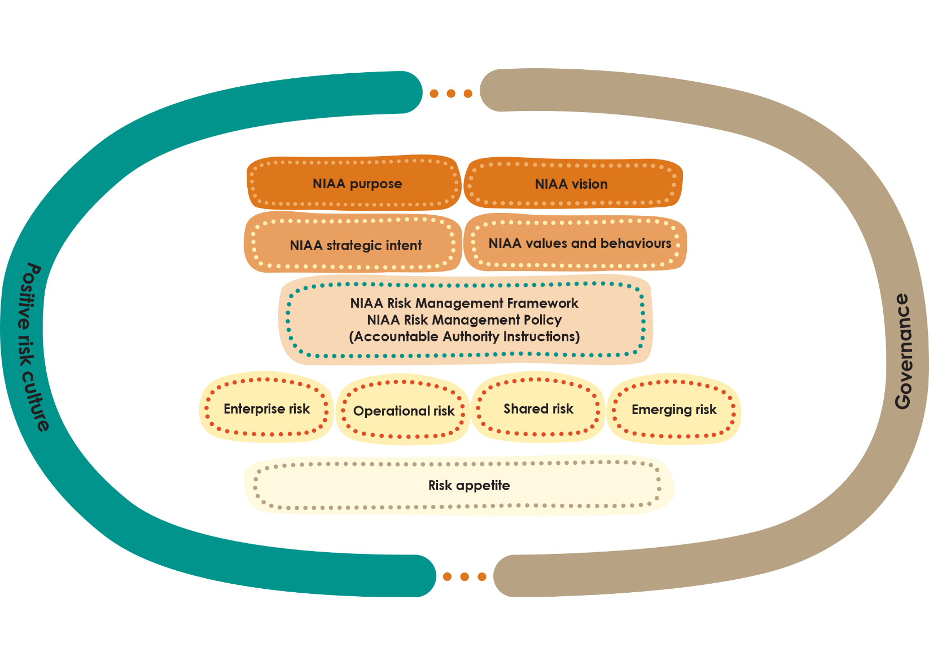

### Enterprise risks and mitigations

#### People and Capability

| Risks | Mitigation |
| --- | --- |
| * The NIAA is not able to maintain the right capabilities (people, resources, processes, systems and culture) to deliver government objectives. * The NIAA’s investment in and management of its people may not meet short and long-term requirements to achieve its purpose. | * Develop an NIAA workforce plan and human resource management model, with a focus on leadership and development, performance management, and our action plan for the Commonwealth Aboriginal and Torres Strait Islander Workforce Strategy. * Continue to implement the Risk Management Framework to embed a strong risk management culture. * Consider broader implementation of the APS Mental Health Capability Framework tailored to the NIAA. * Continue to evolve HR and management processes to ensure that staff confidently raise claims of misconduct or discrimination, in a trauma informed environment, and that any complaint is dealt with appropriately. Ensure any identified trends are addressed at a local or agency level. * Implement the NIAA’s Digital Strategy, Data and Information Management Strategy and ICT strategy, focussing on a tailored capability uplift program. * Invest in a tailored capability uplift program for staff as per the 3 new strategies — digital, data/information and ICT. |

#### Relationships and influence

| Risks | Mitigation |
| --- | --- |
| * The NIAA is not able to maintain credibility with key stakeholders and partners and is unable to collaborate and influence outcomes in support of the organisation’s purpose. * Aboriginal and Torres Strait Islander peoples do not see the NIAA as trusted or reliable. | * A credible regional presence which is connected to and engaged with communities, service providers and state and territory governments. * We invest in a systematic external stakeholder engagement approach at all levels of the NIAA. * We demonstrate the shared benefit of collaboration through a partnership approach. |

#### Culture

| Risks | Mitigation |
| --- | --- |
| * The NIAA’s organisational culture may not continue to work towards the unifying power of a One Team approach and leads to limited cohesion and alignment to the NIAA’s purpose. | * Further develop the Footprints Cultural Learning Program to enhance cross-cultural capabilities. * Embed a positive risk culture at the NIAA through further education about risk and training staff to apply the Risk Management Framework. * Develop and implement an internal communications strategy to increase information sharing and support One Team. * Drive a culture of high performance and accountability through the development of the Organisational Performance Framework, including implementing the Group Performance Review process. * Implement mechanisms to support and monitor culture through ongoing performance reviews. |

#### Delivery

| Risks | Mitigation |
| --- | --- |
| * The NIAA’s administrative processes may impact effective and timely delivery of programs and services. * The NIAA’s future sponsored programs are not grounded in evidence and the lived experience of Indigenous communities. | * Review and implement the Agency’s Policy Investment Framework and Performance Monitoring and Evaluation Framework, to better target our investment to the areas of greatest need and to enhance how we measure performance. * Develop a ‘digital first’ approach for enhanced use of information and improved evidence base. This will also improve the internal sharing of information and ability to detect and respond to further performance and compliance issues. * Implement the Agency’s Integrated Compliance and Fraud Framework to further improve our proactive approach to compliance, including prevention, early engagement and response. |

# Partnerships

Working in partnership means sharing decision-making. It is central to our work and vital to achieving our purpose because it enriches our advice to government, thereby contributing to better outcomes for First Nations peoples.

In line with the commitments set out in the National Agreement on Closing the Gap, we partner with First Nations leaders, peoples and communities, and work alongside a broad range of stakeholders across all levels of government, as well as organisations across Australia. Our partnerships strengthen outcomes for First Nations peoples by sharing decision-making, achieving solutions, and realising economic and social development opportunities across local, regional and national levels.

The NIAA recognises that each community is unique. Our staff are based across Australia to work closely with First Nations leaders, communities, organisations and other partners. We make sure policies, programs and services address First Nations peoples unique needs and aspirations. We leverage local capability and investment to deliver on these needs and aspirations.

We play a central role at the national level to lead and coordinate Australian Government policy and influence all programs and outcomes being delivered to First Nations peoples and communities. The influential role we play rests on our inherent and underlying commitment to reconciliation in everything we do. Building and maintaining these cooperative relationships is key to the delivery of robust and considered advice to all stakeholders. We are developing a Commonwealth Engagement and Partnership Framework to support staff capability and set best practice standards of working in partnership with First Nations peoples and communities within the NIAA and across government.

### Our stakeholders and partners

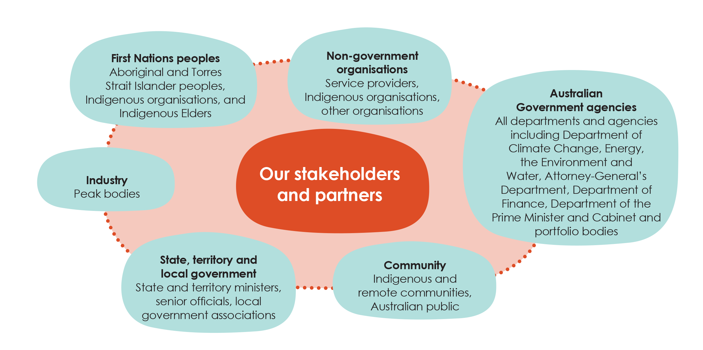

# Our performance

Our performance framework is aligned with the Commonwealth Performance Framework, established under the *Public Governance, Performance and Accountability Act 2013* (PGPA Act). We assess our performance by measuring how we have delivered on our intended results, and through them how we achieve our purpose.

These performance measures have been developed to both plan and measure performance over multiple reporting periods, and are directly linked to our strategic objectives and purpose. Our results against all performance measures will be reported in the Annual Performance Statements which will be included in our 2022–23 Annual Report.

We acknowledge that our ability to deliver intended results requires contribution from a broad range of partners and stakeholders. We work with states and territories, other government agencies, communities, and private stakeholders to achieve our purpose. Our performance is dependent on our ability to build and maintain genuine partnerships and cooperation with all stakeholders.

The ability of the Agency to achieve our outcomes is impacted by a number of external factors such as our environment and interrelated partnerships. Accordingly, our performance measures have been developed with reference to our dynamic operating environment, the interdependencies of our activities, and our role as an influencer across government. To assess our achievement we have used a mix of output and effectiveness measures. Our performance will be measured through a mix of both qualitative and quantitative methodologies and data sources. These sources of information and methodologies are reliable, verifiable and free from bias.

Our performance framework provides details on how we measure progress in achieving our purpose by identifying:

* **Activities** — the work we do to deliver on our priorities and fulfil our purpose
* **Intended results** — the impact or difference we want to achieve through the activities we perform
* **Performance measures** — how we will measure and assess the progress towards an intended result
* **Targets** — specific criteria we will measure success against, over time
* **Rationales and methodologies** — information we will utilise to confirm our performance and the method we use to collect the information to monitor results and track progress

### Performance measures

| Activity 1: | Designing, implementing and delivering policies, strategies and programs to enhance Indigenous economic outcomes. | | | |
| --- | --- | --- | --- | --- |
| Intended result | Improved economic opportunities and access for First Nations peoples in the areas of employment, pathways to jobs, businesses and the generation of economic and social benefits from effective use of their land, resulting in positive progress on relevant Closing the Gap outcomes; and  Stewardship and support for Indigenous participation targets in government procurement and major projects. | | | |
| Measure 1.1 | Proportion of IAS Program 1.1 activities that are assessed by NIAA Agreement Managers as having core service delivery elements which meet or exceed requirements. | | | |
| Targets | | | | |
| 2022–23 | | 2023–24 | 2024–25 | 2025–26 |
| 90% | | 90% | 90% | 90% |
| Rationale:  The Indigenous Advancement Strategy (IAS) is the way the Australian Government funds and delivers a range of programs specifically for First Nations peoples. Since its establishment as an executive agency on 1 July 2019, NIAA has administered the IAS.  This measure relates directly to the purpose of NIAA to enable the self-determination and aspirations of Aboriginal and Torres Strait Islander peoples through employment skills and training pathways by leading the development of the Australian Government’s approach, focusing on place based, service delivery partnerships, and effectively delivering programs through the IAS.  Targets identified reflect how activities are delivered in a complex and multifaceted environment and account for impacting external factors beyond the control of NIAA. For example, in the case of floods, communities can be cut off and service delivery is compromised for periods of time. | | | | |
| Methodology and data sources:   * Quantitative assessment of core service delivery of IAS grant activities, specifically the key service delivery KPI, contained in service provision agreements (output measure). * The period of data used to measure our performance is the most recent 12 month period for which sufficient data is available, to avoid bias in the result. For the 2022–23 Financial Year, the data reported would be drawn from IAS performance report assessments completed by NIAA Agreement Managers for performance reports covering the period from 1 January 2022 to 31 December 2022. * Note: Data reported is drawn from IAS performance report assessments completed by NIAA Agreement Managers, for the relevant reporting periods. A number of Program 1.1 Jobs Land and Economy IAS activities are managed in the Employment Services System. These are employment-focused activities, generally paid per employment outcome. As such, different performance management arrangements apply to this cohort of IAS activities than those applied to most IAS activities, and therefore, they are excluded from data used to calculate achievement of this measure. | | | | |

| Measure 1.2 | Increased Government procurement from First Nations owned businesses in alignment with the commitment under the Australian Government Indigenous Procurement Policy. | | | |
| --- | --- | --- | --- | --- |
| Targets | | | | |
| 2022–23 | | 2023–24 | 2024–25 | 2025–26 |
| 3% increase in value and 3% increase in volume of contracts on previous year | | 3% increase in value and 3% increase in volume of contracts on previous year | 3% increase in value and 3% increase in volume of contracts on previous year | 3% increase in value and 3% increase in volume of contracts on previous year |
| Rationale:  The Indigenous Procurement Policy (IPP) policy document defines success as:   1. An increase in the number of Indigenous businesses awarded a contract 2. An increase in the volume and value of contracts awarded to Indigenous businesses across the Australian Government.   Targets have been developed to reflect the average growth in contract value, which, over the last four years has been around 9% with the lowest being 3% and the highest being 15%. | | | | |
| Methodology and data sources:   * Quantitative assessment of increase in whole-of-government procurement in First Nations owned business (effectiveness measure). * Assessment of result will be of equal weighting between the increase in value and increase in volume targets of eligible procurements awarded to Indigenous enterprises each financial year. * Data collected through the IPP Reporting Solution. AusTender data is matched with ORIC and Supply Nation’s list of First Nations owned business ABNs. Departments manually upload low value purchases with First Nations owned businesses. | | | | |

| Activity 2: | Designing, implementing and delivering policies, strategies and programs to support early childhood development and wellbeing; school attendance, engagement and attainment; and further education. | | | |
| --- | --- | --- | --- | --- |
| Intended result | Improved wellbeing, development, access and attainment of education for Indigenous children and students, resulting in positive progress on relevant Closing the Gap outcomes. | | | |
| Measure 2.1 | Proportion of IAS Program 1.2 activities that are assessed by NIAA Agreement Managers as having core service delivery elements which meet or exceed requirements. | | | |
| Targets | | | | |
| 2022–23 | | 2023–24 | 2024–25 | 2025–26 |
| 90% | | 90% | 90% | 90% |
| Rationale:  The Indigenous Advancement Strategy (IAS) is the way the Australian Government funds and delivers a range of programs specifically for First Nations peoples. Since its establishment as an executive agency on 1 July 2019, NIAA has administered the IAS.  The measure relates directly to the purpose of NIAA to enable the self-determination and aspirations of Aboriginal and Torres Strait Islander peoples through delivering activities aimed at supporting early childhood development and wellbeing, school attendance, attainment and improved post school pathways.  Targets identified reflect how activities are delivered in a complex and multifaceted environment and account for impacting external factors beyond the control of NIAA. For example, in the case of floods, communities can be cut off, and service delivery is compromised for periods of time. | | | | |
| Methodology and data sources:   * Quantitative assessment of core service delivery of IAS grant activities, specifically the key service delivery KPI, contained in service provision agreements (output measure). * The period of data used to measure our performance is the most recent 12 month period for which sufficient data is available, to avoid bias in the result. For the 2022–23 Financial Year, the data reported would be drawn from IAS performance report assessments completed by NIAA Agreement Managers for performance reports covering the period from 1 January 2022 to 31 December 2022. | | | | |

| Activity 3: | Designing, implementing and delivering policies, strategies and programs to improve mental health, emotional and physical wellbeing and safety. | | | |
| --- | --- | --- | --- | --- |
| Intended result | Improved mental health and wellbeing of First Nations peoples, resulting in positive progress on relevant Closing the Gap outcomes. | | | |
| Measure 3.1 | Proportion of IAS Program 1.3 activities that are assessed by NIAA Agreement Managers as having core service delivery elements which meet or exceed requirements. | | | |
| Targets | | | | |
| 2022–23 | | 2023–24 | 2024–25 | 2025–26 |
| 90% | | 90% | 90% | 90% |
| Rationale:  The Indigenous Advancement Strategy (IAS) is the way the Australian Government funds and delivers a range of programs specifically for First Nations peoples. Since its establishment as an executive agency on 1 July 2019, NIAA has administered the IAS.  The measure relates directly to the purpose of NIAA to enable the self-determination and aspirations of Aboriginal and Torres Strait Islander peoples through delivering activities aimed at improving wellbeing and/or reducing levels of offending, violence and substance abuse.  Targets identified reflect how activities are delivered in a complex and multifaceted environment and account for impacting external factors beyond the control of NIAA. For example, in the case of floods, communities can be cut off, and service delivery is compromised for periods of time. | | | | |
| Methodology and data sources:   * Quantitative assessment of core service delivery of IAS grant activities, specifically the key service delivery KPI, contained in service provision agreements (output measure). * The period of data used to measure our performance is the most recent 12 month period for which sufficient data is available, to avoid bias in the result. For the 2022–23 Financial Year, the data reported would be drawn from IAS performance report assessments completed by NIAA Agreement Managers for performance reports covering the period from 1 January 2022 to 31 December 2022. | | | | |

| Activity 4: | Designing, implementing and delivering policies, strategies and programs to ensure the maintenance of Indigenous cultural expression and conservation, and support First Nations participation in policy development and decision-making. | | | |
| --- | --- | --- | --- | --- |
| Intended result | The maintenance of Indigenous cultural expression and conservation, equal participation in the economic and social life of the nation and the improved capabilities of Indigenous organisations. | | | |
| Measure 4.1 | Proportion of IAS Program 1.4 activities that are assessed by NIAA Agreement Managers as having core service delivery elements which meet or exceed requirements. | | | |
| Targets | | | | |
| 2022–23 | | 2023–24 | 2024–25 | 2025–26 |
| 90% | | 90% | 90% | 90% |
| Rationale:  The Indigenous Advancement Strategy (IAS) is the way the Australian Government funds and delivers a range of programs specifically for First Nations peoples. Since its establishment as an executive agency on 1 July 2019, NIAA has administered the IAS.  The measure relates directly to the purpose of NIAA to enable the self-determination and aspirations of Aboriginal and Torres Strait Islander peoples by delivering a wide range of important services that support culture and capability.  Targets identified reflect how activities are delivered in a complex and multifaceted environment and account for impacting external factors beyond the control of NIAA. For example, in the case of floods, communities can be cut off, and service delivery is compromised for periods of time. | | | | |
| Methodology and data sources:   * Quantitative assessment of core service delivery of IAS grant activities, specifically the key service delivery KPI, contained in service provision agreements (output measure). * The period of data used to measure our performance is the most recent 12 month period for which sufficient data is available, to avoid bias in the result. For the 2022–23 Financial Year, the data reported would be drawn from IAS performance report assessments completed by NIAA Agreement Managers for performance reports covering the period from 1 January 2022 to 31 December 2022. | | | | |

| Activity 5: | Designing, implementing and delivering policies, strategies and programs to enhance regional governance, and improved partnerships with communities. | | | |
| --- | --- | --- | --- | --- |
| Intended result | Enhanced regional governance and local decision-making. | | | |
| Measure 5.1 | Proportion of IAS Program 1.5 activities that are assessed by NIAA Agreement Managers as having core service delivery elements which meet or exceed requirements. | | | |
| Targets | | | | |
| 2022–23 | | 2023–24 | 2024–25 | 2025–26 |
| 90% | | 90% | 90% | 90% |
| Rationale:  The Indigenous Advancement Strategy (IAS) is the way the Australian Government funds and delivers a range of programs specifically for First Nations peoples. Since its establishment as an executive agency on 1 July 2019, NIAA has administered the IAS.  The measure relates directly to the purpose of NIAA to enable the self-determination and aspirations of Aboriginal and Torres Strait Islander peoples by delivering a wide range of important services that enhance regional governance, and improve partnerships with communities through place-based practice.  Targets identified reflect how activities are delivered in a complex and multifaceted environment and account for impacting external factors beyond the control of NIAA. For example, in the case of floods, communities can be cut off, and service delivery is compromised for periods of time. | | | | |
| Methodology and data sources:   * Quantitative assessment of core service delivery of IAS grant activities, specifically the key service delivery KPI, contained in service provision agreements (output measure). * The period of data used to measure our performance is the most recent 12 month period for which sufficient data is available, to avoid bias in the result. For the 2022–23 Financial Year, the data reported would be drawn from IAS performance report assessments completed by NIAA Agreement Managers for performance reports covering the period from 1 January 2022 to 31 December 2022. | | | | |

| Measure 5.2 | Progressing regional voice policy development (in partnership with First Nations peoples) and associated implementation of regional voice arrangements agreed by governments. | | | |
| --- | --- | --- | --- | --- |
| Targets | | | | |
| 2022–23 | | 2023–24 | 2024–25 | 2025–26 |
| Progress on implementation ofregional voice arrangements against planning | | Progress on implementation ofregional voice arrangements against planning | Progress on implementation ofregional voice arrangements against planning | Progress on implementation ofregional voice arrangements against planning |
| Rationale:  This measure relates to NIAA’s key role in enabling an Aboriginal and Torres Strait Islander Voice — through the implementation of regional voice arrangements, broadly consistent with the Indigenous Voice Co-design Process Final Report where agreed by Government. | | | | |
| Methodology and data sources:   * Output measure, derived using qualitative data, supplemented by case studies. * Implementation data collected by NIAA and may include feedback from a regional voice arrangements Establishment Group. | | | | |

| Measure 5.3 | Development and implementation of plans and agreements in partnership with communities. | | | |
| --- | --- | --- | --- | --- |
| Targets | | | | |
| 2022–23 | | 2023–24 | 2024–25 | 2025–26 |
| Progress has been made in the development and implementation of plans or agreements in partnership with communities | | Progress has been made in the development and implementation of plans or agreements in partnership with communities | Progress has been made in the development of plans or agreements in partnership with communities | Progress has been made in the development of plans or agreements in partnership with communities |
| Rationale:  A focus on place and working in partnership is central to NIAA’s work and integral to its purpose of enabling the self-determination and aspirations of Aboriginal and Torres Strait Islander peoples and enabling First Nations peoples to have a say in matters that affect them. Improving partnerships with communities and other stakeholders through applying place-based practice/approaches, Closing the Gap Priority Reforms (including PR1 formal partnerships and shared decision-making) and other tools and processes are ways we are working to do this. | | | | |
| Methodology and data sources:   * Qualitative assessment of development and implementation of plans and agreements in partnership with communities, based on case studies. * Managers of relevant NIAA Groups that partner with communities and Indigenous stakeholders would nominate one case study at the start of each financial year (or as part of mid-cycle reporting) — nominated topics should reflect expectation that real progress/change on the ground will be made over the course of the year through partnership with communities and relevant other stakeholders. * The focus is on plans and agreements developed and/or implemented by the NIAA in genuine (formalised) partnership with community and other key partners, and which support community priorities and aspirations. | | | | |

| Activity 6: | Undertaking evaluations of National Indigenous Australian Agency (NIAA) programs in line with the IAS Evaluation Framework and incorporating evaluations into policies and programs delivered by the NIAA. | | | |
| --- | --- | --- | --- | --- |
| Intended result | Evaluation efforts were prioritised based on significance, contribution and policy risk as per the IAS Evaluation Framework; and  Improved outcomes for First Nations peoples as a result of enhanced design, implementation and delivery of agency policies and programs. | | | |
| Measure 6.1 | Publish an annual evaluation work plan each September taking into account the prioritisation criteria outlined in the NIAA Evaluation Framework. | | | |
| Targets | | | | |
| 2022–23 | | 2023–24 | 2024–25 | 2025–26 |
| September 2022 | | September 2023 | September 2024 | September 2025 |
| Rationale:  NIAA invests in evaluations, reviews, data improvement activities, capability development and research to inform the design and delivery of policies and programs, and to understand the extent to which the Indigenous Advancement Strategy is achieving its goal of supporting the aspirations of First Nations peoples. | | | | |
| Methodology and data sources:   * Quantitative assessment against timeline (output measure) | | | | |

| Measure 6.2 | Proportion of completed evaluations or summaries on the work plan that are released. | | | |
| --- | --- | --- | --- | --- |
| Targets | | | | |
| 2022–23 | | 2023–24 | 2024–25 | 2025–26 |
| 100% of completed evaluations or summaries on the work plan released | | 100%of completed evaluations or summaries on the work plan released | 100% of completed evaluations or summaries on the work plan released | 100% of completed evaluations or summaries on the work plan released |
| Rationale:  NIAA invests in evaluations, reviews, data improvement activities, capability development and research to inform the design and delivery of policies and programs, and to understand the extent to which the Indigenous Advancement Strategy is achieving its goal of supporting the aspirations of First Nations peoples. | | | | |
| Methodology and data sources:   * Quantitative assessment of released completed evaluations on the work plan (output measure). | | | | |

| Activity 7: | Coordinating the Australian Government’s implementation of the National Agreement on Closing the Gap through partnership and engagement with other Australian Government portfolios, First Nations representatives as well as state, territory and local governments. | | | |
| --- | --- | --- | --- | --- |
| Intended result | Enable First Nations peoples and governments to work together in partnership to overcome the inequality experienced by First Nations peoples, and achieve life outcomes equal to all Australians. | | | |
| Measure 7.1 | Proportion of NIAA’s investment through Indigenous Advancement Strategy (IAS) grants that align with Closing the Gap outcomes and Priority Reforms. | | | |
| Targets | | | | |
| 2022–23 | | 2023–24 | 2024–25 | 2025–26 |
| 100% of IAS grant investments contribute to Closing the Gap outcomes and Priority Reforms | | 100% of IAS grant investments contribute to Closing the Gap outcomes and Priority Reforms | 100% of IAS grant investments contribute to Closing the Gap outcomes and Priority Reforms | 100% of IAS grant investments contribute to Closing the Gap outcomes and Priority Reforms |
| Rationale:  NIAA is responsible for allocating Australian Government funding via IAS grants to support achievement of the Closing the Gap outcomes and Priority Reforms. | | | | |
| Methodology and data sources:   * Quantitative (output measure). * Data source is the mandatory grant activity coding processes of IAS grants in our grant management system (FUSION). * Calculation will assess proportion of IAS grants assessed within the reporting period that show contribution towards Closing the Gap outcomes and Priority Reforms. | | | | |

| Measure 7.2 | NIAA delivers the National Agreement on Closing the Gap and implementation plan through partnerships and engagement with other Australian Government portfolios, First Nations representatives, and state, territory and local governments. | | | |
| --- | --- | --- | --- | --- |
| Targets | | | | |
| 2022–23 | | 2023–24 | 2024–25 | 2025–26 |
| Coordinates and delivers a Commonwealth Closing the Gap annual report and updates to the Commonwealth Implementation Plan within the reporting period  Coordinates whole-of-government implementation of the National Agreement on Closing the Gap  Milestones in implementing the Priority Reform actions have been achieved (where applicable) | | Coordinates and delivers a Commonwealth Closing the Gap annual report and updates to the Commonwealth Implementation Plan within the reporting period  Coordinates whole-of-government implementation of the National Agreement on Closing the Gap  Milestones in implementing the Priority Reform actions have been achieved (where applicable) | Coordinates and delivers a Commonwealth Closing the Gap annual report and updates to the Commonwealth Implementation Plan within the reporting period  Coordinates whole-of-government implementation of the National Agreement on Closing the Gap  Milestones in implementing the Priority Reform actions have been achieved (where applicable) | Coordinates and delivers a Commonwealth Closing the Gap annual report and updates to the Commonwealth Implementation Plan within the reporting period  Coordinates whole-of-government implementation of the National Agreement on Closing the Gap  Milestones in implementing the Priority Reform actions have been achieved (where applicable) |
| Rationale:  The Commonwealth Implementation Plan outlines the Australian Governments commitments to achieve the targets and deliver on the Priority Reforms in the National Agreement on Closing the Gap.  The Priority Reforms were agreed in partnership with the Coalition of Peaks and all levels of government. Leading the Government’s approach to embedding these Priority Reforms is how we will change the way we work with First Nations Australians and provide the foundation for future progress against the targets and supporting the aspirations of First Nations peoples. | | | | |
| Methodology and data sources:   * Quantitative assessment against timeframe supported by qualitative analysis of actions taken. * Assessment of the NIAA’s leadership and coordination role will be undertaken through analysis of records from committees and meetings. These include weekly Interdepartmental committee meetings across the Government, internal meetings for implementation within NIAA, Joint Working Group, Partnership Working Group and Joint Council. * Analysis of the extent of implementation of the Priority Reforms will include data sets relating to meetings to drive/deliver sector-strengthening plans, policy partnerships and working group meetings. Maintaining effective partnership arrangements with the Coalition of Peaks analysis will include a review of records of fortnightly meetings, drafting group with jurisdictions, and workshop sessions with the Coalition of Peaks. | | | | |

| Activity 8: | NIAA coordinates the delivery of a referendum to enshrine an Aboriginal and Torres Strait Islander Voice in the Constitution, as called for in the Uluru Statement from the Heart. | | | |
| --- | --- | --- | --- | --- |
| Intended result | NIAA supported key stakeholder participation in the process to deliver a referendum.  The referendum is delivered. | | | |
| Measure 8.1 | NIAA supports the Government in the delivery of a referendum that enshrines an Aboriginal and Torres Strait Islander Voice in the Constitution. | | | |
| Targets | | | | |
| 2022–23 | | 2023–24 | 2024–25 | 2025–26 |
| Lead preparation for a referendum, including through First Nations engagement, coordination across the Australian Public Service (APS) and supporting government processes | | Targets for 2023–24 will be considered after the October 2022 budget |  |  |
| Rationale:  This measure relates to NIAA’s role in leading coordination of a referendum to enshrine an Aboriginal and Torres Strait Islander Voice in the Constitution. | | | | |
| Methodology and data sources:   * Qualitative and survey assessment of the level of engagement and support. * Qualitative analysis of the effectiveness of APS coordination. * Quantitative assessment against time frames. | | | | |