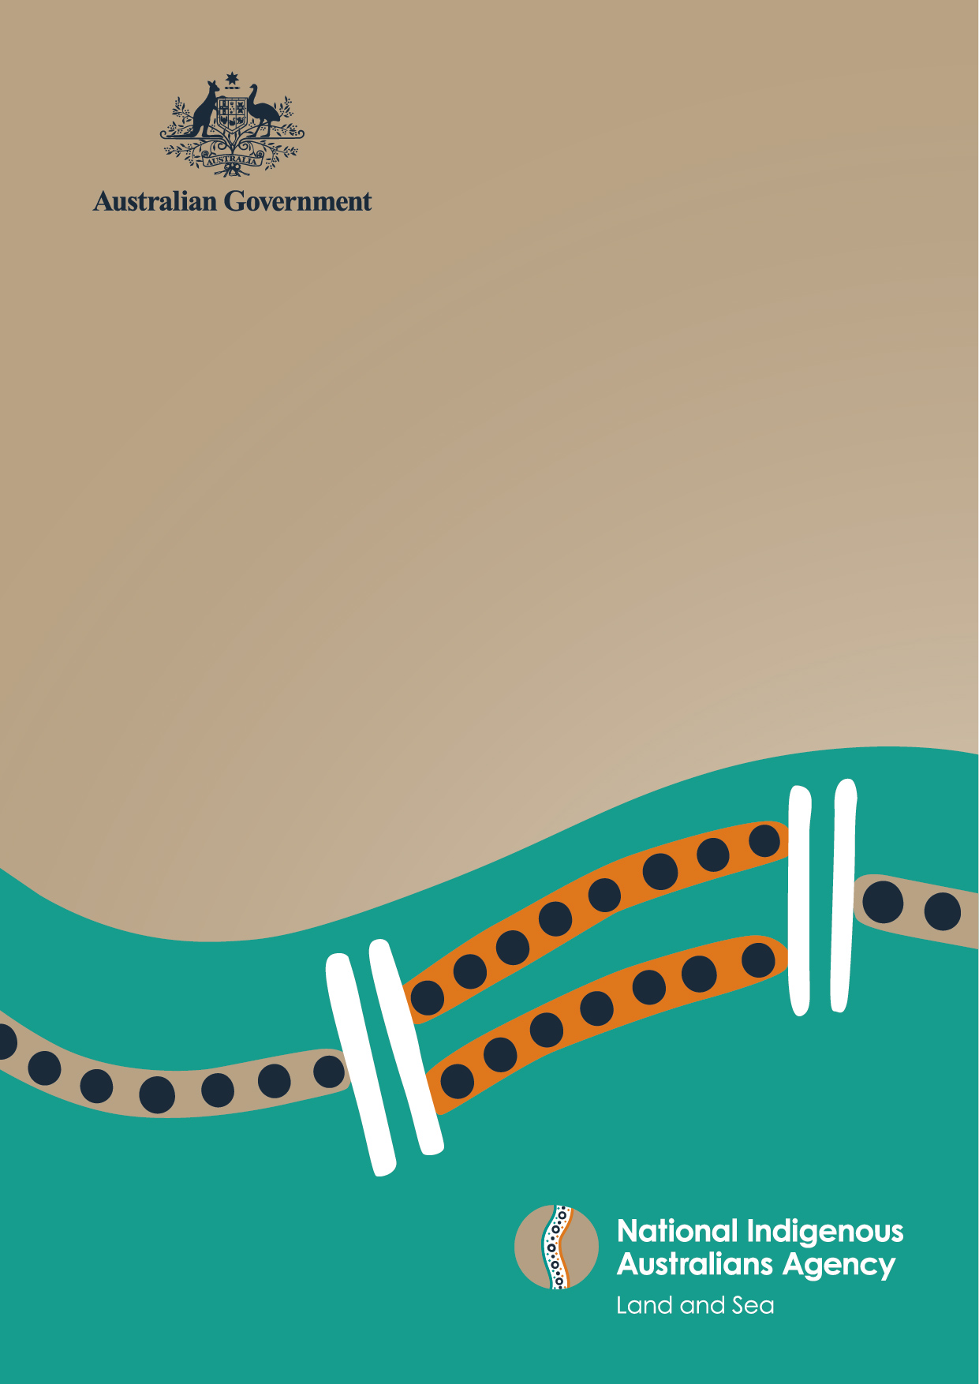
The Power of Commitment

Indigenous Ranger Sector Strategy
Consultation Summary
Report to the NIAA from GHD
31 August 2022
GHD acknowledges the Traditional Owners and custodians of Country throughout Australia and acknowledges their continuing connection to land, waters and community. We pay our respects to the people, the cultures and the elders past, present and emerging.© GHD 2023
This document is and shall remain the property of GHD. The document may only be used for the purpose for which it was commissioned and in accordance with the Terms of Engagement for the commission. Unauthorised use of this document in any form whatsoever is prohibited.

Scope and limitations
This report: has been prepared by GHD for National Indigenous Australians Agency and may only be used and relied on by National Indigenous Australians Agency for the purpose agreed between GHD and National Indigenous Australians Agency.
GHD otherwise disclaims responsibility to any person other than National Indigenous Australians Agency arising in connection with this report. GHD also excludes implied warranties and conditions, to the extent legally permissible

Contents
Introduction 3
The Indigenous Rangers Sector 3
Indigenous Rangers Sector Draft Strategy 3
Summary of engagement 4
Who we heard from 4
What we heard 4
Country and culture focused 5
Approach 7
Strategy in operation 9
Next steps 13

Introduction

The Indigenous Rangers Sector
The Indigenous ranger sector is comprised of community-based organisations that operate ranger groups to carry out management of Country in their regions. They operate throughout Australia on a variety of land, water, coastal and marine areas. As of 2021 there were around 170 community-based Indigenous ranger groups funded under government programs. The Australian Government’s Indigenous Rangers Program is the largest community-based Indigenous ranger program in Australia. It supports more than 128 Indigenous ranger groups, employing around 1,900 Indigenous rangers across Australia.

Indigenous Rangers Sector Draft Strategy
In October 2020, the National Indigenous Australians Agency (NIAA) commenced development of the Indigenous Ranger Sector Draft Strategy. The NIAA undertook early consultation across the Commonwealth, states and territories to socialise the strategic intention and to identify opportunities to strengthen and build the sector. The proposed draft Strategy has a national, sector-wide focus to guide consistent approaches, coordination and collaboration across all ranger organisations, agencies, and regions to achieve improved environmental, cultural, social and economic outcomes and address common challenges.
The draft Strategy’s vision is to create:
“A vital Indigenous ranger sector empowered to manage Country sustainably, strengthen culture, provide economic and career opportunities for Indigenous people and communities, and have a recognised role and voice in land and water management.”
The draft Strategy has four key features:
- National approach
The core features include national principals, high level lead actions supported by detailed implementation plans, the establishment of a reference group to advise on implementation of the Strategy, and evaluation of the Strategy's success. Is intended to be implemented collaboratively with stakeholders involved in the indigenous ranger sector.
B. Proposed actions
The draft strategy proposes high level, lead actions that can be applied to the Indigenous sector across Australia. The actions could be tailored to meet the specific needs of ranger organisations and regions at the organisation, agency and regional level. They are divided into the following sections: Strong Country, Strong Economy - Skills, Jobs and Business, and Strong Culture.

C. Indigenous ranger industry body
The draft strategy proposes an Indigenous Ranger Industry Body as one way to facilitate Indigenous leadership of and support for the sector.
D. Measuring and evaluation
The draft strategy sought feedback on practical measures of success.

Purpose of this report
The NIAA engaged GHD to deliver consultation with stakeholders in the Indigenous ranger sector. GHD was responsible for facilitating all consultation activities, analysing engagement outcomes, and providing the NIAA with a report describing these outcomes. This Consultation Summary Report provides a short overview of what we heard during consultation. This report has been prepared by GHD for use and distribution by the NIAA.

Summary of engagement
Consultation activities included a survey, written submissions, and virtual workshops. The consultation period was initially scheduled from 1 April 2022 until 30 June 2022. The period for receipt of written submissions was also extended to 8 July 2022.

Who we heard from
Stakeholders who participated in the consultation activities represented a broad range of sectors and partners such as Indigenous ranger organisations, government agencies, industry, training providers, philanthropic organisations and research organisations.
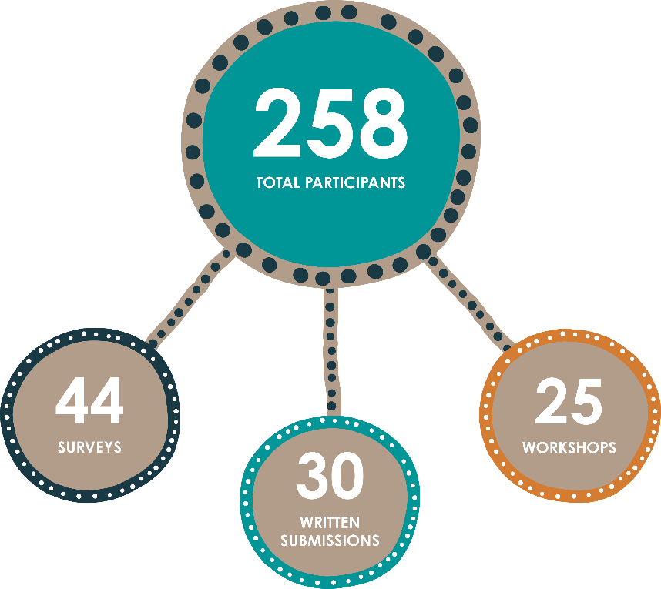

What we heard
Three key themes emerged from feedback collected through surveys, workshops, and written submissions. These themes are summarised below. The outcomes of engagement will inform updates to the final Strategy.
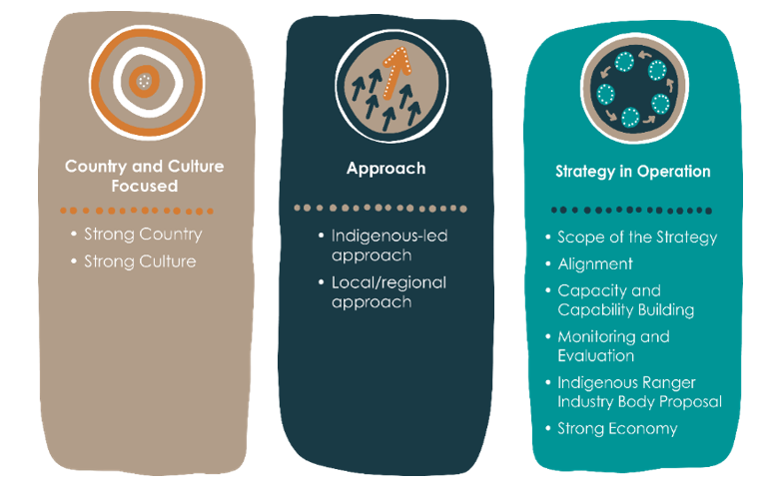

Country and culture focused

Summary
Consultation on the draft Strategy reinforced the importance of Country and culture. Country describes everything tangible and intangible within a landscape. Country is holistic, and is intrinsically linked with knowledge, culture and identity for Indigenous people. Caring for Country is an inherent spiritual obligation for all on Country, especially Traditional Custodians, and provides an opportunity for healing, for cultural practice, and for the improvement of our natural environment.
The Indigenous ranger sector provides a unique opportunity to put Country and culture at the centre of a Strategy to further support local and regional voices. The draft Strategy acknowledges the importance of Country and Culture in the ‘Strong Country’ and ‘Strong Culture’ high-level lead actions but it could be strengthened by focusing on the link between Country and culture. A focus on Country and culture can guide all other aspects of the draft Strategy.

Strong Country
Responded to: | 5 surveys  47 workshop comments  12 mentions in written submissions
Current approach | The draft Strategy acknowledges the importance of Country, and its links with all aspects of cultural, economic, social and environmental wellbeing.  The proposed objective of Strong Country is to increase ranger organisations’ effectiveness in caring for Country and achieving sustainable land and water management that benefits their communities and all Australians.
What we heard | A greater focus on Country: There could be a greater focus on tangible and intangible elements of Country throughout all elements the draft Strategy (including National Approach, Actions and Monitoring and Evaluation).  Redefine Strong Country: The outcomes and measures of success of Strong Country could align more with the health of Country, rather than focussing on access to resources and knowledge.  Elevate the voices of Country: Emphasis on the importance of Traditional Owner voices and Indigenous-led governance, to ensure Country is at the core of decision-making regarding land and sea management.  Strengthen the link between Country and culture: The draft Strategy considers both Strong Country and Strong Culture, but Country and culture could not (and should not) be separated, and should rather be considered together. This would support and strengthen their intrinsic links.  Focus on technology: Some actions in Strong Country focus on access to technology to support ranger activities and projects. Although stakeholders saw the value of using technology to stay connected and collaborate, actions should be more focussed on connecting to, and caring for Country.

Strong Culture
Responded to: | 2 surveys  49 workshop comments  6 mentions in written submissions
Current approach | The draft Strategy acknowledges the importance of culture through the Strong Culture high level lead actions. The proposed objective of Strong Culture is to empower Indigenous ranger organisations to continue to protect and maintain culture and traditional knowledge in conjunction with Traditional Owners and communities.
What we heard | Importance of protecting and maintaining culture: Support for the objective of Strong Culture to protect and maintain culture  Aligning actions to the objective: Some actions under Strong Culture did not align with its objective of protecting and maintaining culture, and the actions could focus more on cultural practice and the sharing of culture and knowledge between generations.  Support cultural knowledge transfer: Some stakeholders noted the important role of Indigenous ranger organisations in providing an opportunity for the transfer of cultural knowledge from Traditional Owners and Elders to younger generations (where deemed appropriated by Traditional Owners). The work carried out by Indigenous ranger organisations on Country could be informed by this knowledge.  Strengthen language: The draft Strategy does not propose actions relating to the protection and revitalisation of traditional language. The decline of language in some parts of Country was noted as a concern for Traditional Owners and community, and the importance of language to culture and knowledge was also noted.

Approach

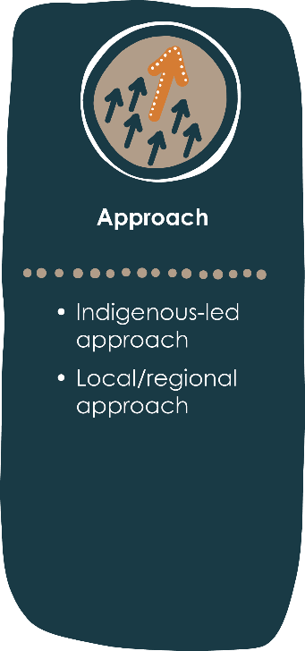
Summary
The draft Strategy proposes an integrated national approach, for collaborative implementation by Indigenous ranger organisations, government agencies and the private sector. It is intended that the Strategy is implemented at the regional and local level, but feedback indicated that this is not clear enough in the draft Strategy. Although there is value in a national and consistent approach, a greater focus needs to be placed on an Indigenous-led and regional approach.
An Indigenous-led draft Strategy will elevate the voices of Traditional Owners, Indigenous Rangers, and Indigenous professionals across the sector. A regional approach will support sector growth whilst managing localised issues, working within regional frameworks, and meeting the needs of that specific place or community.
This will enable the Indigenous Ranger sector to be led by the voice of Country and Indigenous communities.

Indigenous-led approach
Responded to: | 21 surveys  20 workshop comments  4 mentions in written submissions
Current approach | The draft Strategy supports the empowerment of Indigenous communities to achieve Indigenous-led solutions that meet their particular needs and aspirations.
What we heard | Guided by Indigenous leadership: Stakeholders agreed with the importance of an Indigenous-led approach, with some noting that this could be achieved through reference groups and bodies as proposed in the draft Strategy.  Further clarity on expectations for engagement: Stakeholders noted the importance of recognising the decision-making authority of Traditional Owners in land and water management practices and programs. Some noted that more detail around expectations for engaging and involving Traditional Custodians would further strengthen the Indigenous-led approach.  Flexibility around cultural obligations: Some stakeholders recognised the need for rangers to fulfil cultural and family obligations in parallel with employment duties. The development of flexible working arrangements that appropriately reflect and support these obligations could further improve outcomes for Indigenous ranger organisations and their employees.  Aspirational targets: Some stakeholders considered the proposed National Principles to be minimum standards as opposed to aspirational targets. They noted that principles and actions could encourage the sector to be more aligned with principles like self-determination and youth engagement, that are a strong focus of the Uluru Statement from the Heart and Closing the Gap targets.

Local and regional approach
Responded to: | 21 surveys  138 workshop comments  58 mentions in written submissions
Current approach | The draft Strategy is proposed to support an integrated, national approach that will be relevant to all Indigenous ranger organisations, governments and private sector stakeholders.  An element of the national approach is detailed implementation plans, to allow for region-specific place-based approaches. This is proposed to support different stakeholders with the regional implementation of a national Strategy.
What we heard | Support for national principles: Most stakeholders agreed that national principles are important. While some stakeholders agreed with the national approach and principles overall, some suggested additional national principles to reflect the importance of Country and culture.  Preference for a regional-based approach: While stakeholders recognised the value in a national approach and principles, some expressed concern about a top-down approach failing to recognise the different needs, challenges and aspirations of stakeholders at local and regional levels.  Driven by local voices: Stakeholders emphasised that for the National Approach to be successful, it must be driven by local and regional voices, to keep what is important to community at the forefront.  Leverage existing governance structures: Some stakeholders identified opportunities for the draft Strategy to leverage existing governance structures in specific communities or regions. This may improve implementation and reduce duplication.  Consider resourcing required to implement the Strategy: Indigenous ranger organisations face existing resourcing and capacity challenges, with concerns raised about the potential administrative burden that the reporting, monitoring and governance of the draft Strategy could bring. Although there was a strong preference for a regional place-based approach, it was also suggested that a national approach or governance structure could work to alleviate some of this administrative burden (through the Indigenous Ranger Industry Body for example).

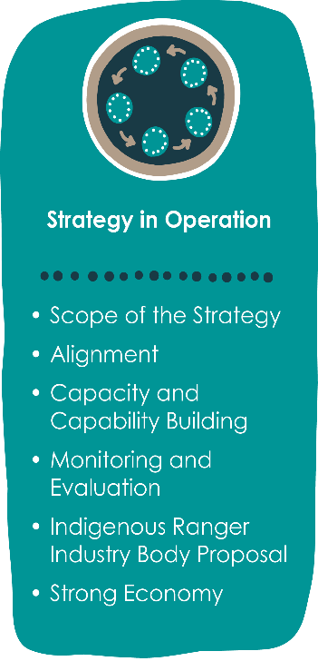
Strategy in operation

Summary
The draft Strategy provides an important framework for the Indigenous Ranger Sector to grow over the next six years. Strategy implementation will have influence on the success of the sector. There are opportunities for improving the draft Strategy so that it is complimentary to, and aligned with, the current needs of the sector, and the gaps in existing policies.
It is important to clarify the purpose and scope of the draft Strategy, articulate how it will align with existing legislation and policies, how success will be monitored, and how it will build the capacity of Indigenous rangers. This will support the function and operation of the draft Strategy in the long-term.

Scope of the strategy
Responded to: | 5 surveys  57 workshop comments  66 mentions in written submissions
Current approach | The draft Strategy identifies the Indigenous Ranger Sector as comprised of community-based organisations that operate ranger groups to carry out management of Country in their regions. It also identifies that the draft Strategy applies to Indigenous ranger organisations, government agencies and private sector companies.
What we heard | Clarity on who the Strategy applies to: Some stakeholders questioned who the draft Strategy would apply to, and how it would interact with organisations outside of the sector. It will be important for the Strategy to be inclusive and allow coordination with natural resource management organisations, Indigenous Protected Areas, and other relevant organisations that may not be clearly identified as Indigenous ranger organisations.  Challenges with broad principles: There may be challenges with applying broad principles at the local level to create meaningful change. There was concern that the national principles could be misinterpreted at the local level.  Guidance on how the Strategy would be applied: There were requests for more guidance in the Strategy regarding how the actions would be implemented. Further clarity on the detailed implementation plans and proposed roles and responsibilities of relevant stakeholders could increase support for a national approach, and reduce potential for misinterpretation or duplication of efforts by different Indigenous ranger organisations.

Alignment
Responded to: | 15 surveys  199 workshop comments  58 mentions in written submissions
Current approach | The draft Strategy proposes that it will contribute to broad strategies that work with and support Indigenous Australians. It also acknowledges that the implementation of the Strategy would be collaborative between different stakeholders as required.
What we heard | Existing policies and frameworks: Stakeholders showed interest in how the draft Strategy would align with other policies, frameworks, and the work of other stakeholders.  Opportunities for alignment with existing reporting: Where possible, monitoring and evaluation of the Strategy could align with the existing reporting undertaken by Indigenous ranger organisations or other stakeholders for other government programs.  Establish pathways with education institutions: There is opportunity for alignment between the draft Strategy actions and education pathways offered by institutions.  Build relationships: Stakeholders recognised the opportunity for the draft Strategy to support collaboration and build strong, respectful relationships and genuine partnerships with stakeholders such as private landholders, industry, and local and state governments.
Capacity and capability building
Responded to: | 17 surveys  243 workshop comments  5 mentions in written submissions
Current approach | The proposed actions in the draft Strategy align with building capacity and capability for Indigenous ranger organisations, and it is identified as a key goal for the Indigenous ranger sector in the short-term.
What we heard | Access to support and resources: Stakeholders, particularly Indigenous ranger organisations, highlighted a need for improved support and access to resources. The capacity and capability of organisations is fundamental to their ability to achieve outcomes.  Long-term funding: Lack of funding was identified as a challenge for Indigenous ranger organisations hoping to improve capacity, retain skilled staff and build capability.  Training and exchange programs: Training courses (e.g. through TAFE) provide a good basis for ranger skills development.  Focus on fee-for-service: The draft Strategy identifies opportunities to improve fee-for-service operations for some Indigenous organisations. However, some stakeholders noted that while fee-for- service activities attract income to organisations, they also utilise project resources and can detract from their core ranger group project purposes.  Elevate female rangers: There is a need for a stronger focus on women in the ranger sector.

Monitoring and evaluation
Responded to: | 5 surveys  189 workshop comments  9 mentions in written submissions
Current approach | The draft Strategy proposes an approach to monitoring, evaluation and reporting on progress against the Strategy. It is noted that monitoring and reporting is required to evaluate the effectiveness and guide adaptation to new evidence and experience through the life of the Strategy.
What we heard | Timeframes: There were some questions about the proposed staged approach and whether the timeframes were adequate and allowed for meaningful implementation.  Clarity around what is being monitored: Some stakeholders expressed confusion about what was being monitored by the draft Strategy, or suggested measures of success that focused on the success of the ranger programs, rather than the growth of the Indigenous ranger sector.  Focus of the measures of success: There were comments that the proposed measures of success did not seem to align with the objectives of the high-level lead actions.  Regional approach: There is a need for measures of success to be determined by individual ranger organisations, as each region or community may have a different expectation of what Strong Country, Strong Culture, and Strong Economy would look like.  Administrative burden: Additional resources and time may be required to meet expectations for monitoring, evaluation and reporting, as proposed in the draft Strategy.

Indigenous Industry Body Proposal
Responded to: | 7 surveys  219 workshop comments  5 mentions in written submissions
Current approach | The draft Strategy included a proposal for an Indigenous Ranger Industry Body (peak body) that might potentially be established, should it be supported by Indigenous stakeholders
What we heard | Refine the role of the Industry Body: There was support for the idea of an Indigenous Ranger Industry Body, provided it aligned with an Indigenous-led approach and met cultural obligations.  Membership of the Industry Body: Selecting the right membership for the Industry Body is key. It will be difficult to create a representative group that still meets cultural protocols.

Strong Economy
Responded to: | 6 surveys  117 workshop comments  9 mentions in written submissions
Current approach | The draft Strategy acknowledges the important links between growing the Indigenous ranger sector and strengthening the approach to employment, training and business development. This is captured in the Strong Economy high level lead actions.
What we heard | Focus of skills development: The proposed Strong Economy – Skills section focuses on improving access to culturally appropriate training, but some stakeholders considered the actions focused more on development of western skills, rather than traditional skills.  Promote Indigenous Registered Training Organisations: There were comments that having Indigenous RTOs will help to deliver better training outcomes, which in turn was believed to deliver a Strong Economy.  Need for national award: There was support for a national award pay scale to create equality and limit possibility of poor working conditions. It was stated that the award rate of pay for rangers currently varies across Australia.  Focus of Strong Economy -Jobs: The proposed Strong Economy - Jobs section should focus more on place-based employment and secondments, as well as ranger exchanges and other career development opportunities.

Next steps
The NIAA would like to sincerely thank all stakeholders for taking the time to participate and share their feedback in the consultation activities.
The consultation outcomes presented in this document will inform the approach to, and development of, the final Indigenous Ranger Sector Strategy.
The NIAA will keep all participants informed on progress in developing the Strategy. Updates will be posted on the Indigenous Ranger Sector Strategy website: https://www.niaa.gov.au/indigenous-affairs/environment/indigenous-ranger-sector-strategy
If you have any questions about the further development of the Strategy, please contact IndigenousRangersConsultation@niaa.gov.au

Stakeholder participants

Indigenous ranger organisation / group
Central Land Council
Dawul Aboriginal Corporation
Esperance Tjaltjraak Native Title Aboriginal Corporation
Glen Innes Local Aboriginal Land Council
Gunditj Mirring Traditional Owners Aboriginal Corporation
Jabalbina Yalanji Aboriginal Corporation
Jawoyn Association Aboriginal Corporation
Kanyirninpa Jukurrpa
Karajarri Traditional Lands Association (Aboriginal Corporation)
Kimberley Land Council
Lake Eyre Basin
Laynhapuy Homelands Aboriginal Corporation
Marthakal Homelands Aboriginal Resource Centre - Gumurr Marthakal Rangers
MOPRA Crocodile Island Rangers
Ngaanyatjarra Council Aboriginal Corporation
Nipapanha Community Aboriginal Corpporation
Northern Land Council
Tamworth Local Aboriginal Land Council
Thamarrurr Development Corporation
Tiwi Land Council
Wilinggin Aboriginal Corporation
Yarkuwa Indigenous Knowledge Centre Aboriginal Corporation

Indigenous organisation / alliance
Aboriginal Advancement League
Aboriginal Land Council of Tasmania
Banjima Native Title Aboriginal Corporation
Cape York Land Council
Chuulangun Aboriginal Corporation
Circular Head Aboriginal Corporation
Country Needs People
Darkinjung Local Aboriginal Land Council
DBN WAC
Eynewantheyne Aboriginal Corporation
Federation of Victorian Traditional Owner Corporations
Flinders Island Aboriginal Association
Gogolanyngor Aboriginal Corporation
Goodooga Community Working Party
Gooreng Gooreng
Goori Jones Mob Aboriginal Corporation
Gudjuda Reference Group Aboriginal Corporation
Gujaga Foundation
Gulargambone Community Working Party
Indigenous Carbon Industry Network
Indigenous Desert Alliance
Ivanhoe Community Working Party c/o Murdi Paaki Services Limited
Jerrinja Local Aboriginal Land Council
Jiwah Pty Ltd
KARI
Kooma Traditional Owners Association Inc
Koori Heritage Trust
Larrakia Cultural Centre
Larrakia Nation Aboriginal Corporation
Lightning Ridge Community Working Party
Metropolitan Local Aboriginal Land Council
Murdi Paaki Services Limited
Nambucca Heads Local Aboriginal Land Council
Narrabri Local Aboriginal Land Council
Narrandera Local Aboriginal Land Council
Ngadjuri Adnyamathanha Wilyakali Native Title Aboriginal Corporation RNTBC
North Australian Indigenous Land and Sea Management Alliance
NSW Aboriginal Land Council
Nulla Nulla Local Aboriginal Land Council
Port Curtis Coral Coast Trust
Red Chief Local Aboriginal Land Council
Robe River Kuruma Aboriginal Corporation
Shine Energy
South Australian Native Title Services
Stuart Island Local Aboriginal Land Council
Tharawal Local Aboriginal Land Council
Thunggutti Local Aboriginal Land Council
Tibooburra Local Aboriginal Land Council
Toomelah Local Aboriginal Land Council
Trangie Local Aboriginal Land Council
Wanparta Aboriginal Corporation RNTBC
Warga Badda Nywaigi Aboriginal Corporation RNTBC (Chairperson)
Wonnarua Nation Aboriginal Corporation
Wuthanthi Aboriginal Corporation
Yawuru Native Title Holders Aboriginal Corporation RNTBC
Yilka Talintji Aboriginal Corporation
Yinhawangka Aboriginal Corporation

Australian Government agency
Australian Institute of Marine Science
Department of Agriculture, Water and the Environment

State/Territory Government agency
Department of Environment and Science Queensland
Department of Natural Resources and Environment Tasmania
Department of Planning and Environment NSW
Indigenous Land and Sea Corporation
Indigenous Rangers Independent Reference Group
IP AUSTRALIA
NSW Aboriginal Education Consultative Group (NSW AECG)
NT Department of the Chief Minister and Cabinet
Primary Industries and Regions South Australia
Snowy Hydro
Toowoomba Local Council
Torres Strait Regional Authority
Victorian Government

Local government/ Council
Great Barrier Reef Marine Park Authority
Murray Local Land Services

Research and science institution/academic
Charles Darwin University
National Environmental Science Program Resilient Landscapes Hub
The Lowitja Institute
University of the Philippines

Industry or company
Minerals Council of Australia
Seafood Industry Australia
The Alliance of First Nations Independent Education and Training Providers

Education and training institution /provider
Bularri Muurlay Nyanggan Aboriginal Corporation
Deadly Ed
Envirotech Education
IndigiGrow
Jobs Australia
National Indigenous Youth Education Coalition
RAPAD Employment Services Queensland
Startmate
Stronger Smarter Institute
Tranby Aboriginal Co-operative Limited / Tranby National Indigenous Adult Education & Training

Philanthropic organisation
Foundation for National Parks & Wildlife
Kalyuku Ninti - Puntuku Ngurra Limited

Natural Resource Management organisation
Conservation Management
Landscape SA
Northern Agricultural Catchments Council
The Nature Conservancy

