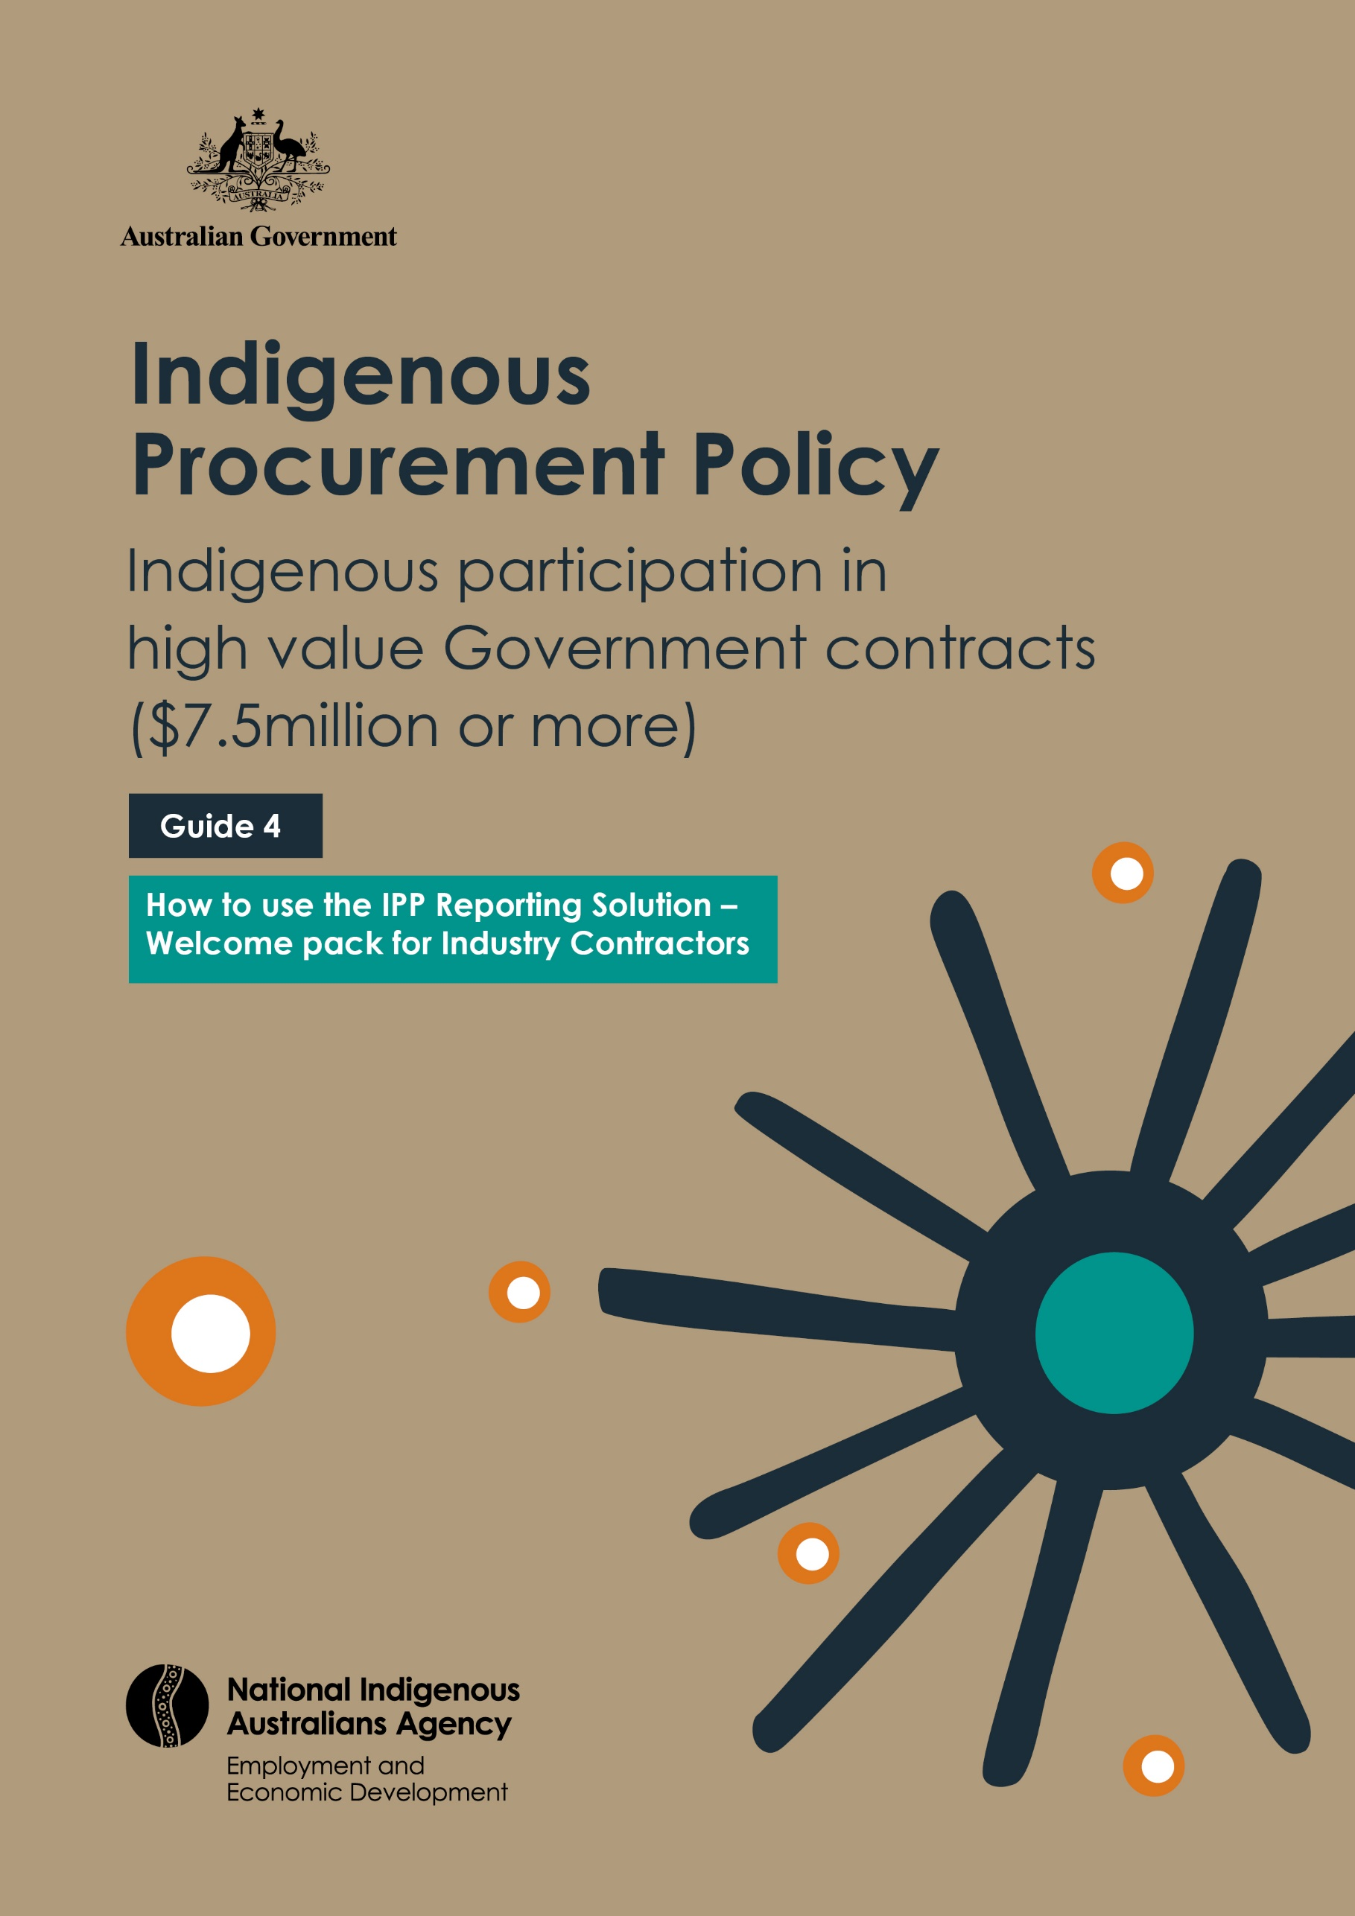

Indigenous Procurement Policy
Indigenous participation in high value Government contracts ($7.5million or more)

Guide 4
How to use the IPP Reporting Solution – Welcome pack for Industry Contractors

Table of Contents

table of Contents 3
Overview 4
Purpose 4
Background 4
System requirements 4
Getting Started 4
What you need to get started 4
Logging In for the first time 6
Logging In 9
Basic Navigation 11
The Home page 12
Support 13
APPENDIX A Project Flyer 14

Overview

Purpose
The purpose of this pack is to help get you get started with the Indigenous Procurement Policy Reporting Solution (IPPRS) Contractor Portal.
This document will address:
- System requirements
- How to get started
- How to login
- Where to get support
- Useful links
If you are unsure about what the IPPRS is, please read APPENDIX A Project Flyer for an overview.

Background
The IPPRS was created to provide Commonwealth agencies and Industry contractors with the ability to more efficiently and accurately manage and report their obligations, as mandated by the Indigenous Procurement Policy (IPP).

System requirements
IPPRS is a Microsoft Dynamics 365 web application and is accessible via a web browser. Users can access IPP Contractor Portal (IPPCP) with the most recent versions of these popular browsers:
- Microsoft Edge (recommended: Chromium-based Edge)
- Chrome
- Firefox
- Safari
- Internet Explorer (not recommended)

Getting Started

What you need to get started
To get started, you will an invitation email from the Indigenous Procurement Policy Reporting Solution (IPPRS).
The invitation email is automatically generated and sent to you when a Commonwealth Agency Contract Manager enters your contact details against a contract with a Minimum Mandatory Reporting requirement,
Note that the invitation you receive is valid for 7 calendar days from receipt, before it expires. If you miss the expiry date, please notify the IPPRS help desk (IPPRS@pmc.gov.au) and request a new invitation.
A sample of the invitation email is shown below.
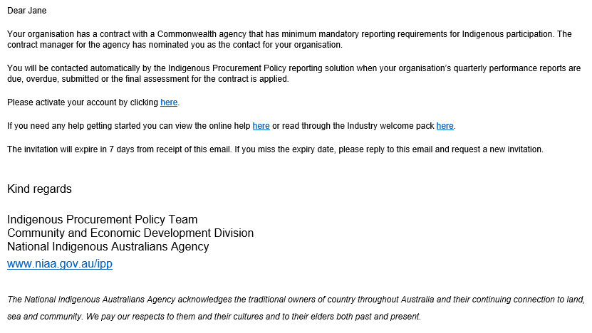
Figure 1: Invitation email example

Logging In for the first time
Login to the IPP Contractor Portal is detailed below:
Step No. | Action
1 | Click the URL shown in the Invitation email. The Microsoft Sign In window is displayed:  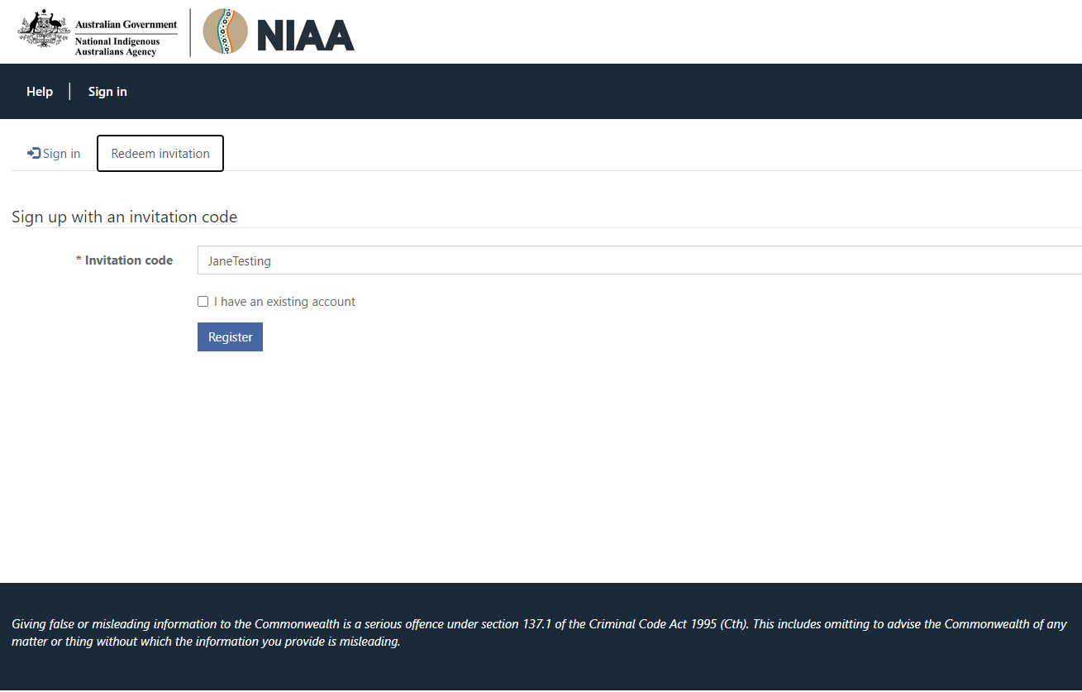  Figure 2: Sign Up with an Invitation Code Screen  Notice that your invitation code has been automatically entered by the system.  Please take note of the statement at the bottom of the screen:  Giving false or misleading information to the Commonwealth is a serious offence under section 137.1 of the Criminal Code Act 1995 (Cth). This includes omitting to advise the Commonwealth of any matter or thing without which the information you provide is misleading.
2 | Click and the screen - Register for a local account is displayed prompting you to set up your Username and Password:  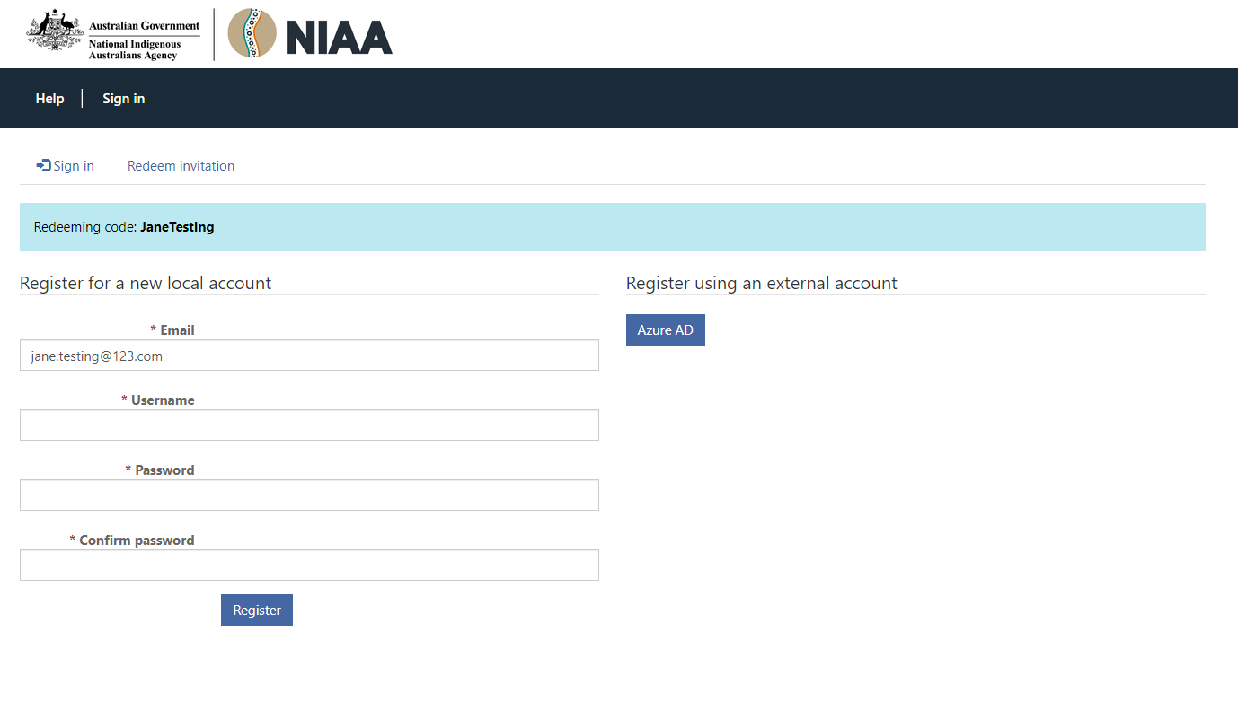  Figure 3: Register for a new local account screen
3 | Into the Username field, enter your email address.
4 | Into the Password field, enter a password.  Passwords must contain 8 characters and contain a mix of alpha, numeric, lowercase, uppercase and special characters.
5 | Click and the screen - Profile is displayed prompting you to set up a Profile:  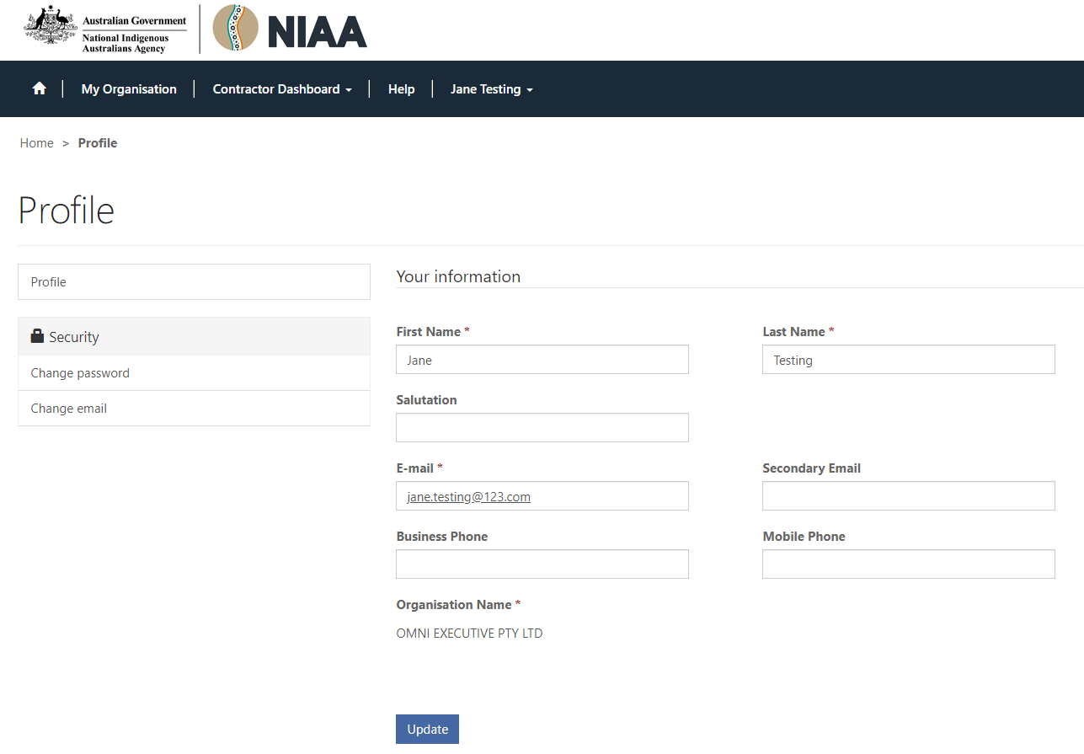  Figure 4: Username and Password setup screen
6 | The mandatory fields, indicated by a red asterisk, are auto populated by the system. Amend them if they are incorrect and add a business phone number (optionally you can enter your mobile phone number).
7 | Click To have the Welcome IPP Contractor Portal screen displayed as below.  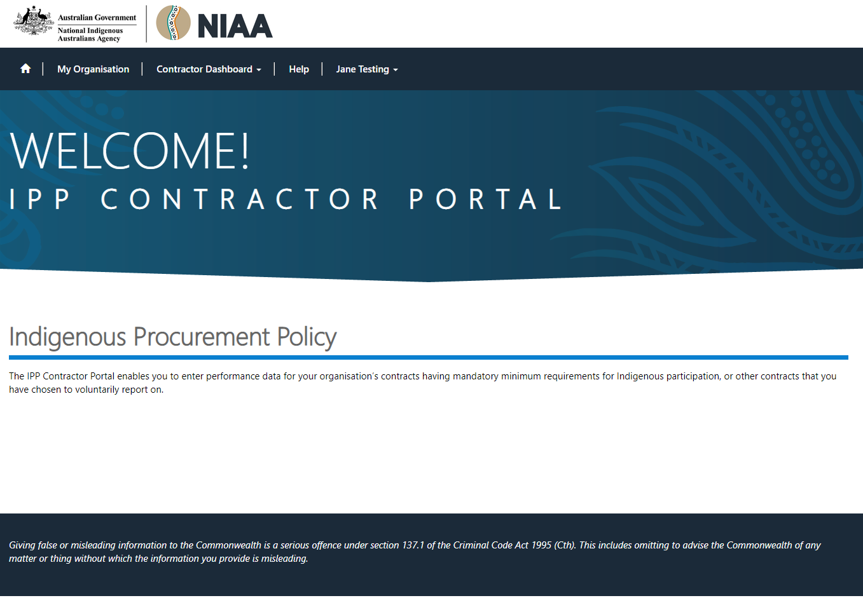  Figure 5: Welcome! IPP Contractor Portal screen  You have now successfully logged in to the IPP Contractor Portal.  Please take note of the statement at the bottom of the screen:  Giving false or misleading information to the Commonwealth is a serious offence under section 137.1 of the Criminal Code Act 1995 (Cth). This includes omitting to advise the Commonwealth of any matter or thing without which the information you provide is misleading.

Logging In
When you have been nominated as a Contractor Contact, you will receive an email, automatically generated by the system, with the details of the contract that is subject to Mandatory Minimum Requirements (MMR) for Indigenous participation, and a link to the IPP Portal.
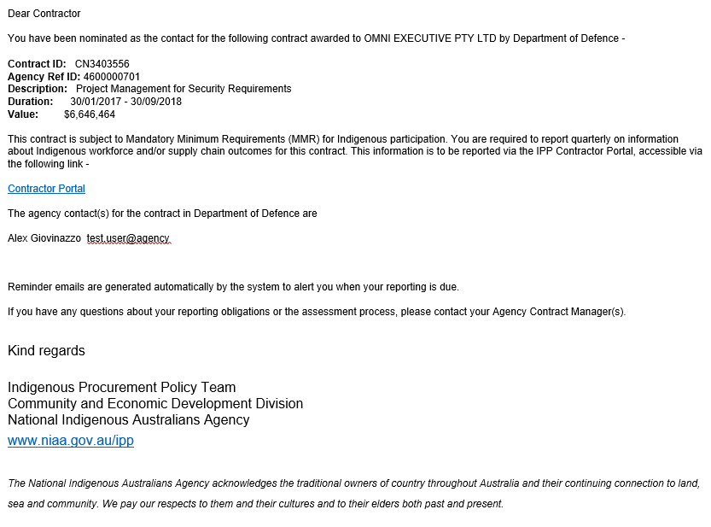
Figure 6: Sample email to contractor with contract details

Follow these steps to login:
Step No. | Action
1 | Click the URL shown in the MMR Reporting Requirements email. Welcome! IPP Contractor Portal screen is displayed:  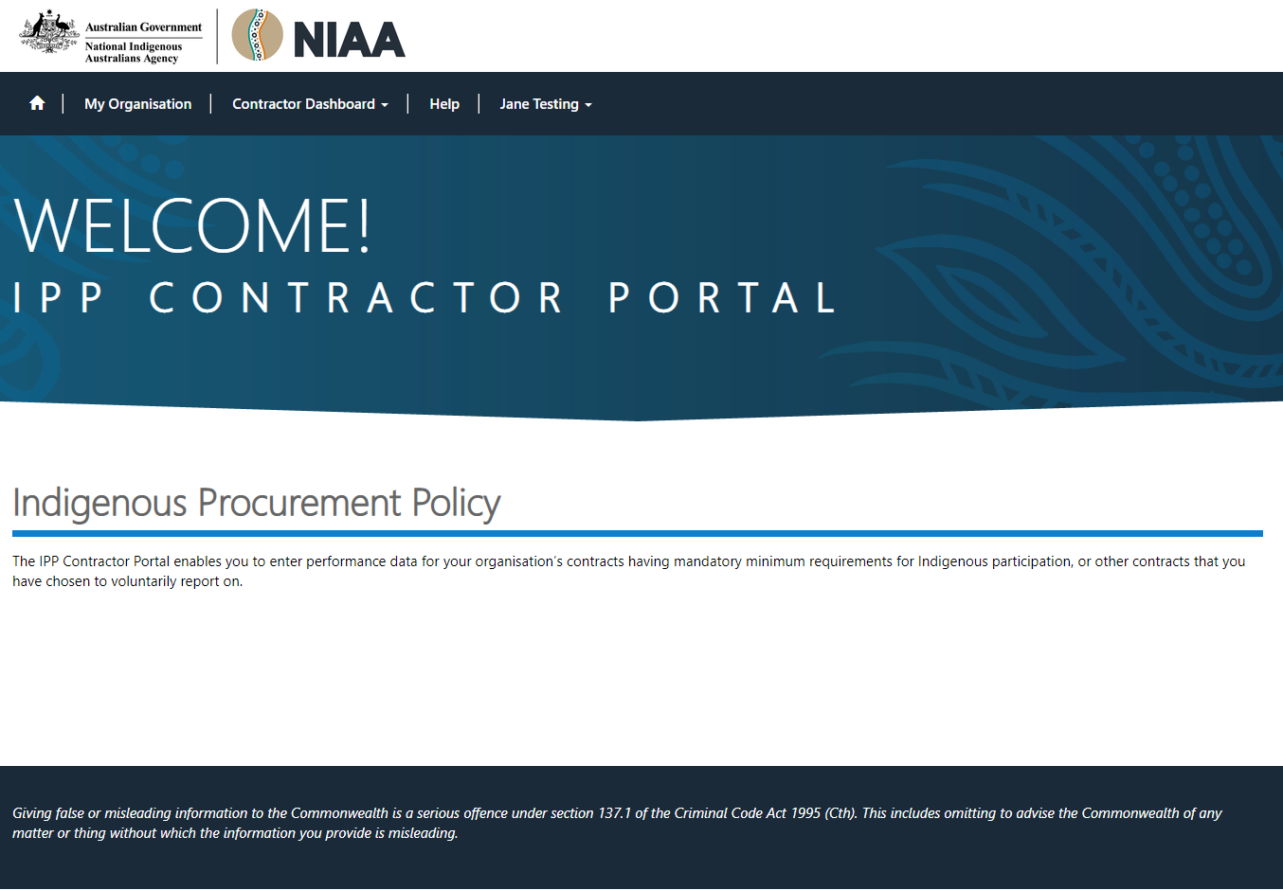  Figure 7: Welcome! IPP Contractor Portal screen
2 | Click to have the Sign in screen displayed:  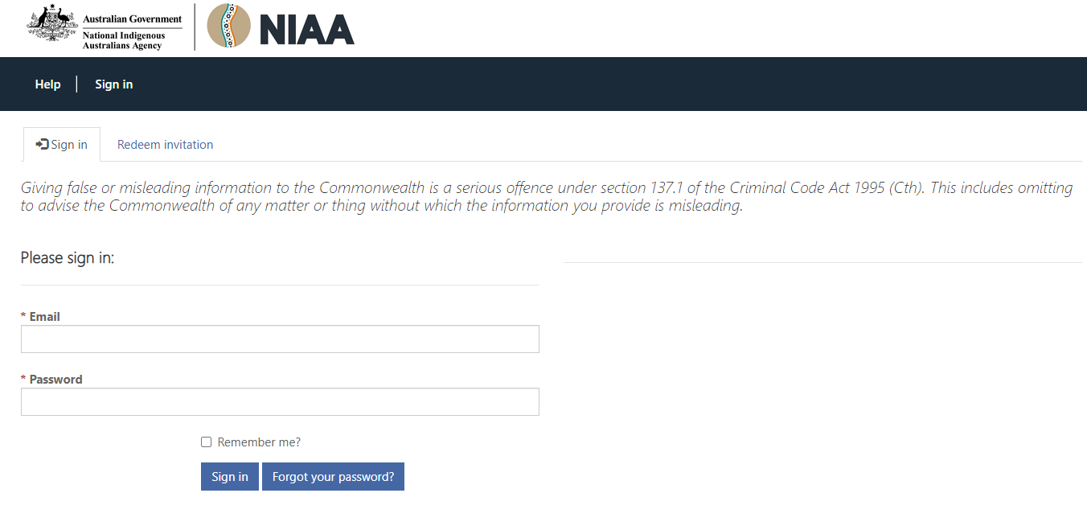  Figure 8: Sign In Screen
3 | Enter your email address into the Email field.
4 | Enter your password into the Password field and click
5 | The Home page is displayed:  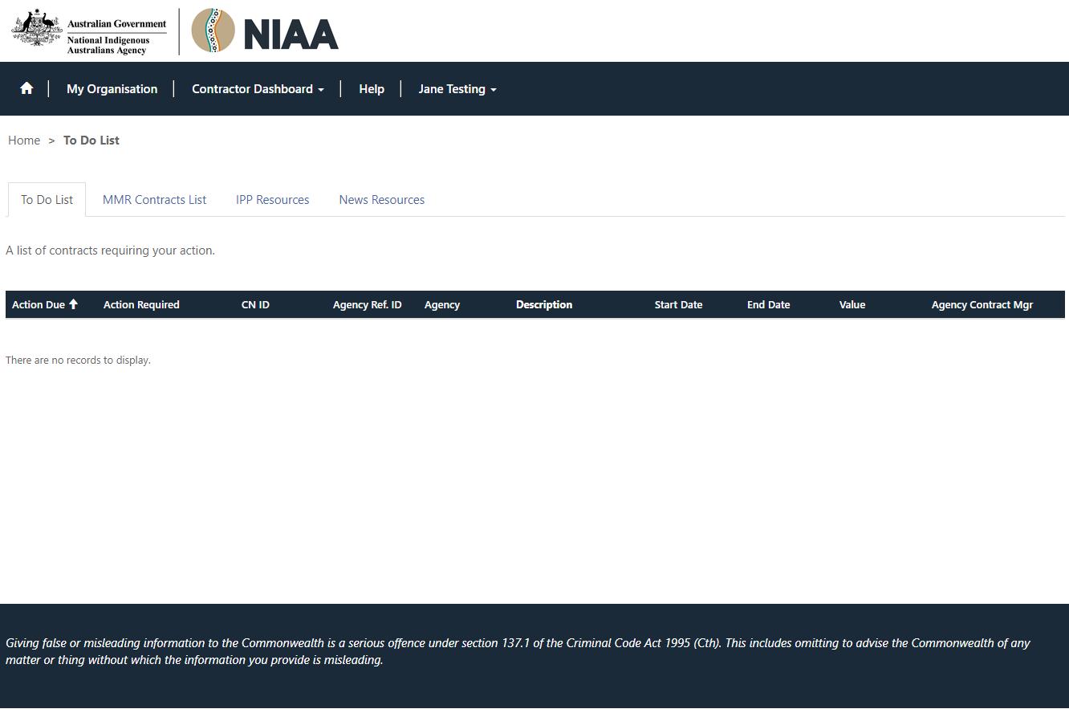  Figure 9: Home Page screen  You have now successfully logged in to the IPP Contractor Portal.

Basic Navigation
On successful login to the IPP Contractor Portal the Home page is displayed:
Figure 10: Home page screen

The Home page
The Home page, consists of the following components:
Navigation Bar
Click here to have the details of “My Organisation” and “My Organisation Contacts” displayed.
Update fields as required.
Click here to have a drop down list displayed from which you can make a selection. Options are:
- To Do List
Displays a list of MMR contracts requiring action.
- MMR Contracts List
Displays a list of all MMR Contracts; including those that do not require immediate action.
- IPP Resources
Displays a list of useful links e.g. Help and IPP etc.
- News
Displays a list of news and notifications.
Click Help to go to the system Help. The Help is opened in a new tab.
Click on your Username to view or update your system profile.

Support
The IPP Contractor Portal contains extensive online help including.
In addition, support is available through:
Email: IPPRS@pmc.gov.au
Telephone: 02 6152 3522
8am to 5pm Monday to Friday AEDT

APPENDIX A Project Flyer
Below is the Project Flyer:
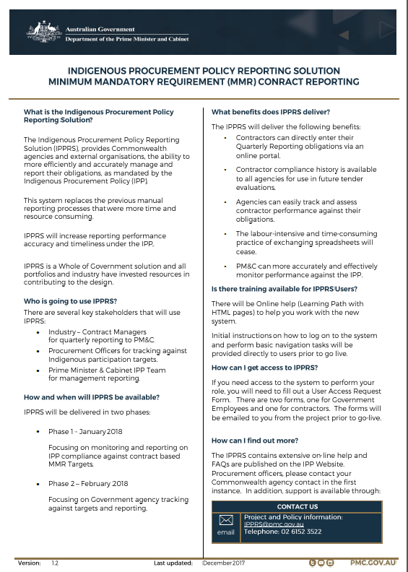
Figure 10: IPPRS Flyer

