Annex F: Indigenous Cadetship Support (ICS) and Tailored Employment Assistant Grants (TAEG) ICS TAEG Map of Cadets by program and suburb

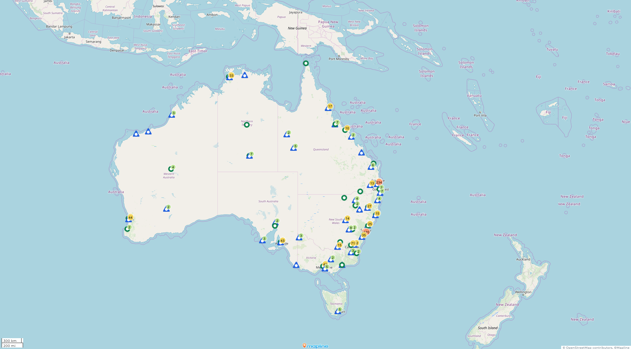
Administrative data shows the vast majority of cadets listed their home address as being in Sydney, followed by Brisbane, with smaller numbers from other capitals and some regional and remote areas. This data should be treated with caution as it is likely that at least some cadets will have listed their home address as the location at which they were living at the time they completed the cadetship commencement form. A map of cadets by program and suburb is included at Annex F.
The demographic characteristics of cadets are broadly consistent with other data, which shows that Indigenous undergraduate students are more likely to be older and female than non-Indigenous students[1] and the majority of Aboriginal and Torres Strait Islander Australians live on the Eastern seaboard.[2]

[1] Universities Australia (n.d.) Universities Australian Indigenous Strategy First Annual Report, page 16.
[2] Australian Bureau of Statistics, Estimates of Aboriginal and Torres Strait Islander Australians, June 2016. [Accessed 13/03/2020]

