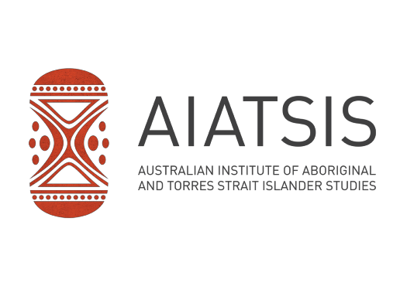

51 Lawson Crescent Acton Peninsula, Acton ACT 2601 GPO Box 553, Canberra ACT 2601
ABN 62 020 533 641
P | 02 6246 1111
F | 02 6261 4286
www.aiatsis.gov.au

05 February 2020
Natalie Walker C/o Kiri Dicker Inside Policy PO Box 1315
POTTS POINT NSW 1335
kiri@insidepolicy.com.au

HREC Reference Number: EO150-08112019
Project Title: ICS-TAEG Cadetships Evaluation

Dear Ms Walker,

Thank you for submitting the above research project for single ethical review. This project was considered by the AIATSIS Research Ethics Committee at its meeting held on 3 December 2019, the committee provided an approval with conditions letter to the applicant on 23 December 2019.
The responses provided on 4 February 2020 have been assessed to the satisfaction of the AIATSIS Research Ethics Committee. I am pleased to advise you that the committee has granted ethical approval of this research project.
In accepting AIATSIS ethics approval you must comply with the following obligations:

 The Coordinating Principal Investigator will immediately report anything that might warrant review of ethical approval of the project.
 The Coordinating Principal Investigator will notify the AIATSIS Research Ethics Committee of any event that requires a modification to the protocol or other project documents and submit any required amendments in accordance with the instructions provided by the HREC.
 The Coordinating Principal Investigator will submit any necessary reports related to the safety of research participants in accordance with AIATSIS policy and procedures
 The Coordinating Principal Investigator will report to AIATSIS annually in the specified format and notify the HREC when the project is completed at all sites.
 The Coordinating Principal Investigator will notify the AIATSIS Research Ethics Committee if the project is discontinued at a participating site before the expected completion date, with reasons provided.
 The Coordinating Principal Investigator will notify the AIATSIS Research Ethics Committee of any plan to extend the duration of the project past the approval period listed above and will submit any associated required documentation.
 The Coordinating Principal Investigator will notify the AIATSIS Research Ethics Committee of his or her inability to continue as Coordinating Principal Investigator including the name of and contact information for a replacement.

This letter constitutes ethical approval only. This project cannot proceed at any site until separate research governance authorisation has been obtained from the CEO or Delegate of the institution under whose auspices the research will be conducted at that site.
Should you have any queries about the AIATSIS Research Ethics Committee’s consideration of your project please contact the Secretary of the AIATSIS Research Ethics Committee, ethics@aiatsis.gov.au. The AIATSIS Research Ethics Committee’s Guidelines, Charter, membership and standard forms are available from http://aiatsis.gov.au/research/ethical-research.

The AIATSIS Research Ethics Committee wishes you every success in your research.

Yours sincerely,

Kevin Williams (Mr) Chair
AIATSIS Research Ethics Committee

This HREC is constituted and operates in accordance with the National Health and Medical Research Council’s (NHMRC) National Statement on Ethical Conduct in Human Research (2007) and the Australian Institute of Aboriginal and Torres Strait Islander Studies (AIATSIS) Guidelines for Ethical Research in Australian Indigenous Studies (2012)

