Department of the Prime Minister & Cabinet
Social Return on Investment analysis of the Minyumai Indigenous Protected Area

FULL REPORT

February 2016

About Social Ventures Australia
Social Ventures Australia (SVA) works with innovative partners to invest in social change. We help to create better outcomes for disadvantaged Australians by bringing the best of business to the for purpose sector, and by working with partners to strategically invest capital and expertise. SVA Impact Investing introduces new capital and innovative financial models to help solve entrenched problems. SVA Consulting partners with non-profits, philanthropists, corporations and governments to strengthen their capabilities and capacity to address pressing social problems.

List of Abbreviations
CDEP Community Development Employment Projects
DoE Department of the Environment
EEC Endangered Ecological Community
IAS Indigenous Advancement Strategy
ILC Indigenous Land Corporation
IPA Indigenous Protected Area
IUCN International Union for Conservation of Nature
MLHAC Minyumai Land Holding Aboriginal Corporation
NGO Non-Government Organisation
NRS National Reserve System
NSW New South Wales
PM&C Department of the Prime Minister & Cabinet
SROI Social Return on Investment
SVA Social Ventures Australia
TEK Traditional Ecological Knowledge
WoC Working on Country

Table of Contents
About Social Ventures Australia 1
List of Abbreviations 2
Executive Summary 4
1 Introduction 7
1.1 Project objective 7
1.2 Project scope 7
1.3 Report structure 7
2 Context 8
2.1 Indigenous Protected Areas 8
2.2 About the Minyumai IPA 9
2.3 Investment (inputs) 11
3 Methodology for this project 13
3.1 Understanding change 13
3.2 Measuring change 15
3.3 Valuing change 16
3.4 SROI ratio 17
4 Impact of the Minyumai IPA 18
4.1 Understanding the change 18
4.2 Stakeholder outcomes 24
4.3 Measuring the change 34
4.4 Valuing the change 38
4.5 Calculating the SROI 40
5 Conclusion 46
6 Appendices 49

Executive Summary
Insights
- The Minyumai Indigenous Protected Areas (IPA) has provided an opportunity for the Bandjalang clan to re-engage with culture and language through country
- Through land and fire management work, Bandjalang traditional owners have seen the restoration of native plants and animals that were thought to have been lost. Their return serves as a powerful reminder of the resilience of the Bandjalang people and enables them to better understand themselves, their culture, and their place in the world
- The IPA programme has demonstrated successes across a broad range of outcome areas, effectively overcoming barriers to addressing Indigenous disadvantage and engaging Indigenous Australians in meaningful employment to achieve large scale conservation outcomes, thus aligning the interests of Indigenous Australians and the broader community
- Other key factors for success are the presence of a passionate and committed community with a strong cultural connection to the land and the collaborative partnership developed with the Firesticks Project.
About the Minyumai IPA
Minyumai is a 2,164 hectare freehold property of largely uncleared native forest, woodland and wetland habitats on the far north coast of New South Wales (NSW). The land was handed back to the traditional owners of the land, the Bandjalang clan, on 16 April 1999 by the Indigenous Land Corporation (ILC) and is managed by the Minyumai Land Holding Aboriginal Corporation (MLHAC). The Minyumai IPA was declared in August 2011.
Over the last five years an estimated 24 Bandjalang have been employed as Rangers. They protect and conserve Minyumai’s threatened plants and animals and their habitats through weed, feral animal and fire management work.

Impact of the Minyumai IPA
In the spotlight: Simone Barker, Director, Minyumai Land Holding Aboriginal Corporation
“The IPA helps us keep things the way they were. It protects [the land]."
Simone is a Director at Minyumai. She and the other Rangers and Directors of MLHAC are united by the late Elder Lawrence Wilson’s vision of restoring the country to health and are actively managing the land according to Geeng, which means respect of country, ancestors, elders and young people who one day will be the elders.

Over the last five years, the Minyumai IPA has produced a wide range of social, economic, cultural and environmental outcomes.
The most significant outcomes for Rangers and Community members relate to better caring for country and strengthening their connection to country. The ability to leverage the IPA for additional funding and economic opportunities, most notably, the Firesticks Project, has also been critical.
Government has experienced a range of outcomes, including more skilled Indigenous people and improved engagement with community. NGO and Research partners have benefitted as well from deeper relationships with community and being better able to meet their core objectives.
Financial proxies have been used to approximate the value of these outcomes. The social, economic, cultural and environmental value associated with the outcomes was estimated to be $1.4m for FY11-15.
During this period, $0.9m was invested in the programs, with most (~90%) coming from Government and the remainder from NGO partners and Foundations and Trusts.
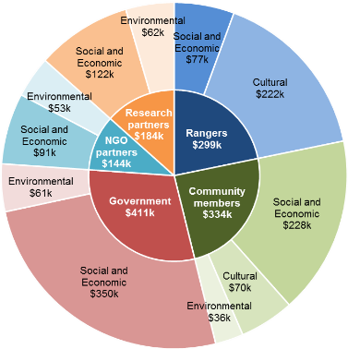
Social Return on Investment (SROI)
The Minyumai IPA delivered an SROI ratio of 1.5:1 based on the investment and operations of FY11-15.
That is, for every $1 invested, approximately $1.5 of social, economic, cultural and environmental value has been created for stakeholders
Figure E.1 – Value of social, economic, cultural and environmental outcomes created by stakeholder, FY11-15
In the spotlight: Daniel Gomes, Coordinating Ranger
“When we burned this area, I didn’t think the native plants would come back but they did. I couldn’t believe it... When I see these changes, I feel proud.”
Daniel grew up hearing the late elder Lawrence Wilson tell stories of the native plants and animals that used to inhabit Minyumai. He worried they would never return.
He has been working on country for the last 15 years, often in his spare time and most recently as a Coordinating Ranger, and is starting to see his land and fire management work pay off. The return of the native plants isn’t just ecological to him. It is intimately connected with his sense of self, locating him in his culture and ancestry, and serves as a powerful symbol and reminder of the resilience of the Bandjalang people.
In the spotlight: Kesha Wilson and Belinda Gomes, Casual Rangers
“We just want to do more; learn more.”
Prior to working on country, Kesha and Belinda weren’t sure if they would like working in the bush. Now they love it and have been involved in burns with high commercial value such as a hazard reduction burn at Coffs Harbour Airport. They want to do more work but are limited by the amount of funding available.
Nevertheless they continue to brainstorm where else they can apply their skills. Community members describe their relentless enthusiasm as inspirational.
About this project
The Department of the Prime Minister & Cabinet (PM&C) commissioned SVA Consulting to understand, measure and value the changes resulting from the investment in the Minyumai Indigenous Protected Area in NSW. This analysis is part of a project that considers five IPAs across Australia including Birriliburu and Matuwa Kurrara Kurrara in Western Australia (together forming one analysis), Girringun in Queensland and Warddeken in the Northern Territory. The Social Return on Investment methodology was used to complete this analysis.
The analysis involved 19 consultations with stakeholders of the Minyumai IPA including five Rangers, six Community members, two Government, two Land councils, two NGO partners, one Corporate partner and one Research partner.
Recommendations
Suggested recommendations derived from this analysis have been provided to the management team.
Consolidated Report
A corresponding report has also been developed by SVA Consulting titled, Consolidated report on Indigenous Protected Areas following Social Return on Investment analyses, which includes key insights from this analysis alongside the analyses of three other IPAs. That report is available on the PM&C website.

1 Introduction

1.1 Project objective
PM&C commissioned SVA Consulting to understand, measure or estimate and value the changes resulting from the investment in the Minyumai IPA in NSW. This analysis is part of a project that analyses five IPAs across Australia including Birriliburu and Matuwa Kurrara Kurrara in Western Australia (together forming one analysis), Girringun in Queensland and Warddeken in the Northern Territory. The SROI methodology was used to complete this analysis. The analysis will enable PM&C to understand the social, economic, cultural and environmental outcomes created by the Minyumai IPA for stakeholders and to inform the future policy direction of the IPA programme.
Social Return on Investment
SROI is an internationally recognised methodology used to understand, measure and value the impact of a programme or organisation. It is a form of cost-benefit analysis that examines the social, economic, cultural and environmental outcomes created and the costs of creating them. The Social Value principles are defined in the methodological attachment to this report.

1.2 Project scope
The scope of the current analysis represents a SROI of the Minyumai IPA for a five year period between July 2010 and June 2015. This period is the time from the beginning of the first financial year following the commencement of consultation to establish the IPA to the end of the 2015 financial year.
There are two forms of SROI analysis outlined in the SROI Guide, a forecast SROI and an evaluative SROI. A forecast SROI makes a prediction about what will happen and is informed by stakeholder consultation and other research. An evaluative SROI looks back to assess the value created as a result of an investment. This analysis is most similar to an evaluative SROI, in that it forms a judgment on the value created by the Minyumai IPA over time. However, due to the limited data available for comparison, this analysis has been less rigorous than an evaluative SROI. This SROI looks back in time and takes account of the available evidence from past performance and, where appropriate, from project social values. In line with Social Value principles, it is informed by stakeholder consultation.
The analysis involved 19 consultations with stakeholders of the Minyumai IPA including five Rangers, six Community members, two Government, two Land councils, two NGO partners, one Corporate partner and one Research partner. A review of Minyumai Land Holding Aboriginal Corporation (MLHAC) financial and payroll data was also undertaken. The methodology for this analysis and interview guides are set out in the Methodological Attachment to this report.

1.3 Report structure
The structure of the report is set out below.
- Section 1 (this section) introduces the analysis
- Section 2 provides the context of the Minyumai IPA
- Section 3 includes information about the methodology for this project
- Section 4 describes the impact of the Minyumai IPA
- Section 5 synthesises the findings and draws insights from the analysis
- Section 6 contains details of the Appendices

2 Context

2.1 Indigenous Protected Areas
An IPA is an area of Indigenous owned or managed land or sea country that is formed when traditional owners voluntarily enter into an agreement with the Australian Government to manage their land for conservation with government support. The IPA programme was developed in the mid 1990’s and supports Indigenous landowners to use land and sea management as a framework for employment and natural and cultural heritage conservation outcomes.
Goals of the IPA programme
- Support Indigenous land owners to develop, declare and manage Indigenous Protected Areas on their lands as part of Australia's National Reserve System
- Support Indigenous interests to develop cooperative management arrangements with Government agencies managing protected areas
- Support the integration of Indigenous ecological and cultural knowledge with contemporary protected area management practices.
There are five key steps involved in establishing and maintaining an IPA:
- Community and stakeholder consultation
- Developing a Plan of Management
- IPA Declaration
- Implementing the Plan of Management
- Monitoring, evaluation, reporting and improvement.
An IPA can be declared after a consultation period has occurred and a Plan of Management has been developed. During the consultation period, Indigenous communities are supported by the Australian Government to consult with their communities and other stakeholders about whether an IPA is suitable for them. A Plan of Management is then developed which sets out how country, its cultural values and threats to these values will be managed.
Once recognised by the Australian Government, IPAs form part of the NRS that seeks to protect Australia’s biodiversity for the benefit of all Australians in line with international guidelines. As at November 2015, there were 72 dedicated IPAs across almost 65 million hectares accounting for more than 43% of the total area of the NRS.
The IPA programme is managed by the Environment Branch of the Indigenous Employment and Recognition Division within the Indigenous Affairs Group of the Department of the Prime Minister and Cabinet. Funding is provided through the Natural Heritage Trust under the National Landcare Programme which is administered by DoE, with $73.08 million allocated from 2013-14 through to 2017-18.
There are four key features of an IPA:
- An open-ended consultation period in which Indigenous traditional owners can decide whether to proceed to IPA declaration or not, depending on their intentions for managing their country
- Commitments made by Indigenous communities outlined in a Management Plan to manage their land and sea within the IPA are voluntary, rather than by statutory agreement with the Australian Government
- Partnerships with various Government agencies, NGOs, corporates, research institutions and others are often formed to support capacity building and undertake joint activities within the IPA
- IPAs can occur over sea country as well as on multi-tenure land including national park, local government reserves, private land and native title returned lands, under co-management arrangements

2.2 About the Minyumai IPA
Minyumai is a 2,164 hectare freehold property of largely uncleared native forest, woodland and wetland habitats on the far north coast of NSW. The IPA was declared in August 2011 and is managed under the International Union for Conservation of Nature (IUCN) Categories IV and VI as a protected area managed mainly for conservation through management intervention and for the sustainable use of natural ecosystems.
Minyumai has been managed by the Bandjalang clan for tens of thousands of years. The land was formerly wetlands and the main route between coastal and inland camp sites. Indeed, the term Minyumai means ‘main camp’.
During the early 20th century, the land was settled by dairy farmers who drained the land and used it for cattle grazing. After a period of low profitability, the now freehold land was acquired by the Indigenous Land Corporation (ILC) and handed back to the Bandjalang clan in 1999. The land has since been managed by the Minyumai Land Holding Aboriginal Corporation (MLHAC) which guides the strategic direction of the IPA on behalf of traditional owners.
Today, Indigenous rangers look after Minyumai through funding provided by the Australian Government’s IPA programme as well as contract funding provided through the Firesticks project, which is delivered by the Nature Conservation Council and funded through the Australian Government Biodiversity Fund. During the five year period of investment covered by this analysis 24 Indigenous people, mostly traditional owners, worked on Minyumai through the IPA programme.
There are five key features of the Minyumai IPA:
- Minyumai is situated in regional NSW abutting the Bundjalung National Park, the Tabbimoble Swamp Reserve and freehold property which presents coordination challenges for land and fire management
- Despite the relatively small size of the IPA at 2,164 hectares versus the average IPA size of approximately 900,000 hectares, the IPA has high conservation significance with presence of both threatened plant and animals species as well as Endangered Ecological Communities (EECs)
- Permanent ranger work is limited as there is no associated Working on Country (WoC) funding
- Nevertheless, through the IPA the Minyumai Rangers have formed a deep partnership with the Firesticks Project, which has provided them fire and land management training, equipment, and funding for contract fire and land management work and has allowed them to become a contract-ready fire management workforce in the region
- The IPA has provided an opportunity for the re-engagement of a community whose experience with colonisation has left it with significant loss of language and culture
Table 2.1 and Figures 2.1 and 2.2 below describe the key activities and participants of the Minyumai IPA.
Activities | Description | Participants and key details (FY09-15)
Ranger work (Indigenous Protected Area and the Firesticks Project) | Provides employment and training for older and younger Bandjalang as rangers fulfilling standard ranger responsibilities to manage the environment (e.g. fire management, feral animal and weed control, monitoring threatened species), but also to support Bandjalang to take ownership of the management of natural and cultural values of their country. | - 24 people employed as IPA rangers (approximately 53% men and 47% women)  - 15,957 ranger hours worked  - $0.3m in salaries paid (gross)
Table 2.1 – Summary of activities
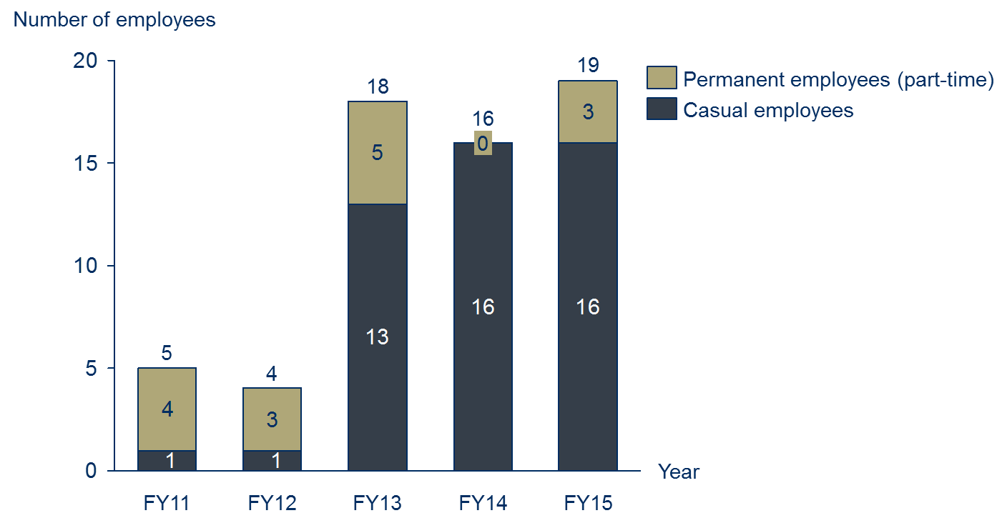
Figure 2.1 – Number of Minyumai Indigenous Rangers (referred to as Rangers throughout this report), FY11-15
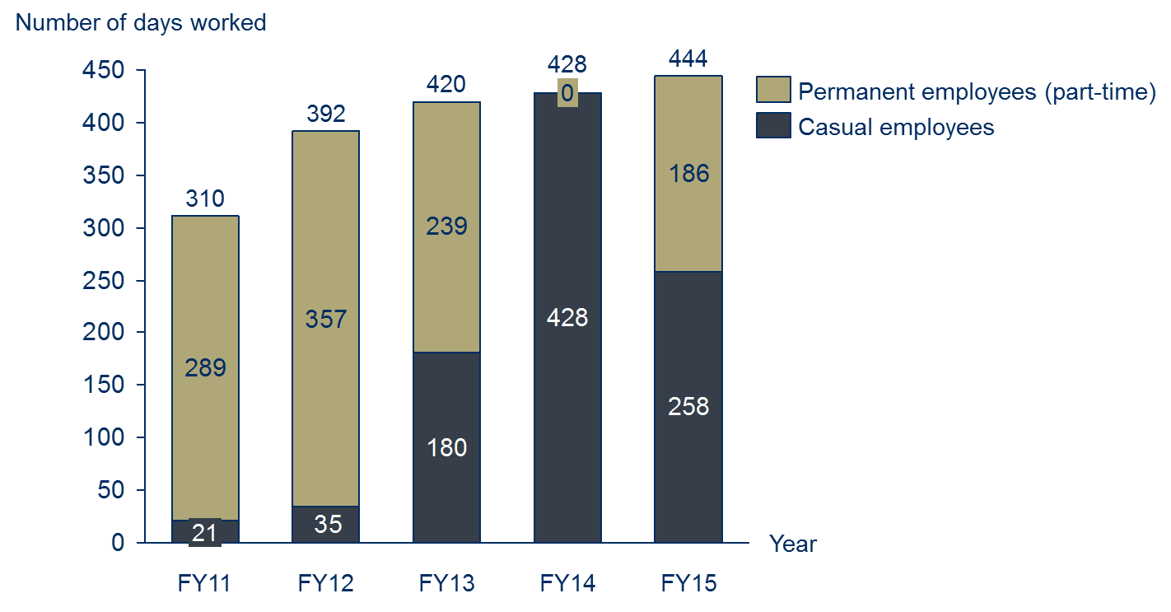
Figure 2.2 – Number of days worked by Minyumai Indigenous Rangers, FY11-15

2.3 Investment (inputs)
The investment included in an SROI analysis is a valuation of all the inputs required to achieve the outcomes that will be described, measured or estimated and valued. For the purpose of this SROI analysis, the investment includes the value of financial (cash) investment over the five year period between FY11 and FY15. No in-kind (non-cash) investments were found to be material. Total investment over the five years was approximately $0.9 million.
Investment Summary
Table 2.2 and Figure 2.3 include a summary of the investment for the Minyumai IPA.
Stakeholder | Total | Notes
Government | $812,636 | Includes funding from the IPA programme (93%), ILC (6%; FY13 only), and National Parks and Wildlife Services (1%; FY13 only)
NGO Partners | $67,408 | Includes funding from the Firesticks project (100%; FY13 and FY15 only)
Foundations and Trusts | $6,800 | Includes funding from donations and sponsorship (87%; FY11 and FY13-14 only); and the Hoffman Foundation (13%; FY13 only)
Total | $933,291
Table 2.2 – Investment by stakeholder group, FY11-FY15
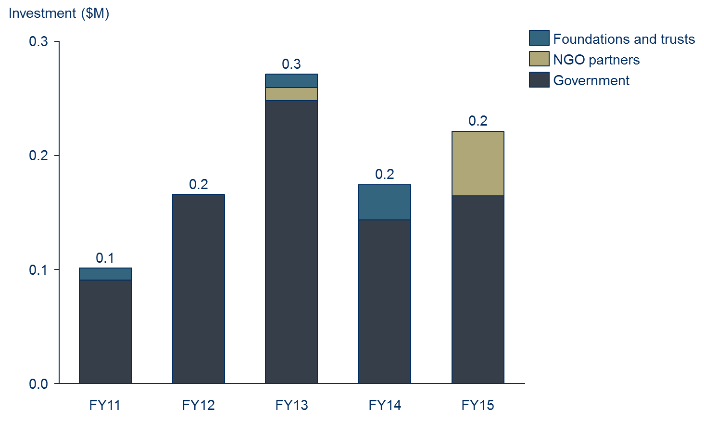
Figure 2.3 - Investment by stakeholder group, FY11-15

3 Methodology for this project

3.1 Understanding change
An SROI analysis requires that the key changes are described, measured or estimated and valued. . It requires a balance between developing a hypothesis that can be tested on the one hand, and hearing the stories which emerge from stakeholder consultation on the other. SVA facilitated a theory of change workshop with PM&C to develop the theory of change for the IPA programme overall in order to define the key changes. The information from the workshop informed the focus of the research approach to ensure relevant data was collected from all key stakeholders.
About theory of change
A theory of change tells the story of change that takes place as a result of the activities of the organisation or programme. It specifies:
- The issue that the organisation or programme is seeking to address
- The key participants in the activities of the organisation or the programme
- The activities that organisation or programmes deliver
- The inputs required to generate the outcomes
- The outcomes of activities that occur through the organisation or programme, for various stakeholders
- The overall impact of these outcomes.

The theory of change developed during the workshop was subsequently refined to incorporate findings from the research and stakeholder consultations and tailored to ensure it adequately reflected the situation within the Minyumai IPA.
Defining stakeholder groups
Stakeholders are defined as people or organisations that experience change, whether positive or negative, or those who want to see change, as a result of the activity. For stakeholders to be included in an SROI, they must be considered material to the analysis. Materiality is a concept that is borrowed from accounting, whereby information is classified as material if it has the potential to affect the readers’ or stakeholders’ decisions about the programme or activity. According to the SROI Guide, a piece of information is material if leaving it out of the SROI would misrepresent the organisation’s activities.
A preliminary list of stakeholders was developed by the management team of MLHAC, which was used as a basis for stakeholder consultation. Stakeholder consultations were later completed to test the materiality of changes experienced by those stakeholders.
Based on this analysis, it was determined that there were five material stakeholder groups that experience outcomes as a result of the Minyumai IPA:
- Rangers
- Community members, including Indigenous traditional owners
- Government, including the Australian and NSW Governments
- NGO partners
- Research partners

Stakeholder consultations
Stakeholders were consulted to identify and understand the relative importance of changes (or outcomes); consider how to prove and measure or estimate change; and consider how to value the outcomes. The consultation approach completed for this analysis involved a two-phased approach:
- Phase 1: SVA and PM&C completed phone consultations, predominately with non-Indigenous stakeholders, prior to visiting on country in early October 2015. These consultations involved stakeholders identified by the MLHAC management team during the initial kick-off meeting. These stakeholders were consulted to determine whether the Minyumai IPA had generated material changes for them, and to define the nature of those changes.
- Phase 2: SVA and PM&C completed in-person consultations, predominately with Indigenous stakeholders, while on country within the Minyumai IPA and surrounding areas in mid-October 2015
An outline of completed stakeholder consultations is included in Table 3.1 below.
Stakeholder group | Participation in consultations | Estimated total number of stakeholders
Rangers | 6 | 24
Community members | 5 | 50
Government | 2 | N/A
Land councils | 2 | 3
Non-Government Organisation (NGO) partners | 2 | 2
Corporate partners | 1 | 1
Research partners | 1 | 1
Total | 19 engaged through consultation | 81
Table 3.1 – Summary of stakeholder consultations
The management team of MLHAC were involved in the verification of results at three main points:
- Stakeholder consultations – through feedback on the theory of change;
- The measurement and valuation phase – through feedback on the measurement or estimation approach and the calculation of the value of outcomes; and
- The reporting phase – through feedback on the draft report.
Research and analysis
To complement the stakeholder consultations, desktop research and analysis was completed using MLHAC data as well as secondary research relating to land management and previous evaluations of aspects of the IPA programme. Key data sources used to supplement the stakeholder consultations are outlined in the Table 3.2 below.
Data source | Use in the SROI analysis
Dermot Smyth, Indigenous Protected Areas and ICCAs: Commonalities, Contrasts and Confusions, 2015 | Background information
Dermot Smyth, Caring for Country: An Indigenous Propitious Niche in 21st Century Australia, 2014 | To inform Ranger and Community member outcomes
PM&C, Working on Country and Indigenous Protected Areas programmes, 2013-14 | To inform section 2 of this report
Urbis, Assessment of the social outcomes of the Working on Country program, 2012 | Background information
The Allen Consulting Group, Assessment of the economic and employment outcomes of the Working on Country program, 2011 | Background information
Garnett and Sithole, Healthy Country, Healthy People: Sustainable Northern Landscapes and the Nexus with Indigenous Health, 2007 | To inform Ranger and Community member outcomes
Putnis, Josif and Woodward, Healthy Country, Healthy People: Supporting Indigenous Engagement in the Sustainable Management of Northern Territory Land and Seas, 2007 | To inform Ranger and Community member outcomes
MLHAC, Annual Reports, 2011-15 | To inform section 2 of this report
Table 3.2 – Data sources used to supplement consultation

3.2 Measuring change
The stakeholder outcomes included in the SROI represent the most significant consequences that are experienced by stakeholders as a result of the Minyumai IPA up to July 2015. The measures are estimates inferred through stakeholder consultation and quantitative data. Wherever possible we have estimated the extent to which the outcomes have occurred through the use of quantitative data previously collected by the IPA or by other sources. The measures have also been deeply informed by stakeholder consultation. Throughout the data collection process, attention was paid to all possible consequences that arise as a result of the Minyumai IPA: intended and unintended, positive and negative.
Defining the material outcomes for stakeholder groups is complex. When defining the material outcomes for each stakeholder group, an SROI practitioner must ensure that each outcome is unique or it would be considered double counting. This is difficult as the outcomes for each stakeholder group are necessarily related because they describe all of the changes experienced by the stakeholder. Outcomes also happen at different times throughout the period being analysed with different levels of intensity.
These various factors were considered when identifying appropriate measures or estimates and indicators for a particular outcome or set of outcomes created through the Minyumai IPA.

3.3 Valuing change
Financial proxies
Financial proxies are used to value an outcome. This is particularly important in SROI as it relates to the principle of valuing what matters. This means that there is a need to value outcomes even if there isn’t an existing market value.
There are a number of techniques used to identify financial proxies and value outcomes. Importantly, within an SROI, the financial proxy reflects the value that the stakeholder experiencing the change places on the outcome. This could be obtained directly through stakeholder consultation, or indirectly through research. The financial proxies approximate the value of the outcome from the stakeholder’s point of view. Techniques for valuing outcomes are included in the Methodological Attachment to this report.
SROI (Valuation) filters
To present an accurate view of the value created through the Minyumai IPA, valuation filters (SROI filters) have been applied to different financial proxies. This is in accordance with the Social Value principle to not over-claim. Different techniques were used to identify the most appropriate filter for each of the outcomes, including SROI filter assumption categories, also included in the Methodological Attachment to this report.
Consideration of the different SROI filters for this analysis is as follows:
- Deadweight: Deadweight is an estimation of the value that would have been created if the activities from the programme did not happen. To estimate deadweight for the current analysis, stakeholder consultations and desktop research were completed to understand the context and nature of outcomes
- Attribution: Attribution estimates how much change was as a result of other stakeholders or activities, which were not included in the investment. An understanding of the contribution of others to each outcome was determined through stakeholder consultations and research
- Displacement: Displacement is an assessment of how much of the activity displaced other outcomes. Stakeholder consultations and desktop research were completed to identify if any of the outcomes displaced other activities
- Duration and drop-off: Duration refers to how long an outcome lasts for. The duration and drop- off are linked to whether the stakeholder is likely to benefit from the activities over a defined period.
Valuing the outcomes
The total adjusted value is the value calculated for each outcome, which takes into account the following components:
- Quantity: the number of stakeholders who will experience an outcome
- Financial proxy: value of the outcome
- SROI filters: accounting for whether the outcome would have happened anyway (deadweight), who else will contribute to the change (attribution), whether the outcome will displace other activities or outcomes (displacement) and how long the outcome will last for (duration) and how it changes over time (drop off).

3.4 SROI ratio
The SROI ratio is a comparison of the value of the benefits to the value of investment. It is expressed in numerical terms e.g. 3:1, which means that for every dollar invested, $3 of value is returned.
It is important that the SROI calculations are tested by understanding how the judgements made throughout the analysis affect the final result. The judgements that are most likely to influence the SROI ratio were identified, and a sensitivity analysis was conducted to see how sensitive the ratio was to changes in these judgements. To decide which judgements to test, two key questions were considered:
Considerations for interpreting the ratio
- The SROI ratio represents the additional value created, based on the Social Value principles. This is the unique value that is created by a programme or organisation for a specific period
- SROI ratios should not be compared between organisations without having a clear understanding of each organisation’s mission, strategy, theory of change, geographic location and stage of development. A judgement about investment decisions can only be made when using comparable data
- How much evidence is there to justify our judgement? The less evidence available, the more important it is to test
- How much does it affect the final result? The greater the impact, the more important it is to test.

4 Impact of the Minyumai IPA

4.1 Understanding the change
Theory of change
A theory of change was initially drafted for the Minyumai IPA via a workshop completed with 12 PM&C staff. The theory of change developed during the workshop was extensively tested and subsequently refined to incorporate evidence collected through stakeholder consultations and specific feedback from stakeholders. At least one stakeholder from each stakeholder group provided feedback during the testing of the theory of change. The refined theory of change is included in Figure 4.1.
The theory of change tells the story of change for the Minyumai IPA. It consists of four pages:
- Issues, Stakeholders, Activities and Inputs
- Outputs, outcomes and impact for Community members and Rangers
- Outputs, outcomes and impact for Government
- Outputs, outcomes and impact for other stakeholders – NGO partners and Research partners
The first page outlines the issue that the Minyumai IPA seeks to address, the stakeholders involved, the activities that take place and the inputs (investments) into the programme. Only those stakeholders that appear in bold experience outcomes that are measured or estimated in the analysis.
The next three pages consist of outputs (i.e. the immediate consequences of activities), outcomes and impact for stakeholders identified in bold. The outcomes represented on these pages should be interpreted from left to right, and consist of short, medium and long term outcomes. There are three types of outcomes represented:
- Material outcomes
- Intermediate outcomes
- Other outcomes
Material outcomes are outcomes that have been measured or estimated and valued as part of the SROI analysis. These outcomes are considered “material” because they are relevant and significant changes that stakeholders experienced due to the Minyumai IPA during the period of investment being analysed. Decisions around materiality were informed by stakeholder consultation.
Intermediate outcomes are outcomes that have been achieved as a result of the Minyumai IPA. However their value is subsumed by later outcomes that carry a higher value. For this reason, intermediate outcomes are not measured or valued in the analysis as it would be considered double counting.
Other outcomes are those outcomes that have not yet been achieved, and are aspirational outcomes based on the logic of what should occur given other outcomes have been achieved.
The theory of change emphasises the interrelationship between social, economic, cultural and environmental outcomes. This is aligned with how stakeholders perceived the change they experienced through the programme. The key points to draw out of this representation are:
- The outcomes generated by the Minyumai IPA are widespread across the social, economic, cultural and economic domains
- Over the last five years, the Minyumai IPA has pushed well beyond outputs to generate extensive short and medium term outcomes, and some long term outcomes
- Many of the outcomes for different stakeholders are interrelated. For example, more burning using cultural practices in the community manifests as an outcome for Community members (“More burning using cultural practices”) and Government (“More burning using cultural practices”).
- In all cases, stakeholders are striving for two interrelated impacts: healthier people and healthier country.
Potential negative or unintended outcomes were tested throughout stakeholder consultation, for example, negative effects from physically demanding ranger work on health. On balance, it was determined that there were no material negative outcomes associated with the Minyumai IPA. Ongoing, significant challenges are evident, particularly for Community members and Rangers (such as alcohol overuse) however the Minyumai IPA was not seen as contributing negatively to these issues.

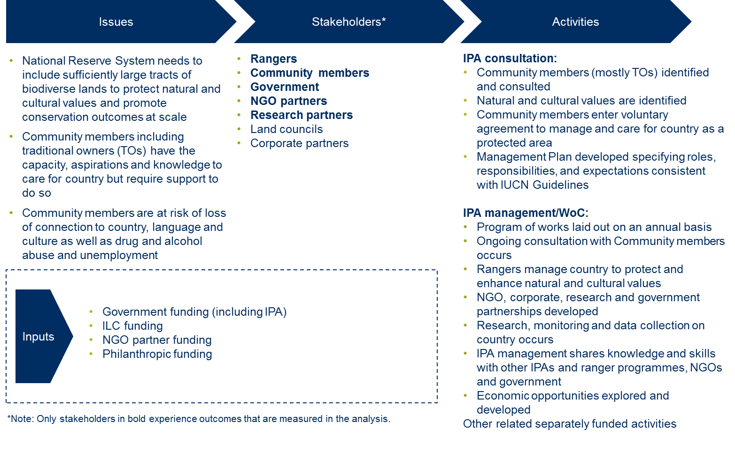
Figure 4.1a –Theory of change for the Minyumai IPA – Issues, Stakeholders, Activities and Inputs (Investment)

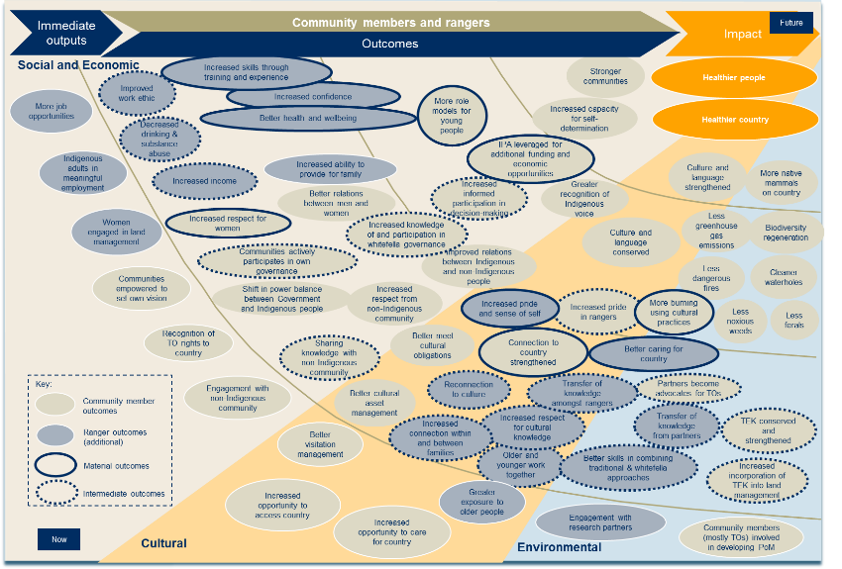
Figure 4.1b –Theory of change for the Minyumai IPA – Community member and Ranger outcomes
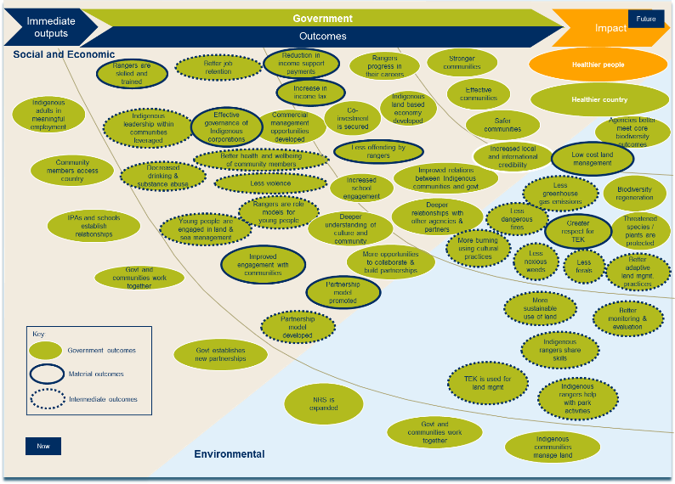
Figure 4.1c –Theory of change for the Minyumai IPA – Government outcomes
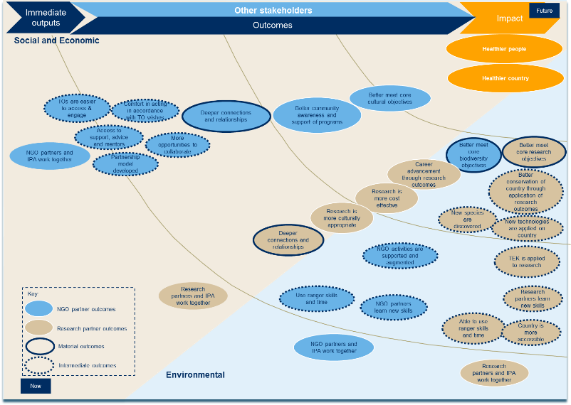
Figure 4.1d –Theory of change for the Minyumai IPA –NGO partner and Research partner outcomes

4.2 Stakeholder outcomes
The stakeholder outcomes are represented in the theory of change outlined in section 4.1. This section describes the outcomes experienced by each of the following stakeholders, in more detail:
- Rangers
- Community members, including Indigenous traditional owners
- Government, including the Australian and NSW Governments
- NGO partners
- Research partners
The outcomes described below are included in the SROI analysis and represent incremental changes for stakeholders that occur as a result of the Minyumai IPA.
- Rangers
Rangers include all those people who work on country at Minyumai, whether on a casual or permanent basis. During the period of investment covered by this analysis 24 Indigenous people, mostly traditional owners, worked on Minyumai. The average tenure of Rangers within the investment period was 2.6 years. The average number of days worked by Rangers during the investment period was equivalent to 83 full (i.e. eight-hour) days.
Rangers working on country is the foundation upon which all outcomes are based. Because Rangers work on country, they experience personal benefits including increased skills and confidence, and better health and wellbeing. Community members benefit directly from ranger activities with the reassurance that country is being cared for and the transfer of cultural knowledge that occurs while working on country. As a result, all of the outcomes experienced by Community members are directly related to ranger activities. Similarly, all Government outcomes are linked to ranger work on country because of its flow-on effects including skilled rangers, greater respect for TEK and low cost land management.
It is likely that a Ranger working on country fits within two stakeholder groups: Rangers and Community Members, which reflects both their job and their role within community. Outcomes achieved by Rangers, captured in Table 4.1 below, are additional to those that are achieved by Community Members.
A summary of the inputs (investment in the programme), outputs (summary of activity) and outcomes (changes) that are experienced by Rangers is included in Table 4.1 below.
Inputs | Outputs | Material outcomes
Nil | - More job opportunities  - Indigenous adults in meaningful employment  - Greater interaction with older people  - Engagement with research partners | 1.1 Increased skills through training and experience  1.2 Increased confidence  1.3 Better health and wellbeing  1.4 Increased pride and sense of self  1.5 Better caring for country
Table 4.1 – Inputs, Outputs and Outcomes for Rangers
Within Ranger outcomes, there are two threads of outputs and outcomes: social and economic, and cultural.

Social and economic outcomes
The material outcomes that have been generated for Rangers in the social and economic thread are:
- 1.1 Increased skills through training and experience
- 1.2 Increased confidence
- 1.3 Better health and wellbeing
One of the most immediate changes for Rangers working on country is the increase in their technical skills. Technical skills encompass Traditional Ecological Knowledge (TEK) and Western scientific knowledge, which together form a ‘two-toolbox approach’. This is the preferred method among Rangers to undertake land management on country. TEK is gained through learning from older people in the community. Western scientific knowledge is learnt through working alongside NGO and Research partners and undertaking TAFE courses in subjects such as conservation and land management, chemical application (for weed management) and fire management. Most Rangers undertake work across a variety of activities and therefore receive training in relation to fire management, flora and fauna surveys and feral animal and weed management.
Social and economic outcomes for Rangers
This analysis estimates the value of better health and wellbeing as a result of working on country. This outcome is calculated at an average value of $3,438 per Ranger per year. The total adjusted value associated with this outcome over five years is $23,207. See sections 4.3 to 4.5 for more information about the adjusted value of each outcome.

In the spotlight: Mikael Smith, CEO, Ngulingah Land Council
“Indigenous Protected Areas provide a gateway to ancient knowledge.”
The IPA has helped to strengthen Minyumai’s relationships with other Indigenous groups in the region, including the Ngulingah Land Council. Minyumai and Ngulingah Rangers often work side by side and trade knowledge of land and fire management techniques.

An outcome occurring for Rangers slightly later than ‘increased skills through training and experience’ is increased confidence. Achievement of this outcome is directly related to time spent on country learning new skills, spending time with the older people and connecting to culture and landscape. Some Rangers compared their lives before and after working on Minyumai to demonstrate how they had grown and developed over time into a more self-assured person.
Better health and wellbeing is a change that almost all Rangers who were interviewed mentioned as an outcome of working on country. Achievement of this outcome is far broader than physical and mental benefits, and is inextricability linked to their relationship with land, culture and spirituality. Rangers referred to the reduction in stress, exercise, native foods, and, most importantly, connection to the land as elements of this outcome. Rangers compared this with what they would be doing if they were not working on country – sitting around or drinking. In contrast, their experiences on country led to this outcome and ultimately, a deep sense of happiness and contentment.
In the spotlight: Veronica “Bonnie” Wilson, Director, Minyumai Land Holding Aboriginal Corporation
“When I get out there, it's like a weight lifted off my shoulders. And then I get back into town and I'm stressed.”
Bonnie is a Director at Minyumai. She used to work on country through CDEP and left to become a teacher at the local Coraki Public School when the scheme was discontinued. She misses working on country and takes every chance she gets to go out on country. She enjoys feeling connected to country and escaping from the stresses of town life.
Cultural outcomes
The material outcomes that have been generated for Rangers in the cultural thread are:
- 1.4 Increased pride and sense of self
- 1.5 Better caring for country
Increased pride and sense of self is a short to medium term outcome that results from caring for country and connection (or reconnection) to culture. Rangers described this outcome as linked to the restoration of native plants and species that were thought to have been lost. Their return serves as a powerful symbol and reminder of the resilience of the Bandjalang people and enables them to better understand themselves, their culture and their place in the world. For those who transfer knowledge onto the younger generations, pride comes from carrying out the vision of the late elder Lawrence Wilson and helping others to connect with their culture.
In the spotlight: Daniel Gomes, Coordinating Ranger
“When we burned this area, I didn’t think the native plants would come back but they did. I couldn’t believe it... When I see these changes, I feel proud.”
Daniel grew up hearing the late elder Lawrence Wilson tell stories of the native plants and animals that used to inhabit Minyumai. He worried they would never return.
He has been working on country for the last 15 years, often in his spare time and most recently as a Coordinating Ranger, and is starting to see his land and fire management work pay off. The return of the native plants isn’t just ecological to him. It is intimately connected with his sense of self, locating him in his culture and ancestry, and serves as a powerful symbol and reminder of the resilience of the Bandjalang people.
Better caring for country is closely linked with the outcome ‘increased pride and sense of self’. It is a short to medium term outcome that results from people working together, the transfer of knowledge among Rangers and increased respect for cultural knowledge.
Better caring for country is a direct result of ranger work on country. Under the tenure of dairy farmers Minyumai was drained and largely left neglected which resulted in damage by wildfires, feral animals and weeds. The return of the Bandjalang people to work on country has had a transformative effect on the health of country, including seeing a reduction in setaria weeds and the return of native plants. This process has been enabled by the establishment of the IPA because it has enabled more resources – including ranger time, equipment and funding from other partnerships – to be allocated to caring for country.
In the spotlight: Richard “Richie” Brittingham, Project Officer, The Firesticks Project
“People have been fractured, fragmented for a long time so that's the fundamental importance of these places. The IPAs provide a space where Aboriginal people can go and restore cultural practices, be able to burn the land, and learn about species of animals and plants that were managed sustainably by their ancestors.”
Richie is a Project Officer with the Firesticks Project, an Indigenous led network that aims to re-invigorate the use of cultural burning to ensure healthy communities and healthy landscapes. He has seen firsthand the importance to Aboriginal people of being able to care for country and maintain cultural practices.
The transfer of knowledge is an essential element of this outcome. Many key Elders have passed away and with them has been great loss of cultural knowledge. Older Rangers and the new generation of Elders who have learned alongside the late Elders have been critical in passing on knowledge of the landscape, trees and animals to both Indigenous and yirali (non-Indigenous) people so that country is better looked after. Young Rangers are passionate about learning and passing on cultural knowledge and ensuring their country is better cared for now and forever by the Bandjalang people.
In the spotlight: Andrew Johnston, Indigenous mentor
“When I see the young people on Minyumai, it makes me smile... I feel inspired by them.”
Andrew Johnson is a Bundjalang elder and Indigenous mentor. He has worked closely with the Minyumai Rangers and is impressed by their strong cultural connection to land, their desire to learn more and their passion for caring for country.

- Community members
Community members represent Indigenous people, mostly Bandjalang, who are involved with Minyumai. There are two ways in which someone falls within this stakeholder group:
- Minyumai is part of their family’s identified country.
- They are married to or are a relative of someone connected with Minyumai as outlined above.
This classification was informed by stakeholder consultations and tested with the MLHAC management team.
A summary of the inputs (investment in the programme), outputs (summary of activity) and outcomes (changes) that are experienced by Community members is included in Table 4.2 below.
Inputs | Outputs | Material outcomes
Nil | - Communities empowered to set own vision  - Recognition of TO rights on country  - Engagement with non-Indigenous community  - Better visitation management  - Increased opportunity to access country  - Increased opportunity to care for country  - Community members (mostly traditional owners) involved in developing Plan of Management for Minyumai IPA | 2.1 More role models for young people  2.4 IPA leveraged for additional funding and economic opportunities  2.5 Increased respect for women  2.8 Connection to country strengthened  2.10 More burning using cultural practices
Table 4.2 – Inputs, Outputs and Outcomes for Community members
Social and economic outcomes
The material outcomes that have been generated for Community members in the social and economic thread are:
- 2.1 More role models for young people
- 2.4 IPA leveraged for additional funding and economic opportunities
- 2.5 Increased respect for women
As a direct result of Rangers working on country, Community members benefit because role models are created for young people to look up to. Community members emphasised the dearth of role models prior to Minyumai’s IPA programme: most community members were unemployed and many experienced problems with drinking and substance abuse and boredom. There were no resources to look after country and so young people could not observe and learn from the older people fulfilling their cultural obligations. Since the IPA declaration and commencement, young people have been able to see Rangers applying their skills to caring for country and engaging in more consistent employment. For Community members, Rangers are strong and resilient community members that the young people look up to.
In the spotlight: Andrew Johnston, Indigenous mentor
“Working on country provides people with a cultural connection and a sense of purpose. They become role models and people see that and say ‘I can do that.’ And if they have a first try and it doesn't work, they can try again.”
Andrew Johnson is a Bandjalang elder and Indigenous mentor. He has worked closely with the Minyumai Rangers and seen firsthand the cultural connection and sense of purpose that comes with working on country. The Rangers serve as role models in the community, as people who are holding down jobs and are engaged in their work.

Community members experience a direct and significant benefit from the IPA in the form of additional funding and economic opportunities, the largest of which is funding from the Firesticks Project. The Firesticks Project is an Indigenous led network delivered by the Nature Conservation Council and funded by the Australian Government Biodiversity Fund that aims to re-invigorate the use of cultural burning to ensure healthy communities and healthy landscapes. Through the Firesticks Project, Rangers have been provided specialised fire and land management training, equipment, and funding for contract fire management work. The contract work has allowed for the training and employment of female Rangers, which has in turn led to the increased respect and admiration for women for their passion and the work that they do.
Economic outcomes for Community members
Minyumai’s highly successful fire and land management work using traditional burning methods is starting to be recognised in the region, and Rangers have been invited to share their work, including at the South East Queensland Fire and Biodiversity Consortium 2015 in Brisbane. This analysis measures an economic outcome related to Bandjalang’s ability to leverage the IPA to generate additional funding and economic opportunities, such as work undertaken for the Firesticks Project. This outcome is calculated at an average value of $32,794 per opportunity per year. The total adjusted value associated with this outcome over five years is $196,762. See sections 4.3 to 4.5 for more information about the adjusted value of each outcome.

The skills gained through the Firesticks Project have allowed the Rangers to become a contract-ready workforce in the region, assisting other Indigenous and non-Indigenous organisations in the region including the Rural Fire Service. The Rangers at Minyumai have been involved in burns with high commercial value, including a hazard reduction burn at the nearby Coffs Harbour Airport in August 2015.
Through the Firesticks Project, Rangers are able to engage and develop deeper relationships with other Indigenous groups in the region. Where there were few, if any, relationships before, the Indigenous groups now regularly consult one another for advice on fire and land management, application for the IPA programme, and other relevant matters. The Rangers are also sought out as experts by non-Indigenous groups. As an example, Coordinating Ranger Daniel Gomes was invited to present his work to a network of land managers and fire management and biodiversity stakeholders at the South East Queensland Fire and Biodiversity Consortium 2015 in Brisbane.
Cultural outcomes
The material outcomes that have been generated for Community members in the cultural thread are:
- 2.8 Connection to country strengthened
This outcome is closely linked to the ranger outcome related to caring for country. Without the resources provided and leveraged through the IPA programme, Community members would not as easily access and care for country. Rangers undertake preventative fire, weed, and feral animal management. As a result of Rangers carrying out this and other land management work, Community members experienced strengthened connection to country through seeing the restoration of native plants and animals from their youth and through passing on traditional knowledge of native plants and animals to the younger generation. The IPA also serves as a meeting place for Bandjalang community gatherings.

Environmental outcomes
The material outcomes that have been generated for Community members in the environmental thread are:
- 2.10 More burning using cultural practices
More burning using cultural practices refers to increased early season burning to address the critical problem of wildfires late in the dry season as well as prescribed ecological burning for biodiversity regeneration. Both are carried out using the knowledge and expertise of traditional owners and NGO and Research partners, with the resources of the IPA and rangers. This outcome leads to greater variation in vegetation growth, return of native animals, less dangerous late season fires and, ultimately, less greenhouse gas emissions.
- Government
In this analysis the Government stakeholder group includes:
- Australian Government including PM&C and DoE
- NSW Government including the National Parks and Wildlife Services, Rural Fire Service and the Environmental Trust.
Social and economic outcomes for Government
An intended outcome for Government under the IAS is adults in jobs. This analysis estimates a material outcome for Government ‘Rangers are skilled and trained” which leads to the achievement of this outcome. This outcome is calculated at a value of $9,000 per Ranger per year. The total adjusted value associated with this outcome over five years is $249,750. See sections 4.3 to 4.5 for more information about the adjusted value of each outcome.
Impact for Government is both broad and deep, and stems from a variety of activities including rangers working on country taking care of the land, Government working more closely with communities and Government establishing new partnerships.
Importantly, there is strong alignment between the impact envisaged and created by the Minyumai IPA and various outcomes targeted through PM&C’s Indigenous Advancement Strategy, including:
- Increasing Indigenous employment, business and economic development
- Supporting Indigenous people to maintain their culture and language
- Indigenous participation in society and organisational capacity.
A summary of the inputs (investment in the programme), outputs (summary of activity) and outcomes (changes) that are experienced by Government is included in Table 4.3 below.
Inputs | Outputs | Material outcomes
$812,636 | - Indigenous adults in meaningful employment  - Community members access country  - Government and communities work together  - Government establishes new partnerships  - NRS is expanded  - Indigenous communities manage land | 3.1 Rangers are skilled and trained  3.2 Reduction in income support payments  3.3 Increase in income tax  3.6 Improved engagement with communities  3.7 Partnership model promoted  3.8 Greater respect for TEK  3.9 Low cost land management
Table 4.3 – Inputs, Outputs and Outcomes for Government
Social and economic outcomes
The material outcomes generated for Government in the social and economic thread are:
- 3.1 Rangers are skilled and trained
- 3.2 Reduction in income support payments
- 3.3 Increase in income tax
- 3.6 Improved engagement with communities
- 3.7 Partnership model promoted
An immediate, direct consequence of Indigenous adults in meaningful employment as rangers is that they are skilled and trained. Government benefits from a more skilled ranger workforce as it improves job retention. Minyumai rangers may remain as Indigenous rangers or they may eventually move into other roles. There is greater demand for ranger work in the community than there is funding available.
There are two flow-on effects of more Indigenous adults in jobs which is a reduction in income support payments and an increase in income tax. These outcomes are based on the assumption, tested during stakeholder consultations that, the vast majority of Minyumai rangers were on income support prior to being rangers. Since Minyumai employed 24 rangers during the five year period, many of whom are casuals, the quantum of these outcomes was modest although material – an average of $284 in income support savings per ranger, per year and an average increase of $1,347 in tax revenue per ranger, per year.
The final two social and economic outcomes for Government deal more directly with Government’s role in the Minyumai IPA. Improved engagement with communities is a short-term outcome experienced by Government as a result of Government and communities working closely together. Representatives from PM&C noted that the IPA programme in particular is perceived favourably by many Indigenous communities and has resulted in the Indigenous people becoming involved and owning a Government funded programme in ways not always observed. The stakeholder consultations for this analysis demonstrated that this experience is mirrored in the Minyumai IPA.
Over time, one of the outcomes from the cooperation with the Minyumai IPA is expected to be a deepening understanding within Government of culture and community, improved relations between Indigenous communities and Government, and ultimately, increased local and international credibility of Government programmes.
The IPA programme has been well-received at Minyumai due to its unique voluntary and consultative nature. Minyumai Rangers serve as advocates of the programme and have been called upon by Indigenous groups in the region interested in learning more about the IPA programme. The Minyumai IPA has facilitated promotion of an Indigenous partnership model, which may lead to more opportunities to collaborate and deepen relationships with partners (including other agencies).
In the spotlight: Bernard Morris, Programme Officer, Environment Management and Policy North East, Environment Branch, Department of the Prime Minister and Cabinet, Australian Government
“If the IPA was not there, there would be no avenue to bring the community together in a focused way.”
Bernard is the Programme Officer for the Minyumai IPA. He believes the IPA and the land and fire management work it has enabled have been critical to Minyumai’s ability to bring together new partners in the region such as nearby Indigenous groups, the Firesticks Project and the NSW Rural Fire Service.

Environmental outcomes
The material outcomes that have been generated for Government in the environmental thread are:
- 3.8 Greater respect for TEK
- 3.9 Low cost land management
Land management is procured at a lower cost and encompasses numerous environmental outcomes including:
- More burning using cultural practices
- Less dangerous fires
- Less greenhouse gas emissions
- Less noxious weeds
- Less feral animals
- Better adaptive land management practices.
The value associated with these intermediate outcomes is accounted for through the estimation of outcome 3.9 “Low cost land management”.
Land management through the Minyumai IPA also facilitates the use of TEK in land management which has numerous flow on effects for Government including sharing of skills by Indigenous rangers, more sustainable use of land and better monitoring and evaluation. Greater respect for TEK from within Government is also a benefit which accrues when Government agencies gain a deeper appreciation of the critical role played by TEK in better land management.
In the spotlight: David Milledge, Director, Landmark Ecological Services
“The people at Minyumai manage this IPA better. If the land had gone to National Parks, it wouldn’t have been managed as well due to a lack of resources and traditional land management knowledge.”
David is a wildlife ecologist who works closely with the Minyumai Rangers. He sees tremendous value in the traditional knowledge and skills that the Minyumai Rangers bring to caring for country and believes they are better at managing country because of their ability to draw on the ‘two-toolbox approach,’ combining traditional ecological knowledge (TEK) and Western scientific knowledge.
- Non-Government Organisation partners
The primary NGO partner of Minyumai is the Firesticks Project delivered by the Nature Conservation Council and funded by the Australian Government Biodiversity Fund.
A summary of the inputs (investment in the programme), outputs (summary of activity) and outcomes (changes) that are experienced by NGO partners is included in Table 4.5 below.
Inputs | Outputs | Material outcomes
$67,408 | - NGO partners and IPAs work together | 5.1 Deeper connections and relationships  5.2 Better meet core biodiversity objectives
Table 4.5 – Inputs, Outputs and Outcomes for NGO partners
Social and economic outcomes
NGO partners experience deeper connections and relationships as a result of working with Minyumai. These relationships build up slowly over time, and are linked to a number of earlier outcomes for NGO Partners (not measured in this analysis) including:
- Traditional owners are easier to access and engage
- Comfort in acting in accordance with traditional owner wishes
- Access to support, advice and mentors
- Partnership model developed
- More opportunities to collaborate.
The Minyumai IPA and the Firesticks Project began working together in 2013 to develop the Minyumai IPA Ecological and Cultural Burning Plan. Since that time, the relationship between them has grown with the Firesticks Project providing specialised fire and land management training, equipment, and funding for contract fire management work and the Rangers leading demonstrations of traditional burning techniques and assisting other Firesticks partners in the region with fire management. This relationship is mutually beneficial and MLHAC is frequently called upon to share their ideas, come up with solutions and connect NGO partners with other organisations where needed.

Environmental outcomes
As a result of working with the Minyumai IPA, NGO partners experience a significant, long term outcome related to better meeting their core biodiversity objectives. The biodiversity objectives of Minyumai’s partners relate broadly to three interrelated themes:
Environmental outcomes for NGO partners
Environmental outcomes that occur as a result of land management undertaken on IPAs have been discussed in numerous reports including PM&C’s Working on Country and Indigenous Protected Areas programmes 2013-14 annual report. This analysis considers the value associated with this work for stakeholders other than Community members and Government, such as NGO partners. An outcome for NGO partners related to better meeting their core biodiversity objectives has been calculated at a value of $70,306 per NGO partner per year. The total adjusted value associated with the outcome over five years is $52,729. See sections 4.3 to 4.5 for more information about the adjusted value of each outcome.
- Protect ecologically important land and sea, including different habitats of plants and animals
- Protect threatened species, and create the right conditions for native species to thrive
- Promote the use of burning using traditional cultural practices
The approach taken to achieving these biodiversity objectives by NGO partners involves:
- Working in partnership and collaboration
- Using traditional and scientific methods
- Being pragmatic and results-focused
NGO partners strongly believe that their deep partnerships with Minyumai have assisted them to achieve these objectives.
- Research partners
Minyumai’s Research partners include Landmark Ecological Services Director David Milledge, who has had a strong, long-term relationship with the Minyumai IPA.
A summary of the inputs (investment in the programme), outputs (summary of activity) and outcomes (changes) that are experienced by Research partners is included in Table 4.7 below.
Inputs | Outputs | Material outcomes
Nil | - Research partners and IPA work together | 7.1 Deeper connections and relationships  7.2 Better meet core research objectives
Table 4.7 – Inputs, Outputs and Outcomes for Research partners
Social and economic outcomes
As a result of Research partners working with the Minyumai IPA, deeper connections and relationships are formed over many years. On all sides, significant time, money and effort has been invested. Partnerships have been successful because of a mutual respect for the other partner’s knowledge and skillset as well as a willingness to share and collaborate. This outcome eventually leads to later outcomes including “research is more culturally appropriate and cost effective”, and “researchers’ careers are advanced through research outcomes”.
Environmental outcomes
Involvement with the Minyumai IPA has also had a substantial impact on the work of its Research partners. Rangers share traditional ecological knowledge and have provided both time and effort to assist with ecological monitoring and research.

4.3 Measuring the change
Modelling indicators of change
At the commencement of this project, there had been some data collected on the activities and outputs of the Minyumai IPA, with particular reference to environmental outcomes. However, there had been little data collected over time to indicate the changes experienced by stakeholders and the quantities of stakeholders experiencing those changes. Having identified the material changes experienced by stakeholder groups, we worked with MLHAC management and used payroll data to calculate (for the investment period):
- Number of people falling within each stakeholder group
- Number of funding and economic opportunities available since the IPA declaration
- Average number of days carrying out burns using cultural practices in a year
- Number of hectares within the IPA where land management is low cost
- Number of NGO partners and Research partners of the IPA
- Degree of Government, NGO partner and Research partner outcomes achieved as a result of the IPA (on a scale of Low to Very High)
As the groups of Rangers and Community Members were large, and their experiences varied, it was not possible to count individuals for whom outcomes had, or had not occurred. Instead we used basic threshold assumptions around the level of engagement required to experience the material outcomes.
The thresholds used with respect to Ranger and Community member outcomes are included in Table 4.9 below.
Outcome | Indicator |  |  | Quantity
Rangers
1.1 Increased skills through training and experience | # of rangers who have worked on country for between 3 and 12 weeks in a year (measured in ranger-years) |  |  | 28
1.2 Increased confidence | # of rangers who have worked on country for more than 12 weeks in a year (measured in ranger-years) |  |  | 9
1.3 Better health and wellbeing | # of rangers who have worked on country for more than 12 weeks in a year (measured in ranger-years) |  |  | 9
1.4 Increased pride and sense of self | # of rangers who have worked on country for more than 12 weeks in a year (measured in ranger-years) |  |  | 9
1.5 Better caring for country | # of rangers who have worked on country for more than 12 weeks in a year (measured in ranger-years) |  |  | 9
Community
2.1 More role models for young people | # of rangers who have worked on country for more than 12 weeks in a year (measured in ranger-years) |  |  | 9
2.4 IPA leveraged for additional funding and economic opportunities | # of funding and economic opportunities available since the IPA declaration |  |  | 6
2.5 Increased respect for women | Inferred # of community members that have experienced increased respect for women |  |  | 44
2.8 Connection to country strengthened | # of community members who engage with country |  |  | 36
2.10 More burning using cultural practices | Average # of days carrying out burns using cultural practices in a year |  |  | 8
Table 4.9 – Outcomes, Indicators and Proxies for Ranger and Community member outcomes
Box 4.1 – Modelling indicators of change – Rangers and Community members
An outline of the measurement approach to a sample of indicators for Rangers and Community members is included below, and corresponds to the indicators outlined in Table 4.9.
- Number of Rangers who have worked on country for between 3 and 12 weeks in a year
The number of Rangers who have worked on country for between 3 and 12 weeks in a year is measured in ranger-years, based on MLHAC’s payroll data. For example, if a Ranger worked 4 weeks a year over the five year investment period, he or she will be counted once for each year worked.
Indicator | FY11 | FY12 | FY13 | FY14 | FY15 | Total
Number of rangers who have worked on country for between 3 and 12 weeks in a year | 1 | 1 | 5 | 16 | 5 | 28

- Number of Rangers who have worked on country for more than 12 weeks in a year
An identical process to number one above has been used for modelling the number of Rangers who have worked on country for more than 12 weeks in a year. MLHAC’s payroll data was used to model this indicator.
Indicator | FY11 | FY12 | FY13 | FY14 | FY15 | Total
Number of rangers who have worked on country for more than 12 weeks in a year | 4 | 3 | 0 | 0 | 2 | 9

- Number of Community members who engage with country
For this indicator, the number of Rangers who have worked on country for more than 12 weeks in a year was used as a reference point. The assumption underpinning this indicator was tested with MLHAC during the project.
Indicator logic steps | Number
Number of rangers who have worked on country for more than 12 weeks in a year | 9
Assumed number of Community members who engage with country for every ranger who works on country for more than 12 weeks in a year | 4
Total number of Community members who engage with country | 36

The indicators for Government are formed using three main sources:
- With reference to the number of Rangers who have achieved certain outcomes (such as Rangers who have increased their skills through ranger work)
- With reference to an inferred level of an outcome achieved by Government (on a scale of Low to Very High)
- With reference to the number of hectares actively managed in the IPA.
The thresholds used with respect to Government outcomes are included in Table 4.10 below.
Outcome | Indicator | Quantity
Government
3.1 Rangers are skilled and trained | # of rangers who have increased skills through ranger work | 37
3.2 Reduction in income support payments | # of rangers not eligible for income support in a year | 21
3.3 Increase in income tax | # of rangers that earn above the tax-free threshold | 8
3.6 Improved engagement with communities | Inferred degree of engagement with communities as a result of IPA | 2
3.7 Partnership model promoted | Inferred promotion of partnership model | 2
3.8 Greater respect for TEK | Inferred increase in respect from TEK as result of the IPA | 3
3.9 Low cost land management | # of hectares in the IPA actively managed | 216
Table 4.10 – Outcomes, Indicators and Proxies for Government outcomes
Box 4.2 – Modelling indicators of change – Government
An outline of the estimation approach to a sample of indicators for Government is included below, and corresponds to the indicators outlined in Table 4.10.
- Number of Rangers who have increased skills through ranger work
The number of Rangers who have increased skills through ranger work is estimated by combining two ranger indicators: Rangers who have worked on country for between 3 and 12 weeks in a year, and Rangers who have worked on country for more than 12 weeks in a year. The rationale behind this modelling is that all Rangers who have worked on country for more than 3 weeks a year have gained skills.
Indicator | FY11 | FY12 | FY13 | FY14 | FY15 | Total
Number of rangers who have worked on country for more than 3 weeks in a year | 5 | 4 | 5 | 16 | 7 | 37

- Number of Rangers not eligible for income support in a year
This indicator was modelled with reference to the number of Rangers with a reduced Newstart Allowance, based on MLHAC’s payroll data and the Income test amounts for the Newstart Allowance available through the Department of Human Services. This indicator assumes all Rangers were on the Newstart Allowance when not working with Minyumai, which was tested and validated during stakeholder consultation.
Indicator | FY11 | FY12 | FY13 | FY14 | FY15 | Total
Number of Rangers not eligible for income support in a year | 5 | 4 | 5 | 16 | 7 | 21

- Number of Rangers that earn above the tax-free threshold
This indicator was modelled with reference to the number of Rangers earning above the tax-free threshold of $18,200 (FY13-15) or $6,000 (FY09-FY12).
Indicator | FY11 | FY12 | FY13 | FY14 | FY15 | Total
Number of Rangers that earn above the tax-free threshold | 4 | 4 | 0 | 0 | 0 | 8

The full set of indicators for each material outcome is set out in the Methodological Attachment to this report.
In our recommendations to the MLHAC management team, improvements to the measurement and evaluation of the Minyumai IPA have been suggested to enable more robust analyses in the future.

4.4 Valuing the change
Financial proxies
SROI seeks to value the things that matter. Financial proxies approximate the value of an outcome from the stakeholders’ point of view. In determining appropriate financial proxies, we were initially informed by:
- Interviews with stakeholders
- Discussions with MLHAC management.
Before applying a financial proxy, we first needed to understand the relative importance of the outcomes. Once this was ascertained, we could find an appropriate financial proxy, most often using the revealed preference technique. This technique looks at the market price of a similar service, programme or activity that could have achieve a similar outcome for the stakeholder. Other techniques used include potential resource reallocation from changes in demand for service and cash transactions.
Table 4.11 shows the value of the financial proxies for each Government outcome, and the description and rationale for selecting the proxy.
Outcome | Financial proxy (description) | Financial proxy value (per annum) | Financial proxy rationale
Government
3.1 Rangers are skilled and trained | Value placed on achieving work readiness (per person per year) | $9,000.00 | Direct savings to Government as a consequence of skilled IPA rangers trained on the job and no longer requiring training through a pre-employment program
3.2 Reduction in income support payments | Average income support savings (per person per year) | $284.47 | Direct savings to Government as a consequence of permanent rangers earning over the threshold for receipt of Newstart and other allowances
3.3 Increase in income tax | Average increase in tax revenue (per person per year) | $1,347.41 | Increased revenue for Government as a result of increased taxable income
3.6 Improved engagement with communities | Annual salary of a Community Relations Coordinator for this IPA (and others) | $18,041.50 | Government stakeholders observed that they are more welcome at, and are able to better engage with, communities through the IPA. No on-costs were included.
3.7 Partnership model promoted | Annual salary of a Strategic Partnerships Manager for this IPA (and others) | $24,627.75 | The IPA programmes have been promoted internally and externally in recognition of their success. No on-costs were included.
3.8 Greater respect for TEK | Average annual cost of Environmental Scientist salary | $32,312.50 | An alternative for achieving a similar depth of connections and relationships is hiring an environmental scientist. No on-costs were included.
3.9 Low cost land management | Difference in cost between land management on IPAs and national parks | $18.20 | Direct savings to Government as a consequence of voluntary commitment of land as an IPA
Table 4.11 – Financial proxies used in the SROI analysis
A detailed description of the valuation of each of the outcomes, including the calculations and the source of the financial proxy, is included in the Methodological Attachment to this report.
Valuation filters
To present an accurate view of the unique value created through the Minyumai IPA, valuation filters (SROI filters) are applied to the financial proxies. This is in accordance with the Social Value principle of not over-claiming. The SROI filters applied to Government outcome 3.1 - ‘Rangers are skilled and trained’ - are included in Table 4.12 below. No displacement was found.
Filter | Assumption | Rationale
Deadweight | 0% | No deadweight has been accounted for in the calculations. It is unlikely that the rangers would be able to obtain skills or training without the ability to work on country provided by the IPA programme or subsequent opportunities that have been catalysed by the IPA programme.
Attribution | 25% | 25% attribution has been accounted for in the calculations. The Rangers received some fire and land management training through the Firesticks Project, an opportunity that was catalysed by the IPA programme.
Duration | 1 | This outcome lasts for the period of the investment (five years). The duration is expressed as ‘1’, to reflect the direct relationship with the period of investment.
Drop-off | 0% | No drop-off is applicable as the outcome is assumed to last for the period of the investment only.
Table 4.12 – SROI filters for Outcome 3.1 ‘Rangers are skilled and trained’

4.5 Calculating the SROI
Once the SROI filters have been applied to each outcome (where applicable), the outcome’s total adjusted value can be determined.
Valuing the outcomes created by the Minyumai IPA
The total adjusted value is the value created for each outcome, which takes into account the following components:
- Quantity
- Financial proxy
- SROI filters: deadweight; attribution; displacement; duration and drop-off.
The application of the SROI filters results in an adjusted value for each financial proxy identified for the analysis. This adjusted value represents the value of the outcome that can be solely attributed to the investment described in this analysis. A worked example of the adjusted value for the outcome the Government outcome 3.1 of - ‘Rangers are skilled and trained’ is set out in Figure 4.1 below.
Deadweight
It is unlikely that the rangers would be able to obtain skills or training without the ability to work on country provided by the IPA/WoC programmes or subsequent opportunities that have been catalysed by the IPA/WoC programme.
Quantity
Number of rangers who have increased skills through ranger work (calculated as by combining two ranger indicators: Rangers who have worked on country for between 3 and 12 weeks in a year, and Rangers who have worked on country for more than 12 weeks in a year
Adjusted
value

37 x $9,000 x (1 - 0%) x (1 - 25%) = $249,750

Attribution
No one else contributed to the outcome
Financial proxy
Revealed preference – Value placed on achieving work readiness (per person per year) based on a per person commitment made by the Australian Government to deliver Vocational, Training & Employment Centres

Figure 4.1 – Worked example for adjusted value of Outcome 3.1
Table 4.13 is a summary of the total adjusted value for all of the outcomes experienced by each stakeholder group.
Outcome | Adjusted value for outcome | Value per stakeholder
Rangers
1.1 Increased skills through training and experience | $32,524 | $298,582  (22%)
1.2 Increased confidence | $21,161
1.3 Better health and wellbeing | $23,207
1.4 Increased pride and sense of self | $95,999
1.5 Better caring for country | $125,692
Community members
2.1 More role models for young people | $10,125 | $334,098  (24%)
2.4 IPA leveraged for additional funding and economic opportunities | $196,762
2.5 Increased respect for women | $21,450
2.7 Connection to country strengthened | $69,761
2.9 More burning using cultural practices | $36,000
Government
3.1 Rangers are skilled and trained | $249,750 | $411,204  (30%)
3.2 Reduction in income support payments | $4,480
3.3 Increase in income tax | $10,779
3.6 Improved engagement with communities | $36,083
3.7 Partnership model promoted | $49,256
3.8 Greater respect for TEK | $57,902
3.9 Low cost land management | $2,953
NGO partners
5.1 Deeper connections and relationships | $91,463 | $144,192  (11%)
5.2 Better meet core biodiversity objectives | $52,729
Research partners
7.1 Deeper connections and relationships | $121,950 | $184,313  (13%)
7.2 Better meet core research objectives | $62,363
Table 4.13 – Total adjusted value of outcomes

Return on investment
The SROI ratio is generated by comparing the total value of the adjusted outcomes experienced by stakeholders to the investment required to create the value.
The Minyumai IPA has delivered an SROI ratio of 1.5:1 based on the investment across seven years between July 2010 and June 2015.
That is, for every $1 invested, approximately $1.5 of social, economic, cultural and environmental value has been created for stakeholders.

That is for every $1 invested, approximately $[ ] of social value is created.

SROI Ratio
1.5:1
Present value of benefits
$1.4 mil
Present value of investment
$0.9 mil
=

Figure 4.1 – SROI ratio for the Minyumai IPA
There are a number of issues that need to be considered when interpreting the SROI ratio. These include:
- The values for the outcomes created are estimates and provide an indication of the value that was generated through the Minyumai IPA
- The SROI ratio represents the additional value created, based on the Social Value principles. This is the unique value that is created by the Minyumai IPA attributable to the investment for this specific period
- SROI ratios should not be compared between organisations without having a clear understanding of each organisation’s mission, strategy, theory of change, geographic location and stage of development. A judgement about investment decisions can only be made when using comparable data.
Note on discount rates
To calculate the present value, costs and benefits incurred or generated in different time periods need to be aggregated. In many cases, for costs and benefits to be comparable, a process called discounting is required to reflect a preference for present consumption, expected inflation and future uncertainty.
In the case of this analysis, no discounting is required. All investments were treated as cash at the time it was received, and there was no need to adjust its value to present dollars. Benefits also required no discounting as there are no outcomes expected to last beyond the duration of the investment.
Testing assumptions
A series of sensitivity analyses was completed to identify the impact of changes to key assumptions. The outcomes for the sensitivity analyses completed for this SROI are included in Table 4.14 below. These show that the return on investment is very sensitive to key assumptions.
Outcome | Variable | Baseline judgement | Low case | High case
1.3 Better health and wellbeing | Financial proxy: Average cost of engaging in stress-reducing activities | $3,438 | 50% of baseline | $7,995  Note: Average health expenditure per Aboriginal/Torres Strait Islander person in 2010-2011.  Source: AIHW, Expenditure on health for Aboriginal and Torres Strait Islander people 2010-11 (2013). Available at: http://www.aihw.gov.au/publication-detail/?id=60129542787 (accessed 5 Dec 2015)
2.4 IPA leveraged for additional funding and economic opportunities | Attribution | 0% | 0% | 25%
2.10 More burning using cultural practices | Financial proxy: Cost of hiring a contractor to carry out a burn (per day) | $6,000 * remoteness multiplier where appropriate | 50% of baseline | 150% of baseline
3.9 Low cost land management | Financial proxy: Difference in cost between land management on IPAs and national parks | $18.20 | $6.17  Note: WA and lowest state estimate in Gilligan (2006) evaluation. Adjusted for inflation. | $49.38  Note: VIC/NSW and highest estimate in Gilligan (2006) evaluation. Adjusted for inflation.
5.2 Better meet core biodiversity objectives | Financial proxy: Estimated value of activities carried out by the IPA that assist with core biodiversity objectives | $35,424 | 50% of baseline | 150% of baseline
7.2 Better meet core biodiversity objectives | Financial proxy: Estimated value of activities carried out by the IPA that assist with meeting core research objectives | $467,723 | 50% of baseline | 150% of baseline
SROI ratio |  | 1.5:1 | 1.4:1 | 1.5:1
Table 4.14 – Sensitivity analyses

In the high and low scenarios tested in this sensitivity analysis, the SROI ratio remains in the range of 1.4:1 to 1.5:1 indicating that – even with the most conservative of assumptions – the social value created by the Minyumai IPA is in excess of the investment.
In the future, it will be important for Minyumai to collect data related to the most sensitive variables over time to ensure that estimates are robust and that the programmes are creating the estimated level of social return on investment. In particular, more accurate data needs to be collected on the number of Rangers and Community members involved with the IPA.

5 Conclusion
An outline of key findings and insights collected through the SROI analysis is included below.
Creation of value
This analysis demonstrates that Minyumai IPA has generated significant social, economic, cultural and environmental outcomes for Rangers, Community members, Government and other stakeholders with an interest in Minyumai. The achievement of these outcomes is strongly dependent on the engagement of Bandjalang on country. For the Rangers, Community Member and Government outcomes in particular, the more time Bandjalang spend on country, the greater the value created by the Minyumai IPA.
In the spotlight: Kesha Wilson and Belinda Gomes, Casual Rangers
“We just want to do more; learn more.”
Prior to working on country, Kesha and Belinda weren’t sure if they would like working in the bush. Now they love it and they have been involved in burns with high commercial value such as a hazard reduction burn at Coffs Harbour Airport. They want to do more work but are limited by the amount of funding available.
Nevertheless they continue to brainstorm where else they can apply their skills. Community members describe their relentless enthusiasm as inspirational.
Value by stakeholder group
Rangers and Community members are the primary beneficiaries of the Minyumai IPA. As a result, a significant amount of value (46% of total value created over five years) accrues to these stakeholder groups consisting of:
- Over $0.3 million in value for Community members (24% of total value)
- Almost $0.3 million in additional value for Rangers (22% of total value).
The accumulation of significant value to these stakeholder groups is logical when their dedication to working on and connecting with country is taken into account. Without Community members and Rangers working on country, none of the outcomes measured or estimated in this analysis would be achieved.
The most significant outcomes for Rangers relate to better caring for country and increased pride and sense of self. These outcomes amount to approximately 74% of value for Rangers ($0.2 million of value across five years). The most significant outcomes for Community members relate to leveraging the IPA for additional funding and economic opportunities and strengthening their connection to country. These outcomes amount to almost 80% of value created for Community members ($0.3 million of value across five years.
Government has also experienced a range of outcomes including more skilled Indigenous people and improved engagement with communities representing approximately 30% of the value created ($0.4 million across five years).
Other stakeholders experience benefit from their involvement with the IPA. NGO and Research partners together experience 24% of the value created ($0.3 million over five years).

Value by outcome type
For Rangers and Community members, the split between the value attributed to social and economic, cultural and environmental outcomes is:
- Social and economic outcomes – 48% of value for Rangers and Community members
- Cultural outcomes – 46% of value for Rangers and Community members
- Environmental outcomes – 6% of value for Rangers and Community members.
When reviewing this information, it must be kept in mind that many cultural outcomes (such as ‘better caring for country’ and ‘connection to country strengthened’) can be viewed simultaneously as environmental outcomes and that a high value has been attributed to environmental outcomes realised by Government.
Across all stakeholder groups, the split between the value attributed to social and economic outcomes, cultural and environmental outcomes is:
- Social and economic outcomes – 63% of total value
- Cultural outcomes – 21% of total value
- Environmental outcomes – 15% of total value.
Differences in the total value of outcomes when Rangers and Community members are considered separately, to when all stakeholders are considered together, has one key drivers:
- There are no cultural outcomes other than for Rangers and Community members, which diminishes the proportional value to this type of outcome when all stakeholders are included
Value over time
During the analysis, the creation of value over time was tested with stakeholders. Initially it was thought that some value would accrue to stakeholders after the period of investment, with a drop-off in that value over time. However, consultation revealed a strong belief that there would be no continuous change without ongoing investment in the Minyumai IPA. The overwhelming reason for this is that the Minyumai IPA facilitates access to and caring for country – without these programs, Rangers would not be able to work on country. Although outcomes such as increased skills, connection to country and better health and wellbeing have occurred, these would not continue to be achieved without ongoing investment.
In the spotlight: Simone Barker, Director, Minyumai Land Holding Aboriginal Corporation
“The IPA helps us keep things the way they were. It protects [the land]."
Simone is a Director at Minyumai. She and the other Rangers and Directors of MLHAC are united by the late Elder Lawrence Wilson’s vision of restoring the country to health and are actively managing the land according to Geeng, which means respect of country, ancestors, elders and young people who one day will be the elders.

Reasons for success
To understand the reasons for success of the Minyumai IPA, one first needs to understand the crucial ingredient which explains the success of both the IPA and WoC programmes nationwide. That is, the alignment of interests of Indigenous Australians and the broader community.
- The IPA programme supports Indigenous Australian nations in their pursuit of self-determination, facilitating reconnection with country, culture and language. The desire to access and care for country runs deep within Indigenous Australians across the country. Time spent on country enables the transfer of traditional knowledge, ensuring that country remains healthy and safe for generations to come.
- Concurrently, Federal and State Governments value the creation of sustainable employment for Indigenous Australians and the achievement of conservation outcomes at scale.
Extraordinary engagement of Indigenous Australians in these programmes has generated a range of positive social, economic, cultural and environmental outcomes, delivering a mutual benefit for all key stakeholders.
In the case of the Minyumai IPA, despite the many challenges faced by the Minyumai IPA, including a relatively small size of investment at $0.9 million, its location abutting National Parks and freehold land presenting coordination challenges for land and fire management and the historic experience of colonisation which has resulted in significant loss of language and culture, the Minyumai IPA has generated impact well beyond its investment.
Its success is largely attributable to two key factors: the presence of a passionate and committed community with a strong cultural connection to the land and the strong collaborative partnership developed with the Firesticks Project.
The Rangers and Directors of MLHAC are united by the late Elder Lawrence Wilson’s vision of restoring the country to health and are actively managing the land according to Geeng, which means respect of country, ancestors, elders and young people who one day will be the elders. There is more desire to do ranger work than there is funding available and some Rangers work on country beyond the hours they are paid.
Many partners have generously volunteered time and resources to the Minyumai IPA. In particular, the partnership with the Firesticks Project, which was leveraged through the IPA programme, has been critical to the success of the Minyumai IPA. The Firesticks Project has provided fire management training, equipment, and funding for contract work which has enabled the engagement of female Rangers and the development of Rangers into a contract-ready workforce in the region. The Rangers are becoming increasingly recognised for their fire and land management expertise by both Indigenous and non-Indigenous groups and are developing stronger partnerships in the region.
Recommendations
Suggested recommendations derived from this analysis have been provided to the MLHAC management team.
Consolidated Report
A corresponding report has also been developed by SVA Consulting titled, Consolidated report on Indigenous Protected Areas following Social Return on Investment analyses, which includes key insights from this analysis alongside the analyses of three other IPAs. That report is available on the PM&C website.

6 Appendices
All appendices have been published separately in a Methodological Attachment to this report. Those appendices, referenced throughout this report, are as follows:
- Social Value principles
- Project methodology
- Interview guides
- List of interviewees
- Stakeholder groups
- Measurement
- Valuation techniques
- Financial proxies
- SROI filter assumptions
- SROI filters
The Methodological Attachment is available upon request from the MLHAC management team. To obtain a copy, please contact:
Daniel Gomes
Coordinating Ranger
T: 02 6682 2885
E: info@minyumai.org.au

End of report

Social Value UK, The SROI Guide, 2012: http://socialvalueuk.org/what-is-sroi/the-sroi-guide
PM&C, Working on Country and Indigenous Protected Areas programmes 2013-14 annual report, 2015: http://www.dpmc.gov.au/pmc-indigenous-affairs/publication/reporting-back-2013-14-working-country-and-indigenous-protected-areas-programmes
PM&C, Indigenous Protected Areas – IPAs: https://www.dpmc.gov.au/indigenous-affairs/about/jobs-land-and-economy-programme/indigenous-environment-branch/indigenous-protected-areas-ipas
Ibid.
PM&C, Indigenous Protected Areas: https://www.dpmc.gov.au/indigenous-affairs/about/jobs-land-and-economy-programme/indigenous-environment-branch/funding-indigenous-land-and-sea-management-projects
Ibid.
Social Value UK, The SROI Guide, 2012: http://socialvalueuk.org/what-is-sroi/the-sroi-guide
Ibid
A detailed outline of the basis for including and excluding stakeholders is included in the Methodological Attachment to this SROI report
This approach to defining connection to country is consistent with the beliefs of the Bandjalang people
The numbering of outcomes is consistent across the four SROI analyses. Only the outcomes for the Minyumai IPA have been identified here, which explains why numbering is not always sequential. This is the approach taken for Community members and for subsequent stakeholder groups
Firesticks, About Firesticks: http://www.firesticks.org.au/about/
For each outcome, a judgement of Low (L = 0.25), Medium (M = 0.5), High (H = 0.75) or Very High (VH = 1.0) has been made, informed by stakeholder consultation, for the state of the outcome as at the end of FY15. This value was then multiplied by five (the number of years since consultation) to obtain the resulting quantity of change for the outcome.
In estimating the extent of change for some outcomes, a judgement of Low (L = 0.25), Medium (M = 0.5), High (H = 0.75) or Very High (VH = 1.0) has been made, informed by stakeholder consultation, for the state of the outcome as at the end of FY15. This value was then multiplied by five (the number of years since consultation) to obtain the resulting quantity of change for the outcome.
Financial proxies do not differ between units based on size and apply average rates where relevant.

