decorative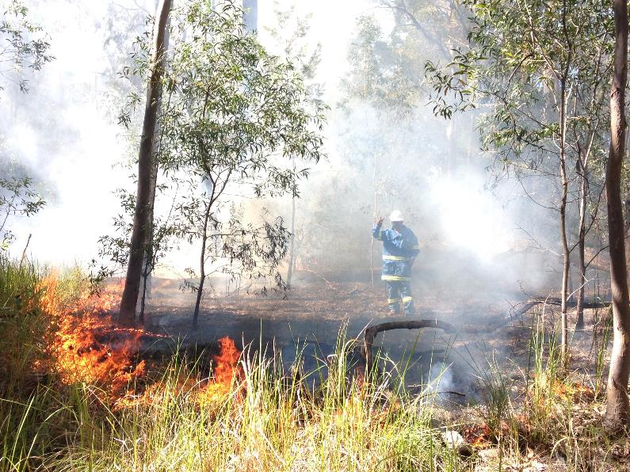

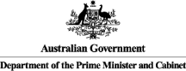**Minyumai Indigenous Protected Area (IPA)**

**Social Return on Investment**

Insights

* The Minyumai IPA has provided an opportunity for the Bandjalang clan to re-engage with culture and language through country
* Through land and fire management work, Bandjalang Traditional Owners have seen the restoration of native plants and animals that were thought to have been lost. Their return serves as a powerful reminder of the resilience of the Bandjalang people and enables them to better understand themselves, their culture, and their place in the world
* The IPA programme has demonstrated successes across a broad range of outcome areas, effectively overcoming barriers to addressing Indigenous disadvantage and engaging Indigenous Australians in meaningful employment to achieve large scale conservation outcomes, thus aligning the interests of Indigenous Australians and the broader community
* Other key factors for success are the presence of a passionate and committed community with a strong cultural connection to the land and the collaborative partnership developed with the Firesticks Project

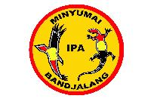

“Being on the land is like meditating to me. Everything drops away and you leave it at the gate.”

Simone Barker, Director, Minyumai Land Holding Aboriginal Corporation

decorative**About the Minyumai IPA**

Minyumai is a 2,164 hectare freehold property of largely uncleared native forest, woodland and wetland habitats on the far north coast of NSW. The land was handed back to the traditional owners of the land, the Bandjalang clan, on 16 April 1999 by the Indigenous Land Corporation (ILC) and is managed by the Minyumai Land Holding Aboriginal Corporation (MLHAC). The Minyumai IPA was declared in August 2011.

Over the last five years an estimated 24 Bandjalang have been employed as Rangers. They protect and conserve Minyumai’s threatened plants and animals and their habitats through weed, feral animal and fire management work.

**Impact of the Minyumai IPA**

Over the last five years, the Minyumai IPA has produced a wide range of social, economic, cultural and environmental outcomes.

The most significant outcomes for Rangers and Community members relate to better caring for country and strengthening their connection to country. The ability to leverage the IPA for additional funding and economic opportunites, most notably, the Firesticks Project, has also been critical.

Government has experienced a range of outcomes, including more skilled Indigneous people and improved engagement with community. NGO and Research partners have benefitted as well from deeper relationships with community and being better able to meet their core objectives.

Financial proxies have been used to approximate the value of these outcomes. The social, economic, cultural and environmental value associated with the outcomes was estimated to be $1.4m for FY11-15.

During this period, $0.9m was invested in the programs, with most (~90%) coming from Government and the remainder from NGO partners and Foundations and Trusts.

**Value of social, economic, cultural and environmental outcomes created by stakeholder, FY11-15**

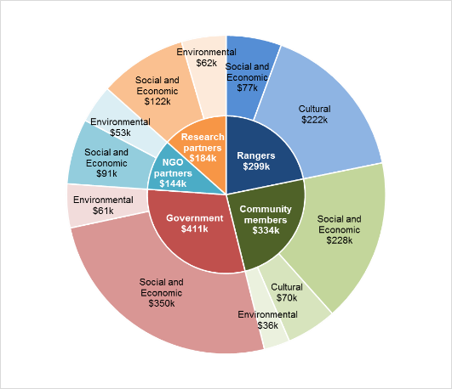

**Social Return on Investment (SROI)**

The Minyumai IPA delivered an SROI ratio of 1.5:1 based on the investment and operations of FY11-15.

That is, for every $1 invested, approximately $1.5 of social, economic, cultural and environmental value has been created for stakeholders

decorative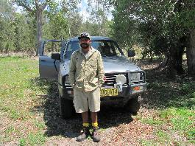

In the spotlight: Daniel Gomes, Coordinating Ranger

*“When we burned this area, I didn’t think the native plants would come back but they did. I couldn’t believe it... When I see these changes, I feel proud.”*

Daniel grew up hearing the late elder Lawrence Wilson, tell stories of the native plants and animals that used to inhabit Minyumai. He worried they would never return.

He has been working on country for the last 15 years, often in his spare time and most recently as a Coordinating Ranger, and is starting to see his land and fire management work pay off. The return of the native plants isn’t just ecological to him. It is intimately connected with his sense of self, locating him in his culture and ancestry, and serves as a powerful symbol and reminder of the resilience of the Bandjalang people.

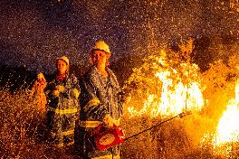

In the spotlight: Kesha Wilson and Belinda Gomes, Casual Rangers

*“We just want to do more, learn more.”*

Prior to working on country, Kesha and Belinda weren’t sure if they would like working in the bush. Now they love it and they have been involved in burns with high commercial value such as a hazard reduction burn at Coffs Harbour Airport. They want to do more work but are limited by the amount of funding available.

Nevertheless they continue to brainstorm where else they can apply their skills. Community members describe their relentless enthusiasm as inspirational.

**About this project**

The Department of the Prime Minister & Cabinet (PM&C) commissioned Social Ventures Australia (SVA) Consulting to understand, measure and value the changes resulting from the investment in the Minyumai Indigenous Protected Area in New South Wales (NSW). This analysis is part of a project that considers five IPAs across Australia including Birriliburu and Matuwa Kurrara Kurrara in Western Australia (together forming one analysis), Girringun in Queensland and Warddeken in the Northern Territory. The Social Return on Investment methodology was used to complete this analysis.

The analysis involved 19 consultations with stakeholders of the Minyumai IPA including five Rangers, six Community members, two Government, two Land councils, two NGO partners, one Corporate partner and one Research partner.

For more information about the Minyumai IPA, or for a copy of the full report, contact:

Daniel Gomes

Coordinating Ranger

T: 02 6682 2885

E: [info@minyumai.org.au](mailto:info@minyumai.org.au)

For more information on the IPA programme, contact:

T: 02 6228 6481 or 02 6228 6717

E: [IndigenousEnvironment@pmc.gov.au](mailto:IndigenousEnvironment@pmc.gov.au)