Department of the Prime Minister & Cabinet
Social Return on Investment analysis of the Girringun Indigenous Protected Area and associated Indigenous ranger programme

FULL REPORT

February 2016

About Social Ventures Australia
Social Ventures Australia (SVA) works with innovative partners to invest in social change. We help to create better outcomes for disadvantaged Australians by bringing the best of business to the for purpose sector, and by working with partners to strategically invest capital and expertise. SVA Impact Investing introduces new capital and innovative financial models to help solve entrenched problems. SVA Consulting partners with non-profits, philanthropists, corporations and governments to strengthen their capabilities and capacity to address pressing social problems.

List of Abbreviations
CDEP Community Development Employment Projects
DoE Department of the Environment
GAC Girringun Aboriginal Corporation
GBRMPA Great Barrier Reef Marine Park Authority
IAS Indigenous Advancement Strategy
IPA Indigenous Protected Area
IUCN International Union for Conservation of Nature
NGO Non-Government Organisation
NRS National Reserve System
PBC Prescribed Body Corporate
PM&C Department of the Prime Minister & Cabinet
Qld Queensland
SROI Social Return on Investment
SVA Social Ventures Australia
TEK Traditional Ecological Knowledge
TUMRA Traditional Use of Marine Resources Agreement
WoC Working on Country
WWF World Wildlife Fund

Table of Contents
About Social Ventures Australia 1
List of Abbreviations 2
Executive Summary 4
1 Introduction 8
1.1 Project objective 8
1.2 Project scope 8
1.3 Report structure 9
2 Context 10
2.1 Indigenous Protected Areas 10
2.2 Working on Country programme 11
2.3 About the Girringun IPA and associated Indigenous ranger programme 12
2.4 Investment (inputs) 15
3 Methodology for this project 17
3.1 Understanding change 17
3.2 Measuring change 19
3.3 Valuing change 20
4 Impact of the Girringun IPA and associated Indigenous ranger programme 22
4.1 Understanding the change 22
4.2 Stakeholder outcomes 28
4.3 Measuring the change 40
4.4 Valuing the change 45
4.5 Calculating the SROI 47
5 Conclusion 54
6 Appendices 58

Executive Summary
Insights
- The Indigenous Protected Areas (IPA) and associated Indigenous ranger programmes have demonstrated successes across a broad range of outcome areas, effectively overcoming barriers to addressing Indigenous disadvantage and engaging Indigenous Australians in meaningful employment to achieve large scale conservation outcomes, thus aligning the interests of Indigenous Australians and the broader community
- The Girringun IPA and associated Indigenous ranger programme has provided an opportunity for Indigenous people from eight traditional owner groups in Northern Qld to actively manage their diverse land and sea country, and re-engage with culture and language through country
- Critical to the success of the Girringun IPA and associated Indigenous ranger programme is its co-management model, whereby Girringun Aboriginal Corporation (GAC) partners with Local, State and Federal Governments as well as numerous NGO and Research partners to achieve shared outcomes for country
- The IPA’s management team offers a culturally assured process to its partners – whereby the appropriate people are consulted about activities undertaken on country – and plays a leading role in the region as advisors, trainers and channels of support for other organisations.
About the Girringun IPA and associated Indigenous ranger programme
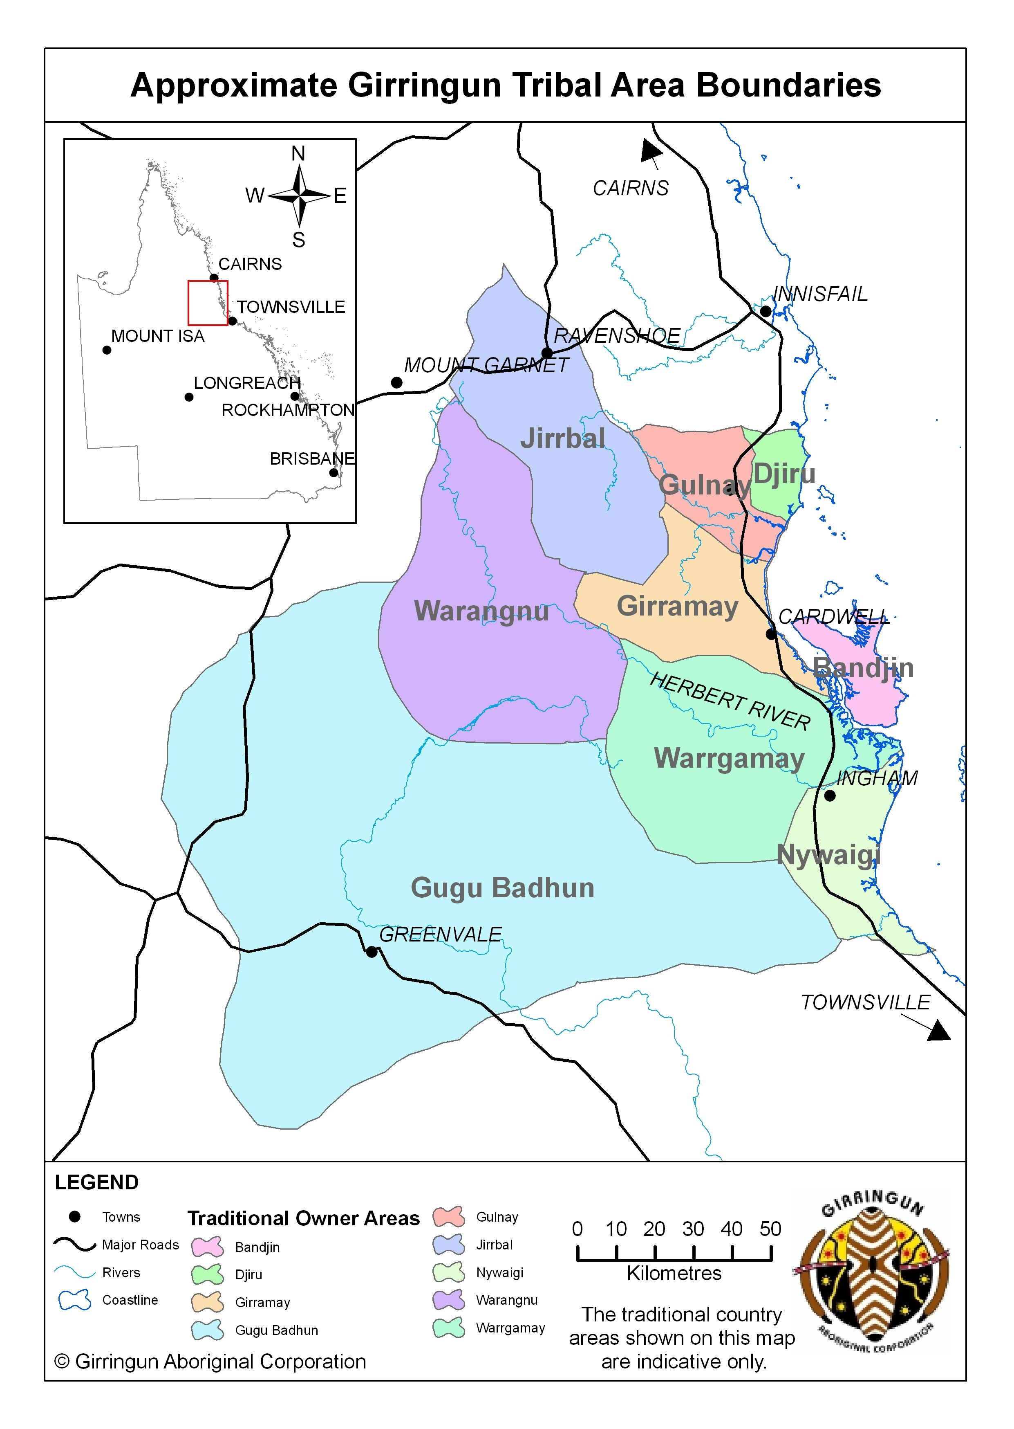
The Girringun IPA is located in Northern Queensland (Qld) and was declared in June 2013. It consists of 1.26 million ha of land and sea country comprising Aboriginal-held land, private landholdings, national parks, conservation parks, fish habitat areas, marine protected areas and world heritage areas including the Great Barrier Reef World Heritage Area and Wet Tropics of Queensland World Heritage Area.
The land within the IPA belongs to eight traditional owner groups - Bandjin, Djiru, Girramay, Gugu Badhun, Gulnay, Nywaigi and Warrgamay, Warungnu traditional owners.
The IPA aims to prioritise outcomes that Indigenous people seek for country alongside the interests of the broader community, which are protected through marine and terrestrial protected areas. The IPA’s plan of management for country identifies works that traditional owners have prioritised through the consultation process including threatened species management, cultural site maintenance and research, monitoring and data collection. The transfer of cultural knowledge and language to young people, and the education of the broader community within the IPA about Indigenous culture, are also high priorities.
Figure E.1 – Map of Northern Australia, depicting the approximate Girringun Tribal Area Boundaries
Impact of the Girringun IPA and associated Indigenous ranger programme
In the six year period covered by this SROI analysis, the Girringun IPA has generated substantial social, economic, cultural and environmental outcomes for Rangers, Community members, Government and other stakeholders. The achievement of these outcomes is strongly influenced by the time Rangers and Community members spend living and working on country.

“You have to be physically fit and mentally fit so that you don’t give up even when the work is hard. You also get the spirituality on the cultural sites. You see the sea shell beds and rock ovens and you get that spiritual connection.”
Chris Muriata, Senior Ranger

The most significant outcomes for Rangers relate to better caring for country, increased pride and sense of self, and better health and wellbeing. The most important outcomes for Community are leveraging the IPA for additional funding and economic opportunities, and better cultural asset management.
Government is also a significant beneficiary of the IPA, experiencing a range of outcomes including more skilled Indigenous people and greater respect for Traditional Ecological Knowledge (TEK). Indigenous corporations, NGO partners and Research partners have also benefited from deeper relationships with traditional owners and being better able to meet their core objectives.
Financial proxies have been used to approximate the value of these outcomes. The social, economic, cultural and environmental value associated with the outcomes was estimated to be $30.9m for FY10-15.
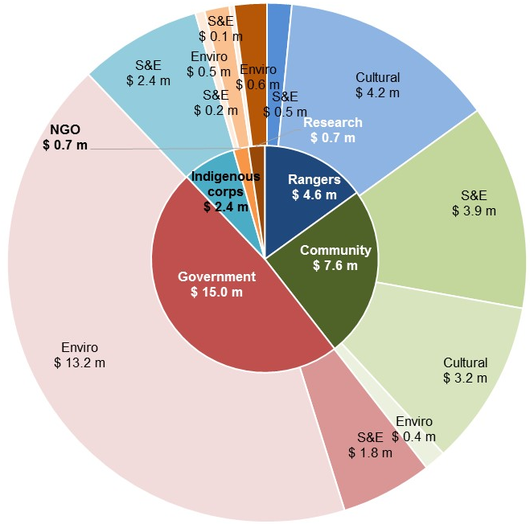
S&E: Social and Economic Outcomes
Cultural: Cultural Outcomes
Enviro: Environmental Outcomes
Social Return on Investment
The Girringun IPA delivered an SROI ratio of 2.2:1 based on the investment in operations between FY10-15.
That is, for every $1 invested, approximately $2.2 of social, economic, cultural and environmental value has been created for stakeholders.
Figure E.2 – Value of social, economic, cultural and environmental outcomes created by stakeholder group, FY10-15
During this period, $13.9m was invested in the Girringun IPA and associated Indigenous ranger programme, with most (96%) coming from Government.
Stakeholder | Total
Government  Includes IPA, WoC and other DoE funding (66%) and Qld Government Department of Employment, Economic Development and Innovation (14%) | $13,422,393
Foundations and Trusts  Includes The Christensen Fund (94%) | $244,520
NGO Partners  Includes Terrain NRM (20%), NQ Dry Tropics (10%) and North Queensland CES (10%) | $238,592
Research Partners  Includes Reef & Rainforest Research Centre (100%) | $34,971
Total | $13,940,476

In the spotlight: Penny Ivey, Girringun Ranger
Penny Ivey is a Girramay woman who has worked as a Girringun Ranger for five years. Prior to becoming a Ranger, Penny was fruit picking. She became a Ranger because she wanted to learn more from the Elders.
While with Girringun, Penny has undertaken training in mapping, dolphin and dugong surveys, operating a front loader and bobcat, and using GPS tracking devices. She is now one of the more experienced Rangers at Girringun and has assumed responsibility for teaching others.
Over time, Penny has transformed from a shy person into a more confident one. Penny attributes this to mixing with other Rangers during trips, conferences and Ranger exchanges where she was representing Girringun. She has career ambitions to one day become a supervisor or work for National Parks.
“I was once a quiet girl - that changed when we went away and met with others.”
About this project
The Department of the Prime Minister & Cabinet (PM&C) commissioned SVA Consulting to understand, measure or estimate and value the changes resulting from the investment in the Girringun IPA and associated Indigenous ranger programme. This analysis is part of a broader project that considers five IPAs across Australia, also including Birriliburu and Matuwa Kurrara Kurrara in Western Australia (together forming one analysis), Minyumai in New South Wales and Warddeken in the Northern Territory. The SROI methodology was used to complete each of these analyses.
This analysis involved 45 consultations with stakeholders of the IPA, including 15 Community members (overlapping with representatives from two Indigenous corporations), five Rangers, seven representatives of Local, Qld and Australian Governments, five NGO partners and five Research partners.
“We benefit from the Girringun IPA as it enables our staff to have a better understanding of the cultural landscape and enables us to have a large resource in terms of identifying and prioritising work to do.”
James Newman, Department of National Parks, Sport and Racing, Qld Government
Recommendations
Recommendations derived from this analysis have been provided to the Girringun management team.
Consolidated Report
A corresponding report has also been developed by SVA Consulting titled, Consolidated report on Indigenous Protected Areas following Social Return on Investment analyses, which includes key insights from this analysis alongside the analyses of three other IPAs. That report is available on the PM&C website.

1 Introduction

1.1 Project objective
PM&C commissioned SVA Consulting to understand, measure or estimate and value the changes resulting from the investment in the Girringun IPA in Qld and associated Indigenous ranger programme. This analysis is part of a project that analyses five IPAs across Australia including Matuwa Kurrara Kurrara in Western Australia (together forming one analysis), Minyumai in New South Wales and Warddeken in the Northern Territory. The SROI methodology was used to complete this analysis. The analysis will enable PM&C to understand the social, economic, cultural and environmental outcomes created by the Girringun IPA and associated Indigenous ranger programme for stakeholders and to inform the future policy direction of the IPA programme.
Social Return on Investment
SROI is an internationally recognised methodology used to understand, measure or estimate and value the impact of a programme or organisation. It is a form of cost-benefit analysis that examines the social, economic, cultural and environmental outcomes created and the costs of creating them. The Social Value principles are defined in the methodological attachment to this report.

1.2 Project scope
The scope of the current analysis represents a SROI of the Girringun IPA and associated Indigenous ranger programme for a six year period between July 2009 and June 2015. This period is the time from the beginning of the consultation period to establish the IPA to the end of the 2015 financial year. The activities of the Girringun Aboriginal Art Centre and the Girringun Region Traditional Use of Marine Resources Agreement (TUMRA) are excluded from this analysis.
There are two forms of SROI analysis outlined in the SROI Guide, a forecast SROI and an evaluative SROI. A forecast SROI makes a prediction about what will happen and is informed by stakeholder consultation and other research. An evaluative SROI looks back to assess the value created as a result of an investment. This analysis is most similar to an evaluative SROI, in that it forms a judgment on the value created by the Girringun IPA and associated Indigenous ranger programme over time. However, due to the limited data available for comparison, this analysis has been less rigorous than an evaluative SROI. This SROI looks back in time and takes account of the available evidence from past performance and, where appropriate, from project social values. In line with Social Value principles, it is informed by stakeholder consultation.
The analysis involved consultations with 45 stakeholders of the Girringun IPA and its associated Indigenous ranger programme including 15 Community members, five Rangers, seven representatives of Local, Qld and Australian Governments, two Indigenous corporations, five NGO partners and five Research partners. A review of the Girringun IPA and associated Indigenous ranger programme financial and payroll data was also undertaken. The methodology for this analysis and interview guides are set out in the Methodological Attachment to this report.

1.3 Report structure
The structure of the report is set out below.
- Section 1 (this section) introduces the analysis
- Section 2 provides the context of the Girringun IPA and associated Indigenous ranger programme
- Section 3 includes information about the methodology for this project
- Section 4 describes the impact of the Girringun IPA and associated Indigenous ranger programme
- Section 5 synthesises the findings and draws insights from the analysis
- Section 6 contains details of the Appendices

2 Context

2.1 Indigenous Protected Areas
An IPA is an area of Indigenous owned or managed land or sea country that is formed when traditional owners voluntarily enter into an agreement with the Australian Government to manage their land for conservation with government support. The IPA programme was developed in the mid 1990s and supports Indigenous landowners to use land and sea management as a framework for employment and natural and cultural heritage conservation outcomes.
Goals of the IPA programme
- Support Indigenous land owners to develop, declare and manage Indigenous Protected Areas on their lands as part of Australia's National Reserve System
- Support Indigenous interests to develop cooperative management arrangements with Government agencies managing protected areas
- Support the integration of Indigenous ecological and cultural knowledge with contemporary protected area management practices.
There are five key steps involved in establishing and maintaining an IPA:
- Community and stakeholder consultation
- Developing a Plan of Management
- IPA Declaration
- Implementing the Plan of Management
- Monitoring, evaluation, reporting and improvement.
An IPA can be declared after a consultation period has occurred and a Plan of Management has been developed. During the consultation period, Indigenous communities are supported by the Australian Government to consult with their communities and other stakeholders about whether an IPA is suitable for them. A Plan of Management is then developed which sets out how country, its cultural values and threats to these values will be managed.
Once recognised by the Australian Government, IPAs form part of the NRS that seeks to protect Australia’s biodiversity for the benefit of all Australians in line with international guidelines. As at November 2015, there were 72 dedicated IPAs across almost 65 million hectares accounting for more than 43% of the total area of the NRS.
The IPA programme is managed by the Environment Branch of the Indigenous Employment and Recognition Division within the Indigenous Affairs Group of the Department of the Prime Minister and Cabinet. Funding is provided through the Natural Heritage Trust under the National Landcare Programme which is administered by DoE, with $73.08 million allocated from 2013-14 through to 2017-18.
There are four key features of an IPA:
- An open-ended consultation period in which Indigenous traditional owners can decide whether to proceed to IPA declaration or not, depending on their intentions for managing their country
- Commitments made by Indigenous communities outlined in a Management Plan to manage their land and sea within the IPA are voluntary, rather than by statutory agreement with the Australian Government
- Partnerships with various Government agencies, NGOs, corporates, research institutions and others are often formed to support capacity building and undertake joint activities within the IPA
- IPAs can occur over sea country as well as on multi-tenure land including national park, local government reserves, private land and native title returned lands, under co-management arrangements

2.2 Working on Country programme
Caring for country is a phrase used by Indigenous Australians to describe their deep spiritual and cultural connection to country and their responsibilities for looking after it. These cultural obligations can sit alongside paid work looking after country as part of the WoC programme.
The WoC programme is now part of the PM&C IAS. It began in 2007 to create real jobs for Indigenous people as part of the reforms to the Community Development Employment Projects (CDEP). The WoC programme supports Indigenous peoples’ aspirations to care for country and seeks to build on Indigenous peoples’ traditional knowledge and obligations with respect to land, sea and culture. Through the WoC programme, nationally accredited training and career pathways for Indigenous people in land and sea management are provided in partnership with others. The WoC programme also helps Government meet its environmental responsibilities and complements the IPA programme.
As at November 2015, there were 108 Indigenous Ranger groups in Australia and 775 full-time equivalent Indigenous Rangers. The WoC programme received funding of $335 million over five years. In the NT, a further commitment of $12.7 million from 2013-16 through Stronger Futures created an additional 53 new jobs.
An IPA can exist without an associated Indigenous ranger programme funded through WoC or another mechanism. Similarly, the existence of an IPA is not a prerequisite to the receipt of WoC funding.

2.3 About the Girringun IPA and associated Indigenous ranger programme
The Girringun IPA is located in Northern Qld. It consists of over 1.26 million hectares of land and sea country comprising Aboriginal-held land, private landholdings, national parks, conservation parks, fish habitat areas, marine protected areas and world heritage areas. These lands include the Great Barrier Reef World Heritage Area, Wet Tropics of Queensland World Heritage Area, Aboriginal-held Mungalla Indigenous Protected Area and privately-held Yabullum Indigenous Protected Area.
The land within the IPA belongs to eight traditional owner groups - Bandjin, Djiru, Girramay, Gugu Badhun, Gulnay, Nywaigi, Warrgamay and Warungnu traditional owners.
The Girringun IPA was declared in June 2013. Different parts of the Girringun IPA are managed under International Union for Conservation of Nature (IUCN) Categories II, III, IV and VI.
Historical context of Girringun
The traditional owners affiliated with the Girringun IPA shared distinctive cultural practices that enabled them to live in the Qld Wet Tropics for many thousands of years. This was interrupted by first contact with Europeans, which began in 1770 when Captain Cook sailed the Endeavour in the area surrounding Halifax Bay, the Palm Islands, Rockingham Bay and Cape Sandwich on Hinchinbrook Island.
The first non-Indigenous settlement within the Girringun IPA was established in 1864 at Port Hinchinbrook (later renamed Cardwell in 1868). Also in the early 1860s, the first registrations for pastoral leases within the IPA began and by the early 1900s a large portion of Girringun’s traditional owner lands were selected for pastoral lands. The arrival of pastoralists, as well as miners, into the area led to a series of violent clashes between traditional owners and non-Indigenous people. This ultimately resulted in traditional owners being driven from their land, which was destroyed by grazing and farming.
From the early 1970s onwards, local traditional owners pushed the Government to set up Aboriginal organisations to establish better living conditions for them and to acquire land for them to live on. In 1996, the Girringun Elders and Reference Group was jointly formed by local traditional owner groups, which in 1998 became the GAC. The GAC is a present day reflection of the pre-existing system of customary law operating between the traditional owner groups.
For approximately four years from 2009, the GAC was responsible for consultation among traditional owners which eventually led to the establishment of the IPA. GAC’s vision for the IPA was to achieve greater involvement of traditional owners in management of their land and sea country. This has been achieved through establishment of the IPA as well as other initiatives including the Cardwell Indigenous Ranger Unit and the Girringun Region TUMRA.
Working on the IPA
Indigenous Rangers look after country within the Girringun IPA through positions funded by the Australian Government’s Working on Country (WoC) programme, which is now part of the Indigenous Advancement Strategy (IAS). The Qld Government’s Department of Environment and Heritage Protection also funded two of Girringun’s Senior Ranger positions.
During the six year period of investment covered by this analysis 96 Indigenous people, mostly traditional owners, worked on the Girringun IPA. Most of these employees are permanent (84%), rather than casual (16%).
Key features of the IPA
There are four key features of the Girringun IPA and associated Indigenous ranger programme:
- The Girringun IPA was declared over land and sea comprising conservation tenures and multi-use protected areas resulting in a complex and overlapping series of responsibilities for land within the IPA; despite this, the Girringun IPA has succeeded in supporting traditional owners to play a more significant role in management of their country through co-management arrangements
- The GAC management team plays a critical role in driving collaboration among Government agencies, local NGOs and research partners, through the IPA co-management Committee, the TUMRA Committee and frequent, informal support provided to its partners
- The Girringun IPA provides a ‘culturally assured process’ to its partners whereby they can understand, respect and recognise the rights and concerns of traditional owners for their natural and cultural values through consultation with Girringun
- The Girringun Rangers have provided significant support to local communities within the IPA, such as Cardwell, during natural disasters such as Cyclone Yasi and through joint activities with the local police.
Table 2.1 and Figures 2.1 and 2.2 below describe the key activities and participants of the Girringun IPA and associated Indigenous ranger programme.
Activities | Description | Participants and key details (FY10-15)
Ranger work | Provides employment and training for older and younger Indigenous men and women within the Girringun IPA as Rangers fulfilling standard Ranger responsibilities to manage the land and sea environment (e.g. threatened and invasive species management and monitoring, feral animal and weed control, fire management, cultural site maintenance, public area maintenance and research, monitoring and data collection) but also to support traditional owners of land and sea within the Girringun IPA to take ownership of the natural and cultural heritage management of their country. All work is done under a co-management arrangement with Government and non-government partners (including Qld Parks, Marine Parks, Fisheries Queensland), GBRMPA, WTMA, Regional NRM Bodies, NGO partners, Research partners and others | - 91 people employed as Rangers (approximately 65% men and 35% women)  - Rangers working across multi-tenure land within the IPA  - 133,600 Ranger hours worked  - $3.2 million in salaries paid (gross)
Culturally-focused activities linked to work undertaken on the IPA | Organised cultural activities take place on the country of the eight tribal groups within the Girringun IPA. These trips provide an opportunity for Rangers and Community members to visit or return to places of cultural or historical significance, having a profound effect on the individuals and facilitating important capture and transfer of knowledge to the younger generation and more broadly to the community. | - Approximately three major organised cultural experiences per year involving 10 Rangers, Community members and IPA co-ordinator  - Numerous other opportunistic ad-hoc cultural activities
Biodiversity / nursery activities | This work involves revegetation of areas damaged by natural disasters (such as cyclones) and the collection and propagation of local endemic plants, trees and grasses for use in revegetation work. A nursery has been developed on site at the Girringun headquarters in Cardwell which grows plants required for revegetation work and for commercial sale to revegetation projects, landscapers and other nurseries | - Over three years of biodiversity work, approximately 30 ha of revegetation completed on project sites within the IPA, as well as on school grounds, national parks and co-managed areas
Economic activities | Mungalla Station, an Indigenous Protected Area within the Girringun IPA is owned by Nywaigi traditional owners and operates a homestead, Aboriginal Tours and other activities on the station | - Approximately 3,000 plants contributed from Girringun nursery  - Labour, equipment and skills transfer contributed  - Business planning, project development and risk management support provided
Table 2.1 – Summary of activities
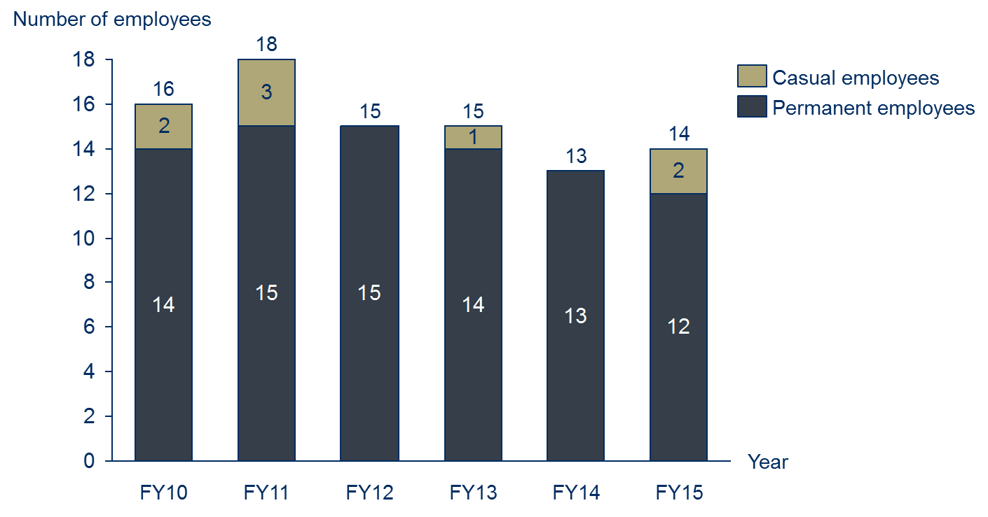
Figure 2.1 – Number of Girringun Indigenous Rangers (referred to as Rangers throughout this report), FY10-15
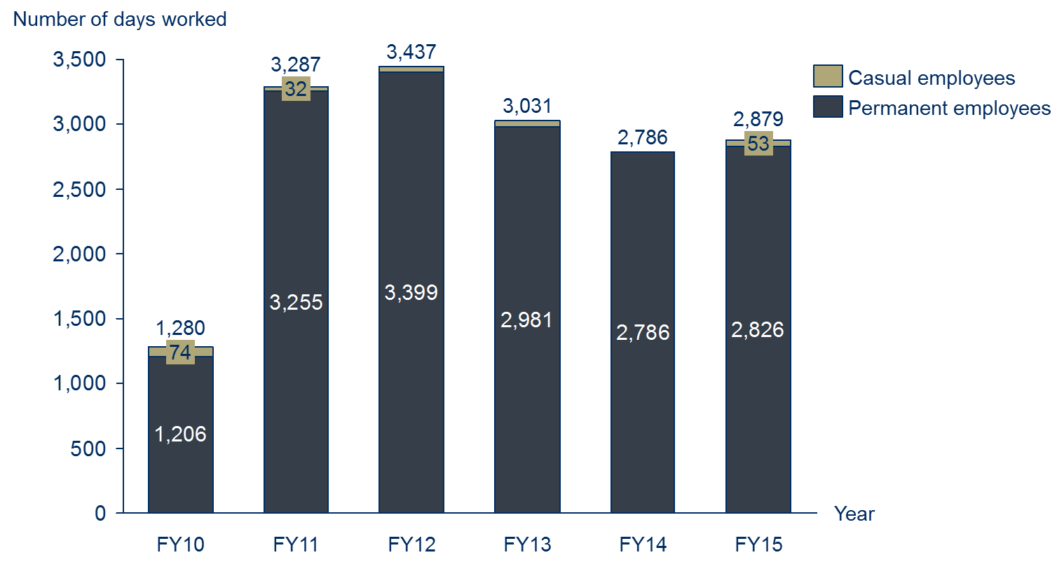
Figure 2.2 – Number of days worked by Girringun Indigenous Rangers, FY10-15

2.4 Investment (inputs)
The investment included in an SROI analysis is a valuation of all the inputs required to achieve the outcomes that will be described, measured or estimated and valued. For the purpose of this SROI analysis, the investment includes the value of financial (cash) investment over the six year period between FY10 and FY15. No in-kind (non-cash) investments were found to be material. Total investment over the six years was approximately $13.9 million.
Investment Summary
Table 2.2 and Figure 2.3 include a summary of the investment for the Girringun IPA and associated Indigenous ranger programme.
Stakeholder | Total | Notes
Government | $13,422,393 | Includes IPA, WoC and other DoE funding (66%) and Qld Government Department of Employment, Economic Development and Innovation (14%)
Foundations and Trusts | $244,520 | Includes The Christensen Fund (94%)
NGO Partners | $238,592 | Includes Terrain NRM (20%), NQ Dry Tropics (10%) and North Queensland CES (10%)
Research Partners | $34,971 | Includes Reef & Rainforest Research Centre (100%)
Total | $13,940,476
Table 2.2 – Investment by stakeholder group, FY10-FY15
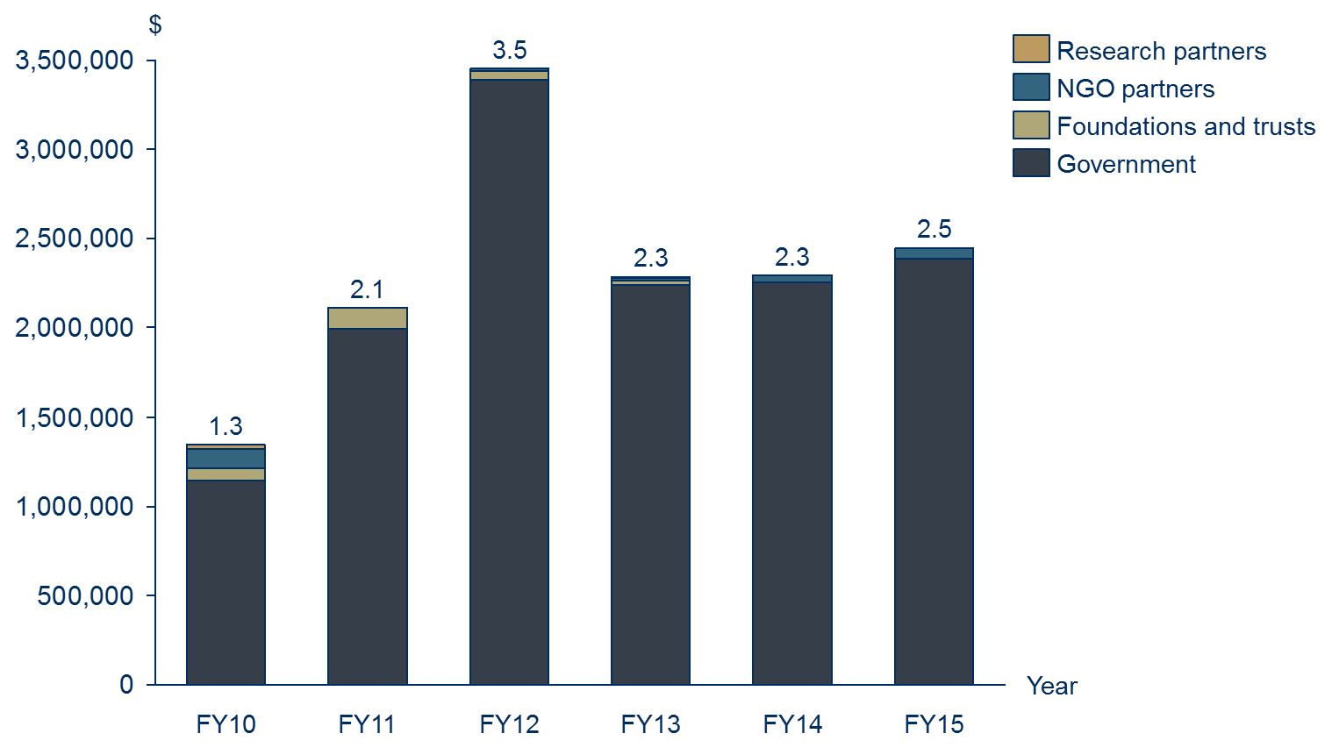
Figure 2.3 - Investment by stakeholder group, FY10-15

3 Methodology for this project

3.1 Understanding change
About theory of change
A theory of change tells the story of change that takes place as a result of the activities of the organisation or programme. It specifies:
- The issue that the organisation or programme is seeking to address
- The key participants in the activities of the organisation or the programme
- The activities that organisation or programmes deliver
- The inputs required to generate the outcomes
- The outcomes of activities that occur through the organisation or programme, for various stakeholders
- The overall impact of these outcomes.

An SROI analysis requires that the key changes are described, measured or estimated and valued. It requires a balance between developing a hypothesis that can tested, against hearing what emerges from stakeholder consultation. SVA facilitated a theory of change workshop with PM&C to develop the theory of change for the IPA programme overall in order to define the key changes. The information from the workshop informed the focus of the research approach to ensure relevant data was collected from all key stakeholders.
The theory of change developed during the workshop was subsequently refined to incorporate findings from the research and stakeholder consultations and tailored to ensure it adequately reflected the situation within the Girringun IPA and associated Indigenous ranger programme.
Defining stakeholder groups
Stakeholders are defined as people or organisations that experience change, whether positive or negative, or those who want to see change, as a result of the activity. For stakeholders to be included in an SROI, they must be considered material to the analysis. Materiality is a concept that is borrowed from accounting, whereby information is classified as material if it has the potential to affect the readers’ or stakeholders’ decisions about the programme or activity. According to the SROI Guide, a piece of information is material if leaving it out of the SROI would misrepresent the organisation’s activities.
A preliminary list of stakeholders was developed by the management team of the Girringun IPA and associated Indigenous ranger programme, which was used as a basis for stakeholder consultation. Stakeholder consultations were later completed to test the materiality of changes experienced by those stakeholders.
Based on this analysis, it was determined that there were six material stakeholder groups that experience outcomes as a result of the Girringun IPA and associated Indigenous ranger programme:
- Rangers
- Community members, including Indigenous traditional owners
- Government, including local councils, and the Qld and Australian Governments
- Indigenous corporation partners
- NGO partners
- Research partners.
Stakeholder consultations
Stakeholders were consulted to identify and understand the relative importance of changes (or outcomes); consider how to prove and measure or estimate change; and consider how to value the outcomes. The consultation approach completed for this analysis involved a two-phased approach:
- Phase 1: SVA and PM&C completed in-person consultations, with Indigenous and non-Indigenous stakeholders, while on country within the Girringun IPA in mid-October 2015
- Phase 2: SVA and PM&C completed phone consultations, predominately with the remaining non-Indigenous stakeholders, after returning from country in late October 2015. These consultations involved additional stakeholders identified by the management team of the Girringun IPA and Indigenous stakeholders on country during phase one. These stakeholders were consulted to determine whether the Girringun IPA programme had generated material changes for them, and to define the nature of those changes.
An outline of completed stakeholder consultations is included in Table 3.1 below.
Stakeholder group | Participation in consultations | Estimated total number of stakeholders
Rangers | 7 | 22
Community members | 15 | ~700
Government | 8 | N/A
Indigenous corporation partners | 2 | 15
NGO partners | 5 | 9
Research partners | 5 | 5
Total | 42 engaged through consultation | ~751
Table 3.1 – Summary of stakeholder consultations
The management team of the Girringun IPA and associated Indigenous ranger programme were involved in the verification of results at three main points:
- Stakeholder consultations – through feedback on the theory of change;
- The measurement and valuation phase – through feedback on the measurement or estimation approach and the calculation of the value of outcomes; and
- The reporting phase – through feedback on the draft report.
Research and analysis
To complement the stakeholder consultations, desktop research and analysis was completed using the Girringun IPA data as well as secondary research relating to land management and previous evaluations of aspects of the IPA and WoC programmes. Key data sources used to supplement the stakeholder consultations are outlined in the Table 3.2 below.
Data source | Use in the SROI analysis
Dermot Smyth, Indigenous Protected Areas and ICCAs: Commonalities, Contrasts and Confusions, 2015 | Background information
Eli Taylor, Collaboration on country: Participatory evaluation of the Girringun Indigenous Protected Areas, 2014 | To inform section 2 of this report
Dermot Smyth, Caring for Country: An Indigenous Propitious Niche in 21st Century Australia, 2014 | To inform Ranger and Community member outcomes
PM&C, Working on Country and Indigenous Protected Areas programmes, 2013-14 | To inform section 2 of this report
Girringun Region Indigenous Protected Area Management Plan 2013-2023, 2013 | To inform section 2 of this report
Girringun Strategic Plan 2012-2015, 2012 | To inform section 2 of this report
Urbis, Assessment of the social outcomes of the Working on Country program, 2012 | Background information
The Allen Consulting Group, Assessment of the economic and employment outcomes of the Working on Country program, 2011 | Background information
Garnett and Sithole, Healthy Country, Healthy People: Sustainable Northern Landscapes and the Nexus with Indigenous Health, 2007 | To inform Ranger and Community member outcomes
Putnis, Josif and Woodward, Healthy Country, Healthy People: Supporting Indigenous Engagement in the Sustainable Management of Northern Territory Land and Seas, 2007 | To inform Ranger and Community member outcomes
Table 3.2 – Data sources used to supplement consultation

3.2 Measuring change
The stakeholder outcomes included in the SROI represent the most significant consequences that are experienced by stakeholders as a result of the Girringun IPA and associated Indigenous ranger programme up to July 2015. The measures are estimates inferred through stakeholder consultation and quantitative data. Wherever possible we have estimated the extent to which the outcomes have occurred through the use of quantitative data previously collected by the IPA or by other sources. The measures have also been deeply informed by stakeholder consultation. Throughout the data collection process, attention was paid to all possible consequences that arise as a result of the Girringun IPA and associated Indigenous ranger programme: intended and unintended; positive and negative.
Defining the material outcomes for stakeholder groups is complex. When defining the material outcomes for each stakeholder group, an SROI practitioner must ensure that each outcome is unique or it would be considered double counting. This is difficult as the outcomes for each stakeholder group are necessarily related because they describe all of the changes experienced by the stakeholder. Outcomes also happen at different times throughout the period being analysed with different levels of intensity.
These various factors were considered when identifying appropriate measures or estimates and indicators for a particular outcome or set of outcomes created through the Girringun IPA and associated Indigenous ranger programme.

3.3 Valuing change
Financial proxies
Financial proxies are used to value an outcome. This is particularly important in SROI as it relates to the principle of valuing what matters. This means that there is a need to value outcomes even if there isn’t an existing market value.
There are a number of techniques used to identify financial proxies and value outcomes. Importantly, within an SROI, the financial proxy reflects the value that the stakeholder experiencing the change places on the outcome. This could be obtained directly through stakeholder consultation, or indirectly through research. The financial proxies approximate the value of the outcome from the stakeholder’s point of view. Techniques for valuing outcomes are included in the Methodological Attachment to this report.
SROI (Valuation) filters
To present an accurate view of the value created through the Girringun IPA and associated Indigenous ranger programme, valuation filters (SROI filters) have been applied to different financial proxies. This is in accordance with the Social Value principle to not over-claim. Different techniques were used to identify the most appropriate filter for each of the outcomes, including SROI filter assumption categories, also included in the Methodological Attachment to this report.
Consideration of the different SROI filters for this analysis is as follows:
- Deadweight: Deadweight is an estimation of the value that would have been created if the activities from the programme did not happen. To estimate deadweight for the current analysis, stakeholder consultations and desktop research were completed to understand the context and nature of outcomes
- Attribution: Attribution estimates how much change was as a result of other stakeholders or activities, which were not included in the investment. An understanding of the contribution of others to each outcome was determined through stakeholder consultations and research
- Displacement: Displacement is an assessment of how much of the activity displaced other outcomes. Stakeholder consultations and desktop research were completed to identify if any of the outcomes displaced other activities
- Duration and drop-off: Duration refers to how long an outcome lasts for. The duration and drop- off are linked to whether the stakeholder is likely to benefit from the activities over a defined period.
Valuing the outcomes
The total adjusted value is the value calculated for each outcome, which takes into account the following components:
- Quantity: the number of stakeholders who will experience an outcome
- Financial proxy: value of the outcome
- SROI filters: accounting for whether the outcome would have happened anyway (deadweight), who else will contribute to the change (attribution), whether the outcome will displace other activities or outcomes (displacement) and how long the outcome will last for (duration) and how it changes over time (drop off).

3.4 SROI ratio
The SROI ratio is a comparison of the value of the benefits to the value of investment. It is expressed in numerical terms e.g. 3:1, which means that for every dollar invested, $3 of value is returned.
It is important that the SROI calculations are tested by understanding how the judgements made throughout the analysis affect the final result. The judgements that are most likely to influence the SROI ratio were identified, and a sensitivity analysis was conducted to see how sensitive the ratio was to changes in these judgements. To decide which judgements to test, two key questions were considered:
Considerations for interpreting the ratio
- The SROI ratio represents the additional value created, based on the Social Value principles. This is the unique value that is created by a programme or organisation for a specific period
- SROI ratios should not be compared between organisations without having a clear understanding of each organisation’s mission, strategy, theory of change, geographic location and stage of development. A judgement about investment decisions can only be made when using comparable data
- How much evidence is there to justify our judgement? The less evidence available, the more important it is to test
- How much does it affect the final result? The greater the impact, the more important it is to test.

4 Impact of the Girringun IPA and associated Indigenous ranger programme

4.1 Understanding the change
Theory of change
A theory of change was initially drafted for the Girringun IPA and associated Indigenous ranger programme via a workshop completed with 12 PM&C staff. The theory of change developed during the workshop was extensively tested and subsequently refined to incorporate evidence collected through stakeholder consultations and specific feedback from stakeholders. At least one stakeholder from each stakeholder group provided feedback during the testing of the theory of change. The refined theory of change is included in Figure 4.1.
The theory of change tells the story of change for the Girringun IPA and associated Indigenous ranger programme. It consists of four pages:
- Issues, Stakeholders, Activities and Inputs
- Outputs, outcomes and impact for Community members and Rangers
- Outputs, outcomes and impact for Government
- Outputs, outcomes and impact for other stakeholders – Indigenous corporation partners, NGO partners and Research partners.
The first page outlines the issue that the Girringun IPA and associated Indigenous ranger programme seek to address, the stakeholders involved, the activities that take place and the inputs (investments) into the programme. Only those stakeholders that appear in bold experience outcomes that are measured or estimated in the analysis.
The next three pages consist of outputs (i.e. the immediate consequences of activities), outcomes and impact for stakeholders identified in bold. The outcomes represented on these pages should be interpreted from left to right, and consist of short, medium and long term outcomes. There are three types of outcomes represented:
- Material outcomes
- Intermediate outcomes
- Other outcomes.
Material outcomes are outcomes that have been measured or estimated and valued as part of the SROI analysis. These outcomes are considered “material” because they are relevant and significant changes that stakeholders experienced due to the Girringun IPA and associated Indigenous ranger programme during the period of investment being analysed. Decisions around materiality were informed by stakeholder consultation.
Intermediate outcomes are outcomes that have been achieved as a result of the Girringun IPA, however their value is subsumed by later outcomes that carry a higher value. For this reason, intermediate outcomes are not measured or valued in the analysis as it would be considered double counting.
Other outcomes are those outcomes that have not yet been achieved, and are aspirational outcomes based on the logic of what should occur given other outcomes have been achieved.
The theory of change emphasises the interrelationship between social, economic, cultural and environmental outcomes. This is aligned with how stakeholders perceived the change they experienced through the programme. The key points to draw out of this representation are:
- The outcomes generated by the Girringun IPA and associated Indigenous ranger programme are widespread across the social, economic, cultural and economic domains
- Over the last six years, the Girringun IPA and associated Indigenous ranger programme has pushed well beyond outputs to generate extensive short and medium term outcomes, and some long term outcomes
- Many of the outcomes for different stakeholders are interrelated. For example, Rangers acquiring new skills manifests as an outcome for Rangers (“Increased skills through training and experience”) and Government (“Rangers are skilled and trained”); in addition, numerous environmental outcomes are shared across Community members and Government (such as “More burning using cultural practices”)
- In all cases, stakeholders are striving for two interrelated impacts: healthier people and healthier country.
Potential negative or unintended outcomes were tested throughout stakeholder consultation, for example, less ability for Indigenous corporations to pursue their own goals; negative effects from physically demanding Ranger work on health. On balance, it was determined that there were no material negative outcomes associated with the Girringun IPA and associated Indigenous ranger programme. Ongoing, significant challenges are evident, particularly for Community members and Rangers (such as alcohol overuse) however the Girringun IPA and associated Indigenous ranger programme were not seen as contributing negatively to these issues.

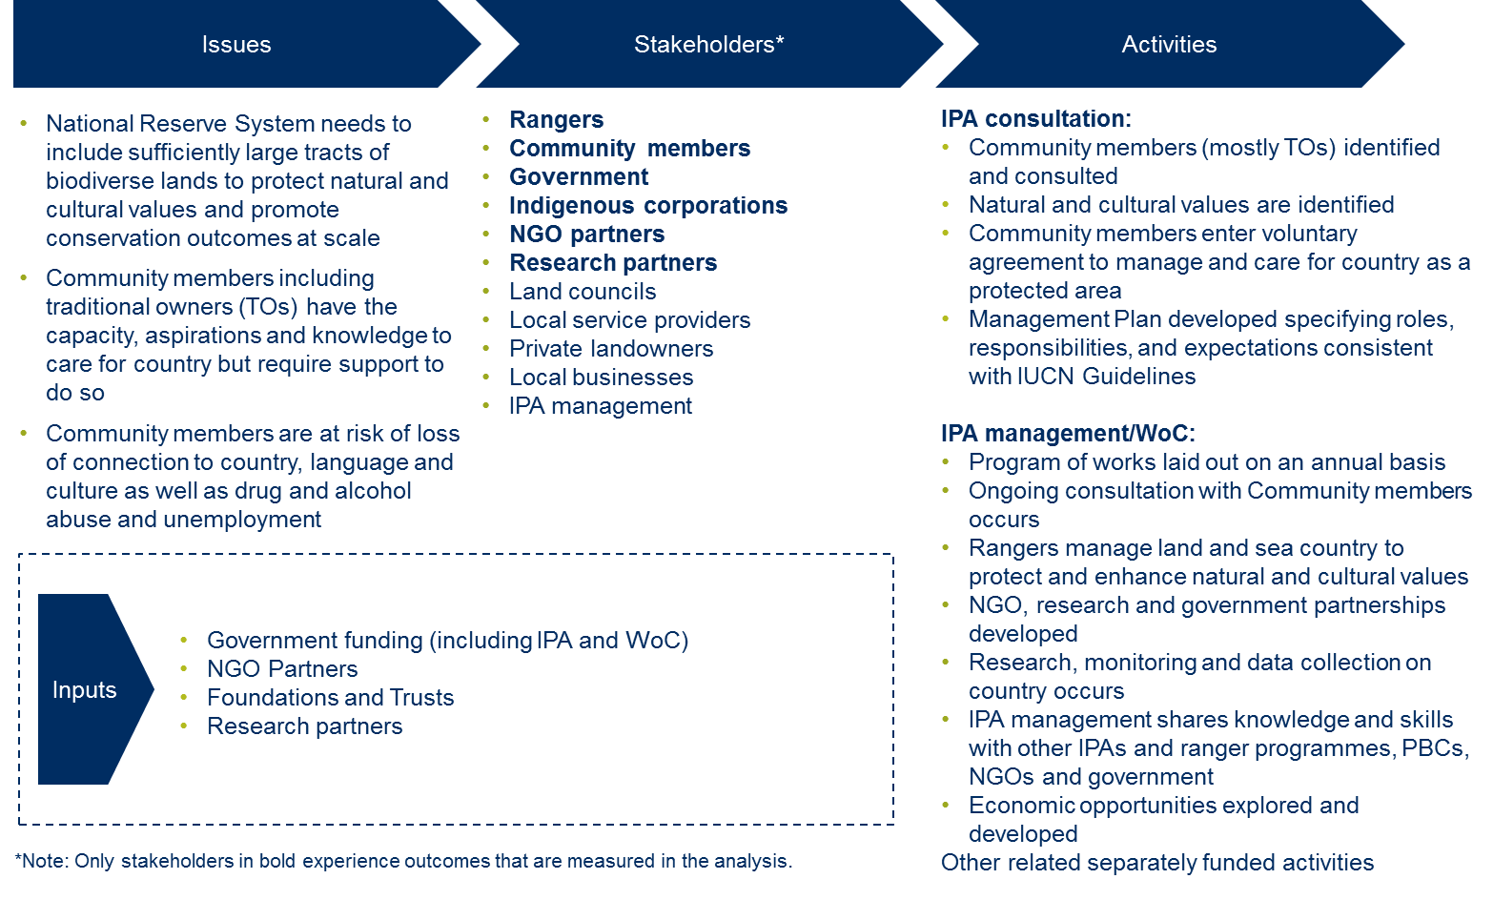
Figure 4.1a –Theory of change for the Girringun IPA and associated Indigenous ranger programme – Issues, Stakeholders, Activities and Inputs (Investment)
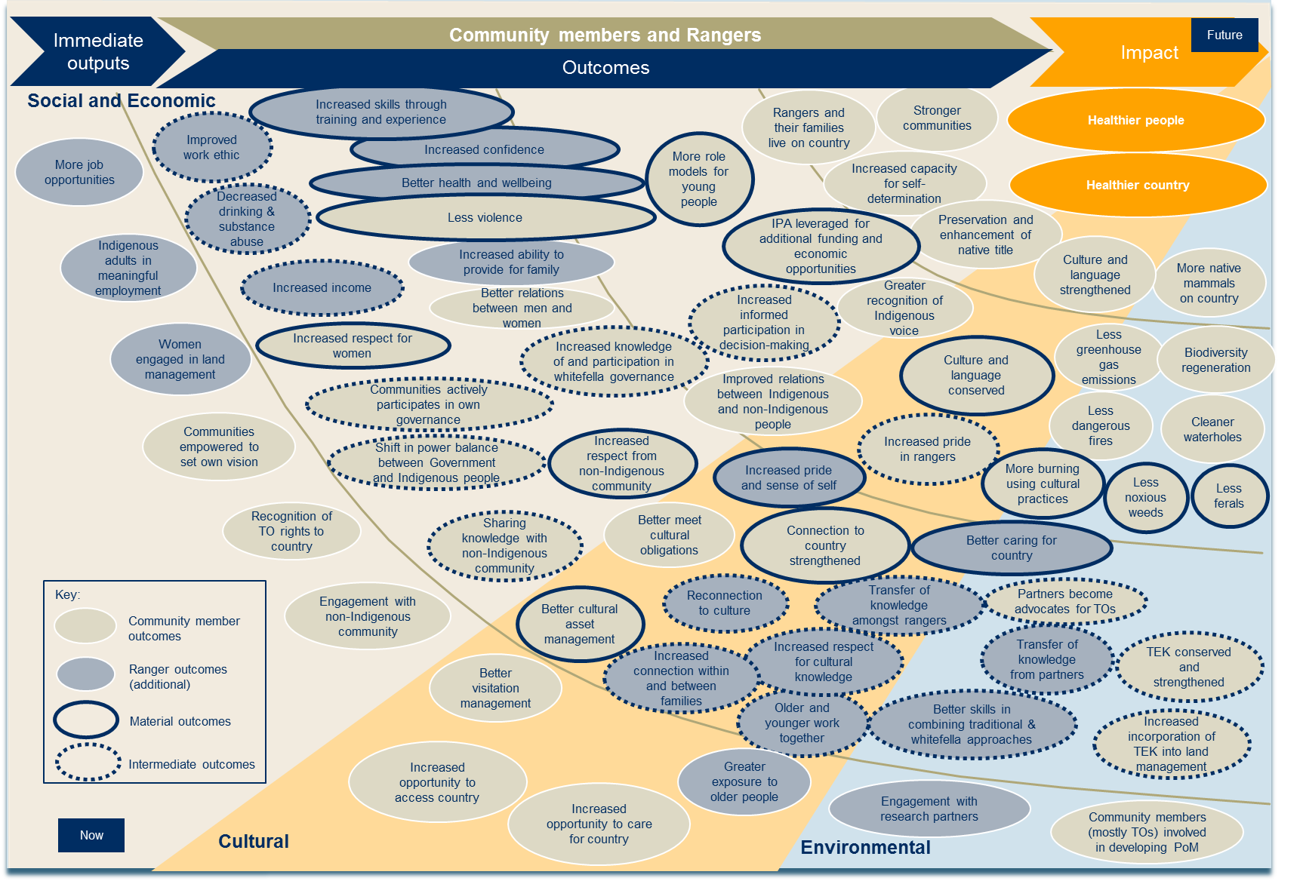
Figure 4.1b –Theory of change for the Girringun IPA and associated Indigenous ranger programme – Community member and Ranger outcomes
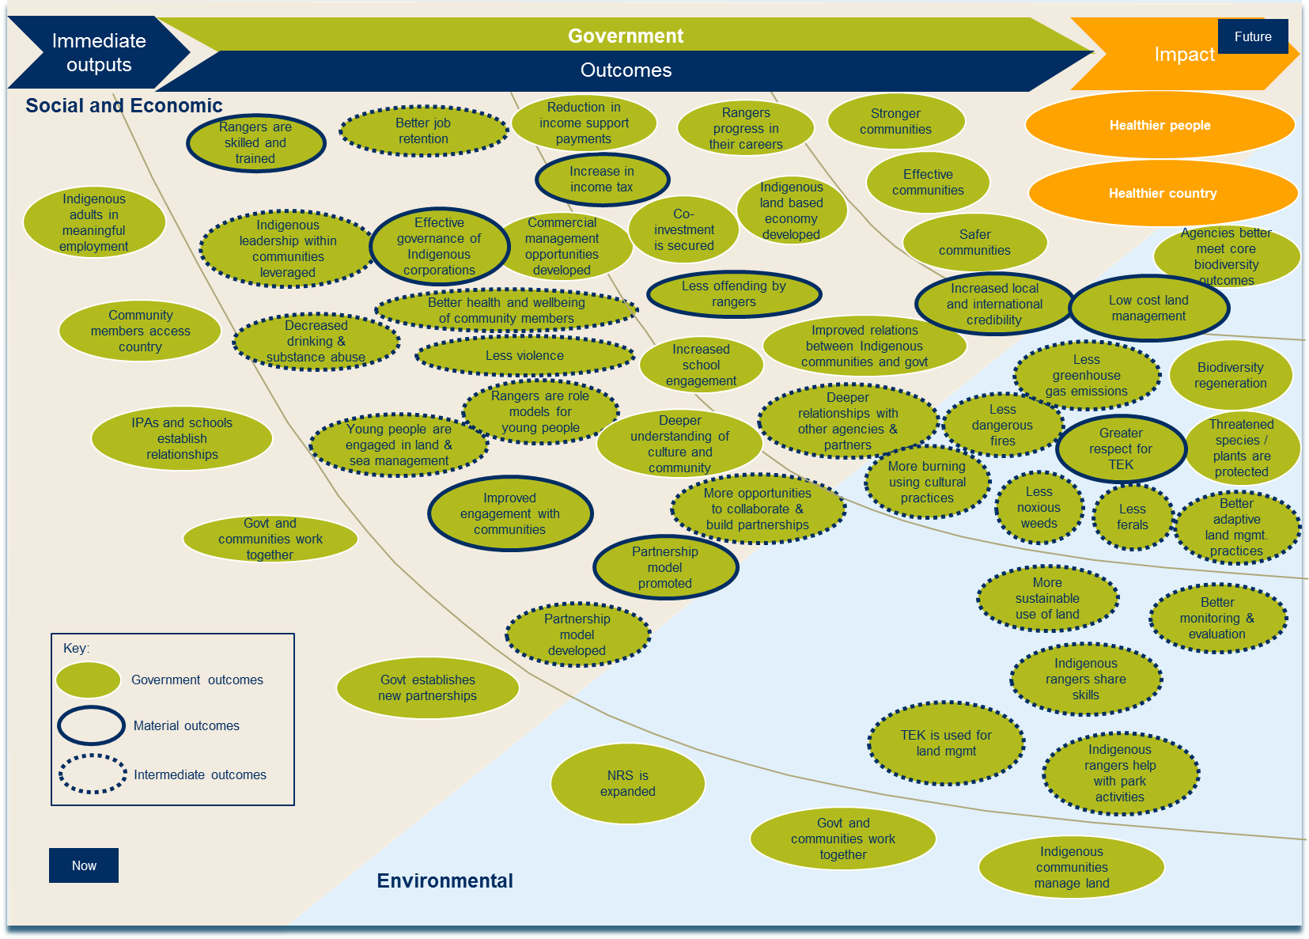
Figure 4.1c –Theory of change for the Girringun IPA and associated Indigenous ranger programme – Government outcomes
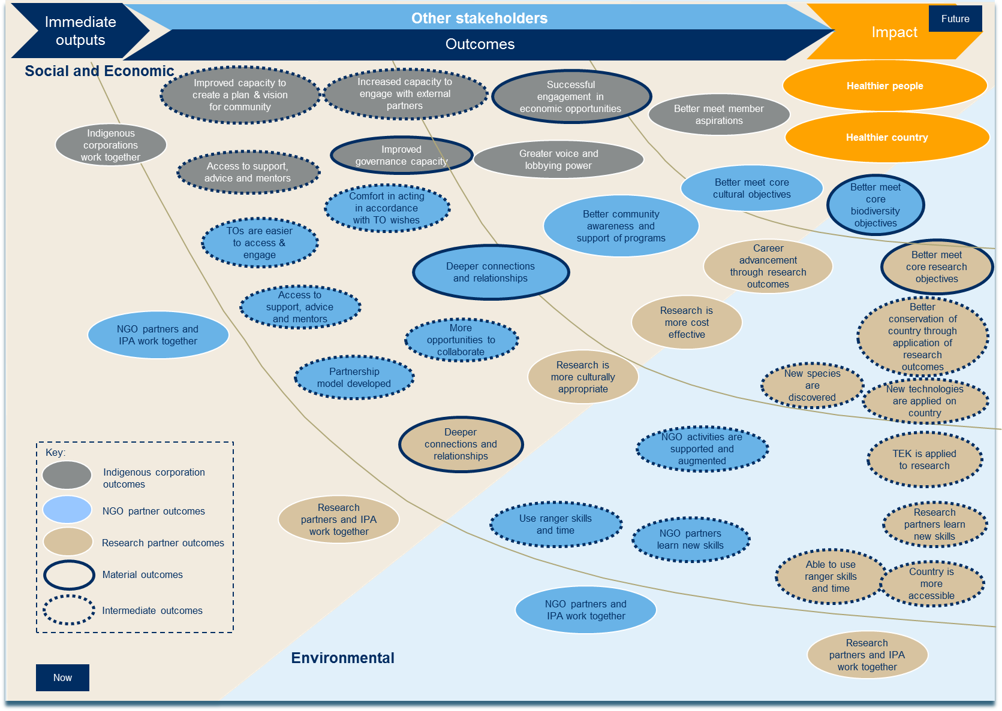
Figure 4.1d –Theory of change for the Girringun IPA and associated Indigenous ranger programme – Indigenous corporations, NGO partner and Research partner outcomes

4.2 Stakeholder outcomes
The stakeholder outcomes are represented in the theory of change outlined in section 4.1. This section describes the outcomes experienced by each of the following stakeholders, in more detail:
- Rangers
- Community members, including Indigenous traditional owners
- Government, including local councils, and the Qld and Australian Governments
- Indigenous corporation partners
- NGO partners
- Research partners
The outcomes described below are included in the SROI analysis and represent incremental changes for stakeholders that occur as a result of the Girringun IPA and associated Indigenous ranger programme.
- Rangers
Rangers include all those people who work on country within the Girringun IPA. During the period of investment covered by this analysis 26 Indigenous people, mostly traditional owners, worked on the Girringun IPA. Almost all Girringun Rangers working on country do so on a permanent basis.
Rangers working on country is the foundation upon which all outcomes are based. Because Rangers work on country, they experience personal benefits including increased skills and confidence, and better health and wellbeing. A significant part of the reason why Community members who spent time on country have thrived is because of Ranger work on country. As a result, all of the outcomes experienced by Community members are directly related to Ranger activities. Similarly, all Government outcomes are linked to Ranger work on country because of its flow-on effects including skilled Rangers, greater respect for TEK and lower cost land management.
It is likely that a Ranger working on country fits within two stakeholder groups: Rangers and Community members, which reflects both their job and their role within community. Outcomes achieved by Rangers, captured in Table 4.1 below, are additional to those that are achieved by Community members.
A summary of the inputs (investment in the programme), outputs (summary of activity) and outcomes (changes) that are experienced by Rangers is included in Table 4.1 below.
Inputs | Outputs | Material outcomes
Nil | - More job opportunities  - Indigenous adults in meaningful employment  - Women engaged in land management  - Greater exposure to older people  - Engagement with research partners | 1.1 Increased skills through training and experience  1.2 Increased confidence  1.3 Better health and wellbeing  1.4 Increased pride and sense of self  1.5 Better caring for country
Table 4.1 – Inputs, Outputs and Outcomes for Rangers
Within Ranger outcomes, there are two threads of outputs and outcomes: social and economic, and cultural.
Social and economic outcomes
The material outcomes that have been generated for Rangers in the social and economic thread are:
- 1.1 Increased skills through training and experience
- 1.2 Increased confidence
- 1.3 Better health and wellbeing
One of the most immediate changes for Rangers working on country is the increase in their technical skills. Rangers undertake a wide variety of work including revegetation, cultural site and public area maintenance, and research, monitoring and data collection. The work involves activities such as operating machinery, marine debris collection and conducting surveys, which all contribute to an increase in technical skills.
Social and economic outcomes for Rangers
This analysis estimates the value of better health and wellbeing as a result of working on country. This outcome is calculated at an average value of $3,438 per Ranger per year. The total adjusted value associated with this outcome over six years is $0.2 million. See sections 4.3 to 4.5 for more information about the adjusted value of each outcome.

Technical skills encompass Traditional Ecological Knowledge (TEK) and Western scientific knowledge related to land and sea management. TEK is gained through learning from older people in the community. This is incredibly important to Rangers, who frequently cited interacting with Elders as an important part of the role for them. Western scientific knowledge is learnt through obtaining TAFE tickets and working with Girringun’s Research partners.
“Everything is positive about this job. I’ve done lots of qualifications and training including operating the front loader and bobcat, mapping exercises, and dolphin and dugong surveys.”
Penny Ivey, Girringun Ranger
An outcome occurring for Rangers slightly later than ‘increased skills through training and experience’ is increased confidence. Achievement of this outcome is directly related to time spent on country learning new skills, spending time with the older people and connecting to culture and landscape. It also relates to time spent representing Girringun at events, conferences and school visits where Rangers are asked to deliver presentations explaining the work Girringun Rangers do. Many Rangers compared their confidence levels before and after working for Girringun to demonstrate how they had grown and developed over time into a more self-assured person.
“I have more confidence now, which others have noticed. I am no longer shy when I talk to anyone. This began when I represented Girringun and mixing with other rangers at conferences and on ranger exchanges.”
Penny Ivey, Girringun Ranger
Better health and wellbeing was a consistent theme of interviews with Rangers. Achievement of this outcome is far broader than physical and mental benefits, and is inextricability linked to their relationship with land, culture and spirituality. Their experiences on country ultimately led to a deepened sense of happiness and contentment.
“You have to be physically fit and mentally fit so that you don’t give up even when the work is hard. You also get the spirituality on the cultural sites. You see the sea shell beds and rock ovens and you get that spiritual connection.”
Chris Muriata, Senior Ranger
Cultural outcomes
The material outcomes that have been generated for Rangers in the cultural thread are:
- 1.4 Increased pride and sense of self
- 1.5 Better caring for country
Increased pride and sense of self is a short to medium term outcome that results from increased connection to family members, and connection (or reconnection) to culture. Some Rangers had little or fragmented contact with family members prior to working with Girringun. The job has enabled them to listen to Elders’ wishes for country and carry them out, giving Rangers a sense of pride. Rangers also feel great reverence for the legacy of GAC, including the hard work carried out by the Elders who established the organisation. To contribute to this work makes Rangers feel proud and contributes to a greater sense of cultural identity.
“We did some revegetation work on my Dad’s country. Once we had done it we took him out to show him. He had tears in his eyes. It was an incredible feeling – I had goose bumps, I was so excited. It heals their bodies by being out there and seeing that. I want to do that for more old people.”
Daniel Beeron, Girringun Nursery
Better caring for country is closely linked with the outcome ‘increased pride and sense of self’. It is a short to medium term outcome that results from older and younger people working together, increased respect for cultural knowledge and the transfer of knowledge from Community members to Rangers. Better caring for country occurs because Rangers have the requisite machinery and other resources to look after country, which traditional owner groups within the Girringun IPA do not have. Rangers also learn and adopt the cultural protocols of asking Elders what they want done on their land, which ensures that caring for country is done in the right way.
Cultural outcomes for Community members
This analysis measures a cultural outcome related to Rangers’ ability to better care for country. This outcome is calculated at an average value of $37,242 per event per year. The total adjusted value associated with this outcome over six years is $3.1 million. See sections 4.3 to 4.5 for more information about the adjusted value of each outcome.
The transfer of knowledge is an essential element of this outcome. Much of this knowledge has been lost due to the violent and turbulent contact with Europeans, and subsequent settlement of Europeans on land within the IPA. Many Rangers do not speak their language. However, through Ranger work they are exposed to Elders meaning stories and language can be passed down. The Elders invest heavily in young Rangers and are passionate about ensuring that country is better cared for now and forever.

“The biggest change for me is the cultural side. It is very different to an office job. Out on country, I take a lead role talking to traditional owners. I have learnt more about my cultural side as a Girramay person through working with Girringun than before. I’ve learnt more language and stories.”
Chris Muriata, Senior Ranger

- Community members
Community members represent Indigenous people, mostly traditional owners of land within the Girringun IPA, who are involved with the IPA and associated Indigenous ranger programme. Community members from the eight different traditional owner groups within the IPA may live on country in areas such as Murray Upper or Mission Beach or in regional towns and communities such as Townsville, Cardwell and Cairns. There are two ways in which someone falls within this stakeholder group:
- They have tribal connections within the Girringun IPA
- They are married to or are a relative of someone connected with the Girringun IPA and associated Indigenous ranger programme as outlined above.
This classification was informed by stakeholder consultations and tested with the Girringun IPA management team and Community members.
A summary of the inputs (investment in the programme), outputs (summary of activity) and outcomes (changes) that are experienced by Community members is included in Table 4.2 below.
Inputs | Outputs | Material outcomes
Nil | - Communities empowered to set own vision  - Recognition of TO rights on country  - Engagement with non-Indigenous community  - Better visitation management  - Increased opportunity to access country  - Increased opportunity to care for country  - Community members (mostly traditional owners) involved in developing Plan of Management for Girringun IPA | 2.1 More role models for young people  2.3 Less violence  2.4 IPAs leveraged for additional funding and economic opportunities  2.5 Increased respect for women  2.6 Increased respect from non-Indigenous community  2.7 Better cultural asset management  2.8 Connection to country strengthened  2.9 Culture and language conserved  2.10 More burning using cultural practices  2.11 Less noxious weeds  2.12 Less ferals
Table 4.2 – Inputs, Outputs and Outcomes for Community members
Social and economic outcomes
The material outcomes that have been generated for Community members in the social and economic thread are:
- 2.1 More role models for young people
- 2.3 Less violence
- 2.4 IPA leveraged for additional funding and economic opportunities
- 2.5 Increased respect for women
- 2.6 Increased respect from non-Indigenous community
As a direct result of Rangers working on country, Community members benefit because role models are created for young people to look up to. Community members emphasised the dearth of role models for young people – many were unemployed and experienced problems with drinking and substance abuse, violence and boredom. There are few opportunities for them to connect with country and learn from the older people about fulfilling their cultural obligations. Since the IPA declaration and commencement of the Ranger programme, young people have been able to see Rangers working hard, earning a wage, looking after their families and, in some cases, avoiding violent behaviour. For Community members, wearing the badge and uniform of the Girringun Rangers is a powerful symbol of a strong and resilient community member that the young people look up to.
“Taking our children out on country keeps them busy and out of trouble. It keeps them away from the temptations of town. Smoking, drinking and ice, all big problems here. But when you are out bush, there is nothing else but country.”
Claude Beeron, traditional owner and Board member of GAC

Community members experience a direct and significant benefit from the IPA in the form of additional funding and economic opportunities. These include sources of income from Government and other sources which relate to work done on the IPA including work with GBRMPA and on building the Girringun nursery. Without the structure and management within the Girringun IPA, these opportunities would not be realised.
Economic outcomes for Community members
This analysis measures an economic outcome related to traditional owners of land within the Girringun IPA’s ability to leverage the IPAs to generate additional funding and economic opportunities. This outcome is calculated at an average value of $306,487 per opportunity per year. The total adjusted value associated with this outcome over six years is $2.5 million. See sections 4.3 to 4.5 for more information about the adjusted value of each outcome.
Another outcome that came through stakeholder consultation was ‘increased respect for women’. Women make up approximately 35% of Girringun Rangers and are visible within communities. Women Elders also actively participate in decision-making and provide leadership for the traditional owner groups. The presence of women in the day-to-day work as well as governance of Girringun both strongly contribute to achievement of this outcome.
The last material outcome in the social and economic thread to be estimated is increased respect from the non-Indigenous community. This outcome is difficult to achieve due to the history of conflict in the Girringun region; there is still division between Indigenous and non-Indigenous people. However Girringun is working hard to break down these barriers, which has resulted in some instances in increased respect from the non-Indigenous community. Girringun played a significant role in assisting the clean-up of the region post-Cyclone Yasi including assisting non-Indigenous community members whose homes had been badly damaged. Girringun Rangers also assist the local police and use local suppliers, which has led to better relations with the non-Indigenous community.
Cultural outcomes
The material outcomes that have been generated for Community members in the cultural thread are:
- 2.7 Better cultural asset management
- 2.8 Connection to country strengthened
- 2.9 Culture and language conserved
These three outcomes are closely linked to each other, and to the Ranger outcomes related to caring for country. Better cultural asset management occurs as a result of significant activity by the Girringun Rangers using knowledge passed down from Elders to Rangers. This work is sometimes carried out in conjunction with National Park Rangers. Without this work, cultural sites are at high risk of being ignored or neglected.
As a result of Rangers carrying out this and other land management work, Community members experience strengthened connection to country. Community members have different levels of connection to country depending on whether they live on country and how often they connect with country through cultural experiences such as camping trips. In the Girringun IPA, traditional owners rely on Rangers to carry out their land management work. Their connection to country is strengthened as a result of seeing healthier country as a result of this work. Passing on and sharing of knowledge of language, cultural and landscape also contribute to this.
“We get strength from knowing that Girringun is looking after our country. Fifteen years ago when we bought Mungalla Station, it was in a bad state. There were lots of weeds down on the riverbank. Girringun helped us - they sprayed the weeds. The rangers are very good at looking after country. They are all like our family.”
Cedric Cassady, traditional owner

Environmental outcomes
The material outcomes that have been generated for Community members in the environmental thread are:
Private landowners
While private landowners were not included within the Community member stakeholder group, some have significant involvement with the IPA. Suzie Smith is a landholder who has dedicated 53 ha of her land, also a Nature Reserve, into the IPA. Indigenous community members come and care for graves on the land, and use it as a place for inter-generational learning. The dedication has enabled Suzie to form closer, deeper ties with the Indigenous community. Girringun Rangers also undertake weed management work on pastoral lands within the IPA.
- 2.10 More burning using cultural practices
- 2.11 Less noxious weeds
- 2.12 Less ferals
Better caring for country by Rangers leads to these two outcomes for Community members. More burning using cultural practices refers to increased early season burning to address the critical problem of wildfires late in the dry season. This is carried out using the knowledge and expertise of traditional owners, with the resources of the IPA and Rangers. This outcome leads to greater variation in vegetation growth, less dangerous late season fires and, ultimately, less greenhouse gas emissions.
Less noxious weeds and less ferals lead to biodiversity regeneration and healthier country. Weed management work is a more significant activity than feral animal management within the Girringun IPA, as weeds are a bigger problem. Many Community members highlighted the assistance Girringun Rangers have given them in reducing the weeds on their country.
- Government
In this analysis the Government stakeholder group includes:
- Australian Government including PM&C, DoE and GBRMPA
- Qld Government including Department of Environment and Heritage Protection, Qld Parks, Marine Parks and Fisheries Queensland
- Local Government including five local councils in the area such as Cassowary Coast Regional Council.
Impact for Government is both broad and deep, and stems from a variety of activities including Rangers working on country taking care of the land, Government working more closely with communities and Government establishing new partnerships.
Social and economic outcomes for Government
An intended outcome for Government under the IAS is adults in jobs. This analysis estimates a material outcome for Government ‘Rangers are skilled and trained” which leads to the achievement of this outcome. This outcome is calculated at a value of $9,000 per Ranger per year. The total value associated with this outcome is $574k. See sections 4.3 to 4.5 for more information about the adjusted value of each outcome.
Importantly, there is strong alignment between the impact envisaged and created by the Girringun IPA and various outcomes targeted through PM&C’s Indigenous Advancement Strategy, including:
- Increased Indigenous employment, business and economic development
- Increased levels of community safety and wellbeing, and less alcohol and substance misuse and associated harm
- Supporting Indigenous people to maintain their culture and language
- Indigenous participation in society and organisational capacity.
A summary of the inputs (investment in the programme), outputs (summary of activity) and outcomes (changes) that are experienced by Government is included in Table 4.3 below.
Inputs | Outputs | Material outcomes
$13.4 million | - Indigenous adults in meaningful employment  - Community members access country  - IPAs and schools establish relationships  - Government and communities work together  - Government establishes new partnerships  - NRS is expanded  - Indigenous communities manage land | 3.1 Rangers are skilled and trained  3.3 Increase in income tax  3.4 Effective governance of Indigenous corporations  3.5 Less offending by rangers  3.6 Improved engagement with communities  3.7 Increased local and international credibility  3.8 Greater respect for TEK  3.9 Low cost land management
Table 4.3 – Inputs, Outputs and Outcomes for Government
Social and economic outcomes
The material outcomes generated for Government in the social and economic thread are:
- 3.1 Rangers are skilled and trained
- 3.3 Increase in income tax
- 3.4 Effective governance of Indigenous corporations
- 3.5 Less offending by rangers
- 3.6 Improved engagement with communities
- 3.7 Increased local and international credibility
An immediate, direct consequence of Indigenous adults in meaningful employment as Rangers is that they are skilled and trained. Government benefits from a more skilled Ranger workforce as it improves job retention. Girringun Rangers may remain as Indigenous Rangers or they may eventually move into other roles. Some Girringun Rangers spoke of aspirations to work with National Parks or Marine Parks.
One of the flow-on effects of more Indigenous adults in jobs is an increase in income tax. This is a direct result of employment of Girringun Rangers, almost all of whom are permanent employees. Girringun employed 26 Rangers during the six year period which resulted in an average increase of $7,439 in tax revenue per Ranger, per year.
Government also experiences benefit in the form of effective governance of Indigenous corporations. The Girringun IPA supports 15 Indigenous corporations, including five Prescribed Bodies Corporate (PBCs) of traditional owner groups within the IPA, with a wide variety of capacity building activities including governance training, financials and payroll. In this way, Indigenous leadership within Girringun is leveraged for the benefit of these organisations. This situation is also advantageous for Government as the work carried out by Indigenous corporations is more effective and Government’s dealings with Indigenous corporations are easier.
As we noted in Community member outcomes, as a result of the Girringun IPA there is less violence in communities. The logic underpinning this assertion is that Rangers who spend time on country and experience outcomes including pride and sense of self are less likely to be violent. The corollary of this for Government is that there is less offending by Rangers. This was referred to during stakeholder consultation with the Girringun management team and is a direct consequence of working with Girringun and exposure to Elders.
The final two social and economic outcomes for Government deal more directly with Government’s role in the Girringun IPA. Improved engagement with communities is a short-term outcome experienced by Government as a result of Government and communities working closely together. Representatives from PM&C noted that the IPA programme in particular is perceived favourably by many Indigenous communities and has resulted in the Indigenous people becoming involved and ‘owning’ a Government funded programme. The stakeholder consultations for this analysis demonstrated that this experience is mirrored in the Girringun IPA and associated Indigenous ranger programme.
Over time, one of the outcomes from the cooperation with Girringun IPA is expected to be a deepening understanding within Government of culture and community, and improved relations between Indigenous communities and Government.
“The positive partnership between traditional owners of the Great Barrier Reef region and the Australian Government was recognised internationally as part of the government’s response to World Heritage Committee concerns about the Reef. Girringun played a role in this and helped shape the actions of the Reef 2050 report.”
Jessica Hoey, Director – Indigenous Partners, GBRMPA
The Government has established a variety of new partnerships through the Girringun IPA. One of the most significant is the partnership with GBRMPA, which has resulted in numerous benefits for Government. GBMRPA has worked with Girringun in a wide variety of contexts including during the clean-up following Cyclone Yasi and the Australian Government’s submission to the United Nations Educational, Scientific and Cultural Organization (UNESCO) World Heritage Committee (WHC) regarding the Great Barrier Reef’s risk of an ‘in danger’ listing. After Cyclone Yasi, Girringun’s Executive Officer, Phil Rist, gave GBRMPA the “lay of the land” so they could understand the scope of the damage and what resources they should send for the clean-up and recovery. Girringun’s assistance with a submission to the WHC resulted in an increase in the Australian Government’s credibility. The Australian Government was required to address “man’s interaction with the environment” which includes engagement with Indigenous heritage. Girringun led stakeholder engagement with local Indigenous communities on the Government’s behalf and was mentioned numerous times as a case study in the submission.
Environmental outcomes
The material outcomes that have been generated for Government in the environmental thread are:
- 3.8 Greater respect for TEK
- 3.9 Low cost land management
“They assist us to protect the natural and cultural integrity of the land through support with monitoring and compliance activities, fire management and operational activities. The joint management partnership with Girringun is very cost effective for us. There’s a big benefit to us from working with Girringun.”
James Newman, Department of National Parks, Sport and Racing, Qld Government
Land management is procured at a low cost and encompasses numerous environmental outcomes including:
- More burning using cultural practices
- Less dangerous fires
- Less greenhouse gas emissions
- Less ferals
- Less noxious weeds
- Better adaptive land management practices.
The value associated with these intermediate outcomes is accounted for through the estimation of outcome 3.9 “Low cost land management”.
Land management through the Girringun IPA also facilitates the use of TEK in land management which has numerous flow on effects for Government including sharing of skills by Indigenous Rangers, more sustainable use of land and better monitoring and evaluation. Greater respect for TEK from within Government is also a benefit which accrues when Government agencies gain a deeper appreciation of the critical role played by TEK in land management.
“We have supported a number of other ranger groups funded through Queensland Government to spend time with the Girringun Rangers as part of a ‘ranger exchange’ in order to learn and share new skills, undertake informal training, and share information and ideas.”
Carla Wilson, Senior Project Officer, Qld Indigenous Land and Sea Rangers, Department of Environment and Heritage Protection, Qld Government
- Indigenous corporations
This stakeholder group consists of Indigenous corporations including PBCs that are involved with land management, engage with Government and develop economic and other opportunities to improve the wellbeing of their people, for whom native title has been determined. The Indigenous corporations supported by the Girringun IPA include the five PBCs that represent traditional owners of land within the Girringun IPA.
A summary of the inputs (investment in the programme), outputs (summary of activity) and outcomes (changes) that are experienced by Indigenous corporations is included in Table 4.4 below.
Inputs | Outputs | Material outcomes
Nil | - Indigenous corporations work together | 4.1 Improved governance capacity  4.2 Successful engagement in economic opportunities
Table 4.4 – Inputs, Outputs and Outcomes for Indigenous corporations
Social and economic outcomes
The material outcomes that have been generated for Indigenous corporations in the social and economic thread are:
- 4.1 Improved governance capacity
- 4.2 Successful engagement in economic opportunities
PBCs are required to carry out a wide variety of functions and can operate on limited resources, often carrying out significant unpaid work since negotiated settlements or consent determinations often lack ‘inbuilt’ funding mechanisms. Related to this, the PBCs that the Girringun IPA and associated Indigenous ranger programme have supported lack governance capacity. Having operated for over 17 years, GAC is at an advanced stage of development and, over time, traditional owners that sit on the Board have gained increased knowledge of, and participation in, governance structures. In recent years, this knowledge and expertise has been shared with PBCs to support them to increase traditional owners’ informed participation in decision-making for their communities. As mentioned in the Government outcomes section, this interaction between GAC and Indigenous corporations also provides a benefit to Government.
Related to outcome 4.1, Indigenous corporations are able to successfully engage in economic opportunities partly as a result of working with GAC. This stems from support provided by GAC in assisting Indigenous corporations to develop a plan and vision for their communities, and by increasing their ability to engage with external partners – with whom economic opportunities can flourish. Without this support, it would be more difficult for these Indigenous corporations to develop viable opportunities to enhance the prosperity of their traditional owners.
- Non-Government Organisation partners
NGO partners of Girringun include Terrain NRM, North Queensland Dry Tropics, World Wildlife Fund (WWF) and Reconciliation Australia.
A summary of the inputs (investment in the programme), outputs (summary of activity) and outcomes (changes) that are experienced by NGO partners is included in Table 4.5 below.
Inputs | Outputs | Material outcomes
$239k | - NGO partners and IPAs work together | 5.1 Deeper connections and relationships  5.2 Better meet core biodiversity objectives
Table 4.5 – Inputs, Outputs and Outcomes for NGO partners
Social and economic outcomes
NGO partners experience deeper connections and relationships as a result of working with Girringun. These relationships build up slowly over time, and are linked to a number of earlier outcomes for NGO partners (not measured in this analysis) including:
- Traditional owners are easier to access and engage
- Comfort in acting in accordance with traditional owner wishes
- Access to support, advice and mentors
- Partnership model developed
- More opportunities to collaborate.
The existence of multi-tenured land within the Girringun IPA necessitates partnerships between Girringun and NGO bodies operating in the region to co-ordinate joint activities and support mutual objectives. NGO partners strongly indicated that Girringun IPA is highly collaborative and has generated significant value for their organisations by going above and beyond their expectations of the partnership.
Environmental outcomes for NGO partners
Environmental outcomes that occur as a result of land management undertaken on IPAs have been discussed in numerous reports including PM&C’s Working on Country and Indigenous Protected Areas programmes 2013-14 annual report. This analysis considers the value associated with this work for stakeholders other than Community members and Government, such as NGO partners. An outcome for NGO partners related to better meeting their core biodiversity objectives has been calculated at a value of $70,306 per NGO partner per year. The total adjusted value associated with the outcome over six years is approximately $475k. See sections 4.3 to 4.5 for more information about the adjusted value of each outcome.

Most of Girringun’s NGO partners sit on the IPA Co-management Committee resulting in regular contact with Girringun and a good working relationship. Girringun’s management team was described during stakeholder consultations as organised, stable, supportive, reliable, generous with their time and willing to “go the extra mile”. Girringun was recognised as providing substantial in-kind support to its NGO partners.

In each case, these relationships are mutually beneficial and the Girringun management team is frequently called upon to share their ideas, come up with solutions and connect NGO partners with other organisations where needed.
Environmental outcomes
As a result of working with the Girringun IPA and associated Indigenous ranger programme, NGO partners experience a significant, long term outcome related to better meeting their core biodiversity objectives. The biodiversity objectives of Girringun’s partners relate broadly to three interrelated themes:
- Protect ecologically important land and sea, including different habitats of plants and animals
- Addressing threats to conservation
- Protect threatened species, and create the right conditions for native species to thrive
The approach taken to achieving these biodiversity objectives by NGO partners involves:
- Working in partnership and collaboration
- Using proven scientific methods
- Being pragmatic and results-focused
A core component of this is Girringun’s ability to provide a ‘culturally assured process’ whereby all partners are assisted to consider the interests of traditional owners in a respectful and responsible way. Without this support, all partners indicated it would be much more difficult to do their work in a way that appropriately considers the rights of traditional owners. In addition, Girringun provides support for the day to day activities of its partners ranging from support with education and public awareness campaigns, support with monitoring activities and loaning equipment.

“Certain activities would not take place without the in-kind support from Girringun. They have supported our core objectives through activities like monitoring of the glider. It’s a reliable partnership.”
Jacqui Richards, Terrain NRM

Partners strongly believe that their deep partnerships with Girringun have assisted them to achieve these objectives.
- Research partners
Girringun Research partners include: Dr Isabel Beasley, Ellie Bock, Dr Dermot Smyth, Michael Strong and Leah Talbot. All Research partners have had strong relationships with Girringun, some spanning more than 20 years.
A summary of the inputs (investment in the programme), outputs (summary of activity) and outcomes (changes) that are experienced by Research partners is included in Table 4.7 below.
Inputs | Outputs | Material outcomes
$35k | - Research partners and IPA work together | 7.1 Deeper connections and relationships  7.2 Better meet core research objectives
Table 4.7 – Inputs, Outputs and Outcomes for Research partners
Social and economic outcomes
“Girringun has helped me understand what is possible in developing collaborative partnerships. They have exceeded my expectations, which were very high. The multi-tenure IPA has been a win-win for everybody.”
Dr Dermot Smyth, Smyth and Bahrdt Consultants
As a result of Research partners working with the Girringun IPA, deeper connections and relationships have formed over many years. On all sides, significant time, money and effort has been invested. The partnerships have been successful because Research partners have recognised, through support from Girringun, that traditional owners have final control and the work needs to be fundamentally rooted in traditional structures and support systems. This eventually leads to later outcomes including “research is more culturally appropriate and cost effective”, and “researchers’ careers are advanced through research outcomes”.
The Girringun IPA and associated Indigenous ranger programme continues to strive for greater involvement of traditional owner interests in research objectives.
Environmental outcomes
“Girringun has developed ground-breaking new approaches and thinking, is confidently exercising rights and advocating for traditional owner groups and is learning and sharing.”
Leah Talbot, traditional owner, Wet Tropics Management Authority and Researcher with James Cook University and CSIRO
The Girringun IPA and associated Indigenous ranger programme has had a transformative effect on the work carried out by its Research partners. Dr Dermot Smyth, who helped developed the original concept of the IPA, has had a long, highly collaborative relationship with Girringun which he attributes to the work of Phil Rist in working effectively with partners. This has led to the two-way exchange of ideas and has enabled Dr Smyth to share Girringun’s story of strong governance and management, despite little title to country, with other traditional owner groups. For Leah Talbot, Girringun is one of two primary research partners in her doctoral research. Girringun Rangers have shared with her their experiences and land management approaches, and Girringun’s management team has contributed to the development of Indigenous research strategy, a component of her PhD research.
“Girringun has provided me with knowledge about how best to work with traditional owners and what the protocols are. It would have taken me a lot longer to establish relationships with all the traditional owner groups if I had not gained valuable experience and advice from Girringun.”
Dr Isabel Beasley, James Cook University

4.3 Measuring the change
Modelling indicators of change
At the commencement of this project, there had been some data collected on the activities and outputs of the Girringun IPA and associated Indigenous ranger programme, with particular reference to environmental outcomes. However, there had been little data collected over time to indicate the changes experienced by stakeholders and the quantities of stakeholders experiencing those changes. Having identified the material changes experienced by stakeholder groups, we worked with Girringun management and used payroll data to calculate (for the investment period):
- Number of people falling within each stakeholder group
- Number of funding and economic opportunities available since the IPAs declaration
- Number of cultural sites that have been better managed since the IPAs declaration
- Number of organised cultural experiences
- Average number of days carrying out burns using cultural practices in a year
- Number of hectares with less noxious weeds
- Number of hectares with less ferals
- Number of Indigenous corporations that the IPAs support
- Number of hectares within the IPAs where land management is low cost
- Average number of economic opportunities for Indigenous corporations that the IPAs support
- Number of NGO partners, Corporate partners and Research partners of the IPA
- Degree of Government, NGO partner, Corporate partner and Research partner outcomes achieved as a result of the IPAs (on a scale of Low to Very High)
As the groups of Rangers and Community members were large, and their experiences varied, it was not possible to count individuals for whom outcomes had, or had not occurred. Instead we used basic threshold assumptions around the level of engagement required to experience the material outcomes.
The thresholds used with respect to Ranger and Community member outcomes are included in Table 4.9 below.
Outcome | Indicator | Quantity
Rangers
1.1 Increased skills through training and experience | # of Rangers who have worked on country for between 3 and 12 weeks in a year (measured in Ranger-years) | 7
1.2 Increased confidence | # of Rangers who have worked on country for more than 12 weeks in a year (measured in Ranger-years) | 81
1.3 Better health and wellbeing | # of Rangers who have worked on country for more than 12 weeks in a year (measured in Ranger-years) | 81
1.4 Increased pride and sense of self | # of Rangers who have worked on country for more than 12 weeks in a year (measured in Ranger-years) | 81
1.5 Better caring for country | # of Rangers who have worked on country for more than 12 weeks in a year (measured in Ranger-years) | 81
Community members
2.1 More role models for young people | # of Rangers who have worked on country for more than 12 weeks in a year (measured in Ranger-years) | 81
2.3 Less violence | # of community members who avoid violent behaviour | 102
2.4 IPA leveraged for additional funding and economic opportunities | # of funding and economic opportunities available since the IPA declaration | 32
2.5 Increased respect for women | Inferred # of community members that have experienced increased respect for women | 282
2.6 Increased respect from non-Indigenous community | Inferred # of non-Indigenous community members that have increased respect for Indigenous community members | 324
2.7 Better cultural asset management | # of cultural sites that have been better managed since the IPA declaration | 5,000
2.8 Connection to country strengthened | # of community members who engage with country (in addition to Rangers) | 324
2.9 Culture and language conserved | # of organised cultural experiences | 18
2.10 More burning using cultural practices | Average # of days carrying out burns using cultural practices in a year | 25
2.11 Less noxious weeds | # hectares with improved weed management | 63,000
2.12 Less ferals | # of hectares with feral animals actively managed | 138,600
Table 4.9 – Outcomes, Indicators and Proxies for Ranger and Community member outcomes
Box 4.1 – Modelling indicators of change – Rangers and Community members
An outline of the measurement approach to a sample of indicators for Rangers and Community members is included below, and corresponds to the indicators outlined in Table 4.9.
- Number of Rangers who have worked on country for between 3 and 12 weeks in a year
The number of Rangers who have worked on country for between 3 and 12 weeks in a year is measured in Ranger-years, based on Girringun’s payroll data. For example, if a Ranger worked 4 weeks a year over the six year investment period, he or she will be counted once for each year worked.
Indicator | FY10 | FY11 | FY12 | FY13 | FY14 | FY15 | Total
Number of Rangers who have worked on country for between 3 and 12 weeks in a year | 2 | 1 | 1 | 1 | 0 | 2 | 7

- Number of Rangers who have worked on country for more than 12 weeks in a year
An identical process to number one above has been used for modelling the number of Rangers who have worked on country for more than 12 weeks in a year. Girringun’s payroll data was used to model this indicator.
Indicator | FY10 | FY11 | FY12 | FY13 | FY14 | FY15 | Total
Number of Rangers who have worked on country for more than 12 weeks in a year | 14 | 17 | 16 | 14 | 13 | 14 | 88

- Number of Community members who engage with country
For this indicator, the number of Rangers who have worked on country for more than 12 weeks in a year was used as a reference point. The assumption underpinning this indicator was tested with Girringun during the project.
Indicator logic steps | Number
Number of Rangers who have worked on country for more than 12 weeks in a year | 81
Assumed number of Community members who engage with country for every Ranger who works on country for more than 12 weeks in a year | 4
Total number of Community members who engage with country | 324

The indicators for Government are formed using four main sources:
- With reference to the number of Rangers who have achieved certain outcomes (such as Rangers who have increased their skills through Ranger work)
- With reference to the number of Indigenous corporate partners Girringun has
- With reference to an inferred level of an outcome achieved by Government (on a scale of Low to Very High)
- With reference to the number of hectares actively managed by the IPA.
The thresholds used with respect to Government outcomes are included in Table 4.10 below.
Outcome | Indicator | Quantity
Government
3.1 Rangers are skilled and trained | # of Rangers who have increased skills through Ranger work | 88
3.3 Increase in income tax | # of Rangers that earn above the tax-free threshold | 70
3.4 Effective governance of Indigenous corporations | # of Indigenous corporation partner employees who engage with IPA | 15
3.5 Less offending by rangers | # of rangers who do not offend | 102
3.6 Improved engagement with communities | Inferred degree of engagement with communities as a result of IPA | 5
3.7 Increased local and international credibility | # major instances of increased credibility for Government as a result of the IPA | 1
3.8 Greater respect for TEK | Inferred increase in respect from TEK as result of the IPA | 6
3.9 Low cost land management | # of hectares in the IPA actively managed | 1,260,000
Table 4.10 – Outcomes, Indicators and Proxies for Government outcomes
Box 4.2 – Modelling indicators of change – Government
An outline of the estimation approach to a sample of indicators for Government is included below, and corresponds to the indicators outlined in Table 4.10.
- Number of Rangers who have increased skills through Ranger work
The number of Rangers who have increased skills through Ranger work is estimated by combining two Ranger indicators: Rangers who have worked on country for between 3 and 12 weeks in a year, and Rangers who have worked on country for more than 12 weeks in a year. The rationale behind this modelling is that all Rangers who have worked on country for more than 3 weeks a year have gained skills.
Indicator | FY10 | FY11 | FY12 | FY13 | FY14 | FY15 | Total
Number of Rangers who have increased skills through Ranger work | 14 | 17 | 16 | 14 | 13 | 14 | 88

- Number of Rangers that earn above the tax-free threshold
This indicator was modelled with reference to the number of Rangers earning above the tax-free threshold of $18,200 (FY13-15) or $6,000 (FY09-FY12).
Indicator | FY10 | FY11 | FY12 | FY13 | FY14 | FY15 | Total
Number of Rangers that earn above the tax-free threshold | 1 | 13 | 16 | 14 | 13 | 13 | 70

The full set of indicators for each material outcome is set out in the Methodological Attachment to this report.
In our recommendations to the Girringun management team, improvements to the measurement and evaluation of the Girringun IPA and associated Indigenous ranger programme have been suggested to enable more robust analyses in the future.

4.4 Valuing the change
Financial proxies
SROI seeks to value the things that matter. Financial proxies approximate the value of an outcome from the stakeholders’ point of view. In determining appropriate financial proxies, we were initially informed by:
- Interviews with stakeholders
- Discussions with Girringun management.
Before applying a financial proxy, we first needed to understand the relative importance of the outcomes. Once this was ascertained, we could find an appropriate financial proxy, most often using the revealed preference technique. This technique looks at the market price of a similar service, programme or activity that could have achieve a similar outcome for the stakeholder. Other techniques used include potential resource reallocation from changes in demand for service and cash transactions.
Table 4.11 shows the value of the financial proxies for each Government outcome, and the description and rationale for selecting the proxy.
Outcome | Financial proxy (description) | Financial proxy value (per annum) | Financial proxy rationale
Government
3.1 Rangers are skilled and trained | Value placed on achieving work readiness (per person per year) | $9,000.00 | Direct savings to Government as a consequence of skilled IPA Rangers trained on the job and no longer requiring training through a pre-employment program
3.3 Increase in income tax | Average increase in tax revenue (per person per year) | $7,439 | Increased revenue for Government as a result of increased taxable income
3.4 Effective governance of Indigenous corporations | Value of governance programme | $9,065.00 | The improved governance is similar to that which might be achieved through undergoing a governance education program
3.5 Less offending by rangers | Costs to Government related to a domestic violence offence | $2,225.72 | Reduced incarceration, police, and prevention programmes frees up resources
3.6 Improved engagement with communities | Annual salary of a Community Relations Coordinator for this IPA (and others) | $36,083.00 | Government stakeholders observed that they are more welcome at, and are able to better engage with, communities through the IPA. No on-costs were included.
3.7 Increased local and international credibility | Value to Government of submission to World Heritage Committee | $81,186.75 | Girringun was influential in helping ensure the Great Barrier Reef did not receive an ‘in danger’ listing from the UNESCO World Heritage Committee.
3.8 Greater respect for TEK | Average annual cost of Environmental Scientist salary | $68,625.00 | An alternative for achieving a similar depth of connections and relationships is hiring an environmental scientist. No on-costs were included.
3.9 Low cost land management | Difference in cost between land management on IPAs and national parks per hectare | $18.20 | Direct savings to Government as a consequence of voluntary commitment of IPA land
Table 4.11 – Financial proxies used in the SROI analysis
A detailed description of the valuation of each of the outcomes, including the calculations and the source of the financial proxy, is included in the Methodological Attachment to this report.
Valuation filters
To present an accurate view of the unique value created through the Girringun IPA and associated Indigenous ranger programme, valuation filters (SROI filters) are applied to the financial proxies. This is in accordance with the Social Value principle of not over-claiming. The SROI filters applied to Government outcome 3.1 - ‘Rangers are skilled and trained’ - are included in Table 4.12 below. No displacement was found.
Filter | Assumption | Rationale
Deadweight | 25% | 25% deadweight has been accounted for in the calculations. It is likely that the Rangers would be able to obtain skills or training without the IPA/WoC programmes or subsequent opportunities that have been catalysed by the IPA/WoC programmes but only to a limited extent.
Attribution | 0% | No attribution has been accounted for in the calculations. No other programs, initiatives or organisations contribute to achievement of this outcome in a material way.
Duration | 1 | This outcome lasts for the duration of the investment (six years). Since all calculations have been made with reference to the six year investment period, the duration is therefore one.
Drop-off | 0% | This outcome is assumed to be maintained for the duration of the investment period only. Since the outcome does not last beyond the period of investment, no drop-off is recorded.
Table 4.12 – SROI filters for Outcome 3.1 ‘Rangers are skilled and trained’

4.5 Calculating the SROI
Once the SROI filters have been applied to each outcome (where applicable), the outcome’s total adjusted value can be determined.
Valuing the outcomes created by the Girringun IPA and associated Indigenous ranger programme
The total adjusted value is the value created for each outcome, which takes into account the following components:
- Quantity
- Financial proxy
- SROI filters: deadweight; attribution; displacement; duration and drop-off.
The application of the SROI filters results in an adjusted value for each financial proxy identified for the analysis. This adjusted value represents the value of the outcome that can be solely attributed to the investment described in this analysis. A worked example of the adjusted value for the outcome the Government outcome 3.1 ‘Rangers are skilled and trained’ is set out in Figure 4.1 below.
Quantity
Number of Rangers who have increased skills through Ranger work (calculated by combining two Ranger indicators: Rangers who have worked on country for between 3 and 12 weeks in a year, and Rangers who have worked on country for more than 12 weeks in a year)
Deadweight
It is likely that the Rangers would be able to obtain skills or training without the IPA programme or subsequent opportunities that have been catalysed by the IPA programme but only to a limited extent.
Adjusted
value

88 x $9,000 x (1 - 25%) x (1 - 0%) = $594,000
Financial proxy
Revealed preference – Value placed on achieving work readiness (per person per year) based on a per person commitment made by the Australian Government to deliver Vocational, Training & Employment Centres

Attribution
No one else contributed to the outcome

Figure 4.1 – Worked example for adjusted value of Outcome 3.1
Table 4.13 is a summary of the total adjusted value for all of the outcomes experienced by each stakeholder group.
Outcome | Total value for outcome | Value per stakeholder
Rangers
1.1 Increased skills through training and experience | $10,841 | $4,642,219  (15%)
1.2 Increased confidence | $253,935
1.3 Better health and wellbeing | $208,859
1.4 Increased pride and sense of self | $1,151,982
1.5 Better caring for country | $3,016,602
Community members
2.1 More role models for young people | $182,250 | $7,551,437  (24%)
2.3 Less violence | $1,001,201
2.4 IPA leveraged for additional funding and economic opportunities | $2,451,896
2.5 Increased respect for women | $183,300
2.6 Increased respect from non-Indigenous community | $131,220
2.7 Better cultural asset management | $1,890,000
2.8 Connection to country strengthened | $837,135
2.9 Culture and language conserved | $459,019
2.10 More burning using cultural practices | $225,000
2.11 Less noxious weeds | $165,706
2.12 Less ferals | $24,709
Government
3.1 Rangers are skilled and trained | $594,000 | $14,960,720  (48%)
3.3 Increase in income tax | $669,422
3.4 Effective governance of Indigenous corporations | $135,975
3.5 Less offending by rangers | $113,245
3.6 Improved engagement with communities | $162,374
3.7 Increased local and international credibility | $81,187
3.8 Greater respect for TEK | $308,813
3.9 Low cost land management | $12,895,706
Indigenous corporations
4.1 Improved governance capacity | $101,981 | $2,351,981  (8%)
4.2 Successful engagement in economic opportunities | $2,250,000
NGO partners
5.1 Deeper connections and relationships | $182,925 | $657,488  (2%)
5.2 Better meet core biodiversity objectives | $474,563
Research partners
7.1 Deeper connections and relationships | $91,463 | $718,635  (2%)
7.2 Better meet core research objectives | $627,173
Table 4.13 – Total adjusted value of outcomes
Return on investment
The SROI ratio is generated by comparing the total value of the adjusted outcomes experienced by stakeholders to the investment required to create the value.
The Girringun IPA and associated Indigenous ranger programme have delivered an SROI ratio of 2.2:1 based on the investment across six years between July 2009 and June 2015.
That is, for every $1 invested, approximately $2.2 of social, economic, cultural and environmental value has been created for stakeholders.

That is for every $1 invested, approximately $[ ] of social value is created.

SROI Ratio
2.2:1
Present value of benefits
$30.9 mil
Present value of investment
$13.9 mil
=

Figure 4.1 – SROI ratio for the Girringun IPA and associated Indigenous ranger programme

There are a number of issues that need to be considered when interpreting the SROI ratio. These include:
- The values for the outcomes created are estimates and provide an indication of the value that was generated through the Girringun IPA and associated Indigenous ranger programme
- The SROI ratio represents the additional value created, based on the Social Value principles. This is the unique value that is created by the Girringun IPA and associated Indigenous ranger programme attributable to the investment for this specific period
- SROI ratios should not be compared between organisations without having a clear understanding of each organisation’s mission, strategy, theory of change, geographic location and stage of development. A judgement about investment decisions can only be made when using comparable data.
Note on discount rates
To calculate the present value, costs and benefits incurred or generated in different time periods need to be aggregated. In many cases, for costs and benefits to be comparable, a process called discounting is required to reflect a preference for present consumption, expected inflation and future uncertainty.
In the case of this analysis, no discounting is required. All investments were treated as cash at the time it was received, and there was no need to adjust its value to present dollars. Benefits also required no discounting as there are no outcomes expected to last beyond the duration of the investment.
Testing assumptions
A series of sensitivity analyses was completed to identify the impact of changes to key assumptions. The outcomes for the sensitivity analyses completed for this SROI are included in Table 4.14 below. These show that the return on investment is very sensitive to key assumptions.
Outcome | Variable | Baseline judgement | Low case | High case
1.3 Better health and wellbeing | Financial proxy: Average cost of engaging in stress-reducing activities | $3,438 | 50% of baseline | $7,995  Note: Average health expenditure per Aboriginal/Torres Strait Islander person in 2010-2011.  Source: AIHW, Expenditure on health for Aboriginal and Torres Strait Islander people 2010-11 (2013). Available at: http://www.aihw.gov.au/publication-detail/?id=60129542787 (accessed 5 Dec 2015)
2.3 Less violence | Indicator assumption: # of community members not exposed to violence per ranger | 4 | 50% of baseline | 150% of baseline
2.4 IPA leveraged for additional funding and economic opportunities | Attribution | 50% | 25% | 75%
2.7 Better cultural asset management | Financial proxy assumption: Breakdown between diffuse and targeted management | 90% diffuse and  10% targeted management | 95% diffuse and  5% targeted management | 85% diffuse and  15% targeted management
2.10 More burning using cultural practices | Financial proxy: Cost of hiring a contractor to carry out a burn (per day) | $6,000 | 50% of baseline | 150% of baseline
2.12 Less ferals | Financial proxy: Cost per hectare of feral animal control | $0.24 | 50% of baseline | 150% of baseline
3.9 Low cost land management | Financial proxy: Difference in cost between land management on IPAs and national parks | $18.20 | $6.17  Note: WA and lowest state estimate in Gilligan (2006) evaluation. Adjusted for inflation. | $49.38  Note: VIC/NSW and highest estimate in Gilligan (2006) evaluation. Adjusted for inflation.
5.2 Better meet core biodiversity objectives | Financial proxy: Estimated value of activities carried out by the IPA that assist with core biodiversity objectives | $210,917 | 50% of baseline | 150% of baseline
6.2 Increased local and international credibility | Financial proxy assumption: % attributable to corporate | 30% | 50% of baseline | 150% of baseline
7.2 Better meet core biodiversity objectives | Financial proxy: Estimated value of activities carried out by the IPA that assist with meeting core research objectives | $467,723 | 50% of baseline | 150% of baseline
SROI ratio |  | 2.2:1 | 1.5:1 | 3.9:1
Table 4.14 – Sensitivity analyses

In the high and low scenarios tested in this sensitivity analysis, the SROI ratio remains in the range of 1.5:1 to 3.9:1 indicating that – even with the most conservative of assumptions – the social value created by the Girringun IPA and associated Indigenous ranger programme is likely to be in excess of the investment.
In the future, it will be important for Girringun to collect data related to the most sensitive variables over time to ensure that estimates are robust and that the programmes are creating the estimated level of social return on investment. In particular, data needs to be collected on the number of Community members involved with the IPA, other than Rangers.

5 Conclusion
An outline of key findings and insights collected through the SROI analysis is included below.
Creation of value
This analysis demonstrates that the Girringun IPA and associated Indigenous ranger programme have generated significant social, economic, cultural and environmental outcomes for Rangers, Community members, Government and other stakeholders with an interest in Girringun. The achievement of these outcomes is strongly dependent on the engagement of traditional owners of land within the Girringun IPA on-country. For the Ranger, Community Member and Government outcomes in particular, the more time traditional owners of land within the Girringun IPA spend on country, the greater the value created by the Girringun IPA and associated Indigenous ranger programme.
“When the old people get out on country, they feel energised. It lasts for months and they keep talking about it. If they can’t go out onto the sea they withdraw. When they do, it’s a really good feeling.”
Russell Butler, traditional owner
Value by stakeholder group
Rangers and Community members are the primary beneficiaries of the Girringun IPA and associated Indigenous ranger programme. As a result, a significant amount of value (40% of total value created over six years) accrues to these stakeholder groups consisting of:
- Over $7.5 million in value for Community members (24% of total value)
- Over $4.7 million in additional value for Rangers (15% of total value).
The accumulation of significant value to these stakeholder groups is logical when their dedication to working on and connecting with country is taken into account. Without Rangers working on country, none of the outcomes measured or estimated in this analysis would be achieved.
The most significant outcomes for Rangers relate to better caring for country, increased pride and sense of self, and better health and wellbeing. These outcomes amount to almost 95% of value for Rangers ($4.4 million of value across six years). The most significant outcomes for Community members relate to leveraging the IPA for additional funding and economic opportunities, better cultural asset management, less violence and strengthened connection to country. These outcomes amount to approximately 82% of value created for Community members ($6.1 million of value across six years).
Government is also a significant beneficiary of the Girringun IPA and associated Indigenous ranger programme, experiencing 48% of total value created ($14.9 million across six years). With approximately $13.4 million invested by Government in the Girringun IPA and associated Indigenous ranger programme over the six year period, the value generated by Girringun for Government is therefore greater than its investment. The biggest driver of value for Government is the low cost management of land through the IPA, compared with the rest of the NRS, amounting to 87% of value created for Government ($12.9 million across six years).
Other stakeholders experience benefit from their involvement with the IPA. Indigenous Corporations, NGOs, Corporate and Research partners together experience 12% of the value created ($3.7 million over six years).
Value by outcome type
For Rangers and Community members, the split between the value attributed to social and economic, cultural and environmental outcomes is:
- Social and economic outcomes – 36% of value for Rangers and Community members
- Cultural outcomes – 60% of value for Rangers and Community members
- Environmental outcomes – 3% of value for Rangers and Community members.
When reviewing this information, it must be kept in mind that many cultural outcomes (such as ‘better caring for country’ and ‘connection to country strengthened’) can be viewed simultaneously as environmental outcomes and that a high value has been attributed to environmental outcomes realised by Government.
Across all stakeholder groups, the split between the value attributed to social and economic outcomes, cultural and environmental outcomes is:
- Social and economic outcomes – 29% of total value
- Cultural outcomes – 24% of total value
- Environmental outcomes – 48% of total value.
Differences in the total value of outcomes when Rangers and Community members are considered separately, to when all stakeholders are considered together, has two key drivers:
- There are no cultural outcomes other than for Rangers and Community members, which diminishes the proportional value to this type of outcome when all stakeholders are included
- The low cost land management for Government, which comes within Environmental outcomes, is a significant driver of value overall.
Value over time
During the analysis, the creation of value over time was tested with stakeholders. Initially it was thought that some value would accrue to stakeholders after the period of investment, with a drop-off in that value over time. However, consultation revealed a strong belief that there would be no continuous change without ongoing investment in the Girringun IPA and associated Indigenous ranger programme. The overwhelming reason for this is that the Girringun IPA and associated Indigenous ranger programme facilitate access to country – without the IPAs, Rangers would not be able to work on country. Although outcomes such as increased skills, connection to country and better health and wellbeing have occurred, these would not continue to be achieved without ongoing investment.
Reasons for success
To understand the reasons for success of the Girringun IPA, one first needs to understand the crucial ingredient which explains the success of both the IPA and WoC programmes nationwide. That is, the alignment of interests of Indigenous Australians and the broader community.
- The IPA programme supports Indigenous Australian nations in their pursuit of self-determination, facilitating reconnection with country, culture and language. The desire to access and care for country runs deep within Indigenous Australians across the country. Time spent on country enables the transfer of traditional knowledge from the old people to young people, ensuring that country remains healthy and safe for generations to come.
- Concurrently, Federal and State Governments value the creation of sustainable employment for Indigenous Australians and the achievement of conservation outcomes at scale.
Extraordinary engagement of Indigenous Australians in these programmes has generated a range of positive social, economic, cultural and environmental outcomes, delivering a mutual benefit for all key stakeholders.
In the spotlight: Jessica Hoey, Director – Indigenous Partners, Great Barrier Reef Marine Park Authority (GBRMPA)
The Girringun IPA and GBMRPA work closely together since part of the Girringun IPA’s sea country falls within the Great Barrier Reef World Heritage Area.
When the Great Barrier Reef was at risk of an ‘in danger’ listing by the United Nations Educational, Scientific and Cultural Organization (UNESCO) World Heritage Committee (WHC), the Girringun IPA led stakeholder engagement with local Indigenous communities on the Government’s behalf. This information, along with numerous references to the Girringun IPA, was used in a submission which resulted in the WHC deciding against declaring the Reef ‘in danger’.
“The positive partnership between traditional owners of the Great Barrier Reef region and the Australian Government was recognised internationally as part of the government’s response to World Heritage Committee concerns about the Reef. Girringun played a role in this and helped shape the actions of the Reef 2050 report.”
In the case of the Girringun IPA, the achievement of these outcomes is strongly dependent on Rangers working on country and the broader engagement of Community members in the transfer of knowledge. These activities have occurred as the result of the hard work, dedication and patience of traditional owners for over two decades, culminating in the declaration of the IPA in 2013. In particular, the ability of Phil Rist, a Nywaigi traditional owner, to facilitate the coming together of eight traditional owner groups to form the Girringun IPA is an extraordinary achievement.
Since 2013, the IPA management team including IPA co-ordinator Karman Lippitt have ensured ongoing communication with traditional owner groups and collaborative, innovative activities with Government, NGO and Research partners. For these reasons, the Girringun IPA remains strong.
There are many exciting initiatives ahead for the Girringun IPA and associated Indigenous ranger programme including a larger nursery, corporate and philanthropic partnerships and more support for PBCs in the region. Girringun’s track record, collaborative co-management style and ability to influence have the potential to make a significant impact on the self-determination of traditional owner groups in Northern Qld.
“Girringun has helped people, including the Rangers. All the rangers have had a tough background in one way or another. We said to them, whoever you are come and work with us. Since the beginning, it has been about making sure they are a better ranger, better father, better uncle, better auntie. Just having a job helps. It is somewhere to go, something to do. Something meaningful. That's the best medicine.”
Phil Rist, Executive Officer GAC

Recommendations
Recommendations derived from this analysis have been provided to the Girringun management team.
Consolidated Report
A corresponding report has also been developed by SVA Consulting titled, Consolidated report on Indigenous Protected Areas following Social Return on Investment analyses, which includes key insights from this analysis alongside the analyses of three other IPAs. That report is available on the PM&C website.

6 Appendices
All appendices have been published separately in a Methodological Attachment to this report. Those appendices, referenced throughout this report, are as follows:
- Social Value principles
- Project methodology
- Interview guides
- List of interviewees
- Stakeholder groups
- Measurement
- Valuation techniques
- Financial proxies
- SROI filter assumptions
- SROI filters
The Methodological Attachment is available upon request from the Girringun management team. To obtain a copy, please contact:
Karman Lippitt
Girringun Indigenous Protected Area Coordinator
T: 07 4066 8300
E: ipa@girringun.com.au

End of Report

. The Jirrbal people support declaration of the IPA in principle.
Social Value UK, The SROI Guide, 2012: http://socialvalueuk.org/what-is-sroi/the-sroi-guide
Consultation with the Chair of two Prescribed Bodies Corporate is listed under Community members and Indigenous corporations.
PM&C, Working on Country and Indigenous Protected Areas programmes 2013-14 annual report, 2015: http://www.dpmc.gov.au/pmc-indigenous-affairs/publication/reporting-back-2013-14-working-country-and-indigenous-protected-areas-programmes
PM&C, Indigenous Protected Areas – IPAs: https://www.dpmc.gov.au/indigenous-affairs/about/jobs-land-and-economy-programme/indigenous-environment-branch/indigenous-protected-areas-ipas
Ibid.
DoE, Indigenous Protected Areas: https://www.environment.gov.au/land/indigenous-protected-areas.
PM&C, Indigenous Rangers – Working on Country: http://www.dpmc.gov.au/indigenous-affairs/about/jobs-land-and-economy-programme/indigenous-environment-branch/indigenous-Rangers-working-country; PM&C, Working on Country and Indigenous Protected Areas programmes 2013-14 annual report, 2015
PM&C, Indigenous Rangers – Working on Country: http://www.dpmc.gov.au/indigenous-affairs/about/jobs-land-and-economy-programme/indigenous-environment-branch/indigenous-Rangers-working-country
PM&C Working on Country and Indigenous Protected Areas programmes 2013-14 annual report, 2015
PM&C, Indigenous Rangers – Working on Country: http://www.dpmc.gov.au/indigenous-affairs/about/jobs-land-and-economy-programme/indigenous-environment-branch/indigenous-Rangers-working-country
PM&C Working on Country and Indigenous Protected Areas programmes 2013-14 annual report, 2015
Girringun IPA Management Plan, 2013-2023.
The Jirrbal people support declaration of the IPA in principle.
Ibid.
Ibid.
Ibid.
Ibid.
The Mungalla Aboriginal Business Corporation and its parent body the Nywaigi Aboriginal Land Corporation holds the title to Mungalla Station. See Mungalla Aboriginal Tours: http://www.mungallaaboriginaltours.com.au/about/about-mungalla
Social Value UK, The SROI Guide, 2012: http://socialvalueuk.org/what-is-sroi/the-sroi-guide
Ibid
A detailed outline of the basis for including and excluding stakeholders is included in the Methodological Attachment to this SROI report
Stakeholder consultations
Subjects include in subjects such as conservation and land management, chemical application (for weed management), pests and diseases, construction, and heavy machinery
The numbering of outcomes is consistent across the four SROI analyses. Only the outcomes for the Girringun IPA have been identified here, which explains why numbering is not always sequential. This is the approach taken for Community members and for subsequent stakeholder groups
Unlike the Warddeken IPA and Minyumai IPA analyses, a reduction in income support payments was not measured in this analysis as stakeholder consultations indicated this outcome was not material.
Corporations incorporated under the Corporations (Aboriginal and Torres Strait Islander) Act 2006 (CATSI Act)
Native Title Corporations: http://nativetitle.org.au/about.html
Ibid.
Ibid
Interview with Jeremy Russell-Smith, Darwin Centre for Bushfire Research at Charles Darwin University.
For each outcome, a judgement of Low (L = 0.25), Medium (M = 0.5), High (H = 0.75) or Very High (VH = 1.0) has been made, informed by stakeholder consultation, for the state of the outcome as at the end of FY15. This value was then multiplied by six (the number of years since consultation) to obtain the resulting quantity of change for the outcome.
Rangers working between 3 and 12 weeks in a year are expected to have gained increased skills through training and experience. Rangers working more than 12 weeks in a year are expected to have achieved increased confidence and are captured in Outcome 1.2.
Financial proxies do not differ between units based on size and apply average rates where relevant.

