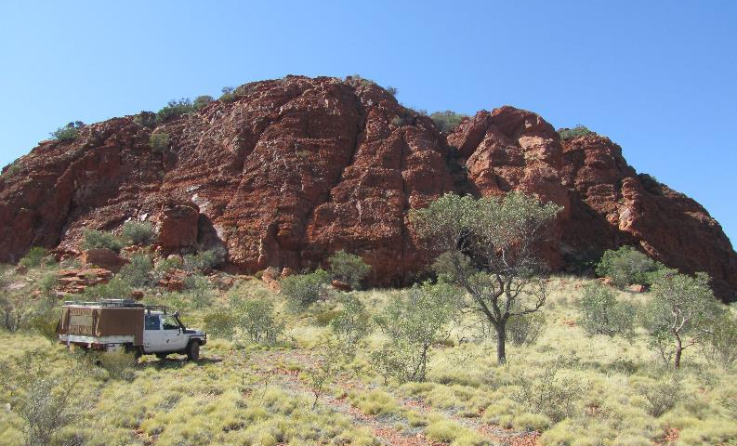

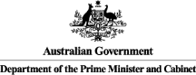
Birriliburu & Matuwa Kurrara Kurrara
Indigenous Protected Areas (IPAs)
Social Return on Investment Analysis
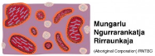

Insights
- The Birriliburu & Matuwa Kurrara Kurrara (MKK) IPAs have provided an opportunity for Martu people to reconnect with and actively manage their traditional country, whilst supporting improved local governance and decision-making
- The two IPAs have delivered critical programme structures with which to attract third party investment, through a joint management arrangement with the Western Australia (WA) Government, fee-for-service environmental service contracts with mining companies and project specific funding from environmental NGOs
- Increased and diversified investment from a range of funding sources would meet the high demand for Ranger jobs and could deliver a more expansive programme of works, which would, in turn, increase the social, economic and cultural outcomes for Martu Rangers and Community Members
- The IPA programme has demonstrated successes across a broad range of outcome areas, effectively overcoming barriers to addressing Indigenous disadvantage and engaging Indigenous Australians in meaningful employment to achieve large scale conservation outcomes, thus aligning the interests of Indigenous Australians and the broader community

“We’ve seen changes in our sisters; they are more confident. And country is healthier now. There is something for young people to do. No one was coming out to teach the young people before."

Annette Williams, Ranger

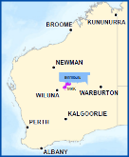
About the Birriliburu & Matuwa Kurrara Kurrara IPAs
The Birriliburu and MKK IPAs are located in central WA, north east of Wiluna. The land belongs to the Martu people, who were among the last of Australia’s Indigenous people to make contact with Europeans. Many living Martu recall their experience of first contact, occurring as late as the 1960’s. Whilst Martu culture and connection to country remains strong, many Martu live in towns on the edge of the desert, rather than on their country.
The Birriliburu IPA consists of 6.6 million ha and was declared in April 2013. The MKK IPA, declared in July 2015, covers 596,754 ha south of Birriliburu and consists of two former pastoral properties, Lorna Glen (Matuwa) and Earaheedy (Kurrara Kurrara).
The IPAs’ plans of management for country identify works that Martu have prioritised through the consultation process. Those works include burning country, managing feral animals, protecting threatened species and managing tourist visitation to important Martu sights. The IPAs do not receive funds through the Australian Government’s Working on Country programme. Instead, revenue generated through Government, NGO and Corporate partnerships contributes to limited Ranger employment opportunities.
Impact of the Birriliburu & Matuwa Kurrara Kurrara IPAs
This Social Return on Investment (SROI) analysis demonstrates that the Birriliburu and MKK IPAs have generated significant social, economic, cultural and environmental outcomes for Martu Rangers, Community members, Government and other stakeholders. The achievement of these outcomes is strongly dependent on the engagement of Martu on country; the more time Martu spend working on country, the greater the value created by the Birriliburu and MKK IPAs.
The three most significant outcomes for Rangers and Community members relate to better caring for country, preserving culture and language and leveraging the IPAs for additional funding and economic opportunities. The Birriliburu IPA is characterised by a strong custodial responsibility to look after country and provides for the transfer of traditional knowledge between generations. The MKK IPA provides for the development of Rangers’ natural resource management and work readiness skills through a joint management arrangement with the WA Department of Parks and Wildlife (DPaW).
The WA and Australian Governments have experienced a range of outcomes, including more skilled Indigenous people and improved engagement with community. Corporate, NGO and Research partners have also benefited from deeper relationships with community and being better able to meet their core objectives.
Financial proxies have been used to approximate the value of these outcomes. The social, economic, cultural and environmental value associated with the outcomes was estimated to be $8.8m for FY11-15.
During this period, $3.8m was invested in the programmes, with most (74%) coming from Government and the remainder from NGO and Corporate partners.
Value of social, economic, cultural and environmental outcomes created by stakeholder group, FY11-15
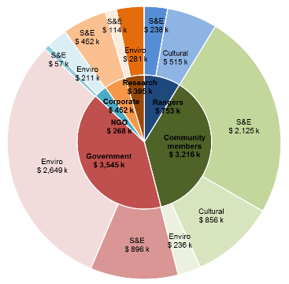
Social Return on Investment
The Birriliburu & MKK IPAs delivered an SROI ratio of 2.3:1 based on the investment in operations between FY11-15.
That is, for every $1 invested, approximately $2.3 of social, economic, cultural and environmental value has been created for stakeholders.
Key:
S&E: Social and Economic Outcomes
Cultural: Cultural Outcomes
Enviro: Environmental Outcomes

In the spotlight: Lena Long, Ranger

Lena Long was born at Well 7 on the Canning Stock Route. Lena tells of how her mother gave birth, then spent the following day on horseback, carrying Lena into the pastoral station at which she worked. Lena is pictured here at Well 5, pointing up the road to her birthplace.

Lena has been one of the most consistent Ranger employees. She has enjoyed reconnecting with country and passing on her knowledge to younger generations. She sees a huge opportunity to effect greater change with increased investment in the IPAs.

At a meeting with representatives of DPaW, Lena explained how Martu and the Department staff can continue to strengthen their working relationship and learn from each other.

"We want to work with the scientists. Even if it's just one or two Martu. Learning from the scientists. And we can teach them Martu names and looking for tracks."

DPaW Regional Manager, Ian Kealley, agrees.

"I don't think our staff could ever read the country and track a cat cross country the way Martu can."

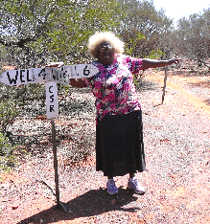

In the spotlight: Zareth Long, Ranger

Zareth started working on country because he liked hearing stories from “the old fellas”. He has since found that Ranger work helps him to get away from the stress of living in town, to live a healthier lifestyle and better manage his alcohol consumption.

Zareth is one of several young Rangers who are working and learning together and growing in confidence. He is pictured (second from right) preparing to chair a meeting with representatives from DPaW at the Lorna Glen research station on the MKK IPA.

Zareth hopes to pass on his knowledge to his wife (who is Noongar, from Perth) and his five year old son.

“I want to teach my son about town stuff and about Martu stuff. I want to teach my wife about Martu stuff. We can’t teach Martu stuff unless we’re out on country.”

About this project

The Department of the Prime Minister & Cabinet (PM&C) commissioned Social Ventures Australia (SVA) Consulting to understand, measure or estimate and value the changes resulting from the investment in the Birriliburu & MKK IPAs. This analysis is part of a broader project that considers five IPAs across Australia including Girringun in Queensland, Minyumai in New South Wales and Warddeken in the Northern Territory. The Social Return on Investment (SROI) methodology was used to complete each of these analyses.
The Birriliburu and MKK analysis involved 34 consultations with stakeholders of the two IPAs, including nine Community members, seven Rangers (overlapping with representatives from two Indigenous corporations), six representatives of local, WA and Australian Government, four NGO partners, two Corporate partners and two Research partners.

For more information about the Birriliburu & MKK IPAs, or for a copy of the full report, contact:

Rob Thomas

General Manager, Land and Community, Central Desert Native Title Services

T: 08 9425 2057

E: robthomas@centraldesert.org.au

For more information on the IPA programme, contact:

T: 02 6228 6481 or 02 6228 6717

E: IndigenousEnvironment@pmc.gov.au

