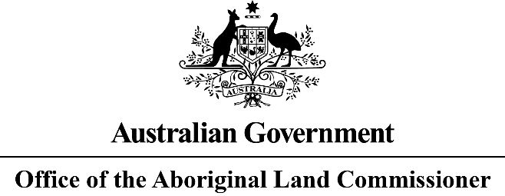
ABORIGINAL LAND RIGHTS (NORTHERN TERRITORY) ACT 1976
REVIEW OF PART V (ABORIGINAL LAND COMMISSIONERS) – ABORIGINAL LAND RIGHTS (NORTHERN TERRITORY) ACT 1976
In April 2022, the former Commonwealth Minister for Indigenous Affairs, the Hon Ken Wyatt AM, requested the current Aboriginal Land Commissioner the Hon John Mansfield AM QC, pursuant to section 50(1)(d) of the Aboriginal Land Rights (Northern Territory) Act 1976, to conduct a review of the future operation of Part V (Aboriginal Land Commissioners) of the Aboriginal Land Rights (Northern Territory) Act 1976.
NOTICE IS HEREBY GIVEN that the Aboriginal Land Commissioner (the Commissioner) is conducting a review of the future operation of Part V (Aboriginal Land Commissioners) of the Aboriginal Land Rights (Northern Territory) Act 1976. The review is to be completed by 30 June 2023.
Persons and organisations who desire to be heard by the Commissioner on the review are invited to give written notice of their interest with a brief outline of any particular matters they seek to raise on the review. Detailed submissions will then be sought at a later date.
The Terms of Reference are available on the website: https://www.niaa.gov.au/indigenous-affairs/land-and-housing/aboriginal-land-commissioner.
Any notice of interest should be in writing, addressed to the Aboriginal Land Commissioner, GPO Box 9932, DARWIN NT 0800 or by email to AboriginalLandCommissioner@official.niaa.gov.au and be provided by 1 July 2022.
Dated 06 June 2022
The Hon JR Mansfield AM QC
Aboriginal Land Commissioner
………
Further information will be also provided in the next editions of the Land Rights News

