Budget 2025-26

Delivering better outcomes for First Nations people

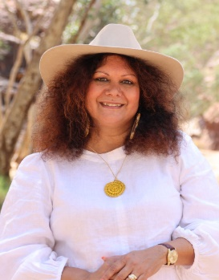Minister’s Statement

The Albanese Labor Government is delivering a substantial investment to help improve the lives of Aboriginal and Torres Strait Islander Australians.

This Budget builds on our commitments to improve health, housing, employment and education outcomes, improve community safety and increase economic empowerment.

We are shifting the way the Commonwealth is working to achieve better outcomes under the National Agreement on Closing the Gap, but we know we have much more to do.

This Budget affirms our commitment to strengthening efforts to work in partnership with First Nations people to ensure policies and programs are community-led and sustainable.

This Budget invests $1.3 billion over 6 years from   
2024-25 in our priority areas of economic empowerment, food security and health and wellbeing as well as a long-term commitment to strengthen service delivery in remote First Nations communities in the Northern Territory.

This Budget builds on our Government’s significant investment for Indigenous Australians since the October 2022-23 Budget.

Over the past year alone, this included partnering with the Northern Territory Government, Aboriginal Land Councils and Aboriginal Housing Northern Territory to invest $4 billion over 10 years to address overcrowding; ensuring more people in remote areas have jobs with real wages and better conditions through the $707 million Remote Jobs and Economic Development program and progressing development of a new remote employment service; and establishing a First Nations Economic Partnership to support First Nations participation in collaborative policy development as part of our economic empowerment agenda.

Together we’re making progress to build a future in which all Australians have access to the same opportunities.

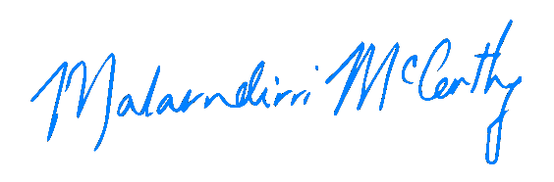

**Senator the Hon Malarndirri McCarthy  
Minister for Indigenous Australians**

# Working with First Nations people to close the gap

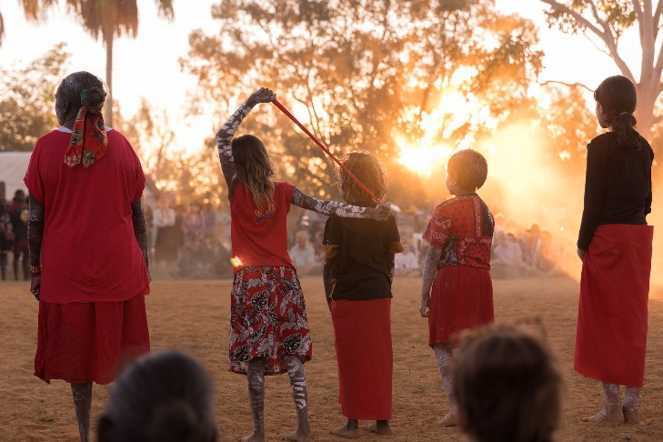

*Children at Barunga Festival 2024, NT*

Closing the Gap – so that all Australians have the same opportunities in life – requires all levels of government to work together in genuine partnership with First Nations people. Measures announced as part of this Budget highlight how the Government is working with First Nations people, communities and organisations and other levels of government in line with the National Agreement on Closing the Gap to address outcomes that are not improving fast enough.

We know better outcomes are achieved when First Nations people and communities have a genuine say in the programs and services that affect them.

On 7 February 2025, the Government announced a landmark Partnership Agreement to strengthen service delivery in remote First Nations communities in the Northern Territory. The Partnership Agreement between the Australian Government, the Northern Territory Government and Aboriginal Peak Organisations Northern Territory (APO NT) will oversee delivery of the *Northern Territory Remote Aboriginal Investment (NTRAI)*.

The $842.6 million investment over 6 years in NTRAI will enhance the delivery of critical services in remote First Nations communities in the Northern Territory, including policing, women’s safety, education and interpreter services. It will also secure over 570 jobs, including more than 278 jobs for First Nations Territorians. We will work in partnership with the Northern Territory Government and APO NT to ensure NTRAI drives progress against Closing the Gap Priority Reforms and socio-economic targets and outcomes. The Partnership Agreement will help to ensure remote First Nations communities have access to the critical services they need, while supporting communities to lead in their economic and social development.

We’re also continuing to bolster efforts to improve community safety in collaboration with the Aboriginal Leadership Group and communities in Central Australia under the *A Better, Safer Future for Central Australia Plan*. An additional $3.7 million will extend coordination and governance arrangements in   
2025-26, strengthening formal partnerships and shared decision-making to support the continuation of community-led initiatives to deliver a safer future for Central Australia.

The Australian Government has also partnered with the South Australian Government to improve safety and wellbeing in Port Augusta. We will provide $6 million over 2 years, matched by the South Australian Government with $6 million over 3 years from 2024-25 through a Federation Funding Agreement. This will support streamlined,   
community-led investment where it is needed most.

A community governance group has been established to provide advice on funding priorities within the Port Augusta region to ensure that shared decision making informs the actions to improve safety and wellbeing in the region.

Food Security and Cost of Living Relief

On 5 March 2025, the Australian Government released the 10-year *National Strategy for Food Security in Remote Aboriginal and Torres Strait Islander Communities* to improve food security and increase access to affordable and nutritious food in remote First Nations communities. The National Strategy has been developed in partnership with state and territory governments, Aboriginal and Torres Strait Islander Community Controlled Health Organisations and remote First Nations communities to improve coordination and collaboration across all levels of government to address remote food insecurity.

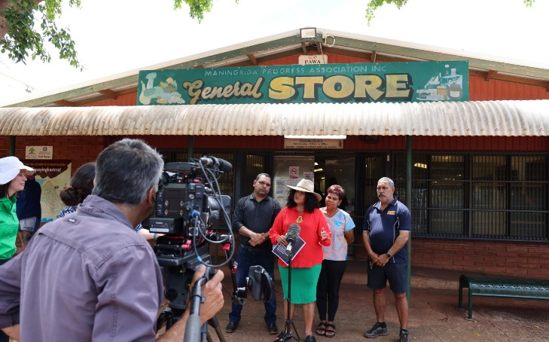  
*Maningrida, NT*

This Budget invests $50 million over 4 years from   
2025-26 for a subsidy scheme to increase access to 30 food and essential products in up to 152 remote stores. The subsidy scheme will be administered by Outback Stores Pty Ltd to support cost-of-living relief in remote First Nations communities.

We’re also investing a further $21.4 million over 3 years from 2025-26 to build a First Nations nutrition workforce through upskilling local First Nations staff in around 100 remote stores. This workforce will support community members to consider healthy food options and promote good nutrition.

# Economic Empowerment

The Government is committed to increasing employment opportunities and delivering long-term economic empowerment for First Nations people.

Extending and strengthening the Indigenous Procurement Policy (IPP), with $23.9 million over 5 years from 2024-25, will boost opportunities for First Nations businesses to grow and create jobs. The reforms will increase the integrity of the IPP by strengthening the eligibility criteria and will drive demand for First Nations businesses by increasing procurement targets. Under the new criteria, businesses will be required to demonstrate they are at least 51 per cent First Nations-owned and controlled (or registered with the Office of the Registrar of Indigenous Corporations) to access Commonwealth IPP procurement contracts. Additionally, the Government will work with regulators to identify opportunities to improve mechanisms to report black cladding (disingenuous conduct designed to gain access to policies like the IPP).

The Government will also provide $3.4 million over 3 years from 2025-26 to increase the participation rate of First Nations women in business through a place-based business mentoring and coaching program, codesigned and delivered by First Nations businesses and organisations with Indigenous Business Australia.

The Government is delivering on its commitment to replace the Community Development Program (CDP) through a staged approach. We will provide an additional $137.3 million over 3 years from 2024-25 to support the transition between CDP arrangements and the new remote employment service for a 4-month period to 31 October 2025.

# Housing, Infrastructure and Essential Services

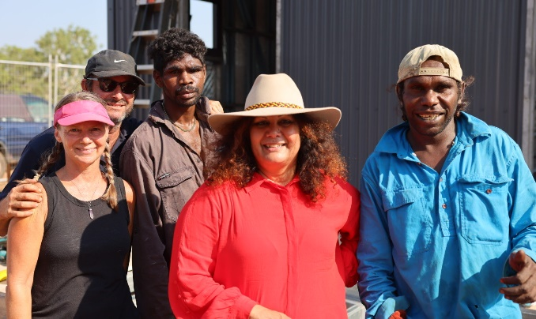

*Borroloola, NT*

We’re supporting increased home ownership and reducing overcrowding for First Nations people and communities. Funding of $70.9 million is being redirected to Indigenous Business Australia’s Indigenous Home Ownership Program to increase opportunities for First Nations people to buy their own home and build intergenerational wealth. This investment will prioritise First Nations women and families through the Single Carers Home Finance package by quarantining $20 million of the $70.9 million package for single carers – most of whom are women – to access more affordable, sustainable and culturally secure housing through home ownership.

The Government has provisioned, subject to a joint investment by the Queensland Government, $36.7 million over 4 years from 2025-26 (and an additional $4.5 million in 2029-30) for urgent community infrastructure works in the Torres Strait Islands. Continuation of the co-funded Major Infrastructure Program (Stage 7) will support infrastructure for essential services in the Torres Strait Islands, including wastewater, solid waste, and potable water supply.

Strengthening Health and Wellbeing

The Government is committed to improving access to culturally safe and high-quality health and wellbeing services for First Nations people.

The Government will provide $24.7 million over 4 years from 2025-26 to enhance investment in social and emotional wellbeing (SEWB) and mental health. This includes establishing a flexible funding pool to enable short term, place-based SEWB supports for First Nations families and communities to manage significant trauma; First Nations-led SEWB assessment tools and processes; and supporting the higher education fees of up to 150 First Nations psychology students to increase the availability of culturally safe and appropriately qualified First Nations psychologists.

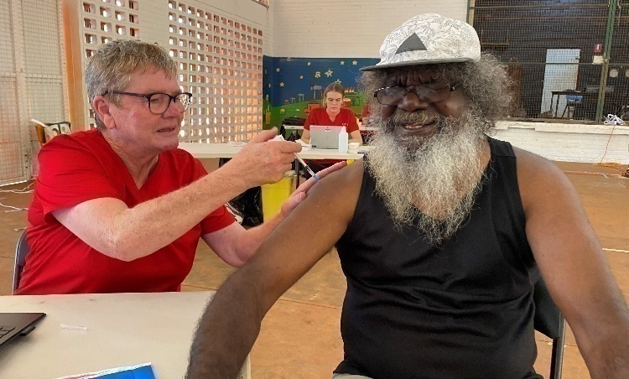

*Mala'la Health Service Aboriginal Corporation, Maningrida*

A further $3.2 million over 4 years from 2025–26 (and $2.0 million per year ongoing) will be provided to remove the cap on the number of medical Commonwealth Supported Places for First Nations students from 2026.

The Territories Stolen Generations Redress Scheme will be extended for an additional 2 years to 30 June 2028. The Scheme is open to Stolen Generations survivors who were removed from their families or communities and whose removal took place in the Northern Territory or Australian Capital Territory before self-government, and the Jervis Bay Territory. The continuation of the Scheme will help ensure eligible survivors don’t miss out on redress and support ongoing healing for survivors, their families and communities.

The Australian Government will provide $9.2 million over 3 years from 2025-26 to deliver improved detection, monitoring and management of acute rheumatic fever and rheumatic heart disease in First Nations communities.

Access to laundry facilities with reliable clean water and power supply is critical to improving long-term health outcomes in remote First Nations communities. The Government will invest $11.4 million over 4 years from 2025-26 to establish or upgrade up to 12 community laundries and maintain and operate them in remote First Nations communities across northern and central Australia to reduce the prevalence of skin infections that can lead to serious secondary illnesses like rheumatic heart disease.

Increasing uptake of health assessments is critical to ensure the detection of common and treatable conditions that are major contributors to First Nations illness and early deaths. The Government will provide $3.5 million in 2025-26 for a one-year extension of the Deadly Choices program, which focuses on increasing the uptake of 715 Health Checks by First Nations people.

We’re also investing $60.3 million over 5 years from 2025-26 in Aboriginal and Torres Strait Islander organisations to deliver culturally appropriate aged care assessments for Aboriginal and Torres Strait Islander people. The culturally safe, trauma-aware and accessible aged care pathways will be delivered by First Nations organisations, aligning with Priority Reform 2 (building the community-controlled sector).

# Strong Families and Children

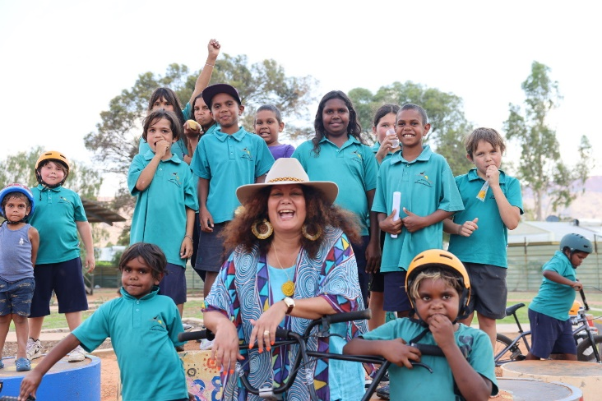 *Alice Springs, NT*

The safety of communities and families are paramount to delivering better outcomes for First Nations people. The Government is continuing to provide targeted support to address domestic violence, community safety and sexual violence, including $21.8 million over 2 years from 2025-26 to continue delivery of critical prevention, early intervention and response services to address family, domestic and sexual violence in First Nations communities.

This investment will provide an extension for successful activities originally funded under the Third and Fourth Action Plans of the previous National Plan to Reduce Violence Against Women and their Children (2010-2022) and continued through commitments made through the Aboriginal and Torres Strait Islander Action Plan 2023-25 under the National Plan to End Violence against Women and Children 2022-32. Services are community-led, trauma informed and culturally safe and provide practical intervention for First Nations peoples at-risk of experiencing or using violence.

The Government has funded a further $1.5 million in 2025-26 to the Making Up Lost Time in Literacy (MultiLit) program, supporting primary age students to catch up in reading and early literacy.

The Clontarf Foundation will receive an additional $33.6 million over 2 years from 2025-26. The Clontarf Foundation supports up to 12,500 Aboriginal and Torres Strait Islander young boys and men through providing in-school support and before and after school activities, to assist in improving student engagement.

# Connection to Land and Waters

*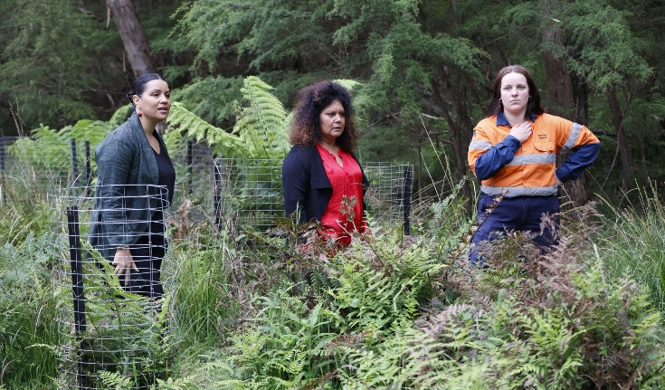Victoria*

We’re continuing to work with First Nations people and communities to support connection to Country through management of drought and climate risks.

The Murray-Darling Basin Indigenous River Rangers Program will be extended for an additional 2 years from 2026 to 2028 in recognition of the program's success to date enabling First Nations people, organisations and communities to leverage their connection to Country to manage and restore waterway health across the Murray-Darling Basin. This extension will support environment and cultural outcomes while enhancing leadership, employment and economic opportunities for First Nations people in water and land management sectors and related fields.

The Saving Australia’s Bushland Program is designed to help reach our target to protect and conserve 30 per cent of Australia’s land by 2030. Under this program, the Government will provide $13 million over 3 years to further expand Indigenous Protected Areas (IPA), building on the success of existing IPA programs which support First Nations people to protect and conserve biodiversity and cultural values in line with Traditional Owners’ aspirations.

The Government has also provisioned $28.4 million over 4 years from 2025-26 (and an additional $7.8 million in 2029-30), subject to joint investment with the Queensland Government, for climate resilience in the Torres Strait Islands. The Seawalls Program (Stage 3) initiative will increase coastal protection for Torres Strait Islander communities exposed to climate impacts of coastal flooding and erosion.

To support implementation of the Government’s *Nature Positive Plan: better for the environment, better for business,* we’re providing$55.2 million over 4 years from 2025-26 (and $14.1 million per year ongoing) to renew lease arrangements with the Traditional Owners of the jointly managed Booderee, Kakadu, and Uluṟu-Kata Tjuṯa National Parks.

# Preserving and Celebrating First Nations Culture, Heritage and Languages

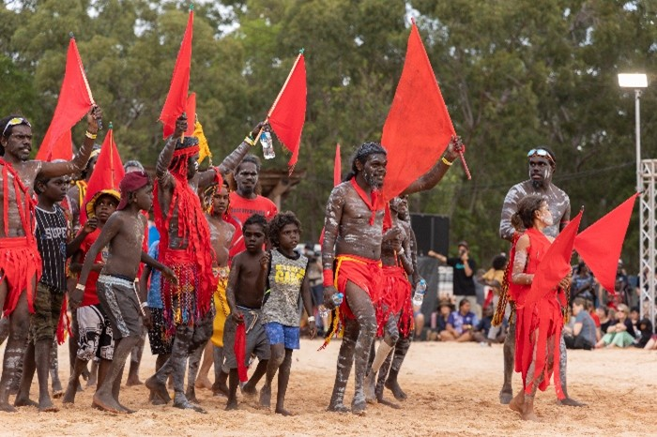

*Red Flag Dancers Garma 2024*

The Government is continuing to invest in the preservation of First Nations cultures, languages and connection to Country by providing $3.6 million over 2 years from 2025-26 to the Australian Institute of Aboriginal and Torres Strait Islander Studies (AIATSIS) for the continued digitisation of at-risk audio and video collections. This work will be undertaken in partnership with First Nations broadcasters and community organisations and is consistent with Priority Reform 4 (Shared Access to Data and Information).

Supporting language revitalisation is an ongoing commitment of the Government. We have committed $11.0 million over 3 years from 2025-26 to extend support for the Languages Policy Partnership.