Replacing the Community Development Program – second phase of community consultations report

What we heard about the design and delivery of the new Remote Jobs and Economic Development program and remote employment service.

# Acknowledgement of Country

The National Indigenous Australians Agency (NIAA) acknowledges the Traditional Owners and Custodians of Country throughout Australia and acknowledges their continuing connection to land, waters and community. We pay our respects to people, cultures and Elders past and present.

Table of Contents

Acknowledgement of Country 1

Delivering on the Australian Government’s commitment 5

Remote Employment Roundtable 5

Job trials to test new approaches to remote employment 5

A new jobs program and new remote employment service announced 6

First Nations Reference Group 6

The Remote Jobs and Economic Development program 7

The new remote employment service 7

Consultation – what we have heard 8

First phase of community consultations – 2023 8

Second phase of community consultations – 2024 9

Extension of second phase of community consultations 11

Summary of the second phase of community consultation feedback 12

1. What parts of the program do you think will work well or not work well in remote communities? 12

2. What would you change about the program? 14

3. Who could you talk to in your community if you wanted to create a job you are interested in? 16

4. What support could be offered to youth, women and other vulnerable groups to succeed in the program? 17

5.What support would you want if you took up a job opportunity created through the RJED program? 18

6. What can be done to maximise effective community-led decision making? 18

7. Are there benefits other than money that could encourage job seekers and remote communities? For example, meals, clothing, vouchers 19

8. What support do communities need to make sure they get the jobs they need? 20

9. How could employers demonstrate that the jobs created are the ones communities want? 20

10. What can the program include to make sure it is flexible for the unique needs of different communities? 21

11. What are good examples of funding or services that are working on the ground? 21

12. Who should be eligible to apply for the program? 22

13. What jobs could you create in your local community under this program? 22

14. What are the challenges in remote communities to fill jobs? 23

15. What do communities need to grow and build a small business? 23

16. What support do organisations need to successfully apply for the new program? 23

17. How can NIAA work with communities to support sustainability of jobs? 24

For more information 25

Appendix A: Evolution of employment services 26

Pre-2000 26

Early 2000s 26

2010–2020 26

2021–2023 27

2024 27

Appendix B: Summary of feedback on the new remote employment service 28

Overarching themes 28

Mutual obligations 28

Quality assessment and wrap-around supports 28

Tailored support to become job-ready 29

Tailored support for youth 29

Training and support for providers 29

Appendix C: CDP communities we engaged with 30

Appendix D: Journey maps 31

Appendix E: Feedback received on the RJED program Grant Opportunity Guidelines 36

# 

# Delivering on the Australian Government’s commitment

The Australian Government is committed to replacing the Community Development Program (CDP) with real jobs, proper wages and decent conditions. This report outlines the pathway to deliver on that commitment and summarises what we heard through recent consultations.

## Remote Employment Roundtable

To begin discussions on how the [Community Development Program](https://www.niaa.gov.au/our-work/employment-and-economic-development/community-development-program-cdp) should be replaced, the former Minister for Indigenous Australians, the Hon Linda Burney hosted a Remote Employment Roundtable in Canberra on 31 August 2022.

The forum was an important element of consultations for the new program to replace the CDP and fed into the [Jobs and Skills Summit on 1- 2 September 2022](https://treasury.gov.au/employment-whitepaper/jobs-summit). The key messages from the roundtable were:

* The importance of real jobs, with proper wages and decent conditions.
* One size does not fit all. The new program needs to be community led, meeting community needs.
* Pathways to work, including access to appropriate training, to ensure that people are job ready.
* Unlocking the barriers for entry to jobs, in particular police checks and licensing.
* Mapping of job opportunities within communities will be an important element in helping connect people to work.
* The engagement and contribution of other Government portfolios, at all levels of government and industry will be important.

## Job trials to test new approaches to remote employment

As part of the event, the former Minister announced CDP providers could opt-in to vary their agreements to redirect 25% of funds to trial new approaches within targeted CDP regions. This was an important first step in moving away from delivering work-like activities to supporting job seekers into real jobs. There will be opportunities to continue some of these approaches through to 30 June 2025.

The 2022-23 Budget also provided funding to trial an additional 200 new remote jobs under the New Jobs Program Trial in a limited number of CDP locations; this was subsequently increased to 300 jobs in the 2024-25 Budget. The trial has allowed for community-controlled organisations and local government to identify local jobs and receive funding for wages and capital.

On 1 July 2023 the Ngaanyatjarra Lands Trial commenced to trial new approaches to remote employment services, to test ideas and understand barriers to employment in very remote communities that are a significant distance from a regional centre.

The lessons from these [three job trials](https://www.niaa.gov.au/our-work/employment-and-economic-development/job-trials-testing-new-approaches-remote-employment) are providing valuable insights to inform design and implementation of a new approach to assist income support recipients in remote Australia move into paid employment.

## A new jobs program and new remote employment service announced

In February 2024, the Government announced it would replace CDP in two stages. The Government is investing $707 million for a new [Remote Jobs and Economic Development](https://www.niaa.gov.au/our-work/employment-and-economic-development/remote-jobs-and-economic-development-program#:~:text=In%20February%202024%2C%20the%20Australian,with%20fair%20pay%20and%20conditions.) (RJED) program to start in the second half of 2024. The new RJED program will provide people in remote communities with meaningful jobs with fair pay and conditions. The RJED program will be the first stage of replacing CDP. The second stage is a new remote employment service that will commence on 1 July 2025. The new remote employment service will support job seekers to prepare for, find and access local job opportunities. Both the RJED program and new employment service will work together to help close the gap in unemployment in remote communities.

## First Nations Reference Group

In March 2024, the former minister, the Hon Linda Burney announced the establishment of the [First Nations Reference Group](https://ministers.pmc.gov.au/burney/2024/first-nations-reference-group-remote-jobs-and-economic-development-program) (FNRG) to re‑enforce the Government’s commitment to work in partnership with First Nations peoples. The FNRG members are jobs and economic development experts from across remote Australia, including from peak organisations, Aboriginal and Torres Strait Islander business leaders, training providers, partnerships, authorities and governing bodies. The FNRG are working with the Government to provide advice on the design and implementation of both the RJED program and the new remote employment service.

The Government’s commitment to remote employment reform is supported by a large evidence base. Over many years we have heard from communities about what is working and what is not working. The Government has provided employment programs and services to job seekers in some form in remote Australia since 1977.

To remain fit for purpose, programs have continuously evolved over time. A summary of the evolution of employment programs and services since 1977 is at **Appendix A.**

# The Remote Jobs and Economic Development program

As mentioned earlier, the RJED program is the first stage in the Government’s commitment to replace the CDP in partnership with First Nations peoples. The RJED program is an ongoing [Budget Measure](https://www.niaa.gov.au/sites/default/files/documents/2024-06/2024-25-fact-sheet-first-nations-budget-measures.pdf) that aims to create 3000 jobs that communities want and need to boost economic opportunities in remote Australia. The 3000 jobs will come online through a phased roll out over 3 years from mid to late 2024.

The RJED program will give more flexibility to communities to determine local programs and services that support economic development. Eligible organisations will be funded to create new jobs to employ local eligible job seekers at the relevant award rate or the National Minimum Wage (whichever is applicable) plus conditions including superannuation and leave. Funding will also cover on-costs and overheads. For example, insurance, training and operational equipment and resources employees need to perform their job.

A $185 million Community Jobs and Business Fund will be an important element of the new program and responds to what communities have overwhelmingly asked for. As part of this fund, eligible employers for the RJED program can apply for funding of minor capital work and equipment to help employees have the resources they need to do their jobs.

# The new remote employment service

The second stage to replace CDP is the transition to a new remote employment service to support job seekers to prepare for, find and access local job opportunities. The new remote employment service is being designed in parallel to broader reform related work across Government including the [Employment White Paper](https://treasury.gov.au/review/employment-whitepaper), the [Inquiry into Workforce Australia Employment Services](https://www.aph.gov.au/Parliamentary_Business/Committees/House/Former_Committees/Workforce_Australia_Employment_Services/WorkforceAustralia), reforms to [Disability Employment Services](https://www.dss.gov.au/disability-and-carers-programs-services-disability-employment-programs/a-new-specialist-disability-employment-program) and work of the [Economic Inclusion Advisory Committee.](https://www.dss.gov.au/groups-councils-and-committees/economic-inclusion-advisory-committee)

CDP provider services will continue to operate and provide support to remote job seekers until 30 June 2025. This will allow time for the new remote employment service to be designed and begin.

Current CDP providers and future service providers will support job seekers to find employment and/or support job seekers to address barriers to employment opportunities. Providers are responsible for connecting people who are job-ready with suitable job opportunities, including jobs through the RJED program. Providers will also support people who are not job-ready with the skills and resources they need.

Whilst the key focus of the second phase of community consultation was on the design and delivery of the RJED program, stakeholders provided feedback regarding what a new remote employment service could look like. A summary of this feedback can be found at **Appendix B.**

# Consultation – what we have heard

To develop the best approach to replacing the CDP, we have undertaken targeted consultations in remote communities in two phases.

Consultation has included a diverse range of stakeholders at a national, jurisdictional and community level. We wanted to hear from individuals, job seekers, CDP participants, former participants, community leaders, service providers, employers and Government or non-government organisations on ways the new program can best help those in remote communities.

A broad range of engagement methods were undertaken to consult and gather feedback such as face-to-face meetings, virtual meetings, workshops, roundtables, phone calls, surveys and submissions.

## First phase of community consultations – 2023

Between February and June 2023, we conducted ‘listen and learn’ consultations with remote communities.

The ‘listen and learn’ phase was an opportunity for communities and stakeholders to speak to us directly about ways to design and deliver a program to replace CDP. We heard from over 2250 people in over 100 CDP communities. An online form and survey provided the opportunity for a further 250 stakeholders to be involved. We heard the new program should:

* Be planned and led by community
* Support more local jobs for local people
* Include something fair and meaningful for the community or for your job prospects in return for income support
* Recognise roles done in community including a new approach for youth
* Have support for people who cannot work right now
* Be flexible to invest in local priorities.

Previous feedback on remote engagement, performance information, committee reports and evaluations also gave us valuable insights into how a new program could be developed and implemented.

A report on what we have heard through this phase of consultation about replacing the CDP is publicly available on the [NIAA website.](https://www.niaa.gov.au/resource-centre/replacing-community-development-program-consultation-report)

## Second phase of community consultations – 2024

Between mid-April and mid-July 2024, we conducted a second phase of community consultations, to hear how the new RJED program could be designed and delivered. Overall, there was positive support from stakeholders on the proposed RJED program. Particularly that the program will be community led and jobs will be created for locals, benefiting community wellbeing.

We heard from both potential employers and employees that the proposed design of the RJED program should provide:

* Skills and support to complete paperwork for employment
* Continuous on-the job training
* Ongoing tailored mentoring and coaching
* Long-term sustainability of jobs
* Employment that supports local cultural needs

We held over 350 individual engagements and heard from more than 3100 people.

* The majority of the meetings held were within remote communities.
* We engaged with approximately 200 remote communities within the 60 CDP regions.
* Approximately 400 CDP provider staff were present at many community meetings.
* We engaged with approximately 40 CDP employment services staff exclusively.
* We received over 80 responses to the discussion paper and survey.

A map showing the communities we engaged with is at **Appendix C.**

We undertook an extensive consultation process to get input from remote communities on the design and delivery of the RJED program. This included seeking input via:

* Face-to-face and virtual sessions with remote communities across the country
* Roundtables
* Survey responses
* Submissions in response to a discussion paper
* Learnings from job trials in remote Australia (the CDP Trial, the
* New Jobs Program Trial and the Ngaanyatjarra Lands Trial).

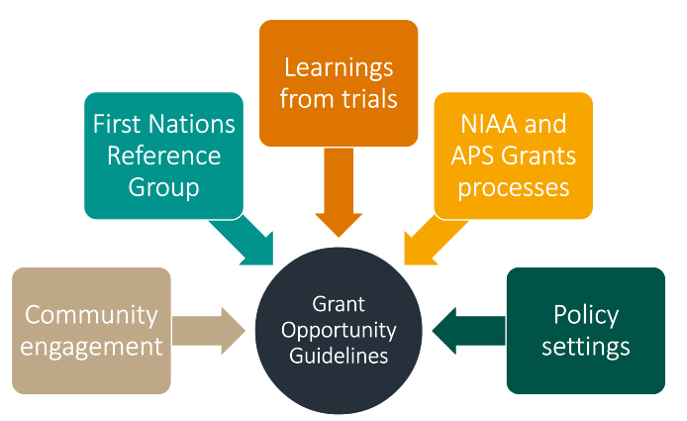

A suite of journey maps were developed as a visual guide for stakeholders with a set series of questions to prompt discussion, collect feedback and generate ideas around how the program should look. The journey maps included the proposed program as a whole, the job seeker journey, the community journey, the employment services journey and the employer journey. In addition to the questions, stakeholders were also encouraged to provide any other feedback or views they had as a whole about the design and delivery of the RJED program. The full suite of journey maps are at **Appendix D.**

A series of roundtables were also held in Adelaide, Alice Springs, Brisbane, Broome, Cairns, Darwin, and Nhulunbuy and with CDP providers to hear from key stakeholders who may not have been involved in remote community consultations. The roundtable consultations attracted a good mix of stakeholders from across community organisations, private sector organisations and state/territory and federal government.

To support the promotion of the public consultation, a range of communication activities were undertaken. A [media release](https://ministers.pmc.gov.au/burney/2024/have-your-say-new-jobs-program-coming-remote-australia) was distributed by the former minister, the Hon Linda Burney on 7 May 2024 detailing ways people could be involved in consultations to help design the RJED program.

The NIAA’s social media channels and Indigenous.gov.au were used throughout the consultation period to promote and encourage people to engage in consultations for the design of the RJED program.

Paid social media through Facebook, Instagram and LinkedIn targeted two key audiences:

* People living in remote communities and First Nations communities to raise awareness about community meetings.
* CDP participants, providers, and peak organisations to create website traffic and raise awareness about the online survey and community meetings.

A paid advertising campaign through Universal McCann promoting consultations commenced 17 May 2024 using targeted radio ads (including in 9 Indigenous languages), public notice ads in newspapers and paid social media. Most consultation locations were targeted via press/print with placements in publications aligning with relevant postcodes/areas for consultation. Newspapers included:

* Twelve regional newspapers in the relevant CDP areas
* Indigenous press – Koori Mail and Torres News
* State/National papers – The West Australian, NT News, The Land, Queensland Country Life.

Radio ads were translated into nine Indigenous languages including Anmatyerr, Djambarrpuyngu (Yolngu Matha), Kriol, Pintupi Luritja, Pitjantjatjara, Tiwi, Walpiri, Yankunytjatjara and Yumpla Tok. The choice of languages for translation were based on advice from the NIAA’s Regional Offices and production timeframes that aligned with the consultation period.

A dedicated consultation web page on the NIAA website was created and received almost 21,000 views.

## Extension of second phase of community consultations

As an extension of the second phase of consultations, [the draft GOGs for the RJED program](https://www.niaa.gov.au/remote-jobs-and-economic-development-program-consultation) were released for public consultation in July 2024 as the next step in working in partnership to design the program. We have also received advice from the FNRG.

The GOGs set out proposed elements of the new program, such as, eligibility criteria, assessment and the overall grant selection process and built on information already shared in the discussion paper. We heard about the difficulties smaller organisations can face when applying for Commonwealth grants with complex application requirements. It was especially valuable to hear about the role of remote employers, employee needs and the types of opportunities available in communities.

Feedback from the FNRG, community consultations and findings from existing evidence on remote employment informed the design of the draft GOGs. Details about further feedback from the FNRG on elements of the proposed GOGs is available on the [NIAA website](https://www.niaa.gov.au/our-work/employment-and-economic-development/remote-jobs-and-economic-development-program#first-nations-reference-group).

We started drafting Grant Opportunity Guidelines (GOGs) for the RJED program soon after the program was announced in February 2024.

The GOGs drafting process is thorough and specialised to ensure the grants comply with Australian Public Service grant processes and legislation, including the [*Commonwealth Grants Rules and Guidelines 2017*](https://www.finance.gov.au/sites/default/files/2019-11/commonwealth-grants-rules-and-guidelines.pdf)and the [*Public Governance, Performance and Accountability Act 2013*](https://www.legislation.gov.au/C2013A00123/latest/text)*.*

The final approved version of the RJED program GOGs will be published on [GrantConnect](https://www.grants.gov.au/) with supporting information regarding what grant funding is available, how the program will work and how to apply.

Not all the advice received is within the scope of what can be delivered to support the creation of 3000 jobs under the RJED program. We will take all of what we’ve heard and learnt through this process to the design of other remote programs, including the new remote employment service.

We are working through all the feedback to incorporate into a final version of the GOGs. A detailed breakdown of the feedback received on the RJED GOGs and how it was considered in the final design of the program is at **Appendix E.**

The final approved GOGs will be published and open for applications on GrantConnect in the second half of 2024.

## Summary of the second phase of community consultation feedback

The set series of questions and the summary of feedback received on phase 2 consultations are as follows:

General questions about the program

### 1. What parts of the program do you think will work well or not work well in remote communities?

#### The RJED program will need to be culturally-informed

The design and implementation of the program needs to fit the diverse and unique cultural environments of each community to enhance program relevance and community buy-in. This should include accommodating cultural obligations within program guidelines.

There is also a need for the program to look beyond the scope of economic development and consider social and wellbeing growth as a key metric. This would require flexibility in job creation pathways and key performance indicators which recognise that roles created may not be economically viable in a standard sense, but which are critical for the community.

#### The RJED program should support traditional practices and cultural obligations

The importance of traditional and cultural practices was frequently raised. The RJED program needs to consider how it can support traditional cultural education and ceremonies practically within some of the job roles.

Additionally, there is a requirement for employers to have cultural awareness regarding First Nations peoples and their cultural commitments. The RJED program needs to implement clear policies in the program around cultural leave obligations, which also impact participant retention. A common example provided was the disincentive for participants to take up paid work and be restricted to workplace cultural leave entitlements, which can often get used up quickly or are unpaid. Acknowledging the sometimes significant cultural obligation requirements of community members, it was highlighted that taking unpaid or a restricted amount of paid leave for cultural reasons, such as Sorry Business may disincentivise transition from welfare to work.

#### The RJED program should leverage existing community relationships and support networks

A strong theme from consultations was that each community has its own unique leadership and governance structure. The program could enhance its effectiveness if it utilised those existing community relationships and networks and collaborated with agencies and stakeholders operating on the ground in communities.

#### Comprehensive support services are critical to the success of the RJED program

Mentorship and wrap-around support for job seekers are crucial factors for job readiness and retention. Feedback highlighted that employing older people within communities to be mentors creates an added layer of employment, while also creating support mechanisms for younger people seeking to transition to employment.

Adequate mentoring and support services are crucial for both participant and employer success under the program, but pre-employment training, on-the-job training support, and post-employment support comes at significant cost. This needs to be considered in program funding due to the requirement for additional capacity to provide that support. Additionally, there’s a requirement for ongoing support beyond the initial job placement, to address challenges for employed participants.

#### The RJED program needs to consider the impacts on job seekers welfare benefits

A common theme was the need to consider the complex interactions between income received through a job funded by the RJED program and existing financial securities of welfare benefits, as reduced access to welfare benefits may raise barriers to participant engagement.

Concerns were raised about how employment through the RJED program will impact the housing stability and concession benefits of participants, acknowledging that much of these benefits (housing, health care cards, etc.) are provided through Centrelink and subject to income tests and limits. Job seekers wanted to know what the process would be to get back on welfare payments if they end their job, or if it doesn’t work out? Their main concern was losing their state housing for their families. Ensuring that the RJED program works in tandem with these other government programs will be important to encourage participation.

#### The RJED program will require access to training and incentives in remote communities

Some of the challenges for potential participants are in the pre-employment training phase around income, incentives and retention.

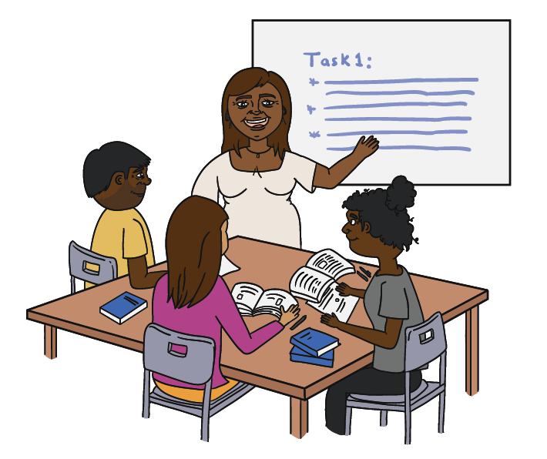There are challenges with delivering training in remote locations and a significant skill shortage across a range of professions. There are difficulties accessing Registered Training Organisations and where they can be accessed, the cost/resources to do so are significant. This includes basic pre-employment training around attaining driver’s licences, literacy, numeracy and computer skills training.

#### The RJED program needs to be designed with long-term stability

It’s important that jobs created through the program have long-term stability and growth opportunities, particularly around project-based work, and that local workforce development will be a key factor for community stability and reducing dependency on transient employment.

It will be difficult to maintain stable employment opportunities without addressing some of the key challenges in communities around safe housing, reliable transport, access to healthy nutritious food and access to laundry facilities. These all need to be considered as part of promoting sustainable employment. There was a perception during consultations that funding provided under the RJED program would be limited to 3 years causing concerns there would not be enough time to build sustainability for some jobs within certain communities.

Promotion around the sustainability of the program and funding beyond the initial 3-year period needs to be communicated effectively. Long term program success hinges on sustainability of employment beyond the initial funding period, and policy continuity.

2. What would you change about the program?

#### The RJED program should consider reviewing the CDP boundaries

There is a need for the program to be flexible to place-based needs, with flexible program boundaries and consideration of participants with diverse needs and disabilities to ensure effective participation and equitable access. This flexibility should also take into account child caring requirements and consider how the employment created can factor in the lack of childcare, including early learning education, before and after school care in many communities.

Stakeholders raised concerns around maintaining current CDP boundaries acknowledging that there are some areas that are falling through the gaps.

If the program guidelines are too inflexible, they may restrict mobility between communities, limiting job opportunities for participants and therefore the impact of the program. It was also noted that in addition to inflexible program design impacting participants, it could also restrict the ability for businesses involved in the program to accommodate their requirements for a mobile workforce.

Stakeholders indicated CDP boundaries should be reassessed and amended as some areas with high Indigenous populations and high unemployment were falling through the gaps.

#### The Community Jobs and Business Fund needs to have clear definitions

Questions were asked around the funding parameters in the program design. It was noted that a lack of transparency in funding parameters (e.g. covered expenses, funding caps) could complicate program implementation, management and accountability when it comes to allowable expenses.

Concerns were expressed around current program funding which has seen organisations who are already funded to create certain roles, double dip and use existing program funding (e.g. through CDP) to cover those roles.

Additionally, there’s risk of external providers setting up in communities and accessing program funding, without adequately investing in the communities in which they are operating. Some people highlighted a preference for direct funding of employers as opposed to channelling funding through employment services.

Stakeholders also addressed concerns around the longevity of funding, acknowledging that the 3-year window outlined in the program documentation will not allow enough time for real change to be achieved. There needs to be a commitment to maintain funding beyond 3 years so the program can achieve its full potential.

#### The administrative processes for the RJED program need to be streamlined

Community members expressed that any new business established would require ongoing admin support including accounting, bookkeeping, invoicing, HR support, marketing, money management, budgeting, costing services etc. and this would need to be funded up-front under the RJED program. There was also an overwhelming request for support to write a good grant opportunity submission.

There are concerns around administrative processes with current programs, and the way that those processes can impact the implementation of programs and efficiency in decision-making. Acknowledging that community organisations can often have limited HR capacity and capability, enabling arrangements with group training and labour hire may facilitate more effective job creation. Small organisations will need more assistance with reporting and applications.

On the topic of current programs, people raised the need to audit those programs and their effectiveness to assess what works and incorporate lessons learned into the new RJED program. Additionally, for current CDP participants, stakeholders cautioned that disruptions in their employment as the new program is phased in could damage the progress made.

#### The RJED program needs to consider all job opportunities and skills gaps

When it comes to job creation, it is important for the program to look beyond the scope of economic development and consider social and wellbeing growth as a key metric, and how it is delivered from a cultural, place-based perspective. This will require flexibility in job creation pathways and key performance indicators to enable roles that may not be economically viable in a standard sense.

The majority of jobs identified included cultural roles and maintenance and repair roles including trades and apprenticeships. Some questioned why certain job opportunities like white-collar and IT roles are not discussed in the program scope and participant employment options. There is a need to look beyond the roles currently offered under CDP, which according to stakeholders reflect a greater number of blue collar roles, and ensure that the opportunity to create roles in broader sectors is reflected in program materials.

Given the ambiguity around the definition of a “real job” it can affect program alignment with participant expectations and industry standards.

There was also feedback on the myriads of training programs that are run in communities, and the often lack of alignment between those programs and current industry needs which impacts job readiness and employability.

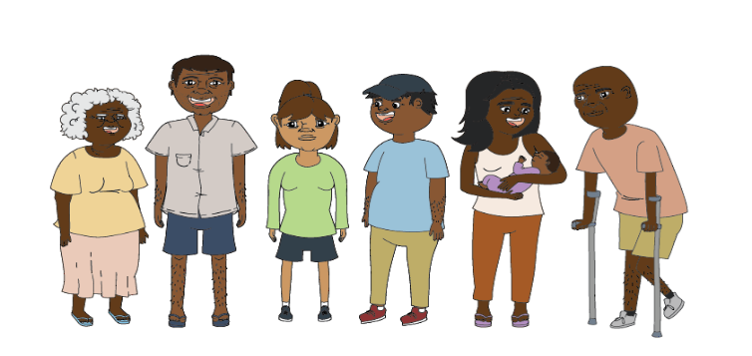Questions for job seekers

### 3. Who could you talk to in your community if you wanted to create a job you are interested in?

#### The majority of stakeholders identified local representatives and community/cultural leaders as the best people to approach

Stakeholders raised the idea of empowering collective groups of community organisations, who can pool capacity, to participate in the program, which can help to support community-driven employment initiatives, strengthening local economies and promoting self-sufficiency.

It was suggested that community organisations and local representatives such as councils, Cultural Authority Groups, providers and Prescribed Body Corporates often have a strong understanding of community needs and regular contact with the community. Individuals would feel comfortable approaching these groups and organisations within the community to help guide and lead job creation opportunities.

Furthermore, many mentioned engaging with Elders, Traditional Owners and community leaders. Through engaging with these groups of people, who have cultural knowledge and lived experience, it will continue to support and strengthen local decision making and ensure job creation aligns with local community priorities.

#### There needs to be a clear communication approach to raise awareness and take-up of the RJED program

There are many important non-financial benefits to work, such as health and wellbeing, social, and educational benefits that would support both participants and their families over the long-term. It would be important to provide clear and accurate advice, through a promotional campaign to RJED program participants about how working for wages will affect their eligibility for income support and other benefits such as the low-income healthcare card.

A clear communications strategy was a key theme that stakeholders raised throughout consultations. Ensuring a well thought out communications strategy, which emphasises the distinction and benefits between individual employment goals and community-driven job creation priorities, and establishes clear communication channels, will be critical for managing expectations and promoting program understanding. Stakeholders emphasised the requirement for the program to establish clear points of contact within communities for job creation ideas and set clear and transparent guidelines on permissible job roles and remuneration levels.

Stakeholders were also unclear on whether the program would only seek to create new jobs, or if funding could be used to expand existing jobs or support the transition of local people into existing jobs currently filled by external stakeholders.

### 4. What support could be offered to youth, women and other vulnerable groups to succeed in the program?

#### There are a number of barriers in remote communities faced by vulnerable groups

A key theme of feedback on women, youth and vulnerable people is that there is a requirement to address root cause problems like maintenance of welfare concessions around housing and healthcare, and upfront barriers like food, fuel and transport to enable better outcomes for these groups through employment.

Issues around mental health, safe accommodation and spaces for women and youth, training on how to create and maintain a healthy home, empowering women and youth, engaging them through culture and navigating domestic violence and alcohol and other drug abuse were all issues raised. The program needs to consider how it can link up with on the ground efforts to address these root cause issues, which are one piece of the puzzle when it comes to creating better employment outcomes for these groups.

There are issues around childcare access while parents are working as a key consideration for the program as a barrier.

Financial management and literacy—support for financial management and literacy, acknowledging the pressures of family and culture on resource sharing in communities, can help to create better economic outcomes.

School-to-work programs—for young people, there needs to be a focus beyond employment, and a recognition that progressing young people through schooling is a key step to ensuring people are set up to be gainfully employed.

Prison-to-work programs—on the topic of community members returning from prison or youth detention, the program needs to take into account how it can support a successful transition from incarceration to work to create better outcomes for these vulnerable groups, who struggle to find employment.

### 5.What support would you want if you took up a job opportunity created through the RJED program?

#### People need to know their work rights and understand their workplace obligations

There is a requirement for robust compliance frameworks to maintain the integrity of the program and keep participating employers accountable. Having a program that incentivises employers is important, but there needs to be a balance with accountability measures.

There was feedback on the unique nature of communities and their interconnectedness, which creates concerns around probity for participants and organisations, and a requirement for clear while realistic guidance to navigate those standards and maintain compliance.

Participants also need to understand their obligations to report earnings to Centrelink to avoid being overpaid and have to pay the money back.

#### Job seekers require support to access the necessary documentation for employment

There are often challenges employing local people due to issues obtaining essential documents like getting police checks and clearances for Working with Vulnerable People, obtaining licences, White Card training for construction jobs, Tax File Numbers, bank accounts and Identification.

There are benefits of having service providers embedded in communities when it comes to effective community engagement and responsiveness to place-based needs.

#### The RJED program needs to prioritise retention of roles and job sharing

Flexibility to accommodate place-based requirements, including in funding guidelines. Ensuring the program is flexible to individual community requirements, cultural obligations and seasonal variations will enhance participant engagement and the impact of the program.

The program funding should also recognise that retention of participants is a serious issue, and be flexible to fund positions as opposed to identified individuals, so that if participants drop out the funding can continue to be used to give another community member employment opportunities.

Questions for communities

### 6. What can be done to maximise effective community-led decision making?

#### Clear communication and set-limits are needed under the RJED program

There needs to be consistent and accessible communication channels to ensure all stakeholders, especially remote communities/homelands/outstations, are well informed about program parameters, due to the complexity in understanding eligibility criteria and funding limits.

The NIAA should have a role in this as the program lead and a neutral facilitator, through regional offices, linking with local decision-making and local authority groups. Ongoing, regular engagement will be important for program success and making sure community leads the decision-making process.

#### There needs to be a simpler grant application processes and ongoing support with capacity building

Complex and burdensome grant application processes were frequently raised as a barrier to participation particularly for community organisations. There needs to be some focus on capacity building, due to the significant differences in organisational capacity across different communities.

### 7. Are there benefits other than money that could encourage job seekers and remote communities? For example, meals, clothing, vouchers

#### Cultural leave, skills development, health care, healthy meals, protective clothing and housing support

Non-monetary benefits such as cultural leave, skills development, and healthcare and housing support (through the maintenance of concessions or concessions through the program) are important.

There is also a strong preference for flexible job arrangements that accommodate cultural practices, part-time roles, job sharing, and pay cycles that reflect the financial literacy and pressures in communities, for example weekly pay to minimise the amount of budgeting required.

Other non-monetary benefits like healthy meals provided at work, clothing/laundry support, childcare, electricity support, grocery vouchers, phone credit and transportation were all raised by stakeholders as things to consider.

#### Community role models could encourage job seekers into the RJED program

There is a need to change the perception of work in communities, especially among young people, but also across the board. Community role models are influential in promoting employment participation and changing community perceptions about work. But there was also an emphasis on the need for targeted support and recognition of local leaders who champion employment initiatives.

There is a need to recognise that changing perceptions is an iterative process and ensure that where targets or KPIs are required in program reporting, that they are realistic and flexible to small steps towards progress.

Many young people who are succeeding in school would like to give back to their peers and work in their own communities. There may be opportunities to leverage these young people through the program to create youth mentor roles, addressing the requirement for youth mentorship while also creating jobs for young people.

### 8. What support do communities need to make sure they get the jobs they need?

#### Communities need accessible information and alignment of community decision-making models

Community consultation and engagement were identified as critical for ensuring job creation efforts align with local priorities and cultural practices. There is a need to empower local communities in decision-making processes to foster ownership and sustainability of employment initiatives. Informed communities are empowered communities, so ensuring that communications about the program are accessible (e.g. in plain English) is something noted as an important measure.

While the question set discusses aligning job creation with community plans, stakeholders noted that not all communities have such plans in place. Support, or alignment with government agencies that can support the creation of these plans will be important, as it will create a clear pathway forward for those communities.

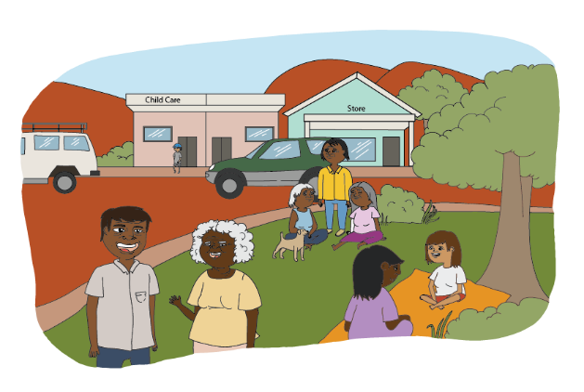

### 9. How could employers demonstrate that the jobs created are the ones communities want?

#### Co-designing job pathways with community members and ongoing community engagement with leaders

The importance of co-designing job pathways with community to ensure they meet local, place-based aspirations and economic priorities was a common theme.

Additionally, robust data collection and evaluation methods will be essential to measure the impact of job creation efforts on community development.

As a key metric, employers could demonstrate the jobs created are the ones that communities want through regular, ongoing engagement. This does not necessarily have to be a huge exercise, but ensuring that employers are listening to the communities in which they work will be a key factor in ensuring the jobs created align with what communities want.

As pre-application proof, it was suggested employers should seek to attach a letter of support to their funding applications from community leadership to demonstrate community support.

### 10. What can the program include to make sure it is flexible for the unique needs of different communities?

#### The RJED program should have realistic program requirements

Each community is different, there is not a one-size fits all approach that will work when it comes to program implementation, so the program should have realistic expectations of employers and organisations participating.

This could include reporting requirements, key performance indicators, measurements of success (not just economic but also social and cultural), the ability to be flexible with how funding is allocated, and flexibility around underspends (no penalties for rolling over funds/underspending).

There are also challenges of cross-government alignment, and the requirement for the RJED program to factor this alignment into its design and implementation. There needs to be consideration into how the RJED program will interact with income management systems, but also how it will support or interact with government agendas around renewable energy and major projects.

Concerns around conflicts of interest, acknowledging that in small communities, decision-makers can also often be employers and/or service providers and the need for transparent guidelines to manage these potential conflicts.

### 11. What are good examples of funding or services that are working on the ground?

#### Good examples include community-led initiatives rooted in culture

Several successful programs, with the community connect program provided as one example, demonstrate the value of community-led initiatives and local employment opportunities. Stakeholders emphasised that it is important to adapt successful models, which may have worked better in some communities than others, to suit the unique cultural and economic contexts of different communities. Many stakeholders raised the old Community Development Employment Project as a program that had a tangible impact on their communities, and noted poorer outcomes since the program was replaced.

There have also been successful partnerships between communities and private sector entities, which can create direct job pathways.

Ranger programs and art centres, as programs which tie into cultural jobs, are consistently held up as successful endeavours with high rates of participation and retention.

Questions for community organisations

### 12. Who should be eligible to apply for the program?

#### Accountable community-controlled organisations

On the topic of eligibility, there was general agreement that eligibility should be broad including sole traders to make sure there is a breadth of opportunities for job seekers. All eligible employers should demonstrate that they are committed to effective community engagement and are culturally competent. However, preference should be given for community-controlled organisations who are accountable to their communities, and where other organisations are involved they should be Aboriginal controlled or managed, or demonstrate a genuine Aboriginal employment strategy.

For community organisations, joint ventures between those organisations and other entities was seen as a potential opportunity to leverage expertise and resources, while still maintaining that community accountability and control.

### 13. What jobs could you create in your local community under this program?

#### Communities identified a broad range of ideas across many sectors

People would like to see a broad range across construction, health, hospitality, administration, trades, education, environmental management, youth and community work, aged care, cultural roles, mining and resources, community roles (for example night patrol and community liaison), and white-collar roles (for example in IT). This includes roles with long-term sustainability which are currently filled by external stakeholders, for example nurses, teachers, police etc.

While some communities stressed the need for part-time and casual roles, other communities said there was a strong desire for full-time jobs and small businesses.

An illustration of four Indigenous workers standing together. A tradesman, female construction worker, male nurse and female cook.


It was noted that there needs to be an emphasis on supporting economic empowerment through microbusiness support and business mentoring, to support community members to create their own jobs.

### 14. What are the challenges in remote communities to fill jobs?

#### Job seekers in remote communities have little or no access to meet job requirements

Challenges to filling jobs in remote communities centre around the ability for participants to meet requirements, or the desire to. Job seekers may experience one or several socio-economic barriers limiting their ability to seek employment. This could include, low level of education, limited opportunities for training or work experience, poor health and/or mental health, current and/or historic experience of trauma, transport and/or housing difficulties, caring responsibilities, or issues related to addictions. Welfare benefits and concessions impacting willingness to transition to employment, limited resources and infrastructure, social issues, family and cultural pressures, and thin economic conditions/labour market are also barriers to employment.

Seasonal fluctuations can significantly impact workforce availability in communities, with peak seasons (e.g. Dry Season) often drawing people away from communities for cultural obligations or work opportunities.

### 15. What do communities need to grow and build a small business?

#### Mentoring and streamlined access to support is critical

Small business growth in remote communities should be a key focus of the program, to create sustainable local economies. However, there is a need for business mentoring, streamlined access to support services, and coordination among funding streams between the RJED program and other business support programs to facilitate this growth.

### 16. What support do organisations need to successfully apply for the new program?

#### Organisations need simplified application pathways and place-based assessment

Clearer guidelines are needed, support for navigating and working through grant application processes, and consideration of funding allocation differences based on job creation scale. For organisations operating in very remote areas for example, the need for simplified application pathways was highlighted as a key point.

Assessment panels for program funding should also reflect local knowledge, or have local representation, to ensure community and place-based context is reflected in grant decisions.

### 17. How can NIAA work with communities to support sustainability of jobs?

#### NIAA needs to be adaptable and responsive to job shifts

A key factor that was raised is the need for the NIAA to ensure that it has the capacity through its regional offices to support facilitation between Aboriginal Corporations, local organisations, and the private sector as a neutral third party. Ensuring that there are clear lines of communication in the NIAA for community stakeholders to engage, and clarity around roles and responsibilities of all involved in the program, will be essential.

Concerns were raised around how the jobs created by the RJED program will remain sustainable in the long term beyond the funding window. While ensuring that the roles are adaptable and responsive to local needs and conditions will be critical for long-term sustainability, the economic conditions in remote communities is a significant factor that needs to be taken into account.

# For more information

You can keep up-to-date on the progress of the remote employment reforms by [registering your interest](https://www.niaa.gov.au/our-work/employment-and-economic-development/remote-jobs-and-economic-development-program#subscribe-for-updates-) to receive email updates, which include additional opportunities to provide feedback.

Email us at [remote.jobs@niaa.gov.au](mailto:remote.jobs@niaa.gov.au)

Contact your local NIAA Regional Office on 1800 079 098.

Visit [NIAA.gov.au/remote-jobs](http://www.niaa.gov.au/remote-jobs)

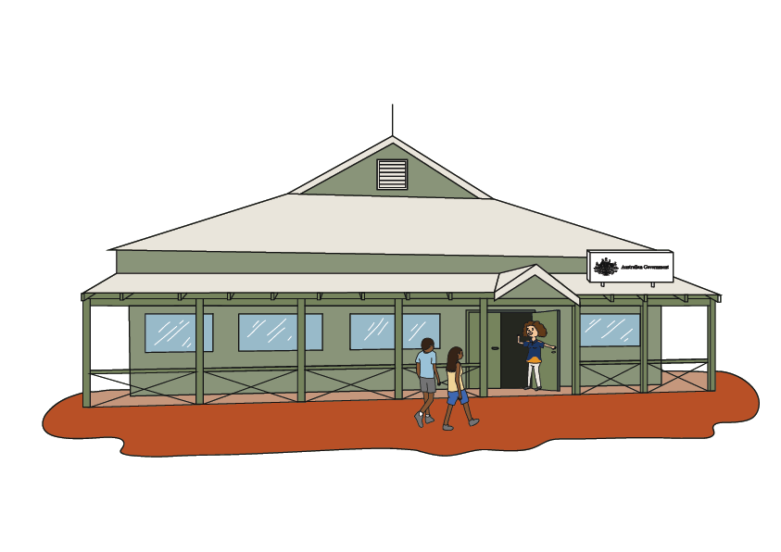

## Appendix A: Evolution of employment services

The Australian Government has provided employment services to job seekers in some form in remote Australia since 1977. To remain fit for purpose, programs have continuously evolved over time.

## 

### Pre-2000

1977 — Community Development Employment Project (CDEP) Commences.

1986 — CDEP expands to non-remote areas.

1991 — Legislative changes to the Social Security Act “The Legislative Bar” to make CDEP participants ineligible for unemployment benefits.

1997 — Work for the Dole pilot introduced in Mainstream Income Support.

1998 — Work for the Dole expansion.

1999 — CDEP Scheme Participant Supplement (CPS) is introduced following the 1998-1999 Budget Announcement.

### Early 2000s

2004 — ATSIC abolished and CDEP transferred to the Department of Employment and Workplace Relations.

2006 — Policy changes to realign with move to Department of Employment and Workplace Relations.

2007 — Northern Territory Emergency Response commences.

2009 — New CDEP participants can no longer receive wages.

### 2010–2020

2013 — Remote Jobs and Communities Program (RJCP) replaces Jobs and Skills Australia, CDEP and Disability Employment Services in remote areas.

July 2015 — Community Development Program (CDP) commences 1 July 2015.

2018 — CDP reforms announced as part of 2018-19 Budget.

2018 — Aboriginal Peak Organisations of the Northern Territory (APO NT)’s *Fair work and Strong Communities* report published.

2019 — CDP Reforms including revised provider payment model; Capital Investment Fund; Community Advisory Boards to support local governance and decision making (noting not established in all regions); reduction in mutual obligation hours; expanded flexibility guidelines for job seekers; subsidised jobs through the 1000 Jobs Package.

March 2020 — COVID pandemic boarder restrictions came into place.

### 2021–2023

May 2021 — Participation in CDP activities became voluntary, CDP participants still required to meet mutual obligation requirements by attending regular appointments with their provider, agree to a Plan, actively look for work (if part of their Job Plan), accept suitable job offers and not voluntarily leave suitable employment.

August 2022 — Former Minister Burney hosted a remote employment roundtable.

September 2022 — National Indigenous Australians Agency (NIAA) conducted consultations on Community Development trials.

November 2022 — Community Development trials commence.

November 2022 — NIAA conducted consultations on New Jobs Program trials.

February 2023 — NIAA consulted with communities on how to design and deliver a program to replace CDP.

July 2023 — Ngaanyatjarra Lands Trial commences.

### 2024

February 2024 — Government announced they will replace CDP in two stages. The first stage will be to develop a new remote jobs program. The second stage will be to transition to a new remote employment service.

March 2024 – First Nations Reference Group established to provide advice and work with Government to design and implement the new program.

April 2024 – NIAA begins Community Consultations in remote Australia on how the RJED program could work.

June 2024 – NIAA held roundtables in regional Australia.

June 2024 – NIAA held the CDP roundtable (virtually).

Mid to late 2024— The RJED program begins, creating 3,000 real jobs, with proper wages and decent conditions, with jobs phased in over 3 years.

30 June 2025 – CDP provider arrangements and CDP end.

From mid 2025 — A new remote employment service will support people to get job ready to find employment.

## Appendix B: Summary of feedback on the new remote employment service

### Overarching themes

* Broadly, feedback indicated that the new remote employment service should be participant centred with case management to focus on the participant’s job readiness pathway.
* The new remote employment service should be planned and led by communities. Some CDP arrangements are not working and Providers could do more to help participants secure employment.
* There is a need for more local job creation – moving people off income support and into real jobs (jobs stimulated through the RJED program or other).
* The relationships between Providers and participants should be based on reciprocity. Some providers could do more to build trust and rapport with participants and encourage engagement.
* We heard providers could be more flexible with appointments i.e. Providers meeting participants in community, rather than participants attending the providers premises.

### Mutual obligations

* In May 2021 compulsory activity attendance was removed as a mutual obligation requirement under current CDP. Some communities have said they would like to see compulsory activity attendance introduced under the new model. In some cases, participating in community activities helped build confidence and overall well-being. Purposeful community activities helped participants move closer to getting a job.
* Community activities under the new model should align with individual and community goals and help build skills leading to employment.
* Some communities have said it is fair and reasonable to participate in community activities in return for income support, and that activities need to be flexible depending on community and participant employment goals.

### Quality assessment and wrap-around supports

* We heard that it is important that participants are assessed to identify aspirations and goals, barriers to work, needs and supports required, capability and capacity to work. Noting previous work experience, education and training also helps build a fulsome assessment of the participant.
* Assessment tools such as the Jobseeker Classification Instrument (JSCI) should be culturally appropriate for First Nations job seekers in remote Australia.
* Under the new model there should be strong support pathways for those who are unable to work right now. This could include referrals to wrap around support services or non-vocational training such as financial literacy.
* Some participants have high barriers to employment or disability. We heard participants in remote Australia should have access to an Employment Services Assessment (ESAt) to ensure they’re receiving the correct payment (Disability Support Payment or other).

### Tailored support to become job-ready

* We heard job seekers require support from providers to become job-ready. These supports include obtaining identification such as a drivers license or birth certificate, setting up an Australian bank account, obtaining a Tax File Number, and/or a superannuation fund. Under the new model it should be explicit that providers support job seekers to obtain such documentation to become job-ready.
* In some cases, training and support offered to job seekers is outside community. This presents transportation barriers and being away from family and cultural responsibilities for a period of time.

### Tailored support for youth

* We heard that young people need tailored supports to find and maintain suitable employment.
* Some young people lack motivation to work due to limited jobs that align with their goals, aspirations and skill set.
* Young people need to be empowered to learn new skills and bring those skills back to community. It’s important for the new service to work differently with young people so they reach their full potential.

### Training and support for providers

* It was suggested to explore opportunities for a Community of Practice or learning exchange between remote employment service providers.
* We heard thorough training and induction packages for Providers would be beneficial.

## Appendix C: CDP communities we engaged with

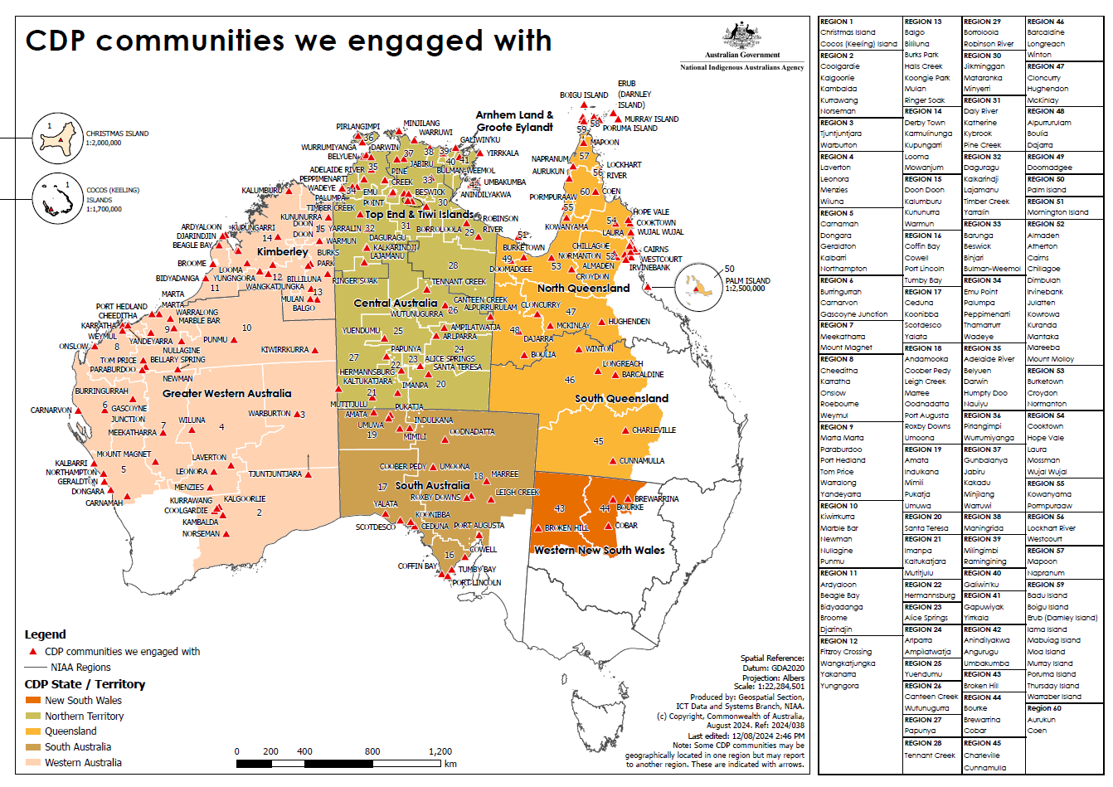

## Journey map Planned and led by community The employer and community leaders will work alongside their community to identify jobs and how they will be created. NIAA will support employers to apply for funding through a grants process for local jobs. How to use funds The employer will sign a grant agreement with NIAA to receive funds. They will be able to start their recruitment process working with a remote employment service provider to fill jobs. On-the-job support The employer will support employees through on-the-job training, cultural mentoring and upskilling to help transition them into paid employment. Eligible employer within community Apply for funding Access and manage a grant Fill the jobs Contribute to building the remote economy Working in Partnership The National Indigenous Australians Agency (NIAA) will partner with the First Nations Reference Group and First Nations communities to design and implement a program that empowers individuals and the community. The Community Jobs and Business Fund means the employer can also identify the equipment or capital needed to make these jobs a reality. Support from service providers Remote employment service providers will support job seekers to get them ready for work-like training, help with job applications and paperwork. Employees will work in culturally safe workplaces with fair conditions, leave and superannuation. They will also receive mentoring. Creating a skilled workforce to help attract more investment into communities. Other Government services Government services, including Centrelink, can also support job seekers. Appendix D: Journey maps

User journey: Job seeker

The Remote Jobs and Economic Development Program will create jobs for people looking for work. 

I want meaningful work
Job seekers want to find meaningful and culturally-safe employment with pathways to progression. 

They want to learn and earn on their Country and receive tailored support. They want fair pay and conditions so they can support themselves and their families. 

I need a hand
job seekers are supported by a remote employment service to get them ready to work - like training, help with job applications and getting a tax file number. 

I'm learning new skills
Employees receive on-the-job training, cultural mentoring and upskilling. 

I got a job
Job seekers move from a remote employment service into a real job created by RJED employers. 

Employers provide wages and conditions, and allow flexibility for personal, family and cultural commitments. 

They may continue to access other Government supports like Centrelink, NDIS, housing and medical. 

I've got a real job, new skills, fair conditions and pay
Employees work in culturally safe workplaces with fair pay and conditions. They have new skills that will help them in employment long-term. 


User journey: Community

The Remote Jobs and Economic Development Program will empower communities to thrive culturally, socially and economically

We want our community to get stronger
Communities want self-determination, connection and care for their community and culture. 

They want to establish a greater level of community control and ownership. 

We have a say in how the new program should work
The National Indigenous Australians Agency engages with the community to understand local needs and opportunities. 
Communities influence the design of the program so it benefits them and their economy. 

We keep giving feedback
Communities keep giving feedback so the program can continue to improve

We decide the jobs we need
Together, communities and employers identify which services, projects and jobs are needed. 

Our community is getting stronger and our economy is growing
The community benefits from local jobs and economic opportunities.  


User journey:
Remote employment service providers

The remote employment service will complement the Remote Jobs and Economic Development program by providing support for participants. 

We want to contribute to a strong workforce

Providers support job seekers, and people who aren't able to work right now to build skills and contribute to their community by connecting them to the services they need to address barriers to employment. 

We partner with government
Providers work with NIAA to design and deliver employment services. They seek and apply for funding from the NIAA and other government agencies. 

We support employers
Providers assist employers to train, mentor and retain their employees. 

We help job seekers get job-ready
Providers support job seekers to get a tax file number, set up a superannuation account, fill out job applications and do training so that they are prepared for work. 

They negotiate flexible work arrangements with an employers based on a job seeker's needs. 

Employees are supported and have pathways to progress

User journey:
Employer

The Remote Jobs and Economic Development program (RJED) employers will create jobs that deliver services local community wants and needs. 

We need local jobs
The local community works with employers to identify services and projects they need and want and the jobs this would create. 

We need funding
RJED employers are supported by the National Indigenous Australians Agency (NIAA) to apply for funding to employ job seekers

As part of this, they may apply for funding under the Community Jobs and Business Fund to purchase equipment and resources to make their jobs a reality. 

We get help to train and retain our new workers
RJED employers work with remote employment service providers to prepare and support jobseekers into paid employment. 

We're hiring local people and buying equipment
RJED employers sign a grant agreement with the NIAA and receive funds. 

They can purchase equipment and resources, and work together with a remote employment service provider to fill jobs. 

People have meaningful work
Local people have meaningful work in their community, and the economy is getting stronger. 

## Appendix E: Feedback received on the RJED program Grant Opportunity Guidelines

| Section of the GOGs | Sub-section of GOGs | What we heard |
| --- | --- | --- |
| 2. About the RJED grant program | [2.0] | The GOGs need to better define the terms:   * Community, and * Real/meaningful jobs.   A number of feedback submissions indicated that people wanted assurance that lessons learned from the remote job trials would be incorporated into the new program.  A small number of comments suggested that grant should fund more than the planned 3,000 jobs.  Sustainability of jobs long term was a concern and ongoing job funding past the intention of this grant was raised multiple times.  Workforce development is important to communities. Providing people with opportunities to learn new and strengthen existing skills will help with skills shortages which is a major barrier to economic development in communities.  Good and easy communication between communities and the NIAA is important. |
| 3. Grant amount and grant period | 3.1 Grants available | Feedback suggested that there should be more flexibility about the amount of funding that an organisation can apply for, and the length of time that a grant can run. |
| 3.2 Grant period | The need for flexible minimum job periods was raised.  Feedback asked for clarity on the requirement for employees to be supported into other jobs after their RJED job finishes.  Requests for the funding period to be extended beyond 3 years to ensure employer stability, enable better planning and undertake bigger projects in community. |
| 3.3 Indicative regional allocations | There was considerable feedback on regional allocations including:   * using the CDP caseload as the basis for regional allocations * not disadvantaging smaller communities * allocations for each region not being sufficient to meet the needs of community and   Should allocate number of FTEs and/or funding amounts, not the number of employees, so that people can share positions. |
| 4. Eligibility criteria | 4.1 Who is eligible to apply for a grant? | Feedback received indicated that a broad range of entities should be eligible to apply for the grant, including:   * local governments * Vocational Education and Training (VET), TAFEs and Registered Training Organisations (RTO) * joint ventures * CDP providers including trials * partnerships   Submissions suggested that ACCOs should be included with a focus on capability building.  Some feedback indicated that the program should broaden eligibility for other grassroots organisations.  Simplify eligibility requirements to reduce barriers. |
| 4.2 Who is not eligible to apply for a grant? | There was a view that non-Aboriginal for-profit organisations should not be eligible to apply for RJED grant funding.  There should be controls on organisations’ legal and HR capacity to employ people. |
| 4.3 What qualifications, skills or checks are required? | The RJED program should cover the costs of removing barriers to employment such as getting ID, ochre cards, police checks etc. |
| 5. What the grant money can be used for | 5.1 Eligible grant activities | Requests for clarity around the future of jobs currently under the Trialling Pathways to Real Jobs CDP trial and the New Jobs Program Trial for the period.  Some feedback indicated that communities wanted to be able to fund existing jobs. |
| 5.2 Job Creation Eligible Employees (Employer Responsibilities) | Employee’s rights and protections should be supported.  Small ACCOs and community organisations need investment in capacity building to meet the legal obligations of an employer.  Need clarity on employer responsibilities and reporting requirements upfront  Soften the requirement to work with CDP providers  The RJED program should be for all remote job seekers, not just existing CDP caseload  Clarify what entry-level jobs are, and not exclude jobseekers with qualifications or experience |
| 5.4 Job Creation - Eligible locations | Some feedback indicated that eligibility should only be for CDP regions, however there was also feedback received that indicated a need for flexibility to include people just outside CDP boundaries.  We heard that we should consider the different needs between remote and very remote communities. |
| 5.7 B. Community Jobs and Business Fund (CJBF) | CJBF should fund:   * support for ACCOs/small organisations to comply with Fair Work obligations * on-boarding checks and qualifications including WWVP and police checks * housing and transport support for employees * supervisors and mentoring * enterprise creation and development * training and skills development including literacy, numeracy and financial literacy.   Remove the requirement to have a separate bank account for the CJBF component. |
| 5.8 What the grant money cannot be used for | Incentives or vouchers for participants. |
| 6. The assessment criteria | 6 | Be transparent about criteria used to prioritise and award grants.  Flexibility: include casual jobs and proposals offering work using a ‘casual pool’ model  Prioritise youth: set targets based on the proportion of the CDP caseload that are youth. Consider aiming for a 25% target.  Community support/community priorities:   * prioritise jobs that benefit individuals, families and communities * prioritise jobs that don’t exist in the labour market * fund jobs and projects that support economic development * grants should support local communities’ needs – some feedback recommended place-based approaches * incorporate cultural relevance into assessment criteria.   Demonstrating how a project meets community needs:   * Applicants should use letters of support or meeting minutes to demonstrate community support for a project. Other types of evidence should also be accepted (without limiting the types of evidence that could be used). * When consulting on community need, work with existing bodies including councils. * Consider how to confirm that grant recipients are checking in with community as a grant progresses. |
| 7. How to apply | [7.0] | The application process should be as simple as possible and include substantial support from the NIAA.  Organisations are already burdened with significant administration and this process should be as easy as possible.  The better support, the more likely smaller organisations can apply.  Support with grant writing. |
| 7.4 Timing of grant opportunity processes | Processing can take too long.  Application process should be phased. |
| 8. The grant selection process | 8.1 Assessment of grant applications | Fair, inclusive, streamlined and transparent process. |
| 8.2 Indigenous Grants Preferencing Policy | A variety of view were expressed about what kind of organisations should be prioritised for funding, but the majority of feedback expressed that ACCOs and other small, local organisations are best placed to be part of the RJED program.  We heard an even split of views both for and against prioritising local government councils. |
| 8.3 Who will assess applications? | Need diverse and local representation on assessment panels, or local knowledge experts.  Where there are established local decision-making forums, they should be included in the assessment process. |
| 9. Notification of application outcomes | 9.1 Feedback on your application | Clear, concise and timely communications with applicants |
| 10. Successful grant applications | 10.4 Execution of the grant agreement | The program should provide ongoing support and mentorship to successful applicants. |
| 10.6 How we pay the grant | Payment schedule should be flexible and straightforward. |
| 12. How we monitor your grant activity | 12 | The RJED program should have a compliance framework and a robust monitoring and evaluation framework.  Reporting requirements should be made clear upfront, as they can be burdensome and affect whether an employer wants to apply.  Employers should be supported to meet their reporting requirements.  Monitoring should include ensuring workplaces are safe and compliant with Fair Work requirements. |
| 13. Probity | 13.2 Conflicts of interest | These should be effectively managed. |
| 14. Consultation | 14 | Consultation should continue throughout the process of replacing the CDP. |