Budget 2024–25
  - Delivering better outcomes for First Nations peoples

The Government is investing in better outcomes for Aboriginal and Torres Strait Islander peoples in health, housing, jobs, education and justice. This is part of a commitment to the National Agreement on Closing the Gap and to listening to and working with First Nations peoples to create new opportunities, accelerate progress and achieve better outcomes.
This Budget invests $2.4 billion in real actions that will make a tangible difference to First Nations peoples’ lives. The Government has listened to First Nations peoples and is focusing this Budget on:
- Supporting real jobs and economic development, particularly in remote communities.
- Building and maintaining housing and critical infrastructure in the Northern Territory (NT).
- Ensuring First Nations students are educated in culturally competent ways and supported when living away from home.
- Investing in mental health, suicide prevention, and family wellbeing that builds on the cultural strengths in First Nations communities.
- Supporting the health, wellbeing and safety of First Nations women and children.
- Improving access to critical medicines and preventing communicable diseases.
- Supporting and celebrating strong First Nations cultures, language and history.
- Investing in justice reinvestment, a community-led approach to supporting at-risk young people and improving community safety.
Since the 2022–23 October Budget, the Government has invested more than $5.7 billion in initiatives for First Nations peoples and communities.

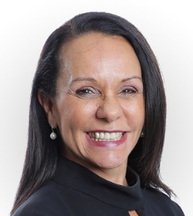
Minister’s statement
The Albanese Labor Government is investing to close the gap.
This Budget delivers on the commitments made in the Commonwealth’s 2024 Closing the Gap Implementation Plan.
This includes investing an additional $2.4 billion to improve housing, and develop a new approach to remote jobs and economic development.
We are investing in better outcomes in mental health and family wellbeing.
We will continue to implement the Aboriginal and Torres Strait Islander Action Plan, under the National Plan to End Violence against Women and Children 2022–2032.
In the NT, our ongoing commitment to delivering A Better Safer Future for Central Australia will see $18 million invested to build new and upgrade existing boarding facilities in Central Australia.
I know the last year has been tough for Indigenous Australians, but together we’re making progress to deliver a better future for our peoples and our communities.
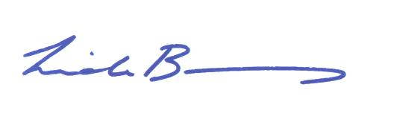
The Hon Linda Burney MP
Minister for Indigenous Australians
May 2024

Delivering real jobs and economic development
Jobs and economic development are crucial to self-determination and improving outcomes for First Nations peoples and communities.
In February, the Government announced the new Remote Jobs and Economic Development Program that will help close the gap in employment outcomes. $777.4 million over 5 years from 2023-24 (and $255.5 million per year ongoing) will fund the:
- Creation of 3,000 real jobs, with proper wages and decent conditions in remote Australia.
- Community Jobs and Business Fund, to support community development and creation of employment opportunities through capital and equipment funding, and capacity building.
- Extension of current Community Development Program provider arrangements from 31 October 2024 to 30 June 2025, while work on the design of the new program gets underway.
- Expansion of the New Jobs Program Trial, to support current demand until the Remote Jobs and Economic Development Program commences this year.
The Government is building on this investment and supporting First Nations economic development with an additional:
- $68.0 million over 4 years from 2023-24 for First Nations Digital Inclusion measures to deliver free community Wi-Fi in remote communities, establish a First Nations Digital Support Hub and a network of digital mentors to provide culturally competent support, and to improve the national collection of data on First Nations digital inclusion.
- $20.2 million over 4 years from 2024-25 (and $3.6 million per year ongoing) for the Federal Court and National Native Title Tribunal to reduce the backlog of Native Title claims, resolve post-determination disputes and preserve culturally and historically significant Native Title records that underpin the resolution of future claims. The Government will also provide $0.5 million over 2 years from 2024-25 to the Australian Law Reform Commission to
review the future acts regime within the
Native Title Act 1993.
- $15.0 million over 4 years from 2024–25 to work with First Nations peoples and communities to support connection to Country through management of drought and climate risks.
- $11.8 million over 4 years from 2024-25 to support First Nations groups to participate in upfront consent processes for Australian Carbon Credit Unit Scheme projects on Native Title lands.
- $2.7 million over 4 years from 2024-25, as part of the Future Made in Australia – Making Australia a Renewable Energy Superpower measure, to expand the First Nations Renewable Hydrogen Engagement Fund.

Indigenous rangers
Indigenous rangers use traditional knowledge and cultural practices to manage land, river and sea Country across Australia and deliver positive environmental, cultural, social and economic development outcomes to rangers and their communities.
The Government is delivering on its election commitment to double the number of Indigenous rangers to 3,800 by 2030. Up to 1,000 new ranger jobs will be delivered through a recent funding round which is expected to increase the number of women rangers and support new Indigenous Rangers Groups to manage Country.

Housing and essential services
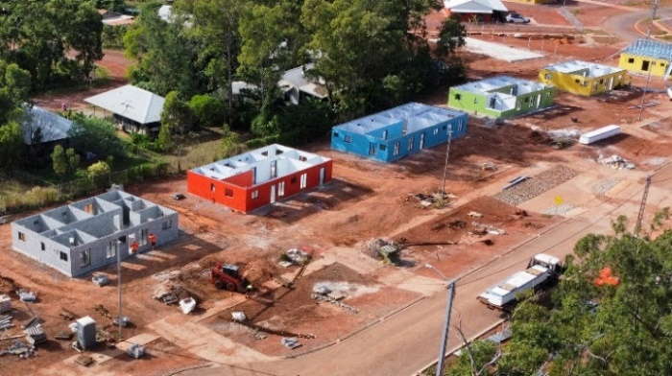
New homes under construction in Yirrkala (NT)
Delivery of much-needed housing across remote NT communities has accelerated significantly, with Commonwealth-funded delivery more than doubling between 2021-22 and 2022-23. Despite this, the problem of overcrowding remains acute and more needs to be done.
In March, the Federal and NT governments announced a joint $4.0 billion investment over 10 years for housing and homelands in remote communities across the NT.
The investment will see up to 270 houses built each year, with the aim of halving overcrowding within a decade. It will also continue support for repairs and maintenance, create local employment opportunities and support the sustainability of Aboriginal Business Enterprises.
Additional investment to support remote NT communities and homelands includes:
- $120.0 million over 3 years from 2024-25 to continue delivering repairs and upgrades to housing and essential infrastructure on NT homelands.
- $20.0 million in 2023-24 to deliver an additional 49 houses under the existing Remote Housing Northern Territory Federation Funding Agreement, in partnership with and jointly funded by the NT Government, delivering a total of 206 houses under the one-year agreement.

- $1.0 million to Aboriginal Housing NT over 2 years from 2024-25 to support their partnership role and development of a Community-Controlled Housing Model.
Improving Closing the Gap outcomes in remote NT communities relies on the delivery of essential services, including health, education and community safety.
The Government is investing $111.1 million in 2024-25 to continue these critical services under the National Partnership on NT Remote Aboriginal Investment. This will support the NT to improve schooling for First Nations children through programs including Families as First Teachers, make communities healthier and safer by maintaining 19 women’s safe houses and remote family support services across 23 communities, and increase access to interpreter services and job opportunities for First Nations Australians.

Investing in First Nations water
The Government is delivering on its $150.0 million commitment to support water infrastructure for First Nations communities in regional and remote Australia.
Clean and reliable drinking water is something that many Australians take for granted. For many First Nations peoples living in remote Australia, reliable drinking water isn’t a given.
The Government has already commenced upgrading water infrastructure in communities in the NT (Maningrida, Yirrkala, Gunyangara, Numbulwar, Yuendumu and Milingimbi) and South Australia (Iga Warta).
The Government continues to work closely with state and territory partners and First Nations communities to plan and deliver water security projects.

Supporting First Nations students to achieve their full learning potential
The Government is committed to ensuring First Nations people have equal access to education and the opportunity to fulfil their potential.
The Government will invest to accelerate action and deliver against the Closing the Gap Priority Reforms, by supporting First Nations education partnership, policy development and program delivery.
Education investment of $110.0 million over 4 years (and $11.0 million per year ongoing) will provide:
- $18.2 million over 4 years from 2024-25 (and $2.2 million per year ongoing) to develop a new National First Nations Education Policy. The Government will work with First Nations peak organisations and stakeholders to develop the policy to drive stronger education outcomes.
- $29.1 million over 4 years from 2024-25 (and $8.7 million per year ongoing) to support national First Nations peak organisations National Aboriginal and Torres Strait Islander Education Corporation and SNAICC - National Voice for our Children to partner with Government on matters affecting First Nations children in early childhood education.
- $27.5 million over 4 years from 2024-25 to extend the existing programs which aim to improve educational outcomes of First Nations students. These include: Australian Indigenous Education Foundation Scholarship Program; Australian Institute for Teaching and School Leadership’s Indigenous Cultural Responsiveness Initiative; and English Language Learning for Indigenous Children.
- $2.4 million over 3 years for the First Nations Teacher Strategy to increase the number of First Nations teachers, helping to ensure students are taught in a culturally appropriate way to achieve their full learning potential.
- $32.8 million to support the Clontarf Foundation in the 2025 school year to continue its school engagement programs for First Nations boys.

Strengthening health and wellbeing
Access to affordable and culturally appropriate health services is essential to closing the gap in life expectancy. This Budget provides:
- $11.1 million over 5 years from 2023-24 (and $2.8 million per year ongoing) to expand coverage of the Closing the Gap Pharmaceutical Benefits Scheme (PBS) Co-payment Program to all PBS medicines for eligible First Nations peoples. There are over 660,000 First Nations patients registered under the co-payment program, with benefits to be extended to an additional 1,315 PBS medicines.
- $94.9 million over 2 years to continue and expand national strategies for First Nations vaccination uptake, sexually transmissible infection testing and culturally safe sexual health services, and communicable disease molecular point of care testing.
- $10.0 million in 2024-25 to deliver targeted and culturally appropriate mental health supports for First Nations peoples.
- $4.7 million over 5 years from 2023–24 for the NT Medical Program to increase the number of First Nations medical practitioners and address recruitment and retention challenges.
- $4.0 million over 4 years from 2024–25 to the Australian Indigenous Doctors’ Association to continue to support First Nations doctors to become medical specialists.
The Government is focused on supporting the health and wellbeing of more First Nations women in this Budget.
- $12.5 million over 4 years from 2024-25 will be provided to the National Aboriginal Community Controlled Health Organisation to facilitate community-led distribution of menstrual products in regional and remote First Nations communities where menstrual products are expensive and hard for First Nations women and girls to access. Improved access is expected to benefit 12,500 First Nations women and girls each year.
Birthing on Country
Birthing on Country will be supported through the measure Women’s Health. The Midwife Professional Indemnity Scheme will expand to cover privately practicing midwifes providing low-risk homebirths, including Birthing on Country models of care.

Stronger families
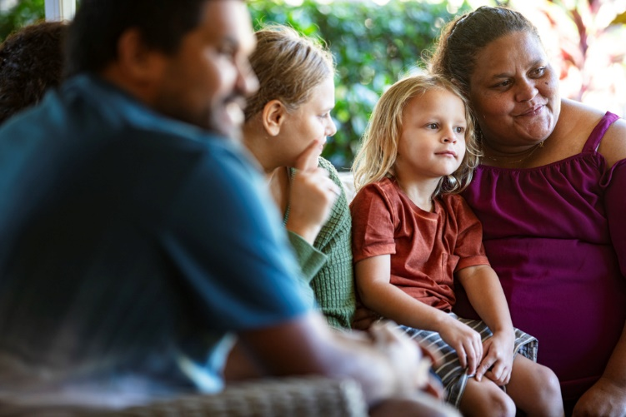
The Government is working together with First Nations organisations and communities in this Budget to create real change for children and families in Australia.
- $5.9 million over 2 years from 2024-25 to establish an interim National Commissioner for Aboriginal and Torres Strait Islander Children and Young People. The interim National Commissioner will work in partnership with First Nations peoples and communities, states and territories and other stakeholders, to design the specific powers, roles, and functions of the legislated independent National Commissioner. The National Commissioner will work to protect and promote the rights, interests and wellbeing of First Nations children and young people.
The Government is investing in several additional measures to support First Nations families.
- $12.8 million over 4 years from 2024-25 to continue the Indigenous Youth Connection to Culture Program in 12 communities, a place-based initiative, designed with First Nations Elders that responds to an immediate need for cultural and community based suicide prevention activities to support First Nations youth.
- $11.7 million over 2 years from 2024-25 for the First Nations Family Dispute Resolution Pilot to continue to support Aboriginal and Torres Strait Islander families to resolve disputes around separation in a culturally safe setting.
- $96.9 million over 4 years from 2023-24 for the Youpla resolution. Those receiving resolution payments will have the choice between a funeral bond or a cash payment.

Justice support services
The Government is committed to working in partnership with communities to prevent crime, improve community safety and reduce the number of Aboriginal and Torres Strait Islander adults and children in the criminal justice system.
The Government is providing $76.2 million over 5 years from 2023-24 (and $18.7 million per year ongoing) to establish a new evidence-led First Nations prison to employment program that is personalised and holistic. The new program is expected to support 3,400 First Nations people in 2025-26, and 6,000 people annually from 1 July 2026.
The program will provide mentoring and help to reconnect with health, housing and other social services, and to better connect to employment opportunities, reducing the risk of re-offending.
In addition, the Government is investing to improve Closing the Gap justice outcomes and support family and community safety.
- $10.7 million over 4 years from 2024-25 to provide the next stage of funding for the First Nations Justice Policy Partnership to continue its work. The partnership will focus on implementing its strategic framework, improving justice outcomes on the ground and transforming the justice system to reduce the rates of adult and youth incarceration.
- $24.0 million in 2024-25 under the National Legal Assistance Partnership to Aboriginal and Torres Strait Islander Legal Services, and National Family Violence Prevention Legal Service (FVPLS) providers as a first step towards addressing the pay disparity between FVPLS and the broader community legal assistance sector.
- $4.6 million in 2024-25 to ensure service continuity for the Custody Notification Service (CNS) while future funding mechanisms are designed in collaboration with First Nations stakeholders and state and territory governments, informed by the National Legal Partnership Review and the CNS Evaluation.

Preserving and celebrating First Nations cultural heritage and language
Strong First Nations cultures, languages and connection to Country are fundamental to improved life outcomes. This Budget provides:
- $53.8 million over 4 years from 2024–25 (and $17.8 million per year ongoing from 2028-29) to increase the number of First Nations language speakers through enhanced support for community language learning and new language centres.
- $10.3 million over 4 years from 2024–25 (and $2.7 million in ongoing funding from 2028–29) to support the Australian Institute of Aboriginal and Torres Strait Islander Studies (AIATSIS) in the Return of Cultural Heritage program to facilitate the return of historic cultural materials held in overseas collections to Traditional Owners and Custodians.
- $7.3 million in 2024–25 for AIATSIS to support and enhance its ongoing role in facilitating Aboriginal and Torres Strait Islander cultural heritage activities and for urgent capital repairs and maintenance at AIATSIS’ facilities.
- $3.6 million over 2 years from 2026-27 for performing arts training organisations to support First Nations students and workers.
Cultural heritage reform delivers on an election commitment to improve and streamline the Aboriginal and Torres Strait Islander Heritage Protection Act 1984 (ATSHIP Act). To improve outcomes and confidence in the cultural heritage protection system, the Government will provide $17.7 million over 3 years from 2024-25 to reduce the backlog, support administration of complex applications under the ATSHIP Act and progress the reform of Australia’s cultural heritage laws.
First Nations land and water resources
The 35-year Resourcing Australia’s Prosperity initiative will support First Nations peoples to manage their land and water resources, and be more fully informed about potential mining projects. It will include national data collection programs and resource potential assessments along with partnerships and co-design of regional projects to understand resource potential, sustainable management of groundwater, and build First Nations peoples’ expertise in applications of geoscience to care for Country.
The Government will also invest $12.9 million over 2 years from 2024-25 for the Indigenous Electoral Participation Program to support First Nations peoples’ enrolment and participation in the electoral process.

Central Australia
The Government continues to work in partnership with local communities in Central Australia and the NT Government to deliver the plan for A Better, Safer Future for Central Australia.
From establishing the Central Australia Plan Aboriginal Leadership Group for independent advice and guidance, to delivering stronger health services and infrastructure including the Todd Street Health hub, the Government’s investment is backing more services and support where they're needed most.
The Plan has already delivered a range of initiatives, including:
- Increasing funding for police, domestic violence services and youth services
- Expanding domestic violence services in remote communities
- Delivering Traditional Owner community night patrols in Alice Springs
- Improving access to preventative health services for children and families with early intervention, fetal alcohol spectrum disorder and autism diagnosis and support
- Supporting more alcohol and other drugs treatment and rehabilitation services
- Increasing funding for every school in Central Australia, getting more kids to school and keeping them there
- Upgrading Wi-Fi in 4 Town Camps
- Funding the construction of 20 beds to provide safe short-term accommodation in Alice Springs
- Improving lighting and safety measures at community spaces across Alice Springs
- Building better health infrastructure, such as the Todd Street Health hub
- Backing more youth programs and activities in Town Camps with a new purpose built Mobile Youth Hub Bus.
In addition to the $250 million Plan, the Government will increase its support by investing $18.0 million over 2 years from 2024-25 to build new and improve existing boarding facilities in Central Australia for students from remote NT communities. The Government will also provide $14.2 million over 18 months in additional funding to deliver policing and other community safety support in Alice Springs.
This investment extends the National Partnership agreement between the Commonwealth and NT governments to ensure a joint approach to building a better, safer future for Central Australia.
