Remote Jobs and Economic Development program
  - Discussion paper
May 2024

Contents
Foreword from the Minister for Indigenous Australians, the Hon Linda Burney MP 4
Purpose of the discussion paper 5
Background 6
Timeline for the Remote Jobs and Economic Development program 7
Why are we seeking feedback? 7
What we will do with your feedback? 8
The Remote Jobs and Economic Development program 8
Who can apply for RJED funding? 9
Who will fill the jobs created by the RJED program? 10
What types of jobs will the RJED program support? 10
Examples of jobs that may be supported by the RJED program 11
What could the RJED program fund? 12
Economic Development 12
Journey Map: Remote Jobs Economic Development program 13
Discussion questions 18
Understanding the RJED program – refer to diagram above 18
Job seekers 18
Community 18
Community organisations (employers) 19
Next Steps 20
Provide your feedback 20
Privacy and Copyright notice 20

Acknowledgment of Country

The National Indigenous Australians Agency (NIAA) acknowledges the Traditional Owners and Custodians of Country throughout Australia and acknowledges their continuing connection to land, waters and community. We pay our respects to people, cultures and Elders past and present

Working together for a future of equality
An artwork by Jordana Angus for the Australian Government.

Foreword from the Minister for Indigenous Australians, the Hon Linda Burney MP
The Albanese Labor Government is transforming the old Community Development Program (CDP) and replacing it in two stages. The first stage, announced in February 2024, is the new Remote Jobs and Economic Development (RJED) program.
The RJED program will provide communities with the jobs you want and need, creating 3,000 jobs over 3 years to boost economic opportunities. These jobs will be real jobs, with proper wages and decent conditions, starting in the second half of 2024.
The second stage, expected to start in the second half of 2025, will look to support people to prepare for and find employment – to help people get ready for local job opportunities.
The purpose of this consultation paper is to provide you with an opportunity to inform the design and implementation of the first stage, the RJED program.
I will work in partnership with First Nations peoples to design the new program.
I know that when we listen to First Nations communities about the design and implementation of policies they are far more likely to make a lasting positive difference, and importantly help close the gap.
I strongly encourage you to look at the key issues in this paper and provide your views.
I look forward to hearing your views on this once in a generation reform.

The Hon Linda Burney MP

Purpose of the discussion paper
The purpose of this discussion paper is to seek views from interested stakeholders on the design and implementation of the Remote Jobs and Economic Development (RJED) program. To ensure the new program meets community needs it must be developed in partnership with remote communities.
This is phase two of the consultation process and will help finalise recommendations to Government on program design prior to the launch of the program in the second half of 2024. The third stage of consultations will be to design a new employment service program to support the RJED program.
Phase one consultations were held between February to June 2023. The-NIAA consulted with over 100 CDP communities and heard from over 2,250 people about what should be included in a new jobs program in CDP communities. We also received more than 210 anonymous survey responses and 50 ‘Have Your Say’ web-forms. We heard from stakeholders that a new program should:
- Be planned and led by community.
- Support more local jobs for local people.
- Include something fair and meaningful for the community or for your job prospects in return for income support.
- Recognise the roles done in community including a new approach for youth.
- Have support for people who cannot work right now.
- Be flexible to invest in local priorities.
You can read the consultation report by visiting the NIAA website.
The NIAA are also testing new approaches to remote employment through job trials to inform the design of the new program.
This discussion paper is about designing the RJED program. Consultation on the new employment services program will be later in the year.
Submissions are open until 30 June 2024.

Background
The Australian Government is committed to improving job opportunities for remote communities. What we know is that the current Community Development Program (CDP) is not working for everyone.
The CDP is a remote employment and community development service. CDP aims to support job seekers in remote Australia to build skills, address barriers to employment and contribute to their communities through activities and training. CDP supports Indigenous and non-Indigenous job seekers in remote communities and is administered by the NIAA.
The first step to replace the CDP is to design a new program that provides real jobs, proper wages and decent conditions.
On 31 August 2022, the Hon Linda Burney MP, Minister for Indigenous Australians, hosted a Remote Employment Roundtable. The Roundtable formally began consultation on the Government’s commitment to replace the CDP. The Roundtable was one of a number being held by Ministers in the lead-up to the Government’s Jobs and Skills Summit on 1–2 September 2022.
The objectives of the Roundtable were to harness expertise and insights on employment challenges and labour markets in remote Australia, particularly those experienced by First Nations peoples. The Roundtable involved representatives from peak bodies, relevant alliances and unions, community and business leaders as well as a number of local councils.
The 2022-23 Budget provided funding to trial remote jobs programs to empower First Nations peoples to choose their own destiny. The trials are used to test practical solutions and consult on the best way to build a new program that supports remote communities. There are four job trials underway: the 1000 Jobs package, CDP Trials, the New Jobs Program Trial and the Ngaanyatjarra Lands Trials.
On 13 February 2024, the Prime Minister announced the RJED program as a part of the Commonwealth’s Closing the Gap Implementation Plan 2024. The Government is investing $707 million to deliver the RJED program in the second half of 2024. The RJED program will continue to be developed in partnership with First Nations peoples. For more information, read Prime Minister Albanese's announcement and Minister Burney’s announcement.
The NIAA is now undertaking a second phase of consultations using what we heard in the first phase to test design options for the RJED program.

Timeline for the Remote Jobs and Economic Development program
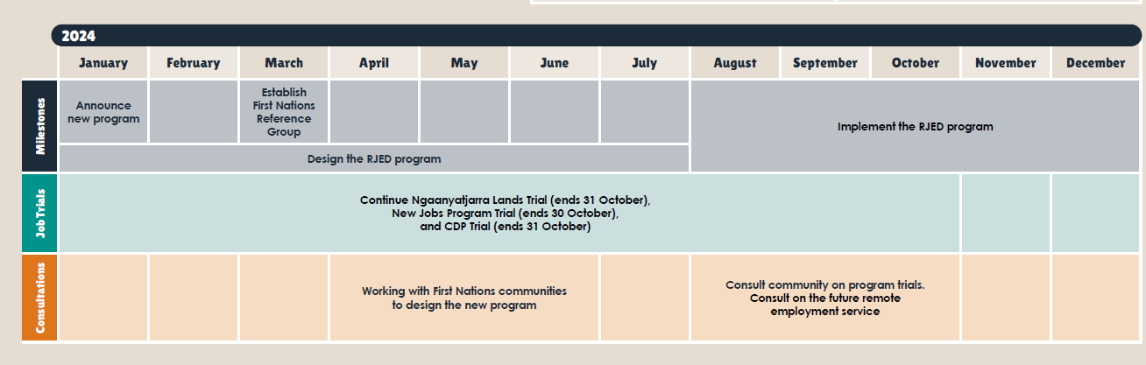

Why are we seeking feedback?
We want to hear from you about how the NIAA can work with communities to identify the programs and services they want and the jobs that can be created. The Government has made some decisions on what the RJED program will do from what we heard during our first phase of consultations. This is your second opportunity to provide feedback on what you need from the program to create opportunities in your community.
It is important to remember that the RJED program is providing funding to organisations to create jobs. This is different to the Community Development Program, which provides employment services only.
We are seeking feedback on how the program can be designed to take into account local conditions so it works for all remote communities.
The challenge for the RJED program is creating jobs where little or no job market exists. This requires funding for local organisations to become employers of choice in their communities and support for people looking for work to move into these jobs.

What we will do with your feedback?
Feedback on the design of the new program will be collected via stakeholder engagement, community consultation, written submissions, survey responses as well as other sources and will be recorded in the NIAA Client Relationship Management system. The feedback will be analysed and synthesised using Qualitative Data Analysis Software and will be reported on publicly.
The Remote Jobs and Economic Development program
The RJED program aims to:
- Fund the creation of new jobs in remote communities with priorities set by local communities.
- Support employees of new jobs to gain relevant work experience and skills for future employment.
- Support community organisations to deliver programs, services and opportunities communities want and need.
- Fund small scale capital, equipment and capacity building that is directly connected to the jobs created through the program.
- Contribute to Closing the Gap:
    - Target 7: By 2031, increase the proportion of Aboriginal and Torres Strait Islander youth (15-24 years) who are in employment, education or training to 67 percent.
    - Target 8: By 2031, increase the proportion of Aboriginal and Torres Strait Islander peoples aged 25-26 who are employed to 62 per cent.
    - Priority Reform 1 Outcome: Aboriginal and Torres Strait Islander people are empowered to share decision-making authority with governments to accelerate policy and place-based progress on Closing the Gap through formal partnership arrangements.
    - Priority Reform 2 Outcome: Building the community-controlled sector: There is a strong and sustainable Aboriginal and Torres Strait Islander community-controlled sector delivering high quality services to meet the needs of Aboriginal and Torres Strait Islander peoples across the country.
    - Priority Reform 3 Outcome: Improving mainstream institutions: Governments, their organisations and their institutions are accountable for Closing the Gap and are culturally safe and responsive to the needs of Aboriginal and Torres Strait Islander people, including through the services they fund.
    - Priority Reform 4 Outcome: Aboriginal and Torres Strait Islander people have access to, and the capability to use, locally-relevant data and information to set and monitor the implementation of efforts to close the gap, their priorities and drive their own development.
The RJED program will initially run over 3 years from 2024-25 to 2026-27 through a grant process. The RJED program will provide funding to organisations to create new jobs in communities that are located within the current CDP regions. The program will fund proper wages and conditions, including superannuation and on costs for 3,000 jobs that communities want over three years.
The RJED program will support remote communities to determine local projects and economic priorities to increase job opportunities in their areas. There will also be a focus on youth to improve their employment opportunities. Eligible community organisations will be funded to create new jobs to employ local people at least at the minimum wage or applicable entry level award wage plus conditions. Jobs are likely to be part-time in most cases, reflecting community feedback for flexibility. The RJED program will support part-time jobs.
Organisations in the current CDP regions that can apply for funding will work together with local communities to decide the jobs that will be created and the training, equipment or capital needed to deliver these jobs.
A critical component of the RJED program will be a requirement for organisations that apply for funding to show how communities have been involved in deciding the priorities for their community, and how this relates to the jobs that are created.

Who can apply for RJED funding?
To apply for funding under the RJED program, organisations must be in a CDP region, have the support of community to apply for the grant and be a community organisation, local government or a joint (consortia) application, where the lead organisation is a community organisation or local government. Proposed eligible entity types could include:
- An Aboriginal and/or Torres Strait Islander Corporation registered under the Corporations (Aboriginal and Torres Strait Islander) Act 2006 (CATSI Act).
- A community organisation or local government or a joint (consortia) application, where the lead organisation is a community organisation.
- A company incorporated in Australia under the Corporations Act 2001.
- An incorporated association.
- An incorporated cooperative.
- An organisation established through a specific piece of Commonwealth or state/territory legislation (e.g. churches and universities).
- An incorporated trustee on behalf of a trust.
- A partnership.
- A joint (consortia) application with a lead organisation that satisfies the entity type.

Who will fill the jobs created by the RJED program?
Successful RJED grant applicants will need to work with a CDP provider to find the right people to be employed in the new jobs.
Once people have gained experience, there may be further opportunities to connect them with jobs in the public or private sectors. It’s important to note that the RJED program is aimed at supporting people into jobs and lifting their skills and experience so they can move into a long term, permanent job.
When a person starts in a new job through the RJED program they will become employees. The RJED program will provide funding for additional support provided through their employer (the local organisation) including training and mentoring.

What types of jobs will the RJED program support?
Design principles have been established for jobs that will be funded through the RJED program and they include that the job is:
- not a currently funded position (a “new” job)
- supported and designed through engagement with the local community
- an entry-level job designed to build work skills, experience and confidence of employees, and
- casual, part-time or full-time with the number of hours worked per fortnight to be negotiated between participants and their employer to reflect local and individual circumstances.

Examples of jobs that may be supported by the RJED program
Strong in culture | Caring for Country | Caring for people | Building community | Servicing community | Small business enterprise
Interpreter | Land manager | Aged care | Machine operator | Kitchen hand | Selling local art
Tour guide | Feral pest control | Support worker | Site manager | Cleaning | Fishing
Artist | Animal welfare | Disability care | Trade assistant | Event organiser | Farming
Mentor | Sacred site manager | Night patrol | Public area maintenance | Sports coach | Natural medicine
Mediator | Gardener, lawn, moving/tidy town | Youth worker |  | Bus driver | Hairdressing
Teaching culture | Cattle station worker | Holistic wellbeing |  | Customer service | Hospitality
Teaching language | Cool fire management | Safe house worker |  | Funeral support services
Cultural adviser | Cultural heritage adviser | Drug and Alcohol worker |  | Administration
 |  | Childcare |  | Working in a shop
 |  | Before and after school care |  | Cemetery maintenance

What could the RJED program fund?
Organisations will be able to apply through the RJED program for funding for:
- Wages/Salaries - Relevant award for entry level positions or National Minimum Wage rate (where there is no relevant award).
- Superannuation (if applicable).
- Leave loading (if applicable).
- On costs – which could include (and may not be limited to).
- workers compensation/ insurance
- human resources support
- training, or travel costs.
- Community Jobs and Business Fund - for one-off business costs directly related to creating jobs.

Economic Development
The economic development aspect of the new program aims to increase economic opportunities in remote communities and generate long term permanent jobs. For example, by localising jobs under fly in fly out programs and service delivery and by generating jobs in the care sector and infrastructure and resource sectors.
We understand each community is different and that is why the new program will support different employment opportunities in every place.
Please note: As not everyone will be ready to go into a job or may require other support services, a remote employment service will still be needed to provide pre-employment support. The CDP will continue to support people looking for work, and/or who become job ready until June 2025, and will then be replaced with a new remote employment service. The NIAA will also continue to work with other parts of Government to help ensure people are getting the right support they need.

Journey Map: Remote Jobs and Economic Development program
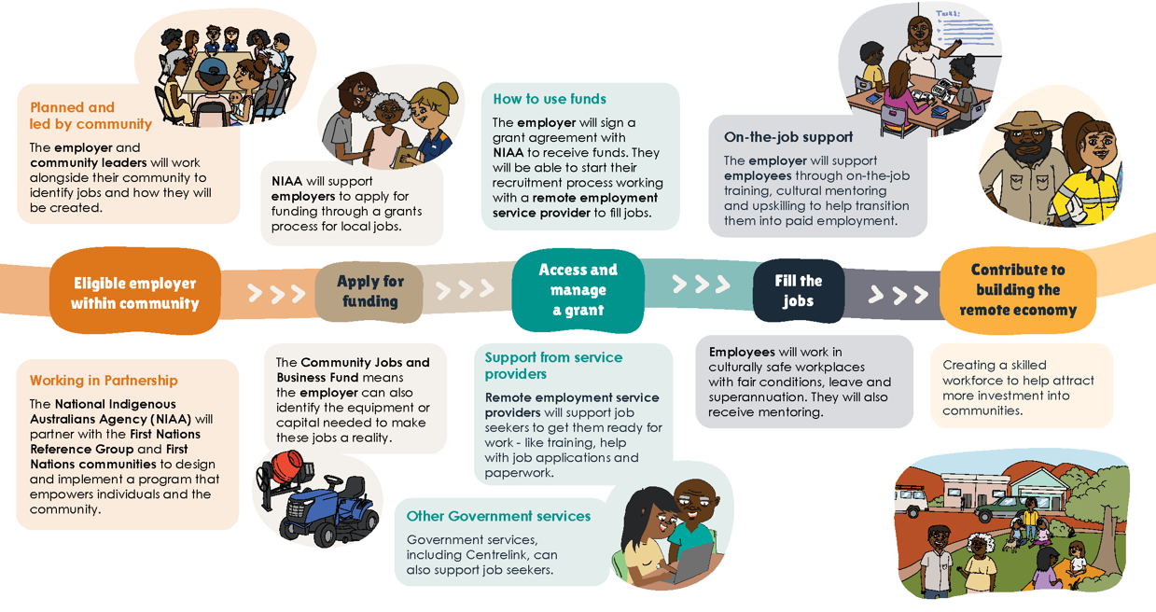

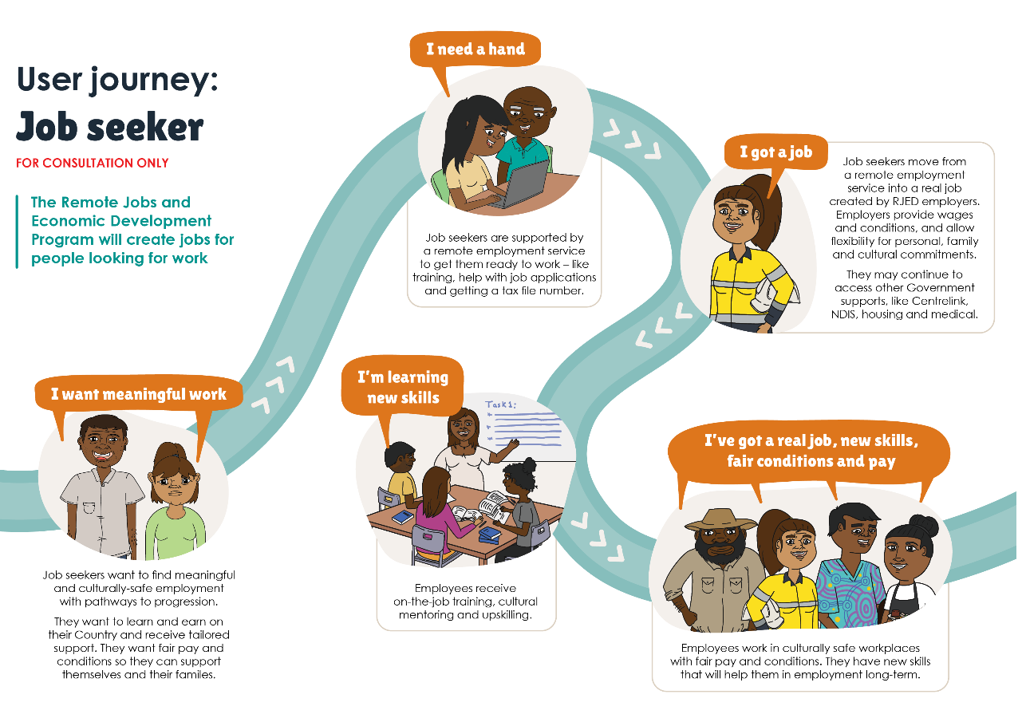
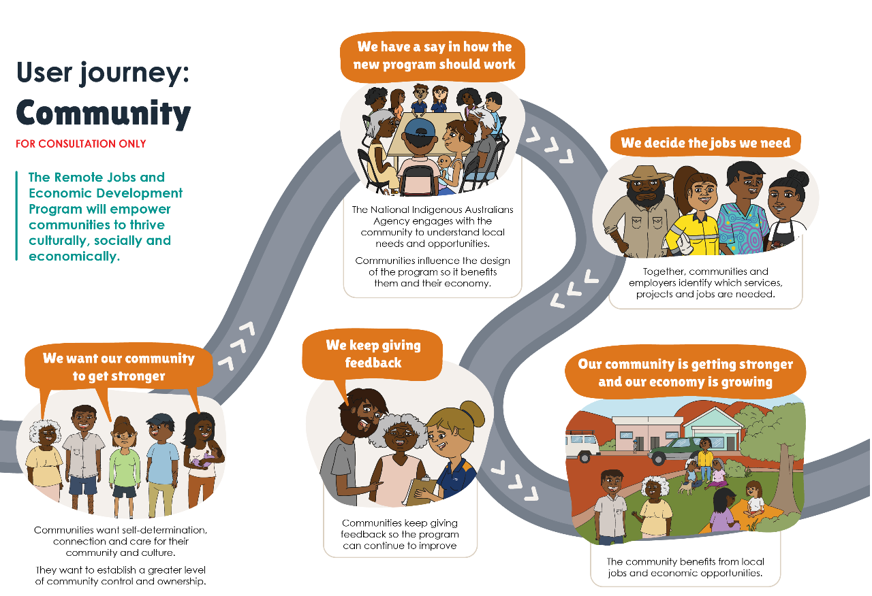

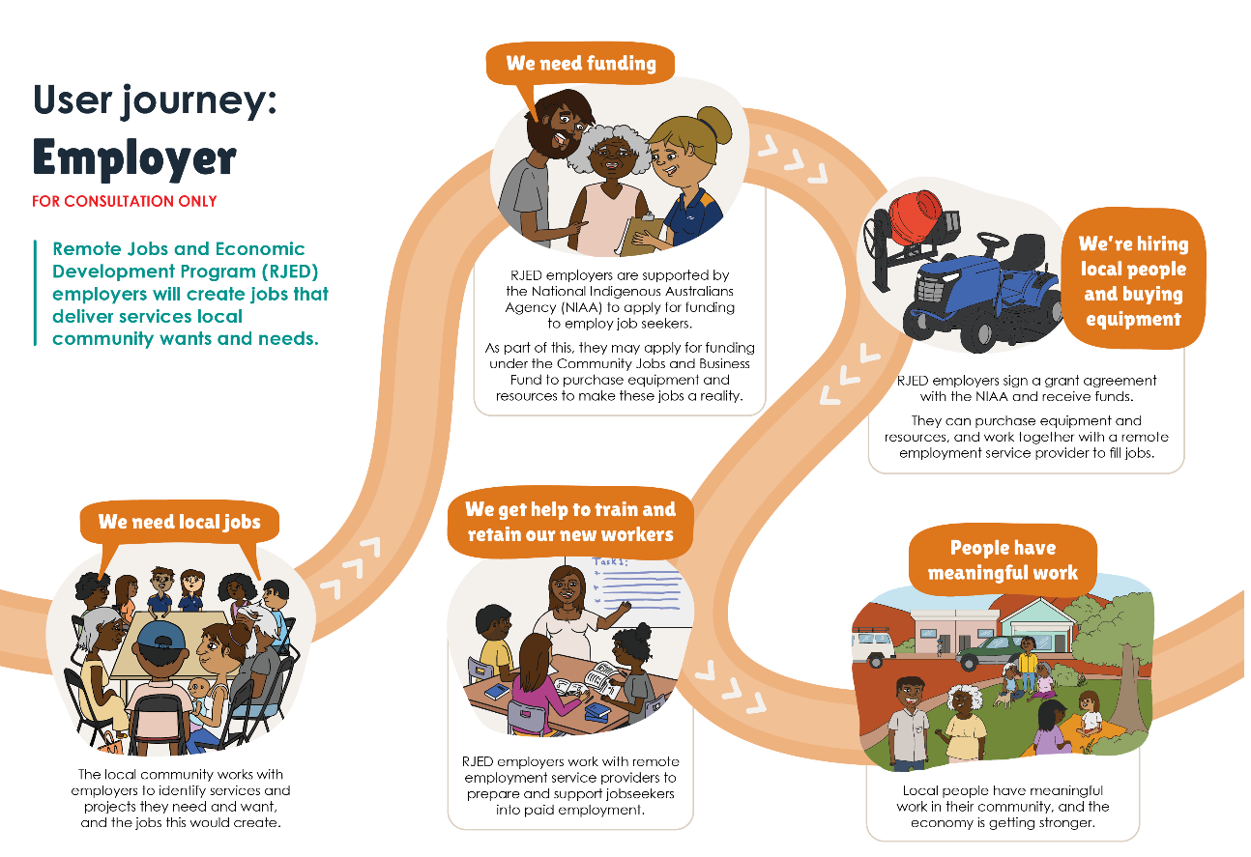

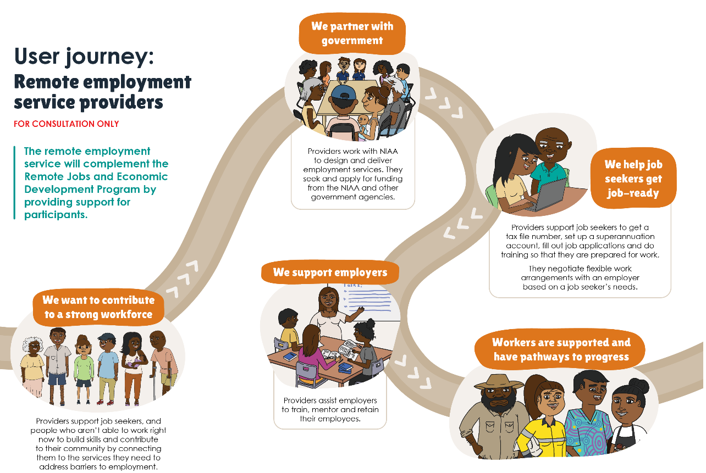

Discussion questions

Understanding the RJED program – refer to diagram above
What parts of the program do you think will work well or not work well in remote communities?
What would you change about the program?

Job seekers
Who could you talk to in your community if you wanted to create a job you are interested in?
What support could be offered to youth, women and other vulnerable groups to succeed in the program?
What support would you want if you took up a job opportunity created through the RJED program?

Community
What can be done to maximise community effective led decision making?
Are there benefits other than money that could encourage job seekers and remote communities? For example, meals, clothing, vouchers.
What support do communities need to make sure they get the jobs they need? For example, writing community plans, facilitating meetings.
How could employers demonstrate that the jobs created are the ones communities want?
What can the program include to make sure it is flexible for the unique needs of different communities?
What are good examples of funding or services that are working on the ground?

Community organisations (employers)
Who should be eligible to apply for the program?
What jobs could you create in your local community under this program?
What are the challenges in remote communities to fill jobs?
What do communities need to grow and build a small business?
What support do organisations need to successfully apply for the new program?
How can NIAA work with communities to support sustainability of jobs?
Is there anything else you would like to add?

Remote Employment Service Providers
How can a remote employment service support participants to take up RJED job opportunities?
How can RJED employer’s best work with remote employment service providers?

Next Steps

Provide your feedback
Visit niaa.gov.au/rjed-consultations to provide a submission or complete the accompanying survey. Responses can also be emailed to remote.jobs@niaa.gov.au. You can find out about upcoming consultations opportunities and subscribe to receive updates on remote employment.

Copyright notice
Copyright in material sent to the National Indigenous Australians Agency (NIAA) resides with the authors(s). ‘Material’ includes anything submitted to the NIAA in response to the RJED program Discussion Paper 2024, including artistic works such as artwork, poems, songs, etc.
In providing submissions(s) you grant a permanent, irrevocable, royalty free licence to allow us to use, reproduce, publish, adapt, perform or communicate to the public any of your material(s) on the website, including converting your material(s) to a different format for use in reporting or other communication channels.
Any submissions published or used by the NIAA are done so under a Creative Commons Attribution License.
Do not send us material for which you are not the copyright owner. If you send us material for which you are not the copyright owner, you warrant that you have obtained all necessary licences and consents required for the use of those materials (including for us to use, reproduce, publish, perform or communicate to the public), and are liable for the payment of any royalties or other fees payable in respect of the use of such material. The NIAA is not responsible or liable for any loss, damage or injury suffered or allegedly suffered as a result of the use of material provided to the NIAA in response to the submission.
Please ensure that any material containing Indigenous knowledge of Indigenous Cultural and Intellectual Property does not include any sensitive information that you are not comfortable with being published or do not have permission to publish or share.
Privacy
The NIAA has obligations for handling personal information. You can find our Privacy policy by visiting niaa.gov.au/privacy

