Senator the Hon Malarndirri McCarthy Assistant Minister for Indigenous Australians Assistant Minister for Indigenous Health Senator for Northern Territory

MS24-000238

Senator the Hon Sue Lines President of the Senate Parliament House CANBERRA ACT 2600

Dear Senator Lines

I refer to the Order of the Senate (15) agreed on 24 June 2008 (and amended on 12 May 2009) relating to departmental and agency appointments and vacancies.

Please find attached a list for tabling for the period 23 January 2024 to 7 May 2024 for the National Indigenous Australians Agency and the Indigenous Portfolio Bodies.

Yours sincerely

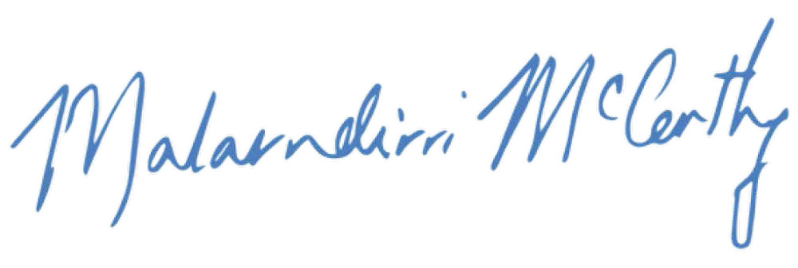

Senator the Hon Malarndirri McCarthy Assistant Minister for Indigenous Australians Assistant Minister for Indigenous Health Senator for the Northern Territory

21 /
05/ 2024

Encl (1) Response to Senate Order 15

Parliament House, Canberra ACT 2600

Appointments

Commonwealth body  Type text here | Position type | First name | Last name | Initial start date | Number of terms served | Term start | Term end | Remuneration | Place of permanent residence
First Nations Reference Group (RJED) | Member | Kate | Russell | 07/03/2024 | 0 | 07/03/2024 | 07/03/2026 | $823 per diem | NSW
First Nations Reference Group (RJED) | Member | Trephina | Bradley | 22/03/2024 | 0 | 22/03/2024 | 07/03/2026 | $823 per diem | NT
First Nations Reference Group (RJED) | Co-Chair | Josephine | Douglas | 07/03/2024 | 0 | 07/03/2024 | 07/03/2026 | $823 per diem | NT
First Nations Reference Group (RJED) | Member | Scott | Wilson | 07/03/2024 | 0 | 07/03/2024 | 07/03/2026 | $823 per diem | SA
First Nations Reference Group (RJED) | Co-Chair | Matthew | Clarke | 07/03/2024 | 0 | 07/03/2024 | 07/03/2026 | $823 per diem | NSW
First Nations Reference Group (RJED) | Member | Valerie | Cooms | 07/03/2024 | 0 | 07/03/2024 | 07/03/2026 | $823 per diem | QLD
First Nations Reference Group (RJED) | Member | Lara | Watson | 07/03/2024 | 0 | 07/03/2024 | 07/03/2026 | $823 per diem | QLD

Commonwealth body | Position type | First name | Last name | Initial start date | Number of terms served | Term start | Term end | Remuneration | Place of permanent residence
First Nations Reference Group (RJED) | Member | Fiona | Jose | 07/03/2024 | 0 | 07/03/2024 | 07/03/2026 | $823 per diem | QLD
First Nations Reference Group (RJED) | Member | Wayne | Miller | 07/03/2024 | 0 | 07/03/2024 | 07/03/2026 | $823 per diem | SA
First Nations Reference Group (RJED) | Member | Iris | Billy | 07/03/2024 | 0 | 07/03/2024 | 07/03/2026 | $823 per diem | QLD
First Nations Reference Group (RJED) | Member | Preston | Thomas | 07/03/2024 | 0 | 07/03/2024 | 07/03/2026 | $823 per diem | WA
First Nations Reference Group (RJED) | Member | Angelina | Dunnett | 07.03.2024 | 0 | 07/03/2024 | 07/03/2026 | $823 per diem | NT
First Nations Reference Group (RJED) | Member | Rick | Callaghan | 07.03.2024 | 0 | 07/03/2024 | 07/03/2026 | $823 per diem | SA
First Nations Reference Group (RJED) | Member | Raymond | Christophers | 07.03.2024 | 0 | 07/03/2024 | 07/03/2026 | $823 per diem | WA

Commonwealth body | Position type | First name | Last name | Initial start date | Number of terms served | Term start | Term end | Remuneration | Place of permanent residence
First Nations Reference Group (RJED) | Member | Rhea | Waia | 22/03/2024 | 0 | 22/03/2024 | 07/03/2026 | $823 per diem | QLD
First Nations Reference Group (RJED) | Member | Tremane | Baxter- Edwards | 22/03/2024 | 0 | 22/03/2024 | 07/03/2026 | $823 per diem | WA

Vacancies

Commonwealth body | Vacant: Chairperson | Vacant:  Deputy Chairperson | Vacant: Director /  Non-Executive Director | Vacant:  CEO / Executive Director / Managing Director | Vacant: Other
Territories Stolen Generation Redress Scheme (TSGRS) External Advisory Board (EAB) |  |  |  |  | 1
Aboriginal Leadership Group for the Central Australia Plan |  |  |  |  | 2

Appointments

Commonwealth body | Position type | First name | Last name | Initial start date | Number of terms served | Term start | Term end | Remuneration | Place of permanent residence
Outback Stores Pty Ltd | Deputy Chairperson | Graham | Cook | 16/09/2015 | 3 | 1/03/2024 | 31/05/2024 | $41,480 per annum | NSW
Outback Stores Pty Ltd | Director | Bess Nungarrayi | Price | 30/11/2017 | 2 | 1/03/2024 | 31/05/2024 | $41,480 per annum | NT
Outback Stores Pty Ltd | Director | Lesley | Nelson | 1/03/2021 | 1 | 1/03/2024 | 31/05/2024 | $41,480 per annum | WA

Vacancies

Commonwealth body | Vacant: Chairperson | Vacant:  Deputy Chairperson | Vacant: Director /  Non-Executive Director | Vacant:  CEO / Executive Director / Managing Director | Vacant: Other
Aboriginal Hostels Limited |  |  | 1 – no intention to fill
Indigenous Business Australia |  | 1 | 2
Outback Stores Pty Ltd |  |  | 1

