Second Statutory Review into the Operation of the
Low Aromatic Fuel Act 2013

Contents
Definitions 4
Introduction 6
Terms of Reference 6
Operating context since the first statutory review of the Act 7
Distribution and increased voluntary footprint 7
Current impact of low aromatic fuel on volatile substance use 8
Data availability on volatile substance use 9
National Drug Strategy Household Survey 9
Causes of Death Data 10
Incident Reporting 10
The Low Aromatic Fuel Act 2013 10
Low Aromatic Fuel Areas 11
Fuel Control Areas 12
Special measures 12
Sunsetting of legislative instruments 13
Implementation of the Low Aromatic Fuel Act 2013 13
State and territory legislation 13
Northern Territory legislation 14
Queensland legislation 14
Compliance in designated areas 15
Reports of volatile substance use involving petrol 15
Monitoring trends within the fuel sector 16
Fuel industry changes 16
Evolving regulatory framework 16
Fuel demand and premium unleaded petrol 16
Submissions 17
Common themes 17
Low aromatic fuel supply and existing designations are effective 18
Complementary legislation and programs continue to be important 19
Regional and voluntary uptake of low aromatic fuel remains the preferred approach 20
Issues involving fuels other than regular unleaded petrol 20
Premium unleaded petrol 21
Avgas 22
Security of fuel bowsers 22
One submission recommended changes to the Act 23
Recommendations 24
Attachment A: The review process 25
Attachment B: Copies of submissions 26
The Hon Paul Papalia, Western Australia Minister for Police 27
The Hon Amber-Jade Sanderson MLA, Western Australia Minister for Health; Mental Health 30
The Hon Joe Szakacs MP, South Australia Minister for Police, Emergency Services and Correctional Services 33
The Hon Kyam Maher MLC, South Australia Minister for Aboriginal Affairs, Attorney General, Minister for Industrial Relations and Public Sector 36
The Hon Chris Picton MP, South Australia Minister for Health and Wellbeing 40
Northern Territory Government; The Hon Natasha Fyles, Chief Minister of the Northern Territory 45
Aboriginal Medical Services Alliance Northern Territory 50
Northern Territory Legal Aid Commission 53
Jetstream Electrical 57
Central Australian Youth Link Up Service 61
Queensland Network of Alcohol and other Drugs Agencies 64
Brisbane Aero Engineers 68
Viva Energy Australia 73
Attachment C: History of Commonwealth engagement with volatile substance use issues 76
Attachment D: Further reading 77

Definitions
Avgas An aviation gasoline intended primarily for use in aircraft spark ignition reciprocating engines. Avgas is generally used in small aircraft and is distinct from jet fuel generally used in larger aircraft.
Low aromatic fuel Unleaded petrol that has a research octane number of less than 95, and that has aromatic compounds of less than 5% to help discourage fuel sniffing.
Low Aromatic Fuel Areas As defined in section 5 of the Low Aromatic Fuel Act 2013 (Cth).
Minister The Australian Government Minister responsible for administering the Low Aromatic Fuel Act 2013 (Cth), currently the Minister for Indigenous Australians.
NIAA The National Indigenous Australians Agency.
Opal fuel Since 2005, low aromatic fuel has been referred to as ‘Opal’, the brand name given to it by bp Australia Pty Ltd, the company to first produce and supply low aromatic fuel. Viva Energy Australia Pty Ltd began production and supply of low aromatic fuel in 2014. While using the term “Opal” to generically describe the fuel produced by both companies is technically incorrect, its colloquial use persists.
Petrol sniffing A form of volatile substance use where the fumes from petrol are inhaled, leading to intoxication. The toxic chemicals in petrol are rapidly ingested by the body through the lungs and affect the brain and central nervous system.
Premium unleaded petrol Unleaded petrol that has a research octane number of
95 or more, including a research octane number of 98.
Regular unleaded petrol Unleaded petrol that has a research octane number of
less than 95 but does not include low aromatic fuel.
The Act The Low Aromatic Fuel Act 2013 (Cth).
Three pillars of harm minimisation Since 1985, Australia’s National Drug Strategy
(refreshed for 2017-2026) has aimed to minimise harms associated with alcohol, tobacco, illicit drug and pharmaceutical drug use through coordinated, multi-agency responses that address the three pillars of harm minimisation. The “three pillars” are:
Demand Reduction - Preventing the uptake and/or delaying the onset of use of alcohol, tobacco and other drugs; reducing the misuse of alcohol, tobacco and other drugs in the community; and, supporting people to recover from dependence through evidence-informed treatment;
Supply Reduction - Preventing, stopping, disrupting or otherwise reducing the production and supply of illegal drugs; and controlling, managing and/or regulating the availability of legal drugs; and
Harm Reduction - Reducing the adverse health, social and economic consequences of the use of drugs, for the user, their families and the wider community.
Volatile substance use (VSU) A behaviour where the fumes or vapours of volatile substances are inhaled by a person to become intoxicated. Volatile substances include petrol, solvents, spray paints and aerosols that when inhaled can cause significant side effects, including brain damage and death.

Introduction
Low aromatic fuel was first introduced in Australia in 2005 as a means of reducing harm caused by volatile substance use involving petrol. Harm caused by volatile substance use includes sudden death (that may occur from first time use), chronic health conditions, youth disengagement, anti-social behaviour and breakdown in community structures. High levels of volatile substance use within a short period of time can lead to depressed breathing, loss of consciousness and asphyxiation. Harms from chronic or long-term use may also include:
- neurological damage/cognitive impairment (affects thinking, learning, memory, movement, hearing, and sight)
- damage to the heart, lungs, liver and kidneys.
The NIAA manages the production, transport and storage (supply) of low aromatic fuel to a range of regional and remote communities across the Northern Territory, Queensland, South Australian and Western Australia to reduce volatile substance use. Around 190 fuel outlets currently sell low aromatic fuel. This is a supply reduction strategy, promoting the use of low aromatic fuel in place of regular unleaded petrol.
In a majority of cases, fuel outlets that stock low aromatic fuel do so voluntarily. Some fuel outlets have voluntarily stocked low aromatic fuel since as early as 2005. Where volatile substance use persists and voluntary arrangements to stock low aromatic fuel have not been reached, the Minister may use provisions of the Low Aromatic Fuel Act 2013 to impose controls on fuels. The operation of the Act is the subject of this second statutory review.
The Act commenced on 14 February 2013 as a means of promoting the supply of low aromatic fuel and controlling the supply of other fuels in certain areas in order to reduce potential harm to the health of people, including Aboriginal and Torres Strait Islander people. Section 18 of the Act requires a statutory review to be undertaken every 5 years. The first statutory review of the operation of the Act was conducted in 2018 and is published on the NIAA website (www.niaa.gov.au).
This second statutory review follows a similar structure to the first statutory review. Some information and analysis contained in the first statutory review is retained here where it remains accurate and relevant.

Terms of Reference
The Minister approved the following Terms of Reference for the second statutory review.
The second statutory review will take account of the following issues:
- The effectiveness of the Act in meeting its primary object: “to enable special measures to be taken to reduce potential harm to the health of people, including Aboriginal persons and Torres Strait Islanders, living in certain areas from sniffing fuel.”
- The effectiveness of the areas designated under the Act: Palm Island in Queensland and the Tennant Creek, Daly and Katherine regions of the Northern Territory (the designated areas).
- The views of fuel manufacturers, outlets and distributors operating in the designated areas as well as other stakeholders, including community representatives, Aboriginal and Torres Strait Islander people (or their representatives), local governance groups
or Empowered Communities organisations, persons with an interest in or knowledge
of human health, and other individuals who have an interest in the use of low aromatic fuel.
- The other provisions of the Act as they relate to achieving the object of the Act, such
as the ability for the Minister to designate ‘Fuel Control Areas’.
- Any other matter with a significant bearing on the operation of the Act that is identified during the process of the second statutory review.

Operating context since the first statutory review of the Act
Efforts to reduce volatile substance use contribute to achieving Closing the Gap Outcome 1 – Aboriginal and Torres Strait Islander people enjoy long and healthy lives.
In 2023-24 the NIAA has committed $12.9 million through the Indigenous Advancement Strategy to supply low aromatic fuel and $2.5 million to support volatile substance use prevention and capacity building activities in a small number of vulnerable locations.
Background on Australian Government initiatives to reduce volatile substance use over the last 25 years is outlined in Attachment C.
State and territory governments have primary responsibility for addressing volatile substance use. The Australian Government’s role in supporting low aromatic fuel reflects the national operation of the fuel market and fuel supply chains, crossing state and territory borders.
The Australian Government’s approach to reducing volatile substance use includes:
- supporting the additional cost of the production, transport and storage of low aromatic fuel. This allows for low aromatic fuel to be sold at a similar price to regular unleaded petrol, both in designated Low Aromatic Fuel Areas as well as areas in which the fuel is sold voluntarily.
- consultation with communities, local service providers and community organisations where volatile substance use issues are identified to assist communities in responding to volatile substance use.
- working with fuel producers, distributors and outlets to maintain voluntarily supply of low aromatic fuel to communities, where possible.
- preventing the sale of regular unleaded petrol, or applying controls on the supply of other fuels, using the provisions of the Act where voluntary approaches have been unsuccessful.
The 5 years since the first statutory review have been dominated by the COVID-19 pandemic. Low aromatic fuel continued to be available without disruption throughout this period due to the continued efforts of fuel suppliers and distributors to maintain supply chains, including supply chains across state and territory borders.

Distribution and increased voluntary footprint
Most outlets in Australia that stock low aromatic fuel do so voluntarily. At the time of the first statutory review, low aromatic fuel was available from approximately 185 fuel outlets around Australia. Between 2016 and 2023 (noting no new Low Aromatic Fuel Areas had been designated under the Act since 2016) the number of fuel outlets stocking low aromatic fuel had increased to approximately 190. This increase reflects additional outlets voluntarily stocking low aromatic fuel, primarily in Western Australia’s Kimberley region. This figure also includes a small number of fuel outlets that have closed since 2018.
The graph below shows the total volume (in litres) of low aromatic fuel sold to fuel distributors each financial year since supply of the fuel began in 2005, illustrating the growth in demand over time. Note that all 4 existing Low Aromatic Fuel Areas were designated, and supply commenced, in the 2015-16 financial year.
While low aromatic fuel is available across a large geographic area, it is a small part of the Australian fuels market. Around 16 billion litres of petrol was sold in Australia in 2022, including regular unleaded petrol, ethanol blends and premium unleaded petrol. Of that amount, only roughly 40 million litres, or less than 1 per cent, was low aromatic fuel.
Low Aromatic Fuel – Demand nationally (litres)
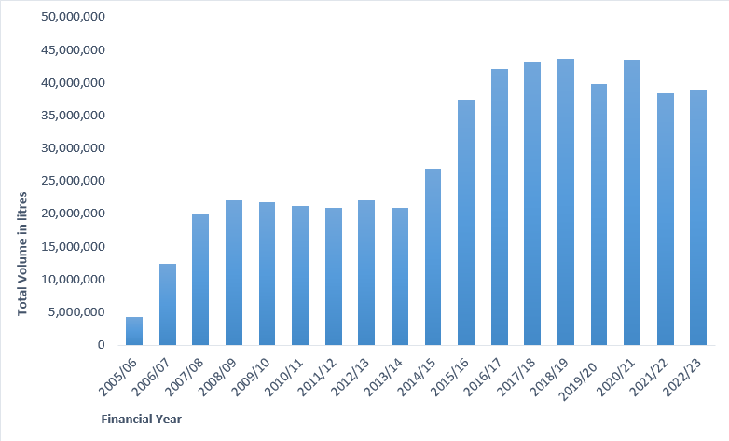
Table 1 - National Demand in litres for Low Aromatic Fuel from 2005/06 - 2022/23

Current impact of low aromatic fuel on volatile substance use
Low aromatic fuel has played a key role in reducing volatile substance use and its associated harms in Australia. The impact of low aromatic fuel has been studied in a series of longitudinal research evaluations supported by the Australian Government and published in 2007, 2008, 2013, 2016 and 2019. The research in each case was conducted by fieldworkers surveying community residents and local stakeholders.
The report published in 2016, conducted by the Menzies School of Health Research, found that volatile substance use involving petrol had reduced by 88 per cent against data from 2005-07 in communities where low aromatic fuel had been rolled out.
The next stage in the series of evaluations, the 2019 evaluation, produced a report titled ‘Longitudinal research into petrol sniffing and other substance abuse trends in Indigenous communities’ (the 2019 report). The 2019 report was based on fieldwork conducted in 25 locations between 2017 and 2018. The results from the 2019 evaluation included information from designated Low Aromatic Fuel Areas.
Consistent with the earlier reports, the 2019 report showed low aromatic fuel had reduced incidences of volatile substance use in areas where it had been introduced, and maintained existing lower rates of volatile substance use where low aromatic fuel has been available for an extended period. The 2019 report used comparable data from previous surveys and concluded that in 11 of the 25 communities surveyed, the total estimated number of people engaged in volatile substance use with petrol declined by 95.2 per cent. In 22 of the 25 communities included in the 2019 report, the number of people engaged in volatile substance use with petrol declined by 52 per cent when compared with the data from the same communities from the 2016 report. The 2019 report noted:
The findings of the study, when combined with evidence from earlier studies of the LAF rollout, also demonstrate that the benefits of the LAF program are sustainable. In light of these observations, we conclude that the continuation of the low aromatic fuel program is vital to the health and wellbeing of young people in Indigenous communities with a history of petrol sniffing.
A de-identified version of the 2019 report is published on the NIAA website (www.niaa.gov.au) and a link is included in the ‘Further Reading’ section at Attachment D.

Data availability on volatile substance use
The longitudinal evaluations discussed above clearly indicate the effectiveness of reducing supply of regular unleaded fuel as a means of reducing incidents of volatile substance use involving petrol. However, national data on volatile substance use more broadly is limited.
Data collection on incidents of volatile substance use is complicated given incidents are often opportunistic, hidden and even when it is witnessed may not be recognised. Limited data collection leads to data sets that are only able to reliably indicate broad trends, examples of which are provided below. These data sets are usually unable to provide an accurate picture of volatile substance use in a given location.
There is no regular national coordinated data collection that can provide a more accurate and current picture of volatile substance use incidents and trends. While outside the scope of this review, this presents an opportunity for all Australian governments to collaborate in future to track volatile substance use issues.

National Drug Strategy Household Survey
In relation to ‘inhalants’ or volatile substances, the National Drug Strategy Household Survey 2019 (the Survey) states:
Use of inhalants in the previous 12 months has been gradually increasing – from 0.4% in 2001 to 1.0% in 2016 and 1.4% in 2019. … People who used inhalants used them quite frequently (compared to drugs such as ecstasy and cocaine), with 33% reporting at least monthly use. The most common forms of inhalants used in 2019 were nitrous oxide (for example, laughing/happy gas) and amyl nitrate and other nitrates (for example poppers), used by at least 6 in 10 people who had used inhalants in the previous 12 months.
This information was self-reported and drawn from responses from 22,274 people aged 14 years and over who volunteered to participate in the survey and give information on their own drug use patterns, attitudes and behaviours. It included Aboriginal and Torres Strait Islander people in eight remote communities, all located in the Northern Territory.
The Survey shows a trend of increasing volatile substance use across a broad range of products. Petrol is not among the products most likely to be used by respondents to the survey, as indicated in the Survey’s supplementary table 4.93 (the most likely being nitrous oxide, amyl nitrate and other nitrates). As is the case for most data sources on volatile substance use, it does not collect information on younger age groups who may also use volatile substances (anecdotally, volatile substance use may involve very young people, as young as 6 or 7 years of age). It is not possible to draw conclusions from the Survey as to the effectiveness of the availability of low aromatic fuel or the designations of Low Aromatic Fuel Areas under the Act to date.

Causes of Death Data
It is apparent from coronial reports over the past 20 years that volatile substance use is strongly connected with youth self-harm and suicide. However, mortality data does not reliably indicate the involvement of volatile substance use either as a cause of death or as having occurred prior to death. As a result, it is difficult to draw any reliable conclusions from data sources connected with mortality or self-harm in considering the Act’s operation.
Volatile substance use is not illegal which means it is also generally not reported in crime data statistics.

Incident Reporting
Incident reports of volatile substance use tend to come to agencies and support services from a range of sources such as health organisations, schools, police, community members and service providers on the ground. While important in facilitating a response, these reports should not be considered a complete data set reflecting actual incidents of volatile substance use in the community.

The Low Aromatic Fuel Act 2013
Up until the introduction of the Act, the replacement of regular unleaded petrol with low aromatic fuel was achieved exclusively through voluntary agreement of fuel outlets. However, a small number of fuel outlets in regions where volatile substance use was occurring chose not to stock low aromatic fuel, creating a pathway for regular unleaded petrol to remain available in vulnerable areas.
To address this issue, the Act’s provisions enable the Minister to restrict or impose controls on the sale of fuels. The Act’s provisions impact corporations, rather than individuals.
Under the Act, the Minister may designate an area as either a Low Aromatic Fuel Area or a Fuel Control Area through a legislative instrument, if satisfied that:
- doing so is reasonably likely to assist in the reduction of petrol sniffing harms to people living in the area.
- there are adequate facilities or arrangements available to supply the area with low aromatic fuel.
- the relevant states and territories do not have legislation that would duplicate the Act, and it is unlikely such legislation will be enacted within a reasonable period.
It is important to note, however, that even after the provisions of the Act were used in 2015 and 2016, the vast majority of fuel outlets selling low aromatic fuel have continued to do so on a voluntary basis and have not been affected by the designations.
In designating an area, the Minister must also have regard to the community’s views, concerns and wellbeing. Before designating an area, the Minister must consult with community representatives, Aboriginal and Torres Strait Islander people in the area, fuel manufacturers and suppliers, health services and any other appropriate people. Where the Act has been used to designate Low Aromatic Fuel Areas, the outcomes of those consultations have been made available on the NIAA website (www.niaa.gov.au).
The four existing designated Low Aromatic Fuel Areas deliberately cover either a region (Tennant Creek, Daly and Katherine regions of the Northern Territory) or an island (Palm Island in Queensland). The designations cover all fuel outlets within its geographic footprint. A regional approach has several benefits:
- it ensures that regular unleaded petrol is not easily accessible to people living within the region or nearby.
- any new fuel outlet is automatically regulated in the same manner as existing outlets.
- fuel outlets that had previously voluntarily agreed to stock low aromatic fuel do not have the option to revert to selling regular unleaded petrol in the event of, for example, a change in ownership.
The available evidence strongly supports taking a regional approach. For example, the 2013 study from the Menzies School of Health Research noted that:
…the most significant factor contributing to the overall reduction in sniffing would appear to be the introduction of a regional approach to rolling out LAF [low aromatic fuel]. It found most of the petrol sniffing that continues to occur takes place in areas where a regional rollout has not yet been implemented, and where sources of RULP [regular unleaded petrol] are consequently relatively accessible.

Low Aromatic Fuel Areas
Under the Act, the Minister may designate Low Aromatic Fuel Areas, in which it is prohibited for a corporation to possess, transport and supply regular unleaded petrol. Corporations who breach the Act can be fined up to 300 penalty units ($93,900 at the time of this second statutory review).
Designation of a Low Aromatic Fuel Area does not compel outlets to supply low aromatic fuel. A designation also does not prohibit outlets from supplying fuels other than regular unleaded petrol (such as diesel and/or premium unleaded petrol). However, outlets generally choose to sell low aromatic fuel rather than have no 91 octane unleaded petrol offering. Low aromatic fuel is a direct equivalent to regular unleaded petrol and can be used in all of the same engines. Purchasing premium unleaded petrol is more expensive, and is unnecessary for motors designed to run on regular unleaded petrol.
The Act has only been used on four occasions in ten years. The Act has been used when fuel outlets have refused to cease supplying regular unleaded petrol despite extensive negotiation and engagement, and there is evidence that the continued availability of regular unleaded petrol is leading to volatile substance use.
NIAA recommends continuing the rollout of low aromatic fuel in regional and remote areas of Australia affected by volatile substance use primarily through the voluntary agreement of fuel outlets. This approach is in keeping with the recommendations from the 2012 Senate Inquiry into the Low Aromatic Fuel Bill (refer to the link at Attachment D).

Fuel Control Areas
The Act provides the Minister with the authority to prohibit or restrict access to other fuels in specified areas (such as premium unleaded petrol and Avgas), and direct outlets to both keep records in relation to their supply orders as well as sales and provide these records to the Australian Government. The provisions under the Act to designate Fuel Control Areas have not been used to date.

Special measures
The Act enables ‘special measures’ to be implemented under the International Convention on the Elimination of All Forms of Racial Discrimination (ICERD). ICERD is given effect by the Racial Discrimination Act 1975. ICERD specifies that:
Special measures taken for the sole purpose of securing adequate advancement of certain racial or ethnic groups or individuals requiring such protection as may be necessary in order to ensure such groups or individuals equal enjoyment or exercise of human rights and fundamental freedoms shall not be deemed racial discrimination, provided, however, that such measures do not, as a consequence, lead to the maintenance of separate rights for different racial groups and that they shall not be continued after the objectives for which they were taken have been achieved.
As outlined in the Statement of Compatibility with Human Rights within the Explanatory Memorandum for the Low Aromatic Fuel Bill 2012, provisions of the Act that are special measures are not deemed to be racially discriminatory despite the fact that the Act is likely to disproportionately impact Aboriginal and Torres Strait Islander people in certain areas.
In reviewing the operation of the Act, the NIAA has particularly considered the effectiveness and appropriateness of the areas designated to date under the Act as Low Aromatic Fuel Areas, and whether the designations continue to be necessary to achieve the Act’s aim of reducing the potential harm to the health of people living in those areas.
The NIAA’s assessment is that the existing designations continue to be necessary to prevent the sale of regular unleaded petrol. In locations that revert to selling regular unleaded petrol (after voluntarily selling low aromatic fuel), the NIAA has commonly monitored a return of volatile substance use. This is supported by feedback from a submission received from the Queensland Network of Alcohol and Other Drug Agencies, discussed further below. The NIAA’s assessment is that the Act’s provisions continue to meet the special measures test in the Convention. It is important for the Act to continue to provide the ability to designate additional Low Aromatic Fuel Areas or Fuel Control Areas, if necessary, to reduce the potential harm to health of people living in those areas stemming from volatile substance use.

Sunsetting of legislative instruments
Legislative instruments automatically repeal, or sunset, after a fixed 10-year period. The Australian Government’s sunsetting framework is set out in Part 4 of Chapter 3 of the Legislation Act 2003 (Cth). The purpose of sunsetting is to ensure that legislative instruments are kept up to date and only remain in force for so long as they are needed.
The legislative instruments that established the four existing designations under the Act are due to sunset in 2026. Prior to the time that the legislative instruments are due to sunset, the NIAA will assess whether those instruments should remain in force. The outcome of this process will be publicly available to ensure stakeholders are aware of obligations.

Implementation of the Low Aromatic Fuel Act 2013
In 2015 and 2016, the then Minister for Indigenous Affairs used the provisions of the Act to designate the following areas as Low Aromatic Fuel Areas:
- Palm Island in Queensland (2015)
- Tennant Creek in the Northern Territory (2016)
- the Daly region of the Northern Territory (2016)
- the Katherine region of the Northern Territory (2016).
As a result, it is now illegal to supply or sell regular unleaded petrol at all fuel outlets in these areas, and all distributors operating in those areas are also subject to the Act.
The Minister has not made any further designations since 2016.

State and territory legislation
The Act requires that a Minister may only designate a Low Aromatic Fuel Area or a Fuel Control Area if:
‘the Minister considers that the appropriate States and Territories have not enacted legislation consistent with this Act to reduce the harm of petrol sniffing, and it is unlikely that they will enact such legislation within a reasonable period’.
Analysis of relevant legislation was conducted before the Minister made the four existing designations. Inhalant use is not a criminal offence in any Australian state or territory. However, it is an offence in some states and territories to knowingly sell or supply an inhalant to a person for the purpose of intentional inhalation. Some Australian states and territories have police powers to intervene in inhalant use in two main ways:
- seize inhalants and related equipment
- apprehend and transport a person under the influence of a volatile substance, and release them into the care of a responsible person, or a place of safety such as a hospital.
Of the two jurisdictions where the Act’s provisions have been used to date, only the Northern Territory has legislation specifically relating to volatile substance use that can be applied both to individuals and regions. Queensland has legislation that generally relates to individuals. In South Australia and Western Australia, where low aromatic fuel is available but there are no designated areas under the Act, there is no legislation that specifically addresses volatile substance use on either an individual or regional basis.

Northern Territory legislation
The Volatile Substance Abuse Prevention Act 2005 (NT) (VSAP Act) aims to support the health of individuals who engage in volatile substance use. It also contains provisions to penalise individuals who supply volatile substances where those individuals have reason to believe volatile substances will be abused. Under the VSAP Act, communities can develop Volatile Substance Abuse Management Plans to control access to identified volatile substances. Individuals can also be placed into mandatory treatment following referral from a person qualified to make that assessment.
By contrast, the Low Aromatic Fuel Act 2013 seeks to regulate the supply of regular unleaded petrol through the fuel industry. As a result, the Act complements the Northern Territory legislation and supports a cross-jurisdictional and regional approach to reducing harms from volatile substance use. The Northern Territory Government provided a consolidated submission to this second statutory review which supports the NIAA’s understanding of the impacts of the Act (refer to Attachment B).

Queensland legislation
There is no Queensland Government legislation that expressly addresses volatile substance use. However, there are two Acts which are relevant and work in a way that is complementary to the Act:
- the Police Powers and Responsibilities Act 2000 (Qld) provides police with powers to seize potentially harmful items, including inhalants, and to detain and transport an affected person to a place of safety, including hospital.
- the Summary Offences Act 2005 (Qld) makes it illegal to sell potentially harmful products that may be inhaled or provided to another person to inhale.

Compliance in designated areas
The NIAA engages with distributors and fuel outlets operating in designated areas to check that parties continue to be aware of their obligations under the Act. The NIAA also monitors external price monitoring websites set up by jurisdictions that can incidentally provide information on the availability of low aromatic fuel and/or regular unleaded petrol. An example is the Northern Territory Government’s MyFuelNT website (www.myfuelnt.nt.gov.au). This website has allowed the NIAA to quickly contact a fuel outlet that reported selling regular unleaded petrol in a designated area (in this example a reporting mistake had been made and low aromatic fuel was still being sold).
The four Low Aromatic Fuel Area designations have the effect of encouraging self-policing within the fuel distribution chain as the provisions impose obligations on both fuel distributors and outlets. Should one corporation in the supply chain (e.g. fuel producer, fuel distributor, or fuel outlet) intentionally or inadvertently attempt to supply regular unleaded petrol in a Low Aromatic Fuel Area, other corporations in the same fuel supply chain face the same penalties under the Act. This has proven effective to date, as the NIAA receives inquiries from corporations in the supply chain seeking to ensure they are compliant, or seeking to confirm their understanding before supplying fuel to another party in the supply chain.
To date, no compliance breaches have been brought forward for prosecution.

Reports of volatile substance use involving petrol
While it remains the responsibility of state and territory governments to respond to volatile substance use incidents, the NIAA has a specific role in subsequent steps where petrol is involved. Where reports are verified, the NIAA works with local stakeholders to ascertain whether low aromatic fuel is currently stocked in local fuel outlets.
If low aromatic fuel is not available, the NIAA assesses the viability of a supply chain for low aromatic fuel. If viable the NIAA works with local outlets with the aim of securing their voluntary agreement to stock low aromatic fuel in place of regular unleaded petrol.
The NIAA also works closely with state and territory governments, local stakeholders and community groups to establish or encourage demand and harm reduction activities. Demand and harm reduction activities are vital in responding to all outbreaks of volatile substance use, including in areas where supply of low aromatic fuel is not viable. This process generally includes consultation with the reporting organisation, community representatives, local health service providers and the police as appropriate, to ensure responses are coordinated.
In response to stakeholder requests to make low aromatic fuel more easily identifiable, the NIAA worked with bp Australia and Viva Energy Australia to change the colour of low aromatic fuel to purple in 2022. Low aromatic fuel is now easily visually identifiable in comparison with regular unleaded petrol or premium unleaded petrol grades that have transitioned to be clear to yellow in colour in recent years. This assists the NIAA and other stakeholders to identify if supply restrictions are effective.

Monitoring trends within the fuel sector
Low aromatic fuel makes up less than one per cent of the petrol sold in Australia each year. Low aromatic fuel meets the specification of 91 octane regular unleaded petrol (‘91 RON grade’) in the Fuel Quality Standards (Petrol) Determination 2019 (the Petrol Determination) made under section 21 of the Fuel Quality Standards Act 2000, but has less than five per cent aromatic content.
The NIAA monitors evolving changes in the fuel industry, the regulatory framework, and fuel demand in connection with changes in technology. Each of these areas has the potential to impact on the future direction of low aromatic fuel supply.

Fuel industry changes
Since the first statutory review, two further oil refineries in Australia have closed, leaving only two domestic refineries in operation – Viva Energy in Geelong, Victoria, and Ampol in Lytton, Queensland.
Low aromatic fuel is now produced from the domestic refinery in Geelong and international sources.

Evolving regulatory framework
Limitations on certain chemical components used in regular unleaded petrol and premium unleaded petrol, including sulfur, are primarily regulated by the Petrol Determination. The Petrol Determination specifies that from 15 December 2024, the allowable amount of sulfur in regular unleaded petrol and premium unleaded petrol will be reduced. This change will also have the effect of reducing the sulfur content of low aromatic fuel but is not expected to affect ongoing supply of low aromatic fuel.
Other potential regulatory changes to fuel specifications are not expected to have an immediate impact on low aromatic fuel. However, they do have the potential to lead to changes in engine technology and increase demand for premium unleaded petrol (while also reducing demand for regular unleaded petrol). These potential changes include adoption of Euro 6 standards in Australia, and the introduction of fuel efficiency standards.

Fuel demand and premium unleaded petrol
Changing engine technologies and consumer trends have led to an increase in the demand for premium unleaded petrol (either 95 or 98 octane). The Australian Petroleum Statistics, published on the Department of Climate Change, Energy, the Environment and Water website (www.energy.gov.au) show that, since 2010, demand for regular unleaded petrol has fallen while sales of premium unleaded petrol have grown. For instance, sales of regular unleaded petrol, including ethanol blends, fell by 25 per cent between 2010-11 and 2022-23. By comparison, sales of premium unleaded petrol grew by 21 per cent over the same period. Despite this trend, in 2022-23 more than twice the quantity of regular unleaded petrol was sold nationally as compared with premium unleaded petrol.
To date, the provisions of the Act have only been used to prohibit the supply of regular unleaded petrol. While the Act does not require fuel outlets in Low Aromatic Fuel Areas to sell low aromatic fuel, usually fuel outlets choose to sell low aromatic fuel as it remains a cheaper alternative to premium unleaded petrol.
Under the provisions of the Act relating to Fuel Control Areas, the Minister may prohibit fuels other than regular unleaded petrol within a specified area. However, at present, there is no alternative low aromatic version of premium unleaded petrol available for engines that require higher octane petrol.
The Fuel Control Areas provisions under the Act also allow for other controls to be placed on the sale of premium unleaded petrol, such as recording the identities of purchasers of fuel or requiring fuel to be stored in a particular type of container.
Premium unleaded petrol is discussed further in the context of submissions received to the second statutory review in the ‘Common Themes’ section below.

Submissions
The following 13 individuals and organisations provided substantive written submissions for this second statutory review during the public consultation period in May and June 2023:
- The Hon Paul Papalia CSC MLA, Western Australia, Minister for Police
- The Hon Amber-Jade Sanderson MLA, Western Australia, Minister for Health and Mental Health
- The Hon Joe Szakacs MP, South Australia, Minister for Police, Emergency Services and Correctional Services
- The Hon Kyam Maher MLC, South Australia, Minister for Aboriginal Affairs
- The Hon Chris Picton MP, South Australia, Minister for Health and Wellbeing
- The Hon Natasha Fyles, Northern Territory Chief Minister (a coordinated Northern Territory Government response from the Department of Health with input from Police, Fire and Emergency Services; Department of Chief Minister and Cabinet; Office of Aboriginal Affairs; Department of the Attorney-General and Justice as well as Territory Families, Housing and Communities)
- Aboriginal Medical Services Alliance Northern Territory (AMSANT)
- Central Australian Youth Link Up Service (CAYLUS)
- Northern Territory Legal Aid Commission
- Jetstream Electrical Pty Ltd
- Brisbane Aero Engineers Pty Ltd
- Queensland Network of Alcohol and Other Drugs (QNADA)
- Viva Energy Australia Pty Ltd.

Common themes
A number of common themes emerged from the submissions.

Low aromatic fuel supply and existing designations are effective
All submissions made to the second statutory review of the Act agreed, or were silent, on the effectiveness of the supply of low aromatic fuel and the restriction of regular unleaded petrol continuing to be effective in reducing volatile substance use. This was both across areas designated under the Act and areas where low aromatic fuel is sold voluntarily.
No submissions suggested the supply of low aromatic fuel was ineffective, nor recommended removing designations under the Act.
The Northern Territory Government’s submission included assessment of data demonstrating a reduction in volatile substance use, including volatile substance use involving petrol, in the Katherine and Barkly regions since the first statutory review. The submission stated:
The current restrictions in the NT designated areas should remain in place. The designated areas in the NT saw substantial initial drops in petrol sniffing that continued to decrease since the designations in 2016.
The Northern Territory Legal Aid Commission noted that the Act, in conjunction with existing Northern Territory legislation, is effective and reduces harm brought about by volatile substance use. The submission stated:
Following commencement of the Commonwealth Act, instances of petrol sniffing have dramatically reduced. The mandating of low aromatic fuel is important in achieving and maintaining this result.
It is vital that the Act remain in operation. We make no recommendation as to there being any requirement for amendment to the provisions.
The Minister for Police of Western Australia (Minister for Police) noted support for the Act in its current form and did not propose any amendments in their submission. The submission noted reductions of volatile substance use where low aromatic fuel is supplied and within communities that had previously identified as having volatile substance use problems. The Minister for Police noted that community leaders and police both advised that the continued use of low aromatic fuel has reduced harm to the community. The submission stated:
Community leaders raise concerns that if volatile substances are reintroduced then there is the potential for increased health issues, anti-social behaviour, risk to vulnerable persons and demand for police resources.
The Western Australian Minister for Health and Mental Health indicated support for low aromatic fuel as a strategy to reduce volatile substance use involving petrol in communities that had previously reported volatile substance use as an issue.
The Central Australian Youth Link-Up Service (CAYLUS) noted that the first statutory review reported a reduction of inhalant misuse in CAYLUS’s Central Australian service area, including in Tennant Creek, Northern Territory. On the basis of CAYLUS’ own reports volatile substance use incidents have continued to fall since 2018. CAYLUS noted:
As a major stakeholder, we can state that low aromatic fuel has been a very successful strategy to reduce inhalant misuse across our region.
The Act allows interventions into substance misuse that do not criminalise the misuser, and therefore are much easier to gain family and community support.
The South Australian Minister for Health and Wellbeing referenced the findings of the National Drug Strategy Household Survey 2019, particularly the South Australian Factsheet (the factsheet) that is published separately. The factsheet indicates that ‘inhalants’ were among the top 5 ‘drugs’ used in the survey in South Australia for the first time. However, the factsheet also indicated that the statistic had ‘… a relative standard error of 25 to 50 per cent and should be used with caution’. It should also be noted that ‘inhalants’ includes petrol as well as a range of other products, making it difficult to draw conclusions specific to the impact of the supply of low aromatic fuel in South Australia. The South Australian Minister for Health and Wellbeing stated:
The Act appears to have been effective in continuing to meet its primary objective of enabling special measures to be taken to reduce potential harms associated with sniffing fuel, including Aboriginal and Torres Strait Islander people, living in certain areas.
The Minister for Police, Emergency Services and Correctional Services of South Australia did not identify any instances of volatile substance use involving petrol in a recent 12 month review of communities and did not see a need to designate any areas under the Act in South Australia.
Similarly, the South Australian Minister for Aboriginal Affairs stated:
In an effort to address petrol sniffing in South Australia, the state government, fuel outlets and Aboriginal communities undertook a collaborative approach in regard to the provision of low aromatic fuel to at risk communities. In my view the implementation of this policy, has had one of the most significant, swift and positive impacts on Aboriginal communities I have witnessed.
The Queensland Network of Alcohol and Other Drug Agencies (QNADA), as a representative of the majority of specialist Non-Government Organisation Alcohol and Other Drug service providers in Queensland, confirmed their support for the Act and stated that they believe the Act continues to be effective in reducing volatile substance use. QNADA stated:
Consultation with our member organisations confirms that the Act continues to effectively reduce the use of petrol as an inhalant in sites where low aromatic fuel (LAF) is consistently available. Members report the use of petrol as an inhalant increases where LAF supply is interrupted and regular unleaded petrol becomes available.

Complementary legislation and programs continue to be important
The Northern Territory Government’s submission outlined the ways in which the Act is complementary to existing Northern Territory VSAP Act. The VSAP Act has provisions to develop community management plans which address volatile substance use through declared management areas and community designated plans. The Northern Territory Government stated:
The use of LAF (low aromatic fuel) is still considered an effective measure in addressing petrol sniffing as evidenced by the continued utilisation of community management plans, voluntary use of LAF…

Special measures applied under the LAF Act covering designated geographical areas have significantly reduced the potential for harm and a decrease in individuals being referred for assessment and treatment. Reports of people sniffing LAF are still being received, though these reports tend to be sporadic and at a considerably lower level than prior to the introduction to LAF.
The Aboriginal Medical Services Alliance Northern Territory (AMSANT) reflected on the complexity of addressing volatile substance use, consistent with their submission to the first statutory review. AMSANT stated:
- LAF is just one part of the solution to addressing petrol sniffing in Aboriginal communities and should be implemented along with other measures including adequately resourced early intervention services, youth and recreation programs and training and employment opportunities; and
- Urgent and sustained action is required on the determinants of VSA specifically and addiction in general, such as through addressing poverty and inequality; poor housing and overcrowding; and lack of access to education.

Regional and voluntary uptake of low aromatic fuel remains the preferred approach
Several submissions to this second statutory review reiterated the importance of a continued regional approach to the rollout of low aromatic fuel.
The Northern Territory Government acknowledged in their submission:
The use of LAF continues to have the support of Aboriginal communities who have led the way in the voluntary adoption of LAF throughout most of the NT.
Most remote NT communities have adopted LAF either voluntarily or via community management plans. The community driven option is preferable to align with principles of self-determination. LAF and fuel controlled areas are useful tools to assist communities if difficulties arise with stakeholder negotiations around switch over to LAF from RUP.
AMSANT reiterated its support for the continuation of the supply of low aromatic fuel with an emphasis on a regional approach.
The Northern Territory Legal Aid Commission noted that they were pleased to observe fuel outlets outside of the designated areas voluntarily stocking low aromatic fuel.

Issues involving fuels other than regular unleaded petrol
A number of submissions raised the potential risk of volatile substance use, or concerns about existing volatile substance use, involving fuels other than regular unleaded petrol. These concerns are linked particularly with premium unleaded petrol or Avgas which meet the definitions under the Act to be subject to controls imposed through the designation of Fuel Control Areas.
To date, the Act’s provisions have not been used to control the supply of premium unleaded petrol or Avgas.
The submission from QNADA noted that the inhalation of volatile substances other than fuels was more common across Queensland and was most prevalent in young people. QNADA stated:
We note that inhalant use is not limited to fuel and the use of other inhalants, such as deodorant, are more common across Queensland. Inhalant use is most prevalent amongst young people, underlining the need for governments to invest in responses that address the social, cultural and structural determinants of health in addition to measures that seek to address supply.
The replacement of regular unleaded petrol with low aromatic fuel is a supply reduction initiative. Supply reduction initiatives for volatile substances other than petrol are also effective. For example, retail outlets restricting customers’ access to aerosol deodorants so that staff retrieve products at the customer’s request, or hardware stores taking similar steps with spray paints. Demand reduction efforts, especially working with young people, are also effective in reducing volatile substance use regardless of the type of products involved. While the NIAA acknowledges the importance of work to prevent volatile substance use involving inhalants other than fuels, this is beyond the scope of this second statutory review.

Premium unleaded petrol
While the Act includes provisions to control supply of regular unleaded petrol through Low Aromatic Fuel areas it also includes provisions to regulate the supply and storage of other fuels including premium unleaded petrol through designation of Fuel Control Areas.
With regard to premium unleaded petrol, the first statutory review found that:
- premium unleaded petrol had remained widely available in the areas designated under the Act (as well as areas that had voluntarily agreed to stock low aromatic fuel).
- while there were isolated reports of incidents, there was little evidence to support concerns of a large-scale transference from volatile substance use involving regular unleaded petrol to premium unleaded petrol.
- in Alice Springs volatile substance use involving petrol dropped significantly and had stayed low over time, despite premium unleaded petrol continuing to be available.
Several submissions noted concerns about the availability of premium unleaded petrol in areas where low aromatic fuel is also sold as premium unleaded petrol becomes more widely used and available. Submissions raised concerns around a risk of an increase in volatile substance use involving premium unleaded petrol as it becomes more widely available in the future. There is a parallel risk that fuel outlets currently selling low aromatic fuel may choose to sell premium unleaded petrol instead.
The Western Australian Minister for Health and Mental Health noted:
Anecdotally, premium unleaded fuel has been reported as contributing to harm in communities. With anticipated increases in consumer demand for premium unleaded fuel for vehicles, there is potential that issues related to petrol sniffing will increase. While provisions in the Act regarding Fuel Control Areas provide a legislative approach to reduce potential harm related to petrol sniffing of premium unleaded fuel, it is recommended that exploration of the feasibility of low aromatic premium unleaded fuel is undertaken.
The submissions concerns are broadly consistent with the findings in connection with premium unleaded petrol from the first statutory review. While at the time of this second statutory review there are reports of volatile substance use involving premium unleaded petrol reported to the NIAA, these are relatively few and isolated. However, the NIAA will continue to review reports of volatile substance use to monitor for trends of involvement of premium unleaded petrol.
The South Australian Minister for Health and Wellbeing’s submission suggested the review consider the provision of low aromatic fuel as the only available option throughout Central Australia to minimise volatile substance use from petrol brought in from other areas. However, given the need for some engines to use premium unleaded petrol, the NIAA would not recommend restrictions on premium unleaded petrol in the absence of a demonstrable and widespread issue involving that grade of petrol.
As discussed above in the section titled ‘monitoring trends within the fuel sector’, evolving vehicle technologies are driving an increasing need for premium unleaded petrol grades and a low aromatic version of premium unleaded petrol does not yet exist. To assess the options to respond to this trend, the NIAA has begun exploring the feasibility of a low aromatic premium unleaded petrol with industry partners.

Avgas
The submission received from Brisbane Aero Engineers Pty Ltd (Brisbane Aero) raised concerns with the composition of Avgas, claiming that Avgas causes premature engine cylinder failures. The specification of Avgas used in Australia is not part of the NIAA’s portfolio responsibilities. The Fuel Quality Standards Act 2000 (Cth) does not regulate Avgas.
The NIAA is aware Brisbane Aero has previously raised its concerns with the Australian Government’s Civil Aviation Safety Authority (CASA). CASA has substantially investigated the allegation raised by Brisbane Aero and has found there is no evidence to support a claim that premature engine cylinder failures are a consequence of aircraft engines being operated with 100 Low Lead Avgas sold in Australia. Further discussion of the technical details and testing conducted in relation to Avgas specifications is beyond the scope of this second statutory review. Any related views or concerns regarding aircraft engine premature failures should be referred to CASA as the relevant Australian Government agency.
Two submissions discussed Avgas bowser security and one submission alleged recent incidents of volatile substance use involving Avgas. The NIAA contacted the stakeholder that raised the concern around volatile substance use involving Avgas as part of this second statutory review, but was not been able to substantiate claims of recent incidents of volatile substance use involving Avgas. The NIAA will continue to monitor any reports of volatile substance use involving Avgas (noting that, as is the case with other volatile substance use incident responses, incidents involving Avgas continue to be a state and territory responsibility). Designation of Fuel Control Areas under the Act continues to be an option in cases of demonstrated need.

Security of fuel bowsers
Jetstream Electrical Pty Ltd detailed concerns about the theft of fuel and vandalism of fuel bowsers caused by people trying to access fuel for volatile substance use purposes, including at regional fuel outlets and remote airports.
Brisbane Aero raised concerns about unsecured remote airstrips, which can allow people to access Avgas from helicopters and small aircraft whose fuel tanks may not be lockable.
The Northern Territory Government also noted security of fuels as an ongoing issue with reports of break-ins to bowsers. The NIAA is aware that the Northern Territory Government has previously taken steps to boost security at airports where Avgas theft was an issue. The Northern Territory Government suggested using the provisions of the Act to require bowser security measures.
The Minister can consider mandating security measures under the Act. However, in practice there are limited security options available to effectively prevent damage. In some cases, there is a risk of more substantial and expensive damage to fuel infrastructure where low level security measures are taken.
One submission suggested businesses should be reimbursed by government for repair of vandalised equipment. The NIAA considers this to be an insurance matter for private business and this issue is out of scope for funding under the Indigenous Advancement Strategy. Investment in this area under the Indigenous Advancement Strategy is focused on the need for demand reduction activities to prevent volatile substance use and anti-social behaviour.

One submission recommended changes to the Act
Viva Energy Australia Pty Ltd recommended making small amendments (similar to the recommendations made to the first statutory review) to the definitions of regular unleaded petrol and the first portion of the definition of low aromatic fuel under the Act.
Viva Energy Australia’s recommended changes to the Act
 | Current definition | Viva Energy’s proposed definition
Regular unleaded petrol | Unleaded petrol that has a research octane number of less than 95, but does not include low aromatic fuel. | Unleaded petrol that has a minimum research octane number of 91.0 and meets the requirements of the Fuel Quality Standards Act 2000 (Cth)
Low aromatic fuel | Unleaded petrol that has a research octane number of less than 95, and that has aromatic compounds of less than 5 per cent to help discourage fuel sniffing; or … | Unleaded petrol that has a minimum research octane number of 91.0, meets the requirements of the Fuel Quality Standards Act 2000 (Cth) and has a total aromatic content of no more than 5 per cent to help discourage volatile substance misuse

The NIAA acknowledges that the definitions under the Act differ from industry terminology. However, the existing definition has not led to any material issues since the passage of the Act and Ministerial designation of the four existing Low Aromatic Fuel Areas. The NIAA does not propose to pursue the proposed amendments, but would review the definitions if a deficiency were to become apparent.

Recommendations
The NIAA makes the following recommendations following consideration of the Terms of Reference, submissions to this second statutory review, feedback from stakeholders, the findings from the series of longitudinal evaluations into the prevalence of volatile substance use involving petrol, earlier inquiries and reports regarding low aromatic fuel, and its role in administering the Act.
- No amendments to the Act are required for it to continue to be effective at this time. Stakeholder submissions demonstrated that the Act is effectively meeting its primary object, ‘to enable special measures to be taken to reduce potential harm to the health of people, including Aboriginal and Torres Strait Islander people, living in certain areas from sniffing fuel’ and these ‘special measures’ under the Act continue to be necessary to avoid the return of volatile substance use issues.
- The four existing Low Aromatic Fuel Area designations should remain in place. The designations have been effective in reducing volatile substance use involving petrol, and lifting the designations would risk a return of volatile substance use involving petrol.
- The NIAA should continue ongoing monitoring of volatile substance use issues and the impact of low aromatic fuel in reducing these in order to assess whether it is appropriate for current designations, and any made in the future, to remain in place.
- Where a need is identified, the Minister should continue to implement the rollout of low aromatic fuel through a voluntary approach in the first instance, using the powers of the Act as a ‘last resort’.
- The NIAA should continue to explore the feasibility of a low aromatic version of premium unleaded petrol. The NIAA has begun working with fuel industry partners to investigate this possibility.
These recommendations are broadly consistent with those from the first statutory review in 2018.

Attachment A: The review process
In April 2023, the Minister initiated the second statutory review process and invited submissions from:
- the Australian Government Attorney-General, Minister for Health and Aged Care, Minister for Youth, and Assistant Minister for Rural and Regional Health.
- relevant ministers in Queensland, South Australia, Western Australia, and the Northern Territory.
- all Members of Parliament in whose electorates low aromatic fuel is sold or host one or more designated areas (electorates of Lingiari, Kennedy, Leichardt, Grey, Durack, O’Connor and Herbert).
The NIAA also wrote to 98 additional stakeholders inviting them to provide a submission to the review. This included Aboriginal and Torres Strait Islander people (through a range of representative bodies), health, education, and youth organisations, as well as police, and fuel outlets and distributors operating in the four designated Low Aromatic Fuel Areas.
The second statutory review, including the open opportunity to make a submission, was also promoted on the NIAA website (www.niaa.gov.au). Thirteen substantive submissions were received. These submissions are provided, with redactions of details of individuals or communities, at Attachment B.

Attachment B: Copies of submissions
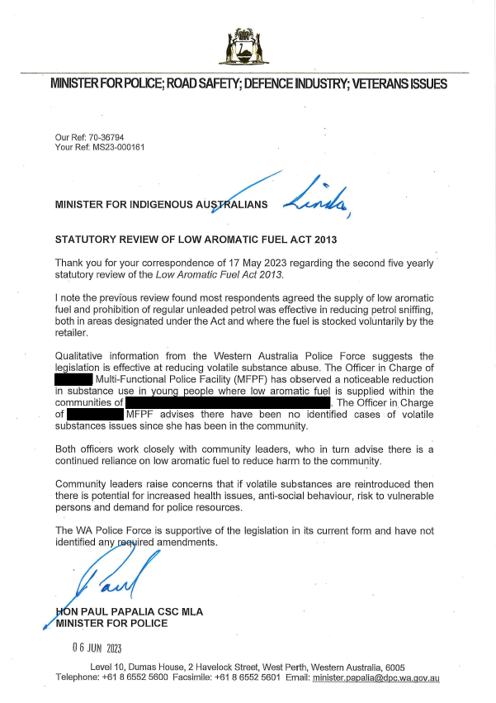
The Hon Paul Papalia, Western Australia Minister for Police
Alternate text format of Image above
[DOCUMENT HEADER]
Western Australian Coat of Arms
Minister for Police; Road Safety; Defence Industry; Veterans Issues

Minister for Indigenous Australians
Statutory Review of the Low Aromatic Fuel Act 2013
Thank you for your correspondence on 17 May 2023 regarding the second five yearly statutory review of the Low Aromatic Fuel Act 2013.
I note the previous review found most respondents agreed the supply of low aromatic fuel and prohibtion of regular unleaded petrol was effective in reducing petrol sniffing, both in areas desginated under the Act and where the fuel is stocked voluntarily by the retailer.
Qualitative information from the Western Australia Police Force suggests the legislation if effective at reducing volatile substance use. The Officer in Charge of Multi-Funcitional Police Facility (MFPF) has observed a noticeable reduction in substance use in young people where low aromatic fuel is supplied within the communities of . The Officer in Charge of MPFP advises there have been no identfited cases of volatile substances issues since she has been in the community.
Both officers work closely with community leaders, who in turn advise there is a continued reliance on low aromatic fuel to reduce harm to the community.
Community leaders raise concerns that if volatile substances are reintroduced then there is potential for increased health issues, anti-social behaviour, risk to vulnerable persons and demand for police resources.
The WA Police Force is supportive of the legislation in its current form and have not identified any required amendments.
SIGNATURE
HON PAUL PAPALIA CSC MLA
MINISTER FOR POLICE

Date: 06 June 2023

[Address Block at bottom of the page]
Level, 10 Dumas House, 2 Havelock Street, West Perth, Western Australia, 6005
Telephone: +61 8 6552 5601 Email: minister.papalia@dpc.wa.gov.au
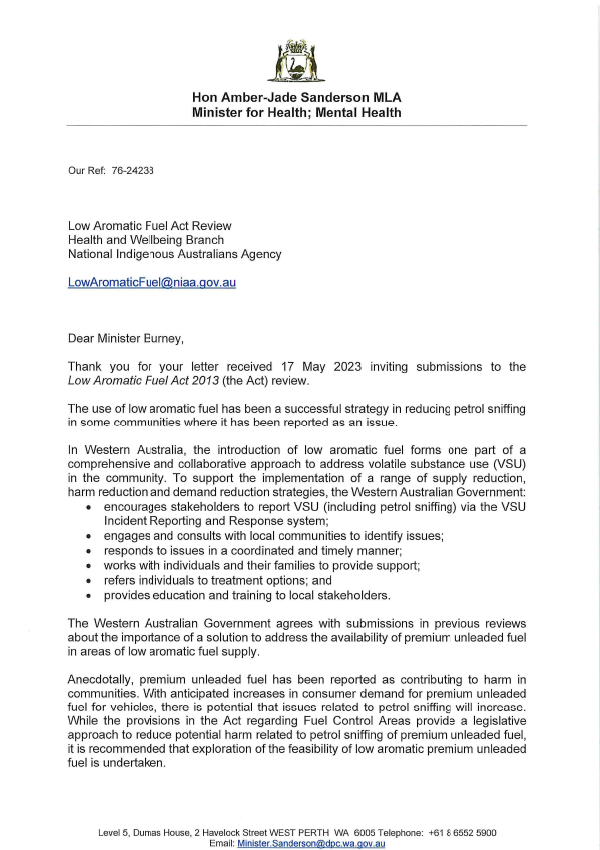
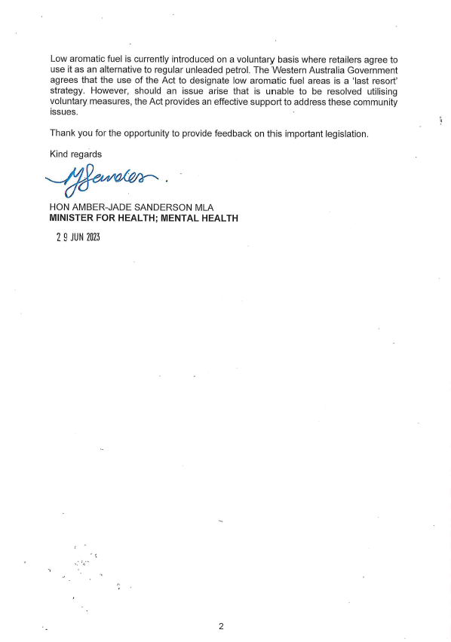
The Hon Amber-Jade Sanderson MLA, Western Australia Minister for Health; Mental Health
Alternate text format of Image above
Low Aromatic Fuel Act Review
Health and Wellbeing Branch
National Indigenous Australians Agency
Lowaromaticfuel@niaa.gov.au
Dear Minister Burney,
Thank you for your letter received 17 May 2023 inviting submissions to the Low Aromatic Fuel Act 2013 (the Act) review.
The use of low aromatic fuel has been a successful strategy in reducing petrol sniffing in some communities where it has been reported as an issue.
In Western Australia, the introduction of low aromatic fuel forms one part of a comprehensive and collaborative approach to address volatile substance use (VSU) in the community. To support the implementation of a range of supply reduction, harm reduction and demand reduction strategies, the Western Australian Government:
- encourages stakeholders to report VSU (including petrol sniffing) via the VSU Incident Reporting and Response system;
- engages and consults with local communities to identify issues;
- responds to issues in a coordinated and timely manner;
- works with individuals and their families to provide support;
- refers individuals to treatment options; and
- provides education and training to local stakeholders.
The Western Australian Government agrees with submissions in previous reviews about the importance of a solution to address the availability of premium unleaded fuel in areas of low aromatic fuel supply.
Anecdotally, premium unleaded fuel has been reported as contributing to harm in communities. With anticipated increases in consumer demand for premium unleaded fuel for vehicles, there is potential that issues related to petrol sniffing will increase. While the provisions in the Act regarding Fuel Control Areas provide a legislative approach to reduce potential harm related to petrol sniffing of premium unleaded fuel, it is recommended that exploration of the feasibility of low aromatic premium unleaded fuel is undertaken.
Low aromatic fuel is currently introduced on a voluntary basis where retailers agree to use it as an alternative to regular unleaded petrol. The Western Australian Government agrees that the use of the Act to designate low aromatic fuel areas is a ‘last resort’ strategy. However, should an issue arise that is unable to be resolved utilising voluntary measures, the Act provides an effective support to address these community issues.
Thank you for the opportunity to provide feedback on this important legislation
Kind regards
SIGNATURE

HON AMBER-JADE SANDERSON MLA
MINISTER FOR HEALTH; MENTAL HEALTH
Date: 29 June 2023
[Address block at bottom of the page]
Level 5, Dumas House, 2 Havelock Street WEST PERTH WA 6005
Telephone: +61 8 6552 5900
Email: Minister.Sanderson@dpc.wa.gov.au

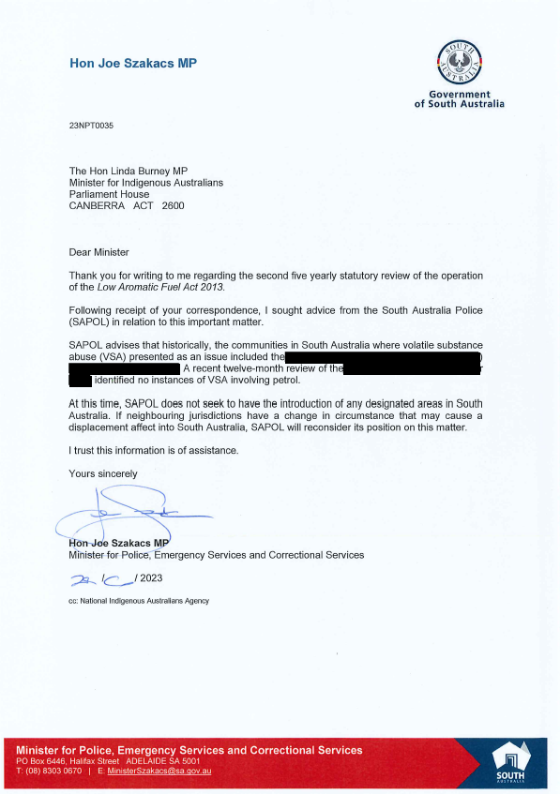
The Hon Joe Szakacs MP, South Australia Minister for Police, Emergency Services and Correctional Services
Alternate text format of Image above
[DOCUMENT HEADER]
Government of South Australia Logo

The Hon Linda Burney MP
Minister for Indigenous Australians
Parliament House
CANBERRA ACT 2600

Dear Minister
Thank you for writing to me regarding the second five yearly statutory review of the operation the Low Aromatic Fuel Act 2013.
Following receipt of your correspondence, I sought advice from the South Australia Police (SAPOL) in relation to this important matter.
SAPOL advises that historically, the communities in South Australia where volatile substance use (VSA) presented as an issue included the . A recent twelve-month review of the identified no instances of VSA involving petrol.
At this time, SAPOL does not seek to have the introduction of any designated areas in South Australia. If neighbouring jurisdictions have a change in circumstance that many cause a displacement affect into South Australia, SAPOL will reconsider its position of this matter.
I trust this information is of assistance.
Yours sincerely
SIGNATURE
Hon Joe Szakacs MP
Minister for Police, Emergency Services and Correctional Services

Date: 28/6/2023

Cc: National Indigenous Australians Agency

[Address block at bottom of the page]
Minister for Police, Emergency Services and Correctional Services
PO Box 6446, Halifax Street ADELAIDE SA 5001
T: (08) 8303 0670 E: Minister.Szakacs@sa.gov.au

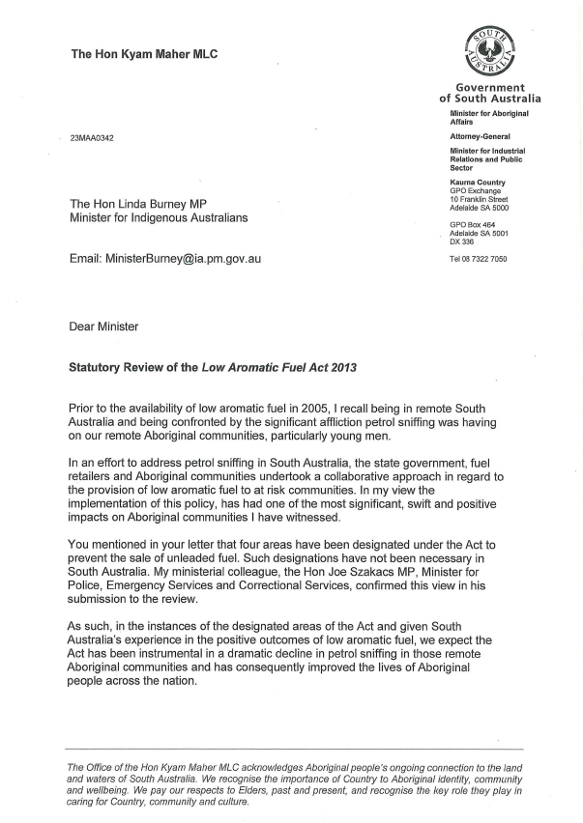
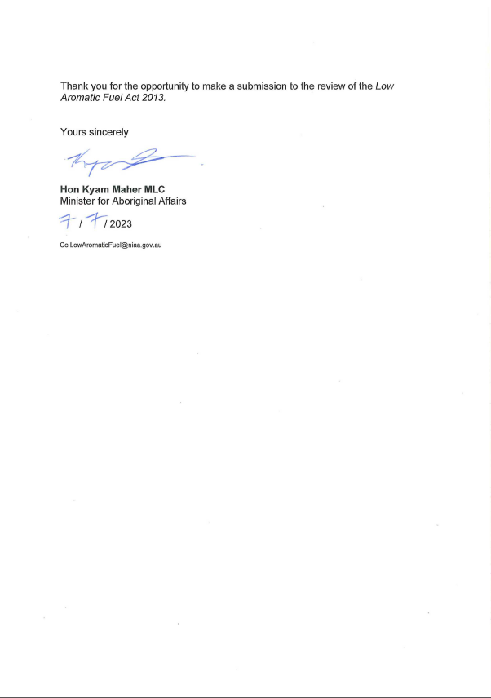
The Hon Kyam Maher MLC, South Australia Minister for Aboriginal Affairs, Attorney General, Minister for Industrial Relations and Public Sector
Alternate text format of Image above

[DOCUMENT HEADER]
Government of South Australia Logo
Minister for Aboriginal Affairs, Attorney General, Minister for Industrial Relations and Public Sector
Kaurna Country
GPO Exchange 10 Franklin Street, Adelaide SA 5001
GPO Box 464, Adelaide SA 5001 DX336 T: 08 73227050

The Hon Linda Burney MP
Minister for Indigenous Australians

Email: MinisterBurney@ia.pm.gov.au
Dear Minister
Statutory Review of the Low Aromatic Fuel Act 2013
Prior to the availability of low aromatic fuel in 2005, I recall being in remote South Australia and being confronted by the significant affliction petrol sniffing was having on our remote Aboriginal communities, particularly young men.
In an effort to address petrol sniffing in South Australia, the state government, fuel retailers and Aboriginal communities undertook a collaborative approach in regard to the provision of low aromatic fuel to as risk communities. In my view the implementation of this policy, has had one of the most significant, swift and positive impacts on Aboriginal communities I have witnessed.
You mentioned in your letter that four areas have been designated under the Act to prevent the sale of unleaded fuel. Such designations have not been necessary in South Australia. My Ministerial colleague, the Hon Joe Szakacs MP, Minister for Police, Emergency Services and Correctional Services, confirmed this view in his submission to the review.
As such, in the instances of the designated areas of the Act and given South Australia’s experience in the positive outcomes of low aromatic fuel, we expect the Act has been instrumental in a dramatic decline in petrol sniffing in those remote Aboriginal communities and has consequently improved the lives of Aboriginal people across the nation.
Thank you for the opportunity to make a submission to the review of the Low Aromatic Fuel Act 2013.
Yours sincerely
SIGNATURE
Hon Kyam Maher MLC
Minister for Aboriginal Affairs
Date: 07/07/2023
[Block at bottom of the page]
The office of the Hon Kyam Maher MLC acknowledges Aboriginal people’s ongoing connection to the land and water of South Australia. We recognise the importance of Country to Aboriginal identity, community and wellbeing. We pay our respects to Elders, past and present, and recognise the key role they play in caring for Country, community and culture.

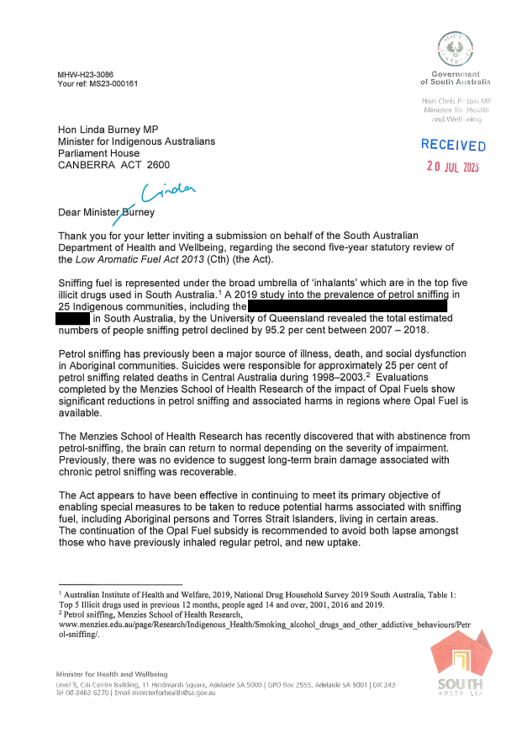
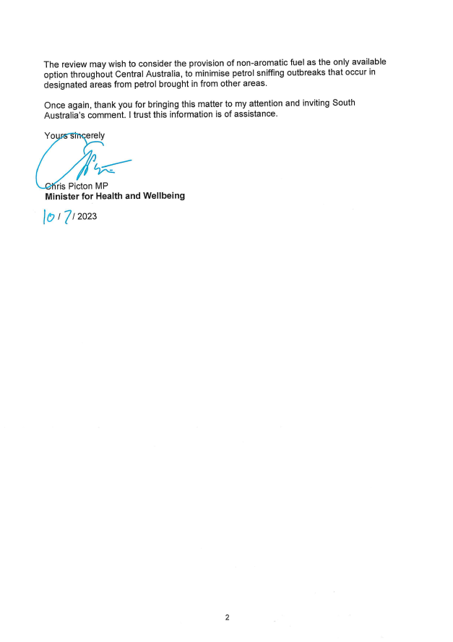
The Hon Chris Picton MP, South Australia Minister for Health and Wellbeing
Alternate text format of Image above
[DOCUMENT HEADER]
Government of South Australia Logo
Hon Chris Picton MP
Minister for Health and Wellbeing

Hon Linda Burney MP
Minister for Indigenous Australians
Parliament House
CANBERRA ACT 2600

Dear Minister Burney (Linda)
Thank you for your letter inviting a submission on behalf of the South Australian Department of Health and Wellbeing, regarding the second five-year statutory review of the Low Aromatic Fuel Act 2013 (Cth) (the Act).
Sniffing fuel is represented under the broad umbrella of ‘inhalants’ which are in the top five illicit drugs used in South Australia. A 2019 study into the prevalence of petrol sniffing in 25 Indigenous communities, including the in South Australia, by the University of Queensland revealed the total estimated numbers of people sniffing petrol declined by 95.2 per cent between 2007-2018.
Petrol sniffing has previously been a major source of illness, death, and social dysfunction in Aboriginal communities. Suicides were responsible for approximately 25 percent of petrol sniffing related deaths in Central Australia during 1998-2003. Evaluations completed by the Menzies School of Health Research of the impact of Opal Fuels show significant reductions in petrol sniffing and associated harms in regions where Opal Fuel is available.
The Menzies School of Health Research has recently discovered that with abstinence from petrol-sniffing, the brain can return to normal depending on the severity of impairment. Previously, there was no evidence to suggest long-term brain damage associated with chronic petrol sniffing was recoverable.
The Act appears to have been effective in continuing to meets its primary objective of enabling special measures to be taken to reduce potential harms associated with sniffing fuel, including Aboriginal persons and Torres Strait Islanders, living in certain areas. The continuation of the Opal Fuel subsidy is recommended to avoid both lapse amongst those who have previously inhaled regular petrol, and new uptake.
The review may wish to consider the provision of non-aromatic fuel as the only available option throughout Central Australia, to minimise petrol sniffing outbreaks that occur in designated areas from petrol brought in from other areas.
Once again, thank you for bringing this matter to my attention and inviting South Australia’s comment. I trust this information is of assistance.
Yours sincerely
SIGNATURE

Chris Picton MP
Minister for Health and Wellbeing
Date: 10/07/2023

[Address block at bottom of the page]
Minister for Health and Wellbeing
Level 9, Citi Centre Building, 11 Hindmarsh Square, Adelaide SA 5000
GPO Box 2555, Adelaide SA 5001 DX 243
Tel 08 8463 6270 Email ministerforhealth@sa.gov.au

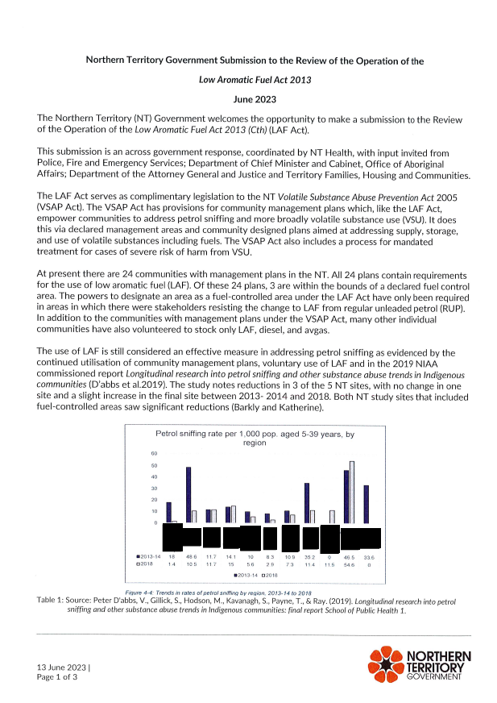
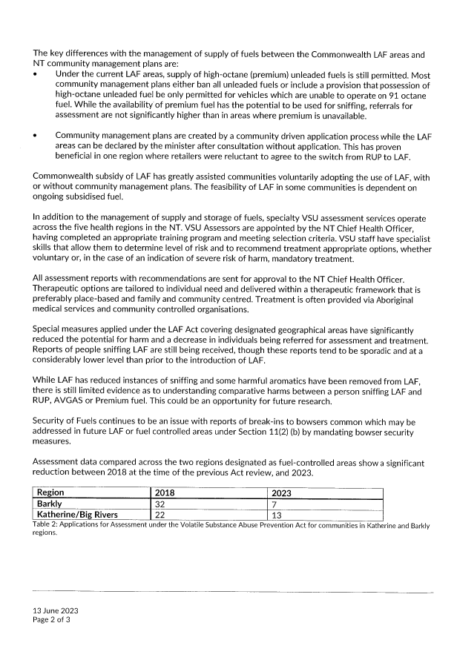
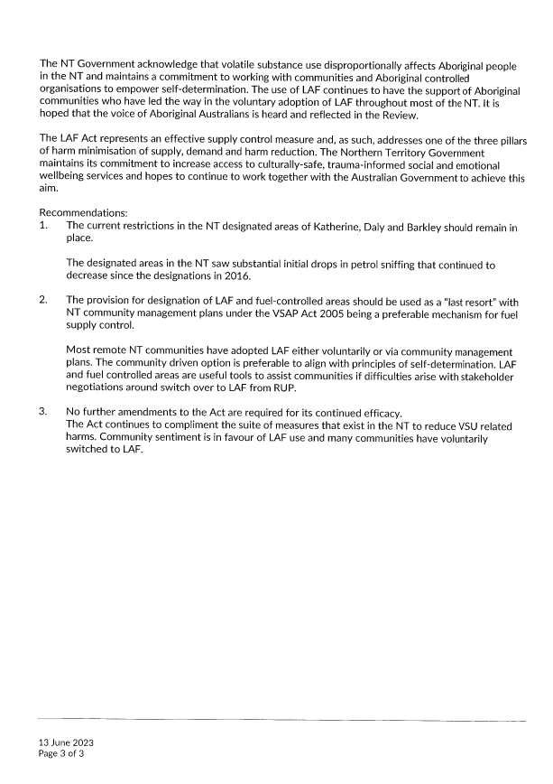
Northern Territory Government; The Hon Natasha Fyles, Chief Minister of the Northern Territory
Alternate text format of Image above
Northern Territory Government Submission to the Review of the Operation of the Low Aromatic Fuel Act 2013
June 2023
The Northern Territory (NT) Government welcomes the opportunity to make a submission to the Review of the Operation of the Low Aromatic Fuel Act 2013 (Cth) (LAF Act).
This submission is an across government response, coordinated by NT Health, with input invited from Police, Fire and Emergency Services; Department of Chief Minister and Cabinet, Office of Aboriginal Affairs ; Department of the Attorney General and Justice and Territory Families, Housing and Communities.
The LAF Act serves as complimentary legislation to the NT Volatile Substance Abuse Prevention Act 2005 (VSAP Act). The VSAP Act has provisions for community management plans which, like the LAF Act, empower communities to address petrol sniffing and more broadly volatile substance use (VSU). It does this via declared management areas and community designed plans aimed at addressing supply, storage, and use of volatile substances including fuels. The VSAP Act also includes a process for mandated treatment for cases of severe risk of harm from VSU.
At present there are 24 communities with management plans in the NT. All 24 plans contain requirements for the use of low aromatic fuel (LAF). Of these 24 plans, 3 are within the bounds of a declared fuel control area. The powers to designate an area as a fuel-controlled area under the LAF Act have only been required in areas in which there were stakeholders resisting the change to LAF from regular unleaded petrol (RUP). In addition to the communities with management plans under the VSAP Act, many other individual communities have also volunteered to stock only LAF, diesel, and avgas.
The use of LAF is still considered an effective measure in addressing petrol sniffing as evidenced by the continued utilisation of community management plans, voluntary use of LAF and in the 2019 NIAA commissioned report Longitudinal research into petrol sniffing and other substance abuse trends in Indigenous communities (D'abbs et al.2019). The study notes reductions in 3 of the 5 NT sites, with no change in one site and a slight increase in the final site between 2013- 2014 and 2018. Both NT study sites that included fuel-controlled areas saw significant reductions (Barkly and Katherine)
[IMAGE OF GRAPH] Trends in rates of petrol sniffing by region, 2013-14 to 2018. Names of communities within graph are removed.
The key differences with the management of supply of fuels between the Commonwealth LAF areas and NT community management plans are:
- Under the current LAF areas, supply of high-octane (premium) unleaded fuels is still permitted. Most community management plans either ban all unleaded fuels or include a provision that possession of high-octane unleaded fuel be only permitted for vehicles which are unable to operate on 91 octane fuel. While the availability of premium fuel has the potential to be used for sniffing, referrals for assessment are not significantly higher than in areas where premium is unavailable.
- Community management plans are created by a community driven application process while the LAF areas can be declared by the minister after consultation without application. This has proven beneficial in one region where retailers were reluctant to agree to the switch from RUP to LAF.
Commonwealth subsidy of LAF has greatly assisted communities voluntarily adopting the use of LAF, with or without community management plans. The feasibility of LAF in some communities is dependent on ongoing subsidised fuel.
In addition to the management of supply and storage of fuels, specialty VSU assessment services operate across the five health regions in the NT. VSU Assessors are appointed by the NT Chief Health Officer, having completed an appropriate training program and meeting selection criteria. VSU staff have specialist skills that allow them to determine level of risk and to recommend treatment appropriate options, whether voluntary or, in the case of an indication of severe risk of harm, mandatory treatment.
All assessment reports with recommendations are sent for approval to the NT Chief Health Officer. Therapeutic options are tailored to individual need and delivered within a therapeutic framework that is preferably place-based and family and community centred. Treatment is often provided via Aboriginal medical services and community controlled organisations.
Special measures applied under the LAF Act covering designated geographical areas have significantly reduced the potential for harm and a decrease in individuals being referred for assessment and treatment. Reports of people sniffing LAF are still being received, though these reports tend to be sporadic and at a considerably lower level than prior to the introduction of LAF.
While LAF has reduced instances of sniffing and some harmful aromatics have been removed from LAF, there is still limited evidence as to understanding comparative harms between a person sniffing LAF and RUP, AVGAS or Premium fuel. This could be an opportunity for future research.
Security of Fuels continues to be an issue with reports of break-ins to bowsers common which may be addressed in future LAF or fuel controlled areas under Section 11(2) (b) by mandating bowser security measures.
Assessment data compared across the two regions designated as fuel-controlled areas show a significant reduction between 2018 at the time of the previous Act review, and 2023.
Region | 2018 | 2 0 2 3
Barkly | 32 | 7
Katherine/Big Rivers | 22 | 13
Table 2: Applications for Assessment under the Volatile Substance Abuse Prevention Act for communities in Katherine and Barkly regions
The NT Government acknowledge that volatile substance use disproportionally affects Aboriginal people in the NT and maintains a commitment to working with communities and Aboriginal controlled organisations to empower self-determination. The use of LAF continues to have the support of Aboriginal communities who have led the way in the voluntary adoption of LAF throughout most of the NT. It is hoped that the voice of Aboriginal Australians is heard and reflected in the Review.
The LAF Act represents an effective supply control measure and, as such, addresses one of the three pillars of harm minimisation of supply, demand and harm reduction. The Northern Territory Government maintains its commitment to increase access to culturally-safe, trauma-informed social and emotional wellbeing services and hopes to continue to work together with the Australian Government to achieve this aim.
Recommendations:
- The current restrictions in the NT designated areas of Katherine, Daly and Barkley should remain in place.
The designated areas in the NT saw substantial initial drops in petrol sniffing that continued to decrease since the designations in 2016.
- The provision for designation of LAF and fuel-controlled areas should be used as a "last resort" with NT community management plans under the VSAP Act 2005 being a preferable mechanism for fuel supply control.
Most remote NT communities have adopted LAF either voluntarily or via community management plans. The community driven option is preferable to align with principles of self-determination. LAF and fuel controlled areas are useful tools to assist communities if difficulties arise with stakeholder negotiations around switch over to LAF from RUP.
- No further amendments to the Act are required for its continued efficacy.
The Act continues to compliment the suite of measures that exist in the NT to reduce VSU related harms. Community sentiment is in favour of LAF use and many communities have voluntarily switched to LAF.

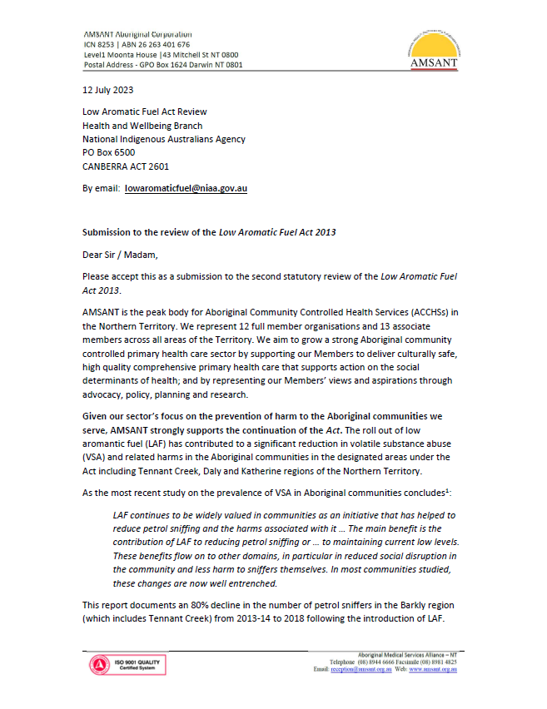
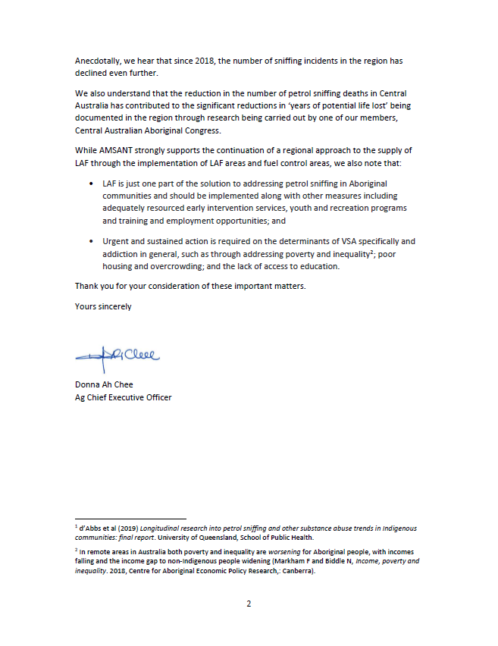
Aboriginal Medical Services Alliance Northern Territory
Alternate text format of Image above
[DOCUMENT HEADER]
Logo of AMSANT Aboriginal Corporation (Aboriginal Medical Services Alliance NT)
ICN 8253 ABN 26 263 401 676
Level 1 Moonta House | 43 Mitchell St NT 0800
Postal Address – GPO Box 1624 Darwin NT 0801
12 July 2023
Low Aromatic Fuel Act Review
Health and Wellbeing Branch
National Indigenous Australians Agency
PO Box 6500
CANBERRA ACT 2601
Email: lowaromaticfuel@niaa.gov.au
Submission to the review of the Low Aromatic Fuel Act 2013
Dear Sir/Madam,
Please accept this as a submission to the second statutory review of the Low Aromatic Fuel Act 2013.
AMSANT is the peak body for Aboriginal Community Controlled Health Services (ACCHSs) in the Northern Territory. We represent 12 full member organisations and 13 associate members across all areas of the Territory. We aim to grow a strong Aboriginal community controlled primary health care sector by supporting our Members to deliver culturally safe, high quality comprehensive primary health care that supports action on the social determinants of health; and by representing our Members’ views and aspirations through advocacy, policy, planning and research.
Given our sector’s focus on the prevention of harm to the Aboriginal communities we serve, AMSANT strongly supports the continuation of the Act. The roll out of low aromatic fuel (LAF) has contributed to a significant reduction in volatile substance abuse (VSA) and related harms in the Aboriginal communities in the designated areas under the Act including Tennant Creek, Daly and Katherine regions of the Northern Territory.
As the most recent study on the prevalence of VSA in Aboriginal communities concludes:
LAF continues to be widely valued in communities as an initiative that has helped to reduce petrol sniffing and the harms associated with it … The main benefit is the contribution of LAF to reducing petrol sniffing or … to maintaining current low levels. These benefits flow on to other domains, in particular in reduced social disruption in the community and less harm to sniffers themselves. In most communities studied, these changes are now well entrenched
This report documents an 80 per cent decline in the number of petrol sniffers in the Barkly region (which includes Tennant Creek) from 2013-14 to 2018 following the introduction of LAF.
Anecdotally, we hear that since 2018, the number of sniffing incidents in the region has declined even further.
We also understand that the reduction in the number of petrol sniffing deaths in Central Australia has contributed to the significant reductions in ‘years of potential life lost’ being documented in the region through research being carried out by one of our members, Central Australian Aboriginal Congress.
While AMSANT strongly supports the continuation of a regional approach to the supply of LAF through the implementation of LAF areas and fuel control areas, we also note that:
- LAF is just one part of the solution to addressing petrol sniffing in Aboriginal communities and should be implemented along with other measures including adequately resourced early intervention services, youth and recreation programs and training and employment opportunities; and
- Urgent and sustained action is required on the determinants of VSA specifically and addiction in general, such as through addressing poverty and inequality; poor housing and overcrowding; and the lack of access to education.
Thank you for your consideration of these important matters.
Yours sincerely

SIGNATURE

Donna Ah Chee
Ag Chief Executive Officer

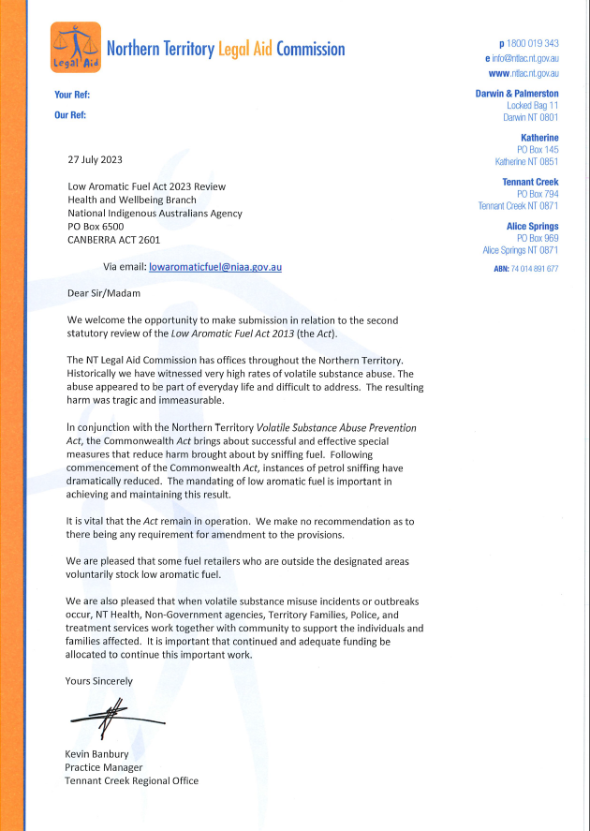
Northern Territory Legal Aid Commission
Alternate text format of Image above
[DOCUMENT HEADER]
Northern Territory Legal Aid Commission
ABN 74 014 891 677
Telephone: 1800 019 343 Email: info@ntlac.nt.gov.au Website: www.ntlac.nt.gov.au
Darwin and Palmerston: Locked Bag 11, Darwin NT 0801
Katherine: PO Box 145, Katherine NT 0851
Tennant Creek: PO Box 794, Tennant Creek NT 0871
Alice Springs: PO Box 969, Alice Springs NT 0871
27 July 2023
Low Aromatic Fuel Act 2023 Review
Health and Wellbeing Branch
National Indigenous Australians Agency
PO Box 6500
CANBERRA ACT 2601
Via email: lowaromaticfuel@niaa.gov.au
Dear Sir/Madam
We welcome the opportunity to make submission in relation to the second statutory review of the Low Aromatic Fuel Act 2013 (the Act).
The NT Legal Aid Commission has offices throughout the Northern Territory. Historically we have witnessed very high rates of volatile substance abuse. The abuse appeared to be part of everyday life and difficult to address. The resulting harm was tragic and immeasurable.
In conjunction with the Northern Territory Volatile Substance Abuse Prevention Act, the Commonwealth Act brings about successful and effective special measures that reduce harm brought about by sniffing fuel. Following commencement of the Commonwealth Act, instances of petrol sniffing have dramatically reduced. The mandating of low aromatic fuel is important in achieving and maintaining this result.
It is vital that the Act remain in operation. We make no recommendation as to there being any requirement for amendment to the provisions.
We are pleased that some fuel retailers who are outside the designated areas voluntarily stock low aromatic fuel.
We are also pleased that when volatile substance misuse incidents or outbreaks occur, NT Health, Non-Government agencies, Territory Families, Police, and treatment services work together with community to support the individuals and families affected. It is important that continued and adequate funding be allocated to continue this important work.
Yours sincerely
SIGNATURE
Kevin Banbury
Practice Manager
Tennant Creek Regional Office
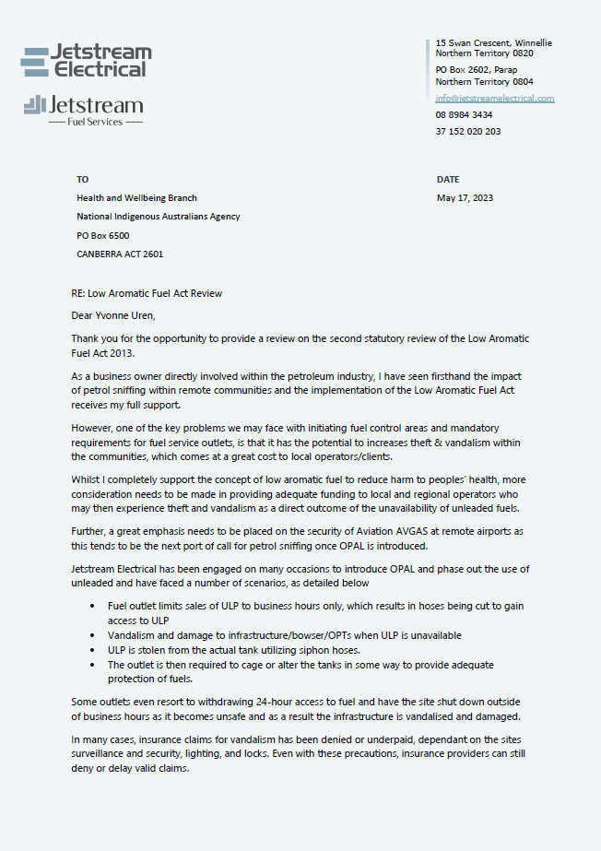
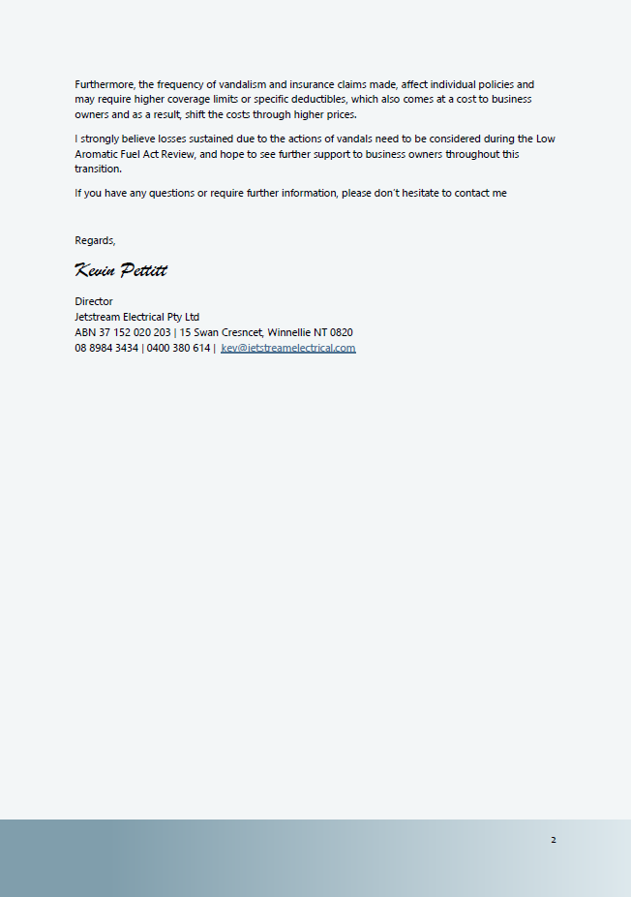
Jetstream Electrical
Alternate text format of Image above
[DOCUMENT HEADER]
15 Swan Crescent, Winnellie, Northern Territory 0820
PO Box 2602, Parap
Northern Territory 0804
info@jetstreamelectrical.com
08 8984 3434
37 152 020 203

May 17, 2023

Health and Wellbeing Branch
National Indigenous Australians Agency
PO Box 6500
CANBERRA ACT 2601

RE: Low Aromatic Fuel Act Review
Dear Yvonne Uren,
Thank you for the opportunity to provide a review on the second statutory review of the Low Aromatic Fuel Act 2013.
As a business owner directly involved within the petroleum industry, I have seen firsthand the impact of petrol sniffing within remote communities and the implementation of the Low Aromatic Fuel Act receives my full support.
However, one of the key problems we may face with initiating fuel control areas and mandatory requirements for fuel services outlets, is that it has the potential to increases theft & vandalism within the communities, which comes at a great cost to local operators/clients.
Whilst I completely support the concept of low aromatic fuel to reduce harm to peoples’ health, more consideration needs to be made in providing adequate funding to local and regional operators who may then experience theft and vandalism as a direct outcome of the unavailability of unleaded fuels.
Further, a great emphasis needs to be placed on the security of Aviation AVGAS at remote airports as this tends to be the next port of call for petrol sniffing once OPAL is introduced.
Jetstream Electrical has been engaged on many occasions to introduce OPAL and phase out the use of unleaded and have faced a number of scenarios, as detailed below
- Fuel outlet limits sales of ULP to business hours only, which results in hoses being cut to gain access to ULP
- Vandalism and damage to infrastructure/bowser/OPTs when ULP is unavailable
- ULP is stolen from the actual tank utilizing siphon hoses.
- The outlet is then required to cage or alter the tanks in some way to provide adequate protection of fuels.
Some outlets even resort to withdrawing 24-hour access to fuel and have the site shut down outside of business hours as it becomes unsafe and as a result the infrastructure is vandalised and damaged.
In many cases, insurance claims for vandalism has been denied or underpaid, dependant on the sites surveillance and security, lighting, and locks. Even with these precautions, insurance providers can still deny or delay valid claims.
Furthermore, the frequency of vandalism and insurance claims made, affect individual policies and may require higher coverage limits or specific deductibles, which also comes at a cost to business owners and as a result, shift the costs through higher prices.
I strongly believe losses sustained due to the actions of vandals need to be considered during the Low Aromatic Fuel Act Review, and hope to see further support to business owners throughout this transition.
If you have any questions or require further information, please don’t hesitate to contact me
Regards,
SIGNATURE
Kevin Pettitt
Director
Jetstream Electrical Pty Ltd

ABN 37 152 020 203 | 15 Swan Cresncet, Winnellie NT 0820
08 8984 3434 | 0400 380 614 | kev@jetstreamelectrical.com

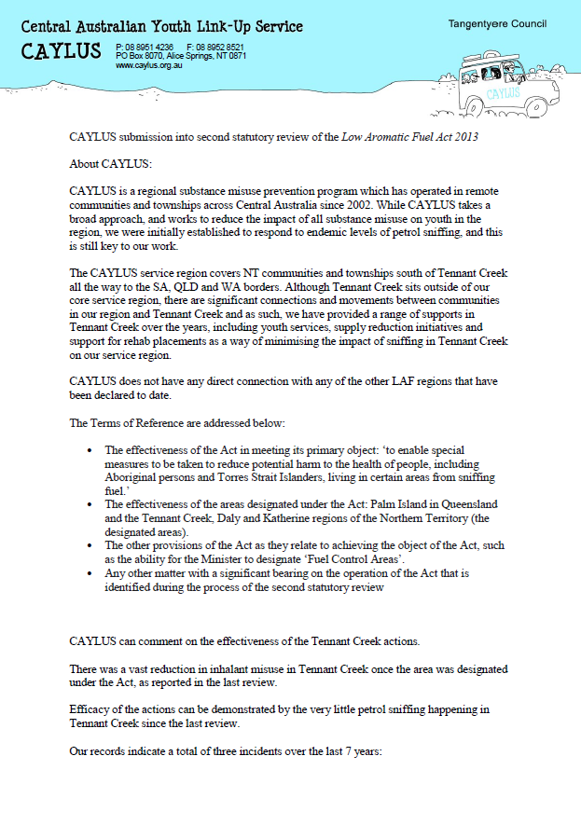
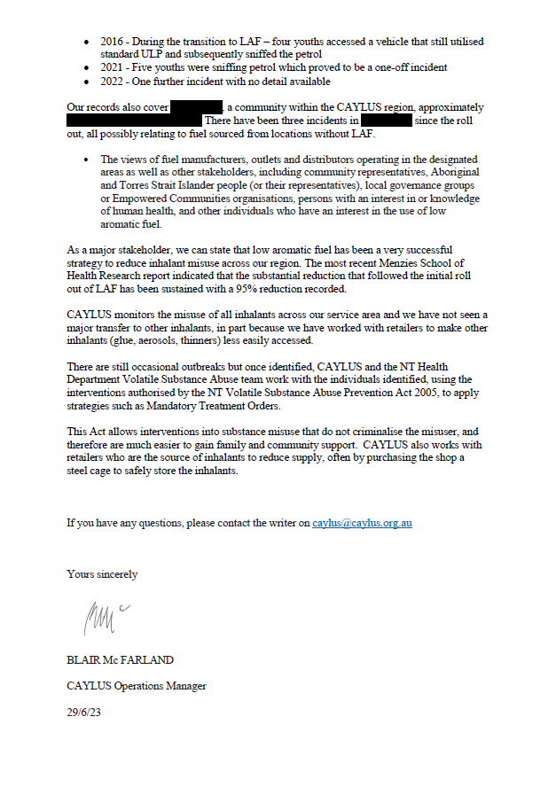
Central Australian Youth Link Up Service
Alternate text format of Image above
[DOCUMENT HEADER]
Central Australian Youth Link Up Service Tangentyere Council
CAYLUS
P: 08 8951 4236 F: 088952 8521
PO Box 8070, Alice Springs, NT 0871
www.caylus.org.au
CAYLUS submission into the second statutory review of the Low Aromatic Fuel Act 2013
About CAYLUS:
CAYLUS is a regional substance misuse prevention program which has operated in remote communities and townships across Central Australia since 2002. While CAYLUS takes a broad approach, and works to reduce the impact of all substance misuse on youth in the region, we were initially established to respond to endemic levels of petrol sniffing, and this is still key to our work.
The CAYLUS service region covers NT communities and townships south of Tennant Creek all the way to the SA, QLD and WA borders. Although Tennant Creek sits outside of our core service region, there are significant connections and movements between communities in our region and Tennant Creek and as such, we have provided a range of supports in Tennant Creek over the years, including youth services, supply reduction initiatives and support for rehab placements as a way of minimising the impact of sniffing in Tennant Creek on our service region.
CAYLUS does not have any direct connection with any of the other LAF regions that have been declared to date.
The Terms of Reference are addressed below:
- The effectiveness of the Act in meeting its primary object: ‘to enable special measures to be taken to reduce potential harm to the health of people, including Aboriginal persons and Torres Strait Islanders, living in certain areas from sniffing fuel.’
- The effectiveness of the areas designated under the Act: Palm Island in Queensland and the Tennant Creek, Daly and Katherine regions of the Northern Territory (the designated areas).
- The other provisions of the Act as they relate to achieving the object of the Act, such as the ability for the Minister to designate ‘Fuel Control Areas’.
- Any other matter with a significant bearing on the operation of the Act that is identified during the process of the second statutory review
CAYLUS can comment on the effectiveness of the Tennant Creek actions.
There was a vast reduction in inhalant misuse in Tennant Creek once the area was designated under the Act, as reported in the last review.
Efficacy of the actions can be demonstrated by the very little petrol sniffing happening in Tennant Creek since the last review.
Our records indicate a total of three incidents over the last 7 years:
- 2016 - During the transition to LAF – four youths accessed a vehicle that still utilised standard ULP and subsequently sniffed the petrol
- 2021 - Five youths were sniffing petrol which proved to be a one-off incident
- 2022 - One further incident with no detail available
Our records also cover , a community with the CAYLUS region, approximately . There have been three incidents in since the roll out, all possibly relating to fuel sourced from locations without LAF,
- The views of fuel manufacturers, outlets and distributors operating in the designated areas as well as other stakeholders, including community representatives, Aboriginal and Torres Strait Islander people (or their representatives), local governance groups or Empowered Communities organisations, persons with an interest in or knowledge of human health, and other individuals who have an interest in the use of low aromatic fuel.
As a major stakeholder, we can state that low aromatic fuel has been a very successful strategy to reduce inhalant misuse across our region. The most recent Menzies School of Health Research report indicated that the substantial reduction that followed the initial roll out of LAF has been sustained with a 95 percent reduction recorded.
CAYLUS monitors the misuse of all inhalants across our service area and we have not seen a major transfer to other inhalants, in part because we have worked with retailers to make other inhalants (glue, aerosols, thinners) less easily accessed.
There are still occasional outbreaks but once identified, CAYLUS and the NT Health Department Volatile Substance Abuse team work with the individuals identified, using the interventions authorised by the NT Volatile Substance Abuse Prevention Act 2005, to apply strategies such as Mandatory Treatment Orders.
This Act allows interventions into substance misuse that do not criminalise the misuser, and therefore are much easier to gain family and community support. CAYLUS also works with retailers who are the source of inhalants to reduce supply, often by purchasing the shop a steel cage to safely store the inhalants.
If you have any questions, please contact the writer on caylus@caylus.org.au
Yours sincerely
SIGNATURE
Blair McFarland
CAYLUS Operations Manager
Date: 29/06/2023
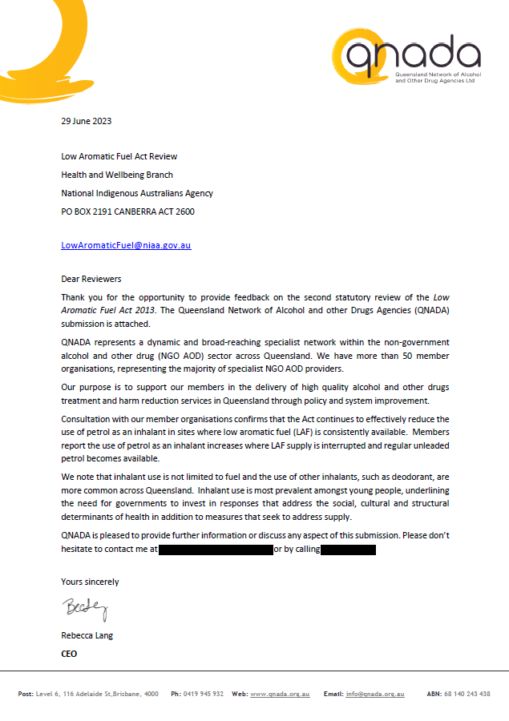
Queensland Network of Alcohol and other Drugs Agencies
Alternate text format of Image above
[DOCUMENT HEADER]
Queensland Network of Alcohol and Other Drug Agencies Ltd

29 June 2023

Low Aromatic Fuel Act Review
Health and Wellbeing Branch
National Indigenous Australians Agency
PO BOX 2191 CANBERRA ACT 2600

Lowaromaticfuel@niaa.gov.au
Dear Reviewers
Thank you for the opportunity to provide feedback on the second statutory review of the Low Aromatic Fuel Act 2013. The Queensland Network of Alcohol and other Drugs Agencies (QNADA) submission is attached.
QNADA represents a dynamic and broad-reaching specialist network within the non-government alcohol and other drug (NGO AOD) sector across Queensland. We have more than 50 member organisations, representing the majority of specialist NGO AOD providers.
Our purpose is to support our members in the delivery of high quality alcohol and other drugs treatment and harm reduction services in Queensland through policy and system improvement.
Consultation with our member organisations confirms that the Act continues to effectively reduce the use of petrol as an inhalant in sites where low aromatic fuel (LAF) is consistently available. Members report the use of petrol as an inhalant increases where LAF supply is interrupted and regular unleaded petrol becomes available.
We note that inhalant use is not limited to fuel and the use of other inhalants, such as deodorant, are more common across Queensland. Inhalant use is most prevalent amongst young people, underlining the need for governments to invest in responses that address the social, cultural and structural determinants of health in addition to measures that seek to address supply.
QNADA is pleased to provide further information or discuss any aspect of this submission. Please don’t hesitate to contact me at
Yours sincerely
SIGNATURE
Rebecca Lang
CEO
[Address Block at Bottom of page]
Post: Level 6, 116 Adelaide St, Brisbane 4000
Ph: 0419 945 932
Web: www.qnada.org.au
Email: info@qnada.org.au
ABN: 68 140 243 438
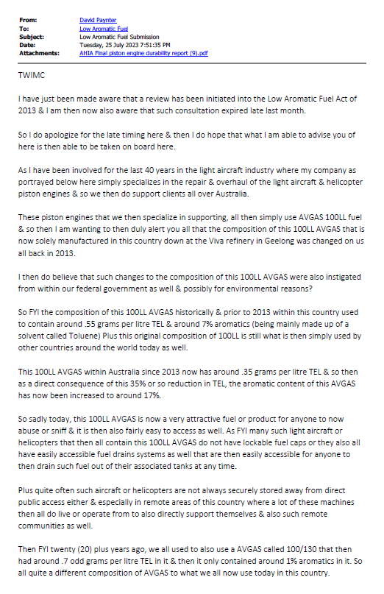
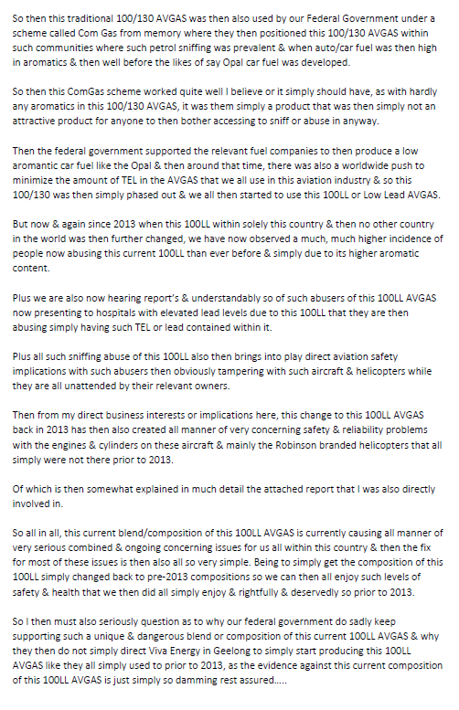
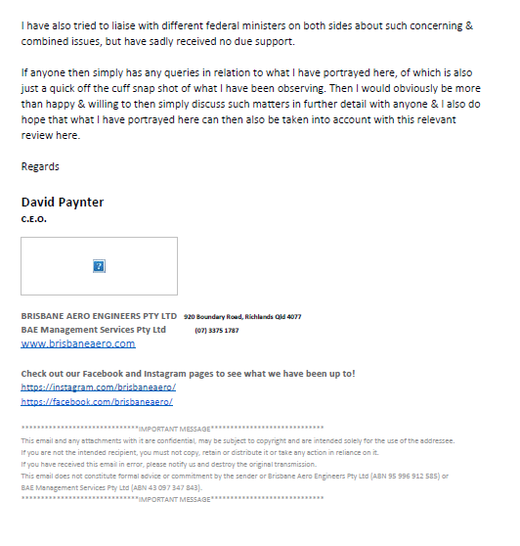

Brisbane Aero Engineers
Alternate text format of Image above
[DOCUMENT HEADER]
From: David Paynter
To: Low Aromatic Fuel
Subject: Low Aromatic Fuel Submission
Date: Tuesday, 25 July 2023
Attachments: AHIA Final piston engine durability report

TWIMC
I have just been made aware that a review has been initiated into the Low Aromatic Fuel Act of 2013 & I am then now also aware that such consultation expired late last month.
So I do apologize for the late timing here & then I do hope that what I am able to advise you of here is then able to be taken on board here.
As I have been involved for the last 40 years in the light aircraft industry where my company as portrayed below here simply specializes in the repair & overhaul of the light aircraft & helicopter piston engines & so we then do support clients all over Australia.
These piston engines that we then specialize in supporting, all then simply use AVGAS 100LL fuel & so then I am wanting to then duly alert you all that the composition of this 100LL AVGAS that is now solely manufactured in this country down at the Viva refinery in Geelong was changed on us all back in 2013.
I then do believe that such changes to the composition of this 100LL AVGAS were also instigated from within our federal government as well & possibly for environmental reasons?
So FYI the composition of this 100LL AVGAS historically & prior to 2013 within this country used to contain around .55 grams per litre TEL & around 7% aromatics (being mainly made up of a solvent called Toluene) plus this original composition of 100LL is still what is then simply used by other countries around the world today as well.
This 100LL AVGAS within Australia since 2013 now has around .35 grams per litre TEL & so then as a direct consequence of this 35% or so reduction in TEL, the aromatic content of this AVGAS has now been increased to around 17%.
So sadly today, this 100LL AVGAS is now a very attractive fuel or product for anyone to now abuse or sniff & it is then also fairly easy to access as well. As FYI many such light aircraft or helicopters that then all contain this 100LL AVGAS do not have lockable fuel caps or they also all have easily accessible fuel drains systems as well that are then easily accessible for anyone to then drain such fuel out of their associated tanks at any time.
Plus quite often such aircraft or helicopters are not always securely stored away from direct public access either & especially in remote areas of this country where a lot of these machines then all do live or operate from to also directly support themselves & also such remote communities as well.

Then FYI twenty (20) plus years ago, we all used to also use a AVGAS called 100/130 that then had around .7 odd grams per litre TEL in it & then it only contained around 1% aromatics in it. So all quite a different composition of AVGAS to what we all now use today in this country.
So then this traditional 100/130 AVGAS was then also used by our Federal Government under a scheme called Com Gas from memory where they then positioned this 100/130 AVGAS within such communities where such petrol sniffing was prevalent & when auto/car fuel was then high in aromatics & then well before the likes of say Opal car fuel was developed.
So then this ComGas scheme worked quite well I believe or it simply should have, as with hardly any aromatics in this 100/130 AVGAS, it was them simply a product that was then simply not an attractive product for anyone to then bother accessing to sniff or abuse in anyway.
Then the federal government supported the relevant fuel companies to then produce a low aromatic car fuel like the Opal & then around that time, there was also a worldwide push to minimize the amount of TEL in the AVGAS that we all use in this aviation industry & so this 100/130 was then simply phased out & we all then started to use this 100LL or Low Lead AVGAS.
But now & again since 2013 when this 100LL within solely this country & then no other country in the world was then further changed, we have now observed a much, much higher incidence of people now abusing this current 100LL than ever before & simply due to its higher aromatic content.
Plus we are also now hearing report’s & understandably so of such abusers of this 100LL AVGAS now presenting to hospitals with elevated lead levels due to this 100LL that they are then abusing simply having such TEL or lead contained within it.
Plus all such sniffing abuse of this 100LL also then brings into play direct aviation safety implications with such abusers then obviously tampering with such aircraft & helicopters while they are all unattended by their relevant owners.
Then from my direct business interests or implications here, this change to this 100LL AVGAS back in 2013 has then also created all manner of very concerning safety & reliability problems with the engines & cylinders on these aircraft & mainly the Robinson branded helicopters that all simply were not there prior to 2013.
Of which is then somewhat explained in much detail the attached report that I was also directly involved in.
So all in all, this current blend/composition of this 100LL AVGAS is currently causing all manner of very serious combined & ongoing concerning issues for us all within this country & then the fix for most of these issues is then also all so very simple. Being to simply get the composition of this 100LL simply changed back to pre-2013 compositions so we can then all enjoy such levels of safety & health that we then did all simply enjoy & rightfully & deservedly so prior to 2013.
So I then must also seriously question as to why our federal government do sadly keep supporting such a unique & dangerous blend or composition of this current 100LL AVGAS & why they then do not simply direct Viva Energy in Geelong to simply start producing this 100LL AVGAS like they all simply used to prior to 2013, as the evidence against this current composition of this 100LL AVGAS is just simply so damming rest assured…..
I have also tried to liaise with different federal ministers on both sides about such concerning & combined issues, but have sadly received no due support.
If anyone then simply has any queries in relation to what I have portrayed here, of which is also just a quick off the cuff snap shot of what I have been observing. Then I would obviously be more than happy & willing to then simply discuss such matters in further detail with anyone & I also do hope that what I have portrayed here can then also be taken into account with this relevant review here.
Regards
David Paynter
C.E.O

[Address block at bottom of page]
Brisbane Aero Engineers PTY LTD
BAE Management Services Pty Ltd
920 Boundary Road, Richlands QLD 4077
(07) 3375 1787
www.brisbaneaero.com
Check out our Facebook and Instagram pages to see what we have been up to!
https://instagram.com/brisbaneaero/
https://facebook.com/brisbaneaero/
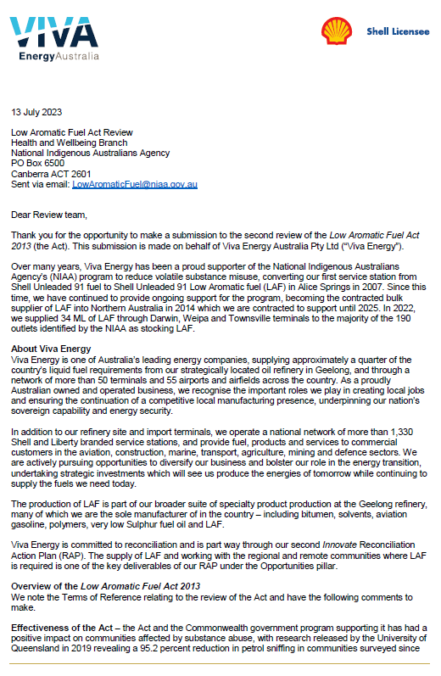
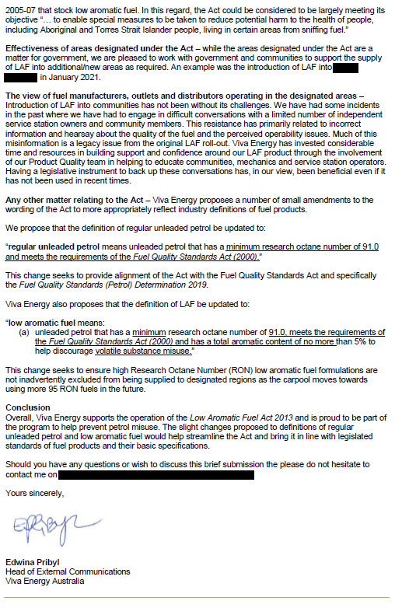
Viva Energy Australia
Alternate text format of Image above
Viva Energy Australia Logo
Shell Logo - Shell Licensee

13 July 2023

Low Aromatic Fuel Act Review
Health and Wellbeing Branch
National Indigenous Australians Agency
PO Box 6500
Canberra ACT 2601
Sent via email: Lowaromaticfuel@niaa.gov.au

Dear Review team,
Thank you for the opportunity to make a submission to the second review of the Low Aromatic Fuel Act 2013 (the Act). This submission is made on behalf of Viva Energy Australia Pty Ltd (“Viva Energy”).
Over many years, Viva Energy has been a proud supporter of the National Indigenous Australians Agency’s (NIAA) program to reduce volatile substance misuse, converting our first service station from Shell Unleaded 91 fuel to Shell unleaded 91 Low Aromatic fuel (LAF) in Alice Springs in 2007. Since this time, we have continued to provide ongoing support for the program, becoming the contracted bulk supplier of LAF into Northern Australia in 2014 which we are contracted to support until 2025. In 2022, we supplied 34 ML of LAF through Darwin, Weipa and Townsville terminals to the majority of the 190 outlets identified by the NIAA as stocking LAF.
About Viva Energy
Viva Energy is one of Australia’s leading energy companies, supplying approximately a quarter of the country’s liquid fuel requirements from our strategically located oil refinery in Geelong, and through a network of more than 50 terminals and 55 airports and airfields across the country. As a proudly Australian owned and operated business, we recognise the important roles we play in creating local jobs and ensuring the continuation of a competitive local manufacturing presence, underpinning our nation’s sovereign capability and energy security.
In addition to our refinery site and import terminals, we operate a national network of more than 1,330 Shell and Liberty branded service stations, and provide fuel, products and services to commercial customers in the aviation, construction, marine, transport, agriculture, mining and defence sectors. We are actively pursuing opportunities to diversify our business and bolster our role in the energy transition, undertaking strategic investments which will see us produce the energies of tomorrow while continuing to supply the fuels we need today.
The production of LAF is part of our broader suite of specialty product production at the Geelong refinery, many of which we are the sole manufacturer of in the country – including bitumen, solvents, aviation gasoline, polymers, very low Sulphur fuel oil and LAF.

Viva Energy is committed to reconciliation and is part way through our second Innovate Reconciliation Action Plan (RAP). The supply of LAF and working with the regional and remote communities where LAF is required is one of the key deliverables of our RAP under the Opportunities pillar
Overview of the Low Aromatic Fuel Act 2013
We note the Terms of Reference relating to the review of the Act and have the following comments to make.
Effectiveness of the Act – the Act and the Commonwealth government program supporting it has had a positive impact on communities affected by substance abuse, with research released by the University of Queensland in 2019 revealing a 95.2 percent reduction in petrol sniffing in communities surveyed since 2005-07 that stock low aromatic fuel. In this regard, the Act could be considered to be largely meeting its objective “…to enable special measures to be taken to reduce potential harm to the health of people, including Aboriginal and Torres Strait Islander people, living in certain areas from sniffing fuel.”
Effectiveness of areas designated under the Act – while the areas designated under the Act are a matter for government, we are pleased to work with government and communities to support the supply of LAF into additional/new areas required. An example was the introduction of LAF into in January 2021.
The view of fuel manufacturers, outlets and distributors operating in the designated areas – Introduction of LAF into communities has not been without its challenges. We have had some incidents in the past where we have has to engage in difficult conversations with a limited number of independent service station owners and community members. This resistance has primarily related to incorrect information and hearsay about the quality of the fuel and the perceived operability issues. Much of this misinformation is a legacy issue from the original LAF roll-out. Viva Energy has invested considerable time and resources in building support and confidence around our LAF product through the involvement of our Product Quality team in helping to educate communities, mechanics and service station operators. Having a legislative instrument to back up these conversations has, in our view, been beneficial even if it has not been used in recent times.
Any other matter relating to the Act – Viva Energy proposes a number of small amendments to the wording of the Act to more appropriately reflect industry definitions of fuel products.
We propose that the definition of regular unleaded petrol be updated to:
“regular unleaded petrol means unleaded petrol that has a minimum research octane number of 91.0 and meets the requirements of the Fuel Quality Standards Act (2000).”
This change seeks to provide alignment of the Act with the Fuel Quality Standards Act and specifically the Fuel Quality Standards (Petrol) Determination 2019.
Viva Energy also proposes that the definition of LAF be updated to:
“low aromatic fuel means:
(a) unleaded petrol that has a minimum research octane number of 91.0, meets the requirements of the Fuel Quality Standards Act (2000) and has a total aromatic content of no more than 5% to help discourage volatile substance misuse.”
This change seeks to ensure high Research Octane Number (RON) low aromatic fuel formulations are not inadvertently excluded from being supplied to designated regions as the carpool moves towards using more 95 RON fuels in the future.
Conclusion
Overall, Viva Energy supports the operation of the Low Aromatic Fuel Act 2013 and is proud to be part of the program to help prevent petrol misuse. The slight changes proposed to definitions of regular unleaded petrol and low aromatic fuel would help streamline the Act and bring it in line with legislated standards of fuel products and their basic specifications.
Should you have any questions or wish to discuss this brief submission the please do not hesitate to contact me on
Yours sincerely,
SIGNATURE

Edwina Pribyl
Head of External Communications
Viva Energy Australia

Attachment C: History of Commonwealth engagement with volatile substance use issues
In the late 1990s, Indigenous communities and organisations concerned about volatile substance use involving petrol requested help from the Australian Government. In response, the Government introduced the Comgas scheme in 1998. The focus of the scheme was to subsidise the provision of Avgas to participating communities. The specification of Avgas in use at that time contained low levels of aromatic content and high levels of lead. As a result of its low aromatic content, this form of Avgas was less likely to be used for volatile substance use. However, this was not a viable long term option as Australia was phasing out leaded fuels used in road going vehicles and engine design was changing to be less compatible with Avgas. Since this time, the specification of Avgas in use in Australia has changed and contains higher aromatic content and lower levels of lead.
In 2005, an unleaded 91 octane low aromatic fuel was developed by bp Australia as a substitute to regular unleaded petrol and the Government began supporting its production and distribution.
The Australian Government’s Petrol Sniffing Prevention Program (PSPP) was established in February 2005 to supply low aromatic fuel to participating communities. The PSPP was implemented by the then Department of Health and Ageing as part of the whole-of-government Petrol Sniffing Strategy (PSS). The PSS was developed in September 2005 as a collaborative approach between the Australian Government and the governments of Western Australia, South Australia and the Northern Territory to reduce petrol sniffing. The Eight Point Plan under the PSS sought to address developing consistent legislation, appropriate levels of policing, further roll out of low aromatic fuel, youth engagement activities, treatment and respite facilities, communication and education strategies, strengthening and supporting communities and evaluation of these initiatives.
From 2005 to 2013 the PSS was managed by the Australian Government jointly across the Indigenous Affairs, Health, Education, and Attorney-General’s portfolios. Following the 2013 federal election, Indigenous programs (including the PSS) were consolidated in the then Indigenous Affairs Group of the Department of the Prime Minister and Cabinet. In 2019 the Indigenous Affairs Group became the standalone National Indigenous Australians Agency, remaining within the portfolio of the Department of the Prime Minister and Cabinet.
In 2023-24 the Australian Government has committed $12.9 million through the Indigenous Advancement Strategy for the supply of low aromatic fuel. The IAS also funds $2.5 million in 2023-24 to support a range of other activities focussed on preventing volatile substance use and building capacity in a small number of vulnerable locations.
Since 2005, low aromatic fuel has become more widely available. At the time of this second statutory review, approximately 190 fuel outlets stock low aromatic fuel across Australia. The current suppliers of low aromatic fuel are bp Australia (to southern parts of Australia) and Viva Energy Australia (to northern parts of Australia), with contracts in place until June 2025.
Most bulk low aromatic fuel storage is owned by the current suppliers of low aromatic fuel (the exception is Darwin where the bulk storage tank was funded by the Australian Government). In 2023, low aromatic fuel is available to distributors from bulk storage facilities in the Northern Territory (1), Queensland (2), South Australia (1) and Western Australia (1).

Attachment D: Further reading
- Low Aromatic Fuel Act 2013 – https://www.legislation.gov.au/Details/C2016C00163
- Palm Island Designation – https://www.legislation.gov.au/Details/F2015L01844 ; and Explanatory Statement – https://www.legislation.gov.au/Details/F2015L01844/Explanatory%20Statement/Text
- Barkly Region Designation – https://www.legislation.gov.au/Details/F2016L00111; and Explanatory Statement – https://www.legislation.gov.au/Details/F2016L00111/Explanatory%20Statement/Text
- Daly Region Designation – https://www.legislation.gov.au/Details/F2016L00123; and Explanatory Statement – https://www.legislation.gov.au/Details/F2016L00123/Explanatory%20Statement/Text
- Katherine Region Designation – https://www.legislation.gov.au/Details/F2016L00122; and Explanatory Statement – https://www.legislation.gov.au/Details/F2016L00122/Explanatory%20Statement/Text
- Senate Inquiry into the Low Aromatic Fuel Bill 2012: https://www.aph.gov.au/Parliamentary_Business/Committees/Senate/Community_Affairs/Completed_inquiries/2010-13/lowaromaticfuels/report/index
- Report from the Low Aromatic Fuel Bills 2012 Digest: https://www.aph.gov.au/Parliamentary_Business/Bills_Legislation/bd/bd1213a/13bd068
- 2005-2006 Senate Inquiry into Petrol Sniffing in remote Aboriginal communities Report: https://www.aph.gov.au/Parliamentary_Business/Committees/Senate/Community_Affairs/Completed_inquiries/2004-07/petrol_sniffing/index
- 2009 Senate Inquiry into Petrol Sniffing and Substance Misuse Central Australia Report and Combined Government Response (2010): https://www.aph.gov.au/Parliamentary_Business/Committees/Senate/Community_Affairs/Completed_inquiries/2008-10/petrol_sniffing_substance_abuse08/index
- “Monitoring trends in the prevalence of petrol sniffing in selected Australian Aboriginal communities 2011-2014 – Final Report” by Menzies School of Public Health Research: https://www.niaa.gov.au/resource-centre/indigenous-affairs/monitoring-trends-prevalence-petrol-sniffing-selected-australian-aboriginal-communities-final-report
- Delivery of the Petrol Sniffing Strategy in Remote Communities – ANAO 2014-15: https://www.anao.gov.au/work/performance-audit/delivery-petrol-sniffing-strategy-remote-indigenous-communities
- “Longitudinal research into petrol sniffing and other substance abuse trends in Indigenous communities: Final Report” published in 2019 by the University of Queensland: https://www.niaa.gov.au/resource-centre/indigenous-affairs/longitudinal-research-petrol-sniffing-and-other-substance-abuse-trends
- 2018 Review into the Operation of the Low Aromatic Fuel Act 2013: https://www.niaa.gov.au/resource-centre/indigenous-affairs/review-operation-low-aromatic-fuel-act-2013

Menzies School of Health Research, Darwin (2016) Monitoring trends in prevalence of petrol sniffing in selected Aboriginal Communities: 2011 to 2014.
The University of Queensland, School of Public Health (2019), Longitudinal research into petrol sniffing and other substance abuse trends in Indigenous communities: final report, pp 7-8.
Australian Institute of Health and Welfare (2020), ‘National Drug Strategy Household Survey 2019’, Drug Statistics series no. 32, p 42.
Menzies School of Health Research (2013), Monitoring trends in prevalence of petrol sniffing in selected Aboriginal communities: an interim report, p 17.
Low Aromatic Fuel Act 2013 (Cth), section 11 (2)
International Convention of the Elimination of All Forms of Racial Discrimination (New York, 21 December 1965) [1969] UNTS 660-14 p 1, article 1.4.
⁴ Sections 14(2)(c) and 15(2)(c) of the Act.
Low Aromatic Fuel Act 2013 (Cth), sections 9, 10, 11, 15, 16, 17
Low Aromatic Fuel Act 2013 (Cth), section 11 (2)
Published at https://www.aihw.gov.au/reports/illicit-use-of-drugs/national-drug-strategy-household-survey-2019/contents/fact-sheets
Low Aromatic Fuel Act 2013 (Cth), sections 9, 15
Australian Institute of Petroleum (2019) Downstream Petroleum Report, p.5.
Australia Institute of Health and Welfare, 2019, National Drug Household Survey 2019 South Australia, Table 1: Top 5 Illicit drugs used in previous 12 months, people aged 14 and over, 2001,2016, and 2019.
Petrol sniffing, Menzies School of Health Research, www.menzies.edu.au/page/Research/Indigenous_Health/Smoking_alcohol_drugs_and_other_addicitve_behaviours/Petrol-sniffing/.
d’Abbs et al (2019) Longitudinal research into petrol sniffing and other substance abuse trends in Indigenous communities: final report. University of Queensland, School of Public Health.
In remote areas in Australia both poverty and inequality are worsening for Aboriginal people, with incomes falling and the income gap to non-Indigenous people widening (Markham F and Biddle N, Income, poverty and inequality. 2018, Centre for Aboriginal Economic Policy Research,: Canberra).

